553/1
BIOLOGY
THEORY
Paper 1
Nov 2020

2½ hours
ST. MARYS’ KITENDE
Uganda Certificate of Education
RESOURCEFUL MOCK EXAMINATION 2020
BIOLOGY THEORY
Paper 1
2 hours 30 minutes

INSTRUCTIONS:
- Answer all questions in section A and B plus any two in section C.

For Examiner’s Use Only
SECTION | MARKS
A: 1-30:
B: No. 31:
No. 32:
No. 33:
C: No.
No.
TOTAL

SECTION A (30 MARKS)
Write the letter representing the most correct alternative in the box provided
1. In flowering plants a transpiration stream is maintained by.
A. Diffusion. B. Active transport.
C. Osmosis. D. Capillarity.

2. During exhalation in human being
A. the rib cage move upwards and downwards.
B. Volume of the thoracic increases.
C. Diaphragm muscles relax.
D. Intercostal muscles contract.

3. The layer of the human skin important for the body to retain water is called.
A. Malpighian layer. B. Cornified layer.
C. Granular layer. D. Subcutaneous layer.

4. The characteristic common in insect pollinated flowers is.
A. stigma and pollen grain often being sticky.
B. Filaments being flexible and anthers loosely attached.
C. Production of small and smooth pollen grains.
D. Having small greenish bracts.

5. Of the following characteristics, the one that suits an amphibian for aquatic life is.
A. Moist skin without scales.
B. Webbed toes.
C. Possession of muscular hind limbs.
D. Possession of wings.

6. The following are caused by oestrogenEXCEPT.
A. Growth of uterine wall.
B. Stooping further secretion of FSH.
C. Release of a ripe ovum from ovary.
D. Healing the uterus lining.

7. The part of a tooth that contains living tissue is called.
A. Enamel. B. Cement.
C. Crown. D. Pulp cavity.

8. The ratio of offspring phenotypes when a roan bull and roan cow are crossed is
A. 2 red: 1 roan: 1 white. B. 1 red: 2 roan: 1 white.
C. 1 red: 1 white. D. 1 red: 1 roan: 2 white.

9. Which of the following is a result of having a human diet deficient of iodine?
A. goiter B. Scurvy.
C. anaemia. D. rickets.

10. The association between a fungus growing on the leaves of a living potato plant is described as.
A. Saprophytic. B. Predation.
C. Parasitism. D. Commensalism.

11. Of the following, mitosis differs from meiosis in that it produces.
A. Two daughter cells with half the chromosome number. .
B. Four daughter cells with half the chromosome number.
C. Four daughter cells with equal chromosome number.
D. Two daughter cells with equal chromosome number.

12. Which of the following conditions for germination is of Leastimportance?
A. Oxygen. B. Light
C. Moisture. D. Moderate temperature.

13. The importance of sweating in humans is to
A. get rid of excess salts.
B. get rid of excess water.
C. Cool the body.
D. Lose urea from the body.

14. Which of the following features are suitable for a mammalian respiratory surface?
A. Moist, many blood vessels.
B. Dry, many blood vessels.
C. Dry, large surface area.
D. Moist, reduced surface area.

15. Digestion of starch in the mammalian alimentary cannal occurs in.
A. mouth and small intestine.
B. stomach and duodenum.
C. mouth and stomach.
D. mouth and stomach.

16. Mature mammalian red blood cell contain no nucleus so as to
A. allow the cell carry more dissolved food substances.
B. allow the cell carry more oxygen.
C. ease the cell passage through capillary livings.
D. create more space for antibodies.
17. During panting in a dog,
A. more gaseous exchange occurs.
B. latent heat of vaporization is lost.
C. More air is inspired.
D. Relaxation from exhaustion is abled.

18. Which of the following human practices controls soilerosion?
A. fertilizing B. Manuring.
C. Agroforestry. D. Terracing.

19. The amount of nitrogen in the atmosphere can be increased through.
A. Denitrification. B. Nitrification.
C. Excretion. D. Putrification.

20. The following are liver functions EXCEPT;
A. secretion of insulin B. Storage of vitamins.
C. Production of bile. D. Regulation of glucose level.

21. Which of the following flowering parts are referred to as essential?
A. Androecium and corolla.
B. Androecium and gynaecium.
C. Androecium and calyx.
D. Gynoecium and corolla.

22. In spirogyra, sexual reproduction occurs through.
A. Budding. B. Fragmentation
C. Binary fission. D. Conjugation.

23. Which one of the following is a response by a mammalian body to a lowering environmental temperature?
A. Reduced metabolic rate. B. Shivering.
C. Sweating. D. Vasodilation.

24. A person of blood group O is referred to as a universal donor because the person
A. Donates blood to all other blood groups
B. Donates blood to only blood group AB.
C. Has blood without antigens to be attacked by recipients antibodies.
D. Has blood without antibodies to attack recipients antigens.

25. The rigidity of a plant cell is enabled by.
A. Osmosis. B. Cell sap.
C. Cell wall. D. Protoplasm.

26. In the infants rennin contained in the stomach is for.
A. Converting proteins to polypeptides.
B. Activation of pepsin enzyme.
C. Converting liquid milk protein to sold milk protein.
D. Activation of protein digestion.

27. The following results were obtained during an analysis a soil sample.
Clay soil used =100cm³
Water used =200cm³
Water + clay soil after stirring =276cm³
What was the percentage of air in the soil used?
A. 24% B. 92% C. 8% D. 12%

28. A cross between white flowered plant and a red flowered plant produced a plant that had pink flowers. This indicates a condition of
A. Co-dominance. B. Dominance.
C. Mutation. D. Recessive ness.

29. The modified structure used for vegetation reproduction of Irish potato plant is the;
A. Leaf B. Bad
C. Root D. Stem

30. Which of the following is found in animal cells only?
A. Flagella. B. Central vacuole
C. Protoplasm. D. Cell membrane.

SECTION B: (40MARKS)
Answer all numbers in this section.Write in the spaces provided.

31. Researchers investigated the changes in the population of two species of mites P and Q. They placed a small number of P in a box with some oranges. Three days later a small number of Q were added. The numbers of mites were estimated at weekly intervals for eight weeks. Some of the results are shown in the table below. Use them to answer questions that follow.
Week | Number of mite species, P | Number of mites species, Q
1 | 210 | 100
3 | 1400 | 1250
4 | 750 | 1900
6 | 170 | 750
8 | 580 | 130
- Plot a graph to show the results (06 marks)

From the graph state the number of each mite species after the
(i) 2nd Week (01 mark)
P…………………………………………………………………………………………
q…………………………………………………………………………………………

(ii) 5th week (01 mark)

P…………………………………………………………………………………………
q…………………………………………………………………………………………

(c) Explain the shape of the graph obtained. (08 marks)
……………………………………………………………………………………………………………………………………………………………………………………………………………………………………………………………………………………………………………………………………………………………………………………………………………………………………………………………………………………………………………………………………………………………………………………………………………………………………………………………………………………………………………………………………………………………………………………………………………………………………………………………………………………………………………………………………………………………………………………………………………………………………………………………………………………………………………………………………………………
…………………………………………………………………………………………………………………………………………………………………………………………………………………………………………………………………………………..

(d) (i) Give the type of relationship shown by the graphs. (01 mark)

…………………………………………………………………………………………………………………………………………………………………………………………………………………………………………………………………………………..
(ii) Suggest what will happen to the number of mites over the next three months and why? (03 marks)
……………………………………………………………………………………………………………………………………………………………………………………………………………………………………………………………………………………
…………………………………………………………………………………………………………………………………………
………………………………………………………………………………………………………………………………………
32. Fig.1 below shows an experimental set up to demonstrate a biological process in living organisms. Use it to answer questions that follow.
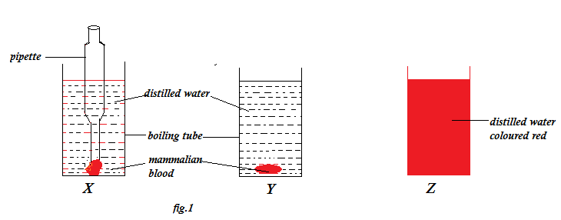
(a) What
(i) biological process was being demonstrated? (01 mark)

…………………………………………………………………………………………………………………………………………………………………………………………………………………………………………………………………………………..
(ii)was the purpose of set up Z above? (01 mark)
……………………………………………………………………………………………………………………………………………………………………………………………………………………………………………………………………………………
(b) Explain why the distilled water in setup Z was colored red? (03 marks)
………………………………………………………………………………………………………………………………………………………………………………………………………………………………………………………………………………………………………………………………………………………………………………………………………………………………………………………………………………………………………………………………………………………………………………………………………………………………………………………………………………………………………………………………………………………………………………………………………………………………………………………………
- i) What would be observed in setup Y if a spoonful of table salt was added in the boiling tube? (01 mark)
…………………………………………………………………………………………………………………………………………
…………………………………………………………………………………………………………………………………………

ii) Explain the answer given in (c) i) above. (03 mark)
………………………………………………………………………………………………………………………………………
………………………………………………………………………………………………………………………………………
………………………………………………………………………………………………………………………………………
………………………………………………………………………………………………………………………………………
………………………………………………………………………………………………………………………………………
………………………………………………………………………………………………………………………………………
………………………………………………………………………………………………………………………………………
…………………………………………………………………………………………………………………………………………
- Suggest one importance of the biological process demonstrated in fig. 1 above to living organisms. (01 mark)
……………………………………………………………………………………………………………………………………………………………………………………………………………………………………………………………………………………

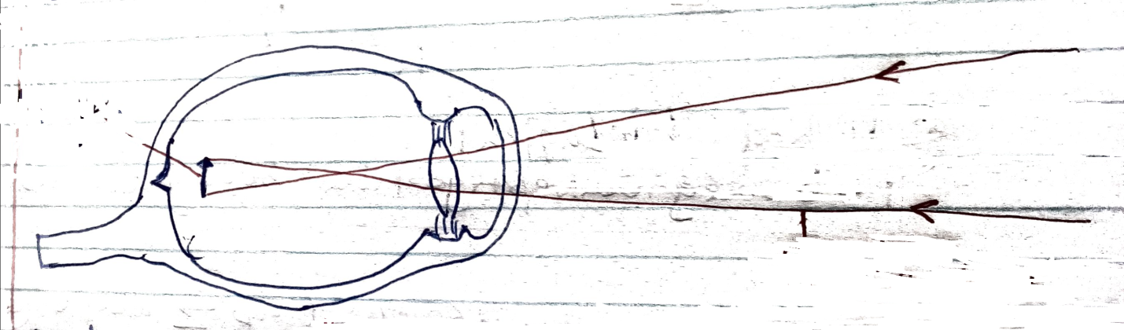
33 A student was found to have an eye defect shown in fig. 2 below. Study it then answer questions that follow.

Image

Rays from distant object

Fig.2

- State the effect illustrated in fig.2 (01 mark)

………………………………………………………………………………………………………………………………………….
- Explain the nature of the image seen by the student in fig. 2 (03 marks)
………………………………………………………………………………………………………………………………………….
………………………………………………………………………………………………………………………………………….
…………………………………………………………………………………………………………………………………………
…………………………………………………………………………………………………………………………………………
…………………………………………………………………………………………………………………………………………
…………………………………………………………………………………………………………………………………………
(c)(i) What type of glasses would you advise the student to wear? And why?
(03 marks)
……………………………………………………………………………………………………………………………………
……………………………………………………………………………………………………………………………………
……………………………………………………………………………………………………………………………………

ii) Give the method the student can use to focus object clearly without using glasses. (01 mark)
……………………………………………………………………………………………………………………………………………………………………………………………………………………………………………………………………………………

- Draw a labeled structure to show the correction of the defect in fig.2 above. (02 marks)

SECTION C: (30MARKS)

- Answer any two questions.
- Write your answers in the answer booklets provided.

34. (a) Describe how a light microscope can be used to see tinny objects. (12 marks)
(b) Suggest any three importances of micro-organisms studied by use of microscopes. (03 marks)

35. (a) Explain the requirements for photosynthesis. (04 marks)
(b) How is a dicotyledonous leaf adapted forabsorbing energy needed for Photosynthesis? (08 marks)

(c) What is the importance of the products of photosynthesis to a dicotyledonous plant? (03 marks)

36. (a) What is aerobic respiration? (02 marks)
(b) How is aerobic respiration different from photosynthesis?
(05 marks)
(c) Explain the relationship between plants and animals in relation to respiration and photosynthesis. (03 marks)
(d) Why is aerobic respiration important in living organisms?
(05 marks)

37. (a) Describe how the activities carried out by humansadversely affect thenatural environment. (10 marks)

(b) Suggest methods used by humans to conserve the natural environment. (05 marks)

END

