SOCIAL STUDIES PRIMARY FIVE LESSON NOTES

TERM ONE
Topic: map work
Sub topic: elements of a good map
A map
- A map is a drawing of an object as seen from above.
Or: A map is a representation of an object as seen from above.

A picture
Is a drawing of an object as seen from the sides.
;or:
A picture is a representation of an object seen from the sides.
Difference between maps and picture
- A map is a drawing of an object as seen from above while a picture is a drawing of an object as seen from the sides.
- A map is not easy to understand while a picture is easy to understand.

Similarities between maps and pictures
- Both represent objects
- Both are drawings
Types of maps
Political maps
They show boundaries of regions, districts and countries

Physical maps
They show landscapes highlighting lakes, rivers and mountains

Thematic maps
They show comparisons between regions and countries in terms of population and tourism and minerals / energy.

Elements of a good map
- Map key
- Map title
- Map compass direction / a compass rose
- Map scale
Map frame

Map Key
It is a table bearing symbols used on a map and their meaning
The main function of a key is to interpret symbols and signs used on a map
- Symbols are signs that represent real objects on a map

Importance of map symbols
- They prevent over crowing on a map
- They make the map tidy
- They make map reading easy.
Examples
meaning symbol
Quarry
Bridge
Rift valley
Water falls
River
Dam
Railway line

Map Title
It is the name or heading of a map
It helps us to know what the map is all about
Map Compass direction:
It is a symbol that is used to show direction of places on a map
Primary / cardinal points
North
East
West
South

Secondary points
North west
North east
South west
South east
Finding directions using a compass direction
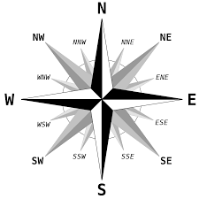

- What is the direction of point NW from SE?
- Give any other examples of finding directions.

People (groups of people) who use a compass
- Sailors - guides
- Pilots - mountain climbers
- Tourists - Austronants
- Soldiers / army - surveyors
Map Scale
Scale helps to determine the actual distance between places on a map

Type of scales
Linear 0 50km

Representative/fractional scale
1:1000km or 1km
1000
Statement scale
1cm represents 50km
1cm = 50km

Using a scale to find Distances
Yole moved from town A to B a distance of 5cm. Given that 1cm represents 50km (1:50km) Find the actual distance.
Soln:
A 5cm B
1cm = 50km
5cm = (5 x 50)km
= 250km.
NB: Give more examples.

Latitudes and longitudes
Line of Latitude are imaginary lines drawn on a map running from East to West
Lines of Longitude are imaginary lines drawn on a map running from north to South
Latitude is the distance of a place north or south of the equator
Longitude is the distance of a place East of west of the prime meridian

Examples of major latitudes
Equator 0⁰
Tropic of cancer 23 ½⁰ N
Arctic circle 66 ½ ⁰N
Antarctic circle 66 ½ ⁰S
Tropic of Capricorn 23½⁰ S

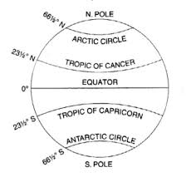

NB:
- The sun is overhead the equator on 21st March and 23rd September
- On the tropic of Cancer – 21st June
- On the tropic of Capricorn - 22nd December
Districts in Uganda crossed by the Equator
Kasese, Mpigi Wakiso Sembabule
Kalungu Ibanda Kamwenge Bukomansimbi

Lakes in Uganda crossed by the Equator
- Lake George
- Lake Victoria
Qn:
- Why is the equator marked 0?
Other lines of latitude are measured after the equator or the numbering of other latitudes begin from the equator.

- Give the meaning of Equinox
Equinox is the period when the sun overheads the equator.

Countries crossed by the equator
- Uganda
- Kenya
- D R C
- Gabon
- Somalia
- Congo
Qn. Name countries of EastAfrica crossed by the equator.
E. African countries that are not crossed by the equator
- Rwanda
- Tanzania
- Burundi

Uses of latitudes
They help in location of places on a map
They determine climate of a place
Note :All latitudes are called parallels

Longitudes
Examples of major longitudes
Prime meridian / Greenwich meridian 0⁰
International dateline 180⁰ W or E
Another name for all lines of longitudes is Meridians

Uses of longitudes
They help to locate places on the map
They help to determine time using the Greenwich meridian
They help in determination of dates using the international dateline
Location of Uganda and her neighbours

Ways of locating places
- Using physical features
- Using the compass direction
- Using longitudes and latitudes/grid reference
The method of locating places using longitudes and latitudes is grid references.
Standard measures of lines of longitudes and latitudes is degrees
- Using landmarks
- Using the position of the sun

Locating Uganda
It lies in the continent of Africa in the region of East Africa
It lies between latitudes 4 ¼ ⁰N and 1 ½ ⁰S of the equator
It lies between longitudes 290⁰E and 350⁰ East of the Greenwich meridian
Uganda is made up of 7 regions namely:
- Central
- South western (Kigezi)
- Western
- North Eastern (Karamoja)
- Eastern
- West Nile
- Northern

Note:
Use your atlas to indicate examples of districts in each region.

Direction country capital city president

North South Sudan Juba H.E Salva Kiir
East Kenya Nairobi H.E.Uhuru Kenyatta
West DR Congo Kinshasa H.EFelix Tshisekedi
South Tanzania Dodoma H.E Samia Suluhu H
South West Rwanda Kigali H. E. Paul Kagame

Map showing Uganda and her neighbours.

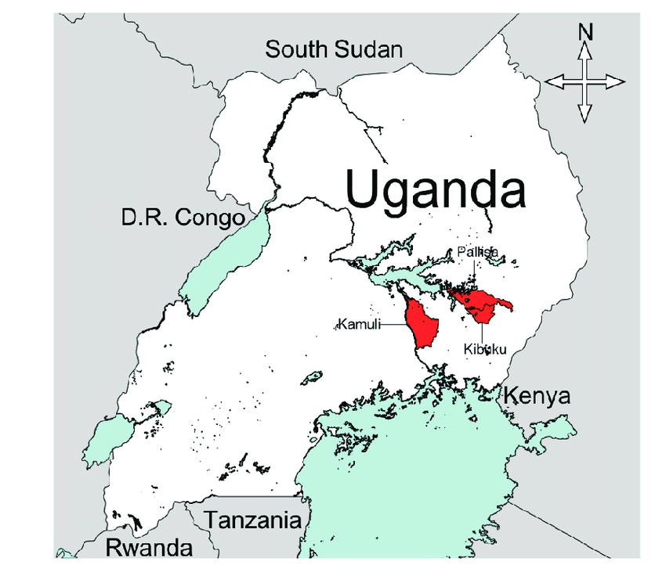

Uganda as a landlocked country
A landlocked country is a country with no direct access to the sea/ without sea port.
A country without a coastline
Hinterland is an area which is served by a sea port
Uganda’s major seaports include
Port Mombasa in Kenya
Port Dar – es – salaam in Tanzania
Both ports handle Uganda’s imports and exports
Exports are goods a country sells to other countries
Imports are goods a country buys from other countries.

Problems of landlocked countries
- High transport costs
- Delays of imports and exports in transit.
- Highway robberies
- High taxation on goods
- Expiry of some products due to delays
- Smuggling of goods - Illegal importation and exportation of goods

Solutions
- Cooperation with neighbouring countries
- Promotion of air transport
- Promotion of peace and security with neighbours

Why Uganda should have good relations with neighbours
- To enable free movement of her people and goods
- To create a wider market for her products
- To promote peace and security

The physical features of Uganda
Physical features are landforms of an area
Relief is the general appearance of the landscape

Classification of physical features
- Relief features e.g. mountains, valleys, plains, hills
- Drainage features are aground water systems like lakes, rivers, oceans and seas.

Examples of major physical features in Uganda
Mountains / lakes / rivers / rift valley / plateau

Plateau (table land)
A plateau is a raised flat piece of land
The plateau covers the largest part of Uganda
A raised table land
Symbol of a plateau

Activities carried out on plateau
- Farming, mining, industrialization, fishing, lumbering, tourism.

Importance of plateau
- They have fertile soil for crop growing.
- They are sources of minerals
- They receive reliable rainfall

Problems faced by people on a plateau
- There is soil erosion
- Poor transport system especially in hilly areas
- Pests and diseases.

Mountains / highlands
A mountain is the highest piece of land / An area about 2000 metres above the sea level.

Types of mountains
- Block/Horst mountains
- Volcanic mountains
- inselbergs

Examples of mountains in Uganda
Rwenzori / Elgon/ Moroto/ Mufumbiro

Mountain Rwenzori
- It is the highest mountain in Uganda
- It is found in Western Uganda in the district of Kasese and Bundibugyo
- It is a block/ horst mountain with many peaks that form ranges
- It is found along the border of DRC and Uganda
- Its highest peak is Margherita
Peak Marherita is snow capped throughout the year because “The peak crosses the snowline”
HM Stanley was the first European to see Mt. Rwenzori
He named it the mountains of the moon because its peaks looked like a rising moon.
The Bamba and Bakonjo live on its slopes in Uganda while the Pygmies live on it in DRC
Donkeys are the major means of transport

Mountain Elgon
- It is a volcanic mountain found in Easter part of Uganda in the districts of Bukwo, Sironko, Mbale and Kapchorwa
- It is the second highest mountain in Uganda
- Its local name is Masaba and Wagagai is its peak
- Its along the border of Uganda and Kenya
- Joseph Thomson was the first European to see it
- It has a large hole on its top called a crater
- The Bagishu and Sabiny live on its slopes
- The Bagisu grow Arabica coffee and the Sabiny grow wheat.
- Kapchorwa is the leading producer of wheat in Uganda

Factors that have favoured the growing of wheat and Arabica coffee on Mt. Elgon
Presence of fertile volcanic soils
Presence of reliable rainfall
Presence of cool climate

Mufumbiro ranges
- It is a volcanic mountain which is active
- It is found in the extreme western part of Uganda along the border of Uganda and Rwanda
- Muhavura is its peak with a small crater lake
- The thick vegetation and Bamboo acts a home of Mr. Gorillas
- The three ranges that lie in Uganda are: -
  - Muhavura 4127m
  - Mgahinga
  - Sabinyo 3645m
- Mufumbiro ranges are sometimes referred to as the switzerland of Africa because it is very cool like the Alps of Europe
- The Bakiga, Bafumbira, Batwa , live on its slopes

Mountain Moroto
- It is a volcanic mountain found in North eastern part of Uganda in Moroto
- Its peak is Sokdek
- It receives little rainfall because it receives dry winds
- The Karamojong live on its slopes and practice cattle keeping.

Problems facing people who live on mountain slopes
- Soil erosion
- Landslides
- Volcanic eruptions
- Poor transportation and communication
- Cool temperatures.

How is soil erosion controlled in mountainous areas
- By contour ploughing
- Terracing
- Strip cropping
Qn: Why is soil erosion common in Kabale and Kapchorwa?

Reasons why mountainous areas are densely populated
- There is fertile soil good for crop growing
- There is reliable rainfall food for crop growing
- There is cool climate good for human settlement
Qn: Why do tourists like to visit mountainous areas?
- To enjoy cool climate
- To enjoy seeing the mountain scenery
- For mountain climbing
- To see the vegetation on mountain slopes.
- to see the animals that live on mountains.

How poor road network can be overcome in hilly areas
By using donkeys / animal transport
By constructing winding roads
Qn: Why is transport difficult in mountainous areas?
- Due to steep slopes

Rift valley
A rift valley is a long depression on the earth’s surface with escarpments

Problems faced in rift valley areas
- Poor road network
- High temperatures
- Soil erosion
Qn: Why does the rift valley floor experience high temperatures?

Advantages of the rift valley
- They have fertile soils for crop farming
- They attract tourists who bring in income
- Their grazing grounds for animals
- Rift valley lakes are fishing grounds
- They have minerals

Economic activities on a rift valley
- Mining
- Fishing
- Tourism
- Farming
Lakes
A lake is a hollow (depression) filled with water on the earth’s surface.

Examples of lakes in Uganda
Victoria / Kyoga / George / Edward / Albert / Wamala / Bunyonyi etc.

Types of lakes
- Depression (basin) lakes / down warped lakes
- Rift valley lakes
- Ox – bow lakes
- Man Made lakes
- Crater lakes
- Lava dammed lakes
- Calderas – an enlarged crater lake – Volcanic lakes

Depression lakes
Depression lakes were formed by the process of down warping such as L. Victoria, L. Kyoga, L. Mburo, L. Kwania ,L. Opeta

Characteristics of depression lakes
- They are shallow
- They have fresh water
- They have inlets and outlets
- They are wide
Qn: Why do depression lakes have fresh waters?
They have inlets and outlets.

Lake Victoria
- It is the largest lake in Uganda
- It is shared by the three East African countries
- It is crossed by the Equator
- It is the source of the Nile
- John Speke was the first European to see and name L. Victoria
L. Victoria is locally known as Nalubaale

Inland ports on L. Victoria
Port Jinja, Entebbe, Bukakata, Port Bell
Map of L. Victoria showing inland ports MK pg 19

Islands on L. Victoria
Kome, Bugala, Ssese etc

Island districts
- Kalangala
- Buvuma

Importance of inland ports on L. Victoria
- They handle Uganda’s imports and exports
- They provide employment

Major activities carried out around lake Victoria
- Fishing
- Tourism
- Crop growing
- Trading
- Lumbering
- Transportation
- mining
- Boat making

Problems experienced on lake Victoria
- Water hyacinth
- Pirates / water robbers
- Storms and strong winds
- Dangerous water animals

Lake Kyoga
- It is the most swampy lake in Uganda
- It is swampy because it is swallow
- It is surrounded by L. Kwania, L. Opeta and L. Nakivale
- It is connected t L.Albert by Victoria Nile
Qn: What shows that L Kyoga is at a lower altitude than L. Victoria?

Rift valley lakes
- They are formed on the floor of the rift valley
- They were formed by faulting

Example
- Lake Edward
- Lake Albert

Characteristics of rift valley lakes
- They are deep
- They have salty water
- They are narrow
- They are oblong/long in shape

Lake Albert
- It is found in western Uganda in the districts of Hoima Kibaale and Buliisa
- It lies along the border of Uganda and DRC
- Port Butiaba is its major inland port
- Other ports include Port Ntoroko,
- Sir Samuel Baker was the first European to see and name it L. Albert
- Its locally known as L. Mwitanzige

Economic activities carried out on L. Albert
Fishing/ tourism/ oil exploration / transportation/ trading

Lake Edward
- It lies along the border of Uganda and DRC
- HM Stanley became the first European to see it
- Kazinga channel connects it to L. George
- Kazinga channel is a tourist attraction with many hippos

Lake George
- It is crossed by the Equator
- The main tourist attraction is hippos
- It is joined to L. Edward by Kazinga channel.

Ox – bow lakes
- They are formed as a result of river erosion and deposition
- These are found along river Rwizi
- Lava Dammed lakes
- These are lakes formed when river blocks a river valley
- These are on lakes formed by man’s activities
Man Made lakes
- These are formed when man blocks a river valley
- These are on lakes formed by man’s activities.
Examples
- Kabaka’s lake
- Lake Kajjansi
- Lake Kibimba
- Lake Namugongo / Martyrs lake)

Volcanic lakes
These are lakes formed by the process of volcanicity/eruption
Categories of volcanic lakes
- Crater lakes:
These are lakes formed where there was volcanic activity e.g Nyamunuka ,L. Lutoto,. L. Katwe, lake Elgon crater
- Lava dammed lakes
These are lakes formed when lava blocks a river flow e.g. lake Mutanda, lake Bulera, Bunyonyi which is the deepest ‘

Rivers
A river is a stream of water flowing from a place of higher altitude to lower altitude

Types of river
Permanent rivers: These are rivers that flow throughout the year

Seasonal rivers: these are rivers that flow during the rainy season and dry during the dry season.

Stages or courses of a river (river development)
- Upper / youthful stage
- Middle / mature stage
- Lower course or old stage / senile

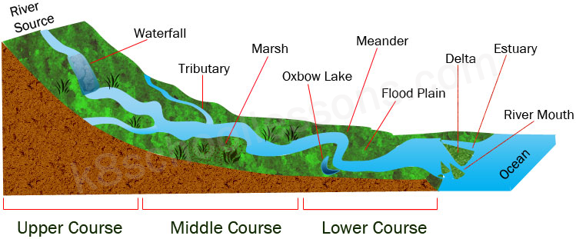

Examples of rivers
- River Nile
- River Kagera
- River Nkusi
- River katonga
- River semliki
- River Kafu
- River Achwa

Map of Uganda showing major lakes and rivers

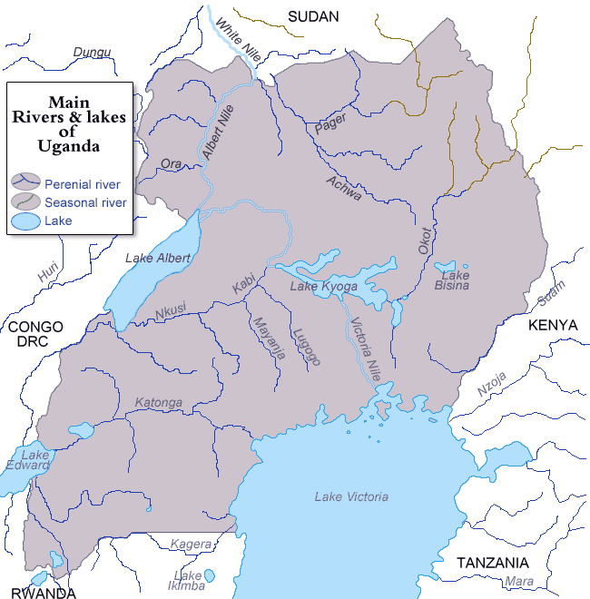

Terms related to rivers
- Source: point where a river starts flowing
- Mouth of a river: point where a river ends flowing
- Estuary: wide mouth of a river / It is where a river has a wide opening as it ends flowing.
- Tributary: small river joining a bigger river
- Distributary: small river flowing away from a bigger river.
- Gorge: narrow part of a river with an over deepened valley a v-shaped valley
- Confluence: point where rivers meet
- Meander: the curved bend of a river
- Delta: It is where a river subdivides into several streams at its mouth.

Characteristics of rivers on each stage
Upper course youth stage
- Has waterfalls which help to generate hydro-electricity and attract tourists
- It flows very fast due to steep slopes
- It is very destructive. erodes a lot of materials
- It has gorge (V-shaped valley)
Middle course
- It flows gently
- It begins forming meandering
- U shaped valley is formed.
Lower course
- Ox-bow lakes are formed
- It is very slow
- Deltas and estuaries are formed

River Nile
- It is the longest river in the World.
- It's locally known as Kiira.
- Its source is at Lake Victoria near Jinja
- Its mouth is at Mediterranean sea and it ends in a Delta
- Damietta and Rosetta are its two main distributaries
- The Nile in Uganda has two sections i.e.
- Victoria Nile: between Lake Victoria and Lake Albert
- Albert Nile: between Lake Albert and Nimule
- River Nile flows northwards because its source is at a higher altitude than the north.
- River Achwa is the only tributary of the Nile in Uganda

Waterfalls along the Nile in Uganda
Murchison falls, Karuma falls

Dams found along the Nile in Uganda
Bujagali dam, Kiira dam, Nalubaale dam

Nile valley countries: countries through which River Nile and its tributaries flow.
Uganda / Sudan / Egypt / Ethiopia

River Kagera
- It pours into Lake Victoria
- It forms a natural boundary between Uganda and Tanzania

River Achwa
- It is a tributary of river Nile found in northern Uganda
- Its main tributaries are Agago and Pader
- It is the most extensively used river for irrigation in Uganda

River Katonga
- It flows from the swamps around L. George
- It flows into L. Victoria
- It is a swampy river and not used for transport

River Semliki
- Found along the border of Uganda and DRC
- It drains into Lake Albert and flows from L. Edward.

River Kafu and Nkusi
- Kafu flows into Lake Kyoga while Nkusi into Lake Albert

Reasons why transport is difficult on some rivers
- They have rapids
- They have waterfalls
- They have rocks
- They are narrow
- They wild dangerous aquatic animals
- They have dams.

Problems facing rivers
- Dumping of waste materials in them.
- Prolonged drought.
- Deforestation along the river valley.
- Farming along river valleys.

Formation of physical features
Mountains
Types of mountains in Uganda
a) Block mountains (horst mountains)
These were formed by faulting e.g. Rwenzori .
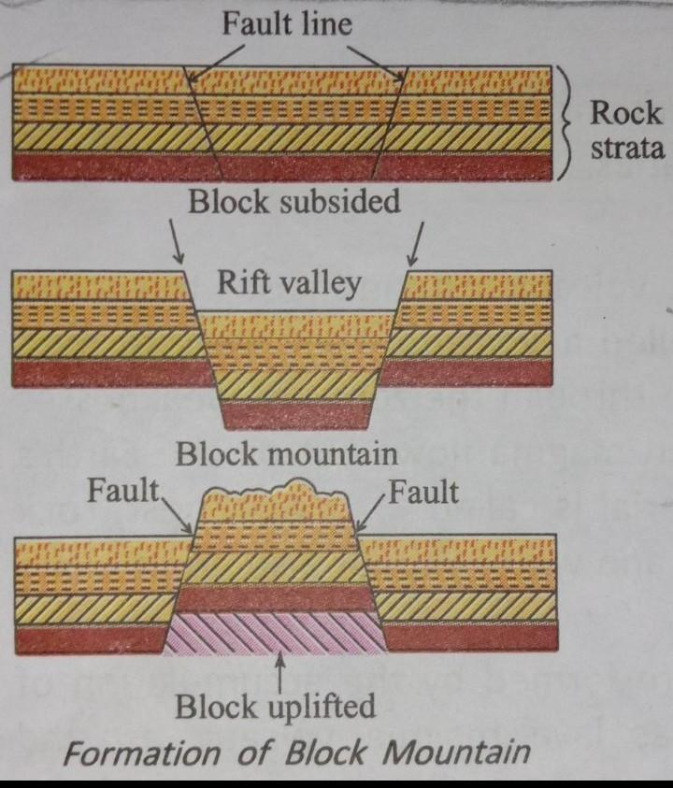

Faulting is the process by which rocks of the earth’s crust are broken down.
Two theories or forces explain the formation of block mountains.
- Tensional forces
- Compressional forces

Formation of block mountains
- Compressional
- Faults
- Horst mountain

b) Volcanic mountain
- These were formed by the process of volcanicity.
- Volcanicity is the process by which molten rock (magima) is forced on the earth’s surface.

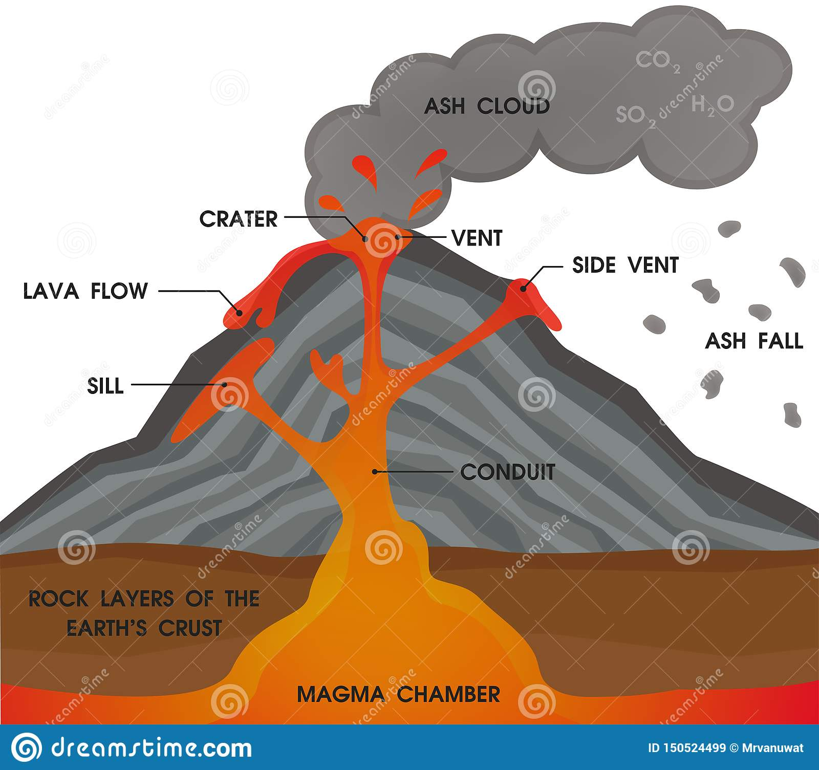
Magma
- Hot molten rocks below the earth’s surface
- Lava molten rocks on the earth’s surface
- Crater: hole on top of a volcano
- Vent: a hole through which magma reaches the earth’s surface.
- Eruption: violent release of lava, ash and gases on the surface of the earth.

Types of volcanic mountains
Active volcano( Live) : This is a volcano that is erupting. e.g. Mufumbiro ranges
Dormant (sleeping) Volcanos: those that are resting but like to erupt in future. e.g. Moroto
Dead (extinct) those that cannot erupt any more e.g. Mt. Elgon

A volcanic mountain (formation of volcanic mountain)
Diagrams on pg 19 Mk

Formation of the rift valley
A rift valley was formed by faulting
Two forces are responsible for the formation of the rift valley
- Tensional force
- Compressional force

How a rift valley was formed
Diagrams not drawn
- Tensional forces
- Faults (fault lines)
- Escarpments

Importance of physical features
- Mountains
- Help in rain formation
- Attract tourists who bring in money
- Used for study purpose
- Have fertile soils for forming
- Form natural boundaries

Rivers
- Help to generate hydro electricity
- Used for transport
- Attract tourists
- Source of minerals
- Source of water for domestic use.
- Source of water for irrigation

Lakes
- Source of water for domestic use .
- Used for transport
- Attract tourists who bring in money
- Used for study purposes.
- Source of water for irrigation.

Plateau
- Used for farming
QN. How do physical features influence human activities

The climate of Uganda
Climate: is the average weather condition of a place recorded for a long period of time.
Weather: Is the state(condition) of the atmosphere at a given time.

Qn.how is climate different from weather?
Climate is recorded over a long period of time (30 – 35 years) while weather is determined after a short period of time.

Main factors (ASPECTS) of climate
- Rainfall
- Temperature

Types of climate in Uganda
- Tropical climate
- Equatorial climate
- Semi desert climate / semi arid
- Mountain climate / montane

Map showing climatic regions in Uganda

Tropical climate
Uganda lies within the tropic of cancer and the tropic of Capricorn(the tropics) so much of Uganda’s climate is of the tropical type i.e. hot and wet.

Characteristics of the tropical climate
- It is hot and wet
- Rainfall received is less than that of the equatorial climate
- Has two main rainfall seasons (750mm – 100mm)
- Rainfall is received during the hottest season of the year.

Economic activities done in tropical climatic regions.
- Growing of crops e.g. simsim, sorghum, cotton
- Pastoralism
- Tourism
- Mining

Equatorial climate
- This type of climate is experienced in areas lying along the equator e.g. Kampala, Jinja, Wakiso, Entebbe
- It is described as hot and wet throughout the year.

Characteristics of equatorial climate
- It is hot and wet throughout the year
- It receives convectional rainfall (1500mm – 225mm)
- Humidity in the region is high due to high transpiration and evaporation rates

Economic activities
- Crop growing coffee, tea, cocoa
- Lumbering
- Fishing
- Hunting
- Tourism
- mining

Problems facing people in equatorial regions
- Diseases / disease vectors
- Poor road network
- Wild animals attacks
- Poor communication
- Rebel activities
- Floods

Semi arid climate
This climate lies in the north eastern part of Uganda in the districts of Kotido, Moroto and Nakapiripirit

Characteristics of semi desert climate
- The temperatures are very high during day
- The temperatures are very low at night
- It has low and unreliable rainfall (cyclonic / frontal)
- It is described as hot and dry.

Economic activities
Animal rearing
Hunting
Tourism
mining

Problems of semi arid areas
- Little rainfall received
- High temperatures during the day and low temperatures at night.

Mountain climate
- This type of climate is experienced in highlands and is cool due to high altitude
- Highlands and mountains help in formation of relief rainfall.
- Places that lie on the leeward side (rain shadow of the mountain receive less or no rainfall while those on the windward side receive much rainfall
- Highland and mountainous areas experience low temperatures compared to low land areas.
- Water bodies help in the formation of convectional rainfall.

Influence of climate of human activities
People in areas with heavy rainfall practice crop growing while those in areas with semi arid areas practice pastoralism’
People who live in areas with heavy rainfall build houses with slanting roofs while those in dry areas build houses with flat roofs.

Farming in Uganda
Farming is the growing of crops and keeping of animals
QN: Why is it important for farmers to know the climate of an area?
Its because the type of crops grown and animals kept depend on the climate

Farming systems in Uganda
Subsistence farming: this is the growing of crops and keeping of animals mainly for home use.

Why do most people in Uganda practice subsistence farming
- It is cheap
- It requires less land
- It requires a cheap labour force from family members.
- It requires the use of simple tools.

Disadvantages of subsistence farming
- Low quality products
- Low yields
- No income is earned.

Mixed farming:
This is the growing of crops and keeping of animals on the same piece of land under the same management on different plots

Advantages of mixed farming
- A farmer gets double income
- A farmer gets a balanced diet
- There is interdependence between crops and animals
- A farmer gets skilled labour

Disadvantages of mixed farming
- It is expensive to start and manage
- It requires skilled labour
- Animals can easily damage the crops
- It requires a large piece of land

Plantation farming
This is the growing of one perennial crop on a large scale for sale

Examples of plantation crops
- Tea
- Cocoa
- Coffee
- Sugarcane
- Oil palm

Tea
This is a beverage crop
It requires warm temperatures and heavy rainfall
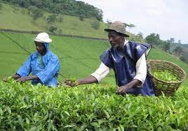
Examples of tea plantation estates
- Kasaku
- Igara
- Nakigalala
- Tea growing districts
- Mubende
- Rukungiri
- Kabarole
- Mukono
- Bushenyi

Tea is harvested by plucking buds

Coffee
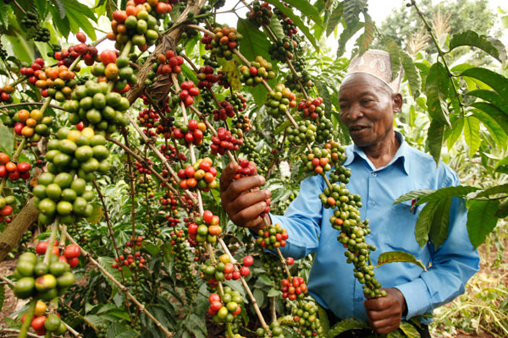

Coffee is a beverage crop
It contains a substance called caffeine

Types of coffee
- Arabica coffee grown in highlands
- Robusta coffee grown in lowlands
- Clonal coffee (improved Robusta)

Advantages of clonal coffee over other types
- More resistant to diseases
- Matures faster than other types
- Gives high yields
NB: coffee is harvested by hand picking of berries

Sugarcane
-It grows in swampy areas
-Its stems are crushed to get juice which makes sugar crystals

Sugarcane plantation in Uganda
- Kakira in Jinja
- Lugazi in Bukwe
- Kinyara in Masindi
- Sango bay in Rakai

Products of sugarcanes
- Sugar
- Sweets
- glucose
- Molasses

Wheat
- Is a cereal crop which requires low temperatures and heavy rainfall.
- The grains provide flour used in baking.
- In Uganda wheat is mainly grown in Kapchorwa, Kisoro, Bundibugyo
Cotton
- It is a fibre crop used in the textile industry
- It is grown using seeds and harvested by picking fluff
- It is taken in ginneries to remove seeds and remaining is lint
- The lint is processed into threads and this is called spinning
- Kenneth Borup introduced fast growing cotton seeds in Uganda in 1903.

Cotton growing districts in Uganda
Kumi, Iganga, Tororo, Jinja, Kamuli, Lira, Gulu, Apac, Pallisa, and Kasese
- Ginning is the separating of cotton seeds from cotton wool
- Lint is cotton wool without seeds
- Spinning is the making of threads out of cotton

Uses of cotton
- To make threads
- To make cloth
- To make cotton wool used in hospitals
- The seeds make animal feeds
- The seeds can produce cooking oil and soap.
- Sources of income

Problems faced by cotton farmers
- Cotton pests and diseases
- Climate change
- Price fluctuation
- Competition from other cotton producing countries
Tobacco
It is especially grown in west Nile region

Methods of processing Tobacco
- Flu curing
- Air curing
- Fire cured tobacco
Products from tobacco
- Cigarette
- cigars

Cattle keeping
- It is divided into three
- Dairy farming
- Ranching
- Nomadic pastoralism

Dairy farming
- Is the keeping of cows for mainly milk production
- Dairy farming is mainly carried out in the cool mountainous areas
- Dairy farms are commonly found in Kisoro and Kabale

Products obtained in a dairy farm
Milk, butter, yoghurt, ghee, cheese

Ranch farming
- Is the rearing of cattle for beef production
- Ranch farming is mainly carried out in dry areas
- Sometimes bulls are used for transport and ox – ploughing

Products from a ranch
- Beef
- Hooves for making glue
- Horn tips for making buttons

Examples of ranches in Uganda
- Nyabushozi – Kiruhura
- Kisozi – Gomba
- Kabula – Sembabule
- Maruzi – Apac
- Buruli – Nakasongola
- Achwa – Kitgum
- Ujuk – Katakwi
- Bunyoro– Masindi

Nomadic pastoralism
- Pastoralism is the keeping of animals as a way of life.
- Nomadic pastoralism is the movement of cattle keepers from one place to another looking for pasture and water.
- It is mainly carried out in Semi arid areas

Districts where nomadic pastoralism is carried out
- Moroto
- Kotido
- Nakapiripirit

Problems facing nomadic pastoralists
- Shortage of water and pasture
- Cattle rustling / cattle raiding
- Animal diseases
Why do nomads keep large numbers of animals
- Prestige
- For cultural purposes
- For food

Irrigation farming
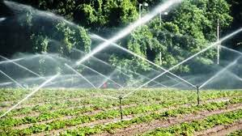
- This is a method of farming where crops are provided with water by artificial means
- This is the supply of water to land in order to make it productive especially in dry areas.
- The artificial supply of water to crops mainly in dry areas. (irrigation)

Types of irrigation
- Overhead sprinkler irrigation
- Canal irrigation

How can crop farming be made possible in dry areas

Advantages of irrigation farming
- Crops can be grown throughout the year
- A farmer gets high yields
- Dry land can be made productive for crop growing

Disadvantages of irrigation farming
- Needs skilled labour
- Requires a reliable source of water
- Leads to erosion and leaching
- It is expensive to start and maintain

Examples of irrigation schemes
Scheme | District | Source of water | Crops grown
Mobuku | Kasese | R. Nyamaba, R. Sebwe  R. Mobuku | Cotton, maize, bananas, onions, tomatoes
Nsimbe | Mpigi |  | Flowers, tomatoes, pineapples
Kiige | Kamuli |  | Citrus fruits, e.g. oranges, lemons, pears
Ongom | Lira | R .Achwa | Citrus fruits
Doho | Butaleja | r. Manafa | Rice

Traditional cash crops
These are crops that were originally grown for sale e.g. cotton, coffee, tobacco, tea.

Nontraditional cash crops
These are crops that were formerly grown for food but now ar sold e.g. maize, beans

Advantages of nontraditional cash crops
- They have ready market
- They mature quickly
they serve more than one purpose

Why are people encouraged to grow nontraditional cash crops?
- To promote export trade
- To promote industrialization

Problems faced by farmers in Uganda
- Poor transport network
- Crop pests and diseases
- Unstable prices
- Shortage of capital
- Soil erosion

Solutions
- Feeder roads should be constructed and maintained
- Agricultural chemicals and tools at low costs
- Set minimum standard prices for goods
- Give loans to boost farming activities
- Set up cooperative societies to look for markets
- Provide improved varieties of seeds and animals

Factors affecting climate
- Nearness to water bodies
- Distance from the equator (latitude)
- Altitude
- Man’s activities
- Vegetation cover
- Local winds / prevailing winds
- Relief of an area

Qn. Let the teacher explain how each factor affects climate

Vegetation of Uganda
Vegetation is all plant life covering the earth’s surface

Types of vegetation
- Natural vegetation
- Plantation vegetation

Natural vegetation
Is the plant cover of an area that grows on its own.

Examples of natural vegetation
- Bushes
- Shrubs
- Trees
- Papyrus

Plantation vegetation
Is the plant cover of an area planted by man

Examples of plantation vegetation
- Crops
- Eucalyptus (plantation forests)
- Grass
- Flowers

Types of natural vegetation
- Equatorial vegetation (tropical rain forests / natural forests)
- Savannah vegetation
- Semi desert
- Mountain vegetation / Montane
- Swamps

Tropical Rain forests
- They are mainly found along the equator

Examples of tropical rainforests
- Mabira (Buikwe)
- Budongo (Masindi)
- Marabigambo (Rakai)
- Bugoma (Hoima)

Types of tree species got from natural forests
- Mvule (troka)
- Mahogany
- Ebony
- Rose wood
- African walnut
- Green heart

Characteristics of tropical rainforests
- They are evergreen (don’t shade off their leaves at the same time)
- They grow very tall and at the same time form canopies
- They have broad leaves and large trunks
- They have buttress roots
- Have thick undergrowth
- Provide hardwood
- Take long to mature

Activities carried out in this vegetation
- Lumbering
- Farming
- Tourism
Savannah vegetation
- This covers the largest part of Uganda
- It is subdivided into two namely;
- Savannah grassland
- Savannah woodland
- Most trees in woodland savannah are deciduous (shed off their leaves during the dry season)

Examples of trees in savannah vegetation
- Acacia
- Baobab

Characteristics of savannah vegetation
- Has tall grass
- Has scattered tree species
- Trees are deciduous

Activities in the savannah
- Tourism
- Animal rearing
- Crop growing

Why most game parks in Uganda found in Savannah vegetation
- Has a lot of food for wild animals
- Has a good habitat for wild animals

Semi desert (bush land and shrub)
- It is found in north eastern Uganda

Characteristics of semi desert vegetation
- Has thorny shrubs and thickets e.g. cactus
- Has short and scattered grasses
- Trees have thin leaves and thick barks

Economic activities
- Nomadic pastoralism
- Tourism
- Hunting

Mountain vegetation
This type of vegetation is commonly found in mountainous areas
The vegetation here changes with altitude.

Diagram showing mountain vegetation
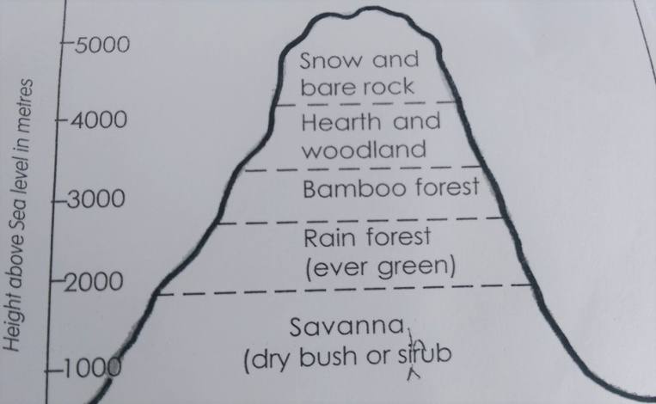

More vegetation is found in the windward side of the mountain because of reliable rainfall.

Why is plant growth difficult on tops of high mountains?
- The areas are too cold and rocky.

Economic activities carried out
- Lumbering
- Tourism
- Animal rearing e.g. dairy
- Crop growing

Swampy vegetation
- Swamps are water logged and vegetated areas
- Sometimes swamps are called wetlands

Swamps are divided into
- Swamp forests are swamps that have trees
- Papyrus swamps: are swamps that have grasses growing in them.

Uses of swamps
- Source of raw materials e.g. clay and papyrus
- Act as fishing grounds
- Habitat for wild animals
- Areas of scientific study
- Help in rain formation
- Filter water and remove pollutants
- They are grazing grounds for animals
- They have fertile soils for crop growing
Qn: How do swamps benefit the craftsmen?

Problems facing wetlands
- Draining swamps
- Disposal of industrial wastes
- Over harvesting of swamp vegetation
- Establishment of infrastructure, roads, industries and housing

Dangers faced by people living near swamps
- Swamps harbor disease vectors e.g. mosquitoes
- Harbor dangerous wild animals like snakes
- In case of heavy rainfall floods can be menace

Plantation vegetation
This vegetation include; trees that are planted by people.

Examples of plantation trees in Uganda
- Eucalyptus
- Conifers
- Pine
- Cedar
- Camphor
- Cypress

Districts with plantation forests in Uganda
Lendu in Zombo district
Mafuga in Kanungu district
Bugamba in Mbarara district
Nyabyeya near Budongo forests Masindi district
Katuugo in Nakasongola district
Magamaga in Iganga district

What type of wood is obtained from plantation forests?
Provide soft wood for making paper rulers pencils plywood and match boxes

Characteristics of plantation forests
- Trees provide soft wood
- Trees have same species
- Trees mature quickly
- Trees are tall and straight
- They are evenly spaced
- There is little undergrowth
- They are evergreen

Importance of forests to man
- They are sources of timber
- They are sources of wood fuel
- They help in rain formation
- They attract tourists
- They are a habitat for wildlife
- They are for education and scientific research
- They are sources of herbs
- They help in controlling soil erosion

Why man has destroyed forests
- To get land for farming
- To get herbal medicine
- To get wood fuel
- To get timber

Ways of conserving forests
- Afforestation
- Re-afforestation
- Agro – forestry
- Enforcing laws against deforestation
- Gazetting land for forests
- Massive sensitization of people on uses of forests

Factors affecting vegetation distribution
- Climate of an area
- Relief of an area
- Nature of the soil
- Human activities e.g. deforestation, afforestation
- NB: Let the teacher explain how each of the above factors influence vegetation distribution.
- Latitude
- Government policy

Natural resources in Uganda
- A resource is anything in the environment that satisfies people's needs .
- A natural resource is anything that satisfies man’s needs and exists on its own.

Types of natural resources
- Renewable natural resources
- These are natural resources that can be replaced naturally after use.

Examples of renewable natural resources
- Vegetation
- Human resources
- Wildlife
- Climate
- Land

Non renewable natural resources
These are natural resources that can not be replaced naturally after use . eg minerals

Land
This is the most important natural resource because
- Most natural resources are found on land
- Most economic activities are done on land

Uses of land
- Used for farming
- Used for construction
- Used for settlement.
- Used for mining etc

How land is misused (degraded)
- Land degradation is the lowering of the quality of land
- Ways of degrading land
- By overgrazing
- By deforestation
- By brick making
- By dumping waste materials on land
- By bush burning
- By mining

Causes of land degradation
- Industrialisation
- Population increase (pressure)
- Road construction
- Farming
- Over mining

How can land be conserved?
- Land conservation is the protection of land against destruction

Land can be conserved by
- Afforestation
- Bush fallowing
- Agroforestry
- Using modern methods of farming like contour ploughing
- Proper disposal of waste materials

Water bodies
Examples of water bodies
- Lakes
- Rivers
- Swamps
- Springs
- Ponds
- Streams

Uses of water bodies
- Source of water for domestic and industrial use
- Source of fish
- Water bodies are used for transport etc
- Some water bodies help to generate electricity e.g. Rivers (fasting running water)
- Hot springs – geothermal power

How water bodies can be misused
- Over using water from water bodies
- Polluting water bodies by .
- i) Dumping waste materials in water bodies
- ii) Washing cars from water bodies
- iii) Urinating, bathing, defecating in water bodies

How can water bodies be conserved?
- Educating people about the dangers of misusing water bodies
- Enforcing laws against misusing water bodies
- Avoiding constructing industries near water bodies

Fishing in Uganda
- Fishing is the catching of aquatic animals

Types of fish caught in Uganda
Tilapia, Nile perch, Mukene, Mudfish, Catfish, Lungfish
NB:
- Tilapia is the commonest type of fish caught in Uganda
- Nile perch is the largest fish caught in Uganda
- Mukene is the smallest fish caught in Uganda
- Mud fish is mainly got from swamps
- Methods of fishing
- Modern methods include:
- By using fishing (gill) nets.
- Trawling.
- seining

Traditional methods
- using hooks (fishing rods)
- By using fishing baskets
- By using spears
- By using hands

Methods of preserving fish
- By sun drying – the cheapest method
- By salting traditional
- Smoking – the commonest method

Modern methods
- Tinning (canning)
- Refrigeration
- Deep frying

Importance of fish
- Source of food
- Source of income
- Used to make medicine
- Used to make animal and poultry feeds
- Fish bones are used to make glue

Importance of the fishing industry
- Source of income (employment )
- Source of government revenue
- Promotes industrialization (leads to development of other industries)
Problems facing the fishing industry of Uganda
- Poor methods of fishing like using chemicals
- Price changes (unstable prices)
- Water weed (hyacinth)
- Poor fishing equipments
- Poor storage facilities
- Poor transport network
- Shortage of capital
- Thieves on water bodies
- Catching of young fish

Solutions to above problems
- Poor methods of fishing – enforcing laws against poor methods of fishing
- Water weed - uprooting using hands
- Removing it using machines
- Applying beetles to feed on it

- Poor fishing equipments – providing modern fishing equipments at low cost
- Poor storage facilities – providing modern storage facilities at landing sites
- Poor transport network – improving on transport network
- Thieves on water bodies – tightening security on water bodies
- Facilitating marine police department
- Catching of young fish – enforcing laws against catching young fish

Vegetation
Vegetation is the plant cover of an area

Uses of vegetation
- Helps in rain formation
- Supports animal life etc

How vegetation can be destroyed
- By deforestation
- By bush burning
- By overgrazing etc

How man can conserve vegetation
- By afforestation
- By agro – forestry
- By enforcing laws against bush burning
- By bush fallowing
- By reafforestation

Why man destroys vegetation
- To get land for construction, settlement, farming
- To get herbal medicine
- To get building materials
- To get wood fuel

Climate
Give human activities that can improve on the climate of an area
Which human activities can affect the climate of an area negatively?

Minerals
A mineral is a substance formed naturally on the earth’s surface.

Types of minerals in Uganda
- Metallic minerals like gold, copper, cobalt, tin etc
- Non metallic like crude oil, limestone, salt, phosphates.

Uses of minerals
- Source of income
- Raw materials for making different products
- Promote industrialization

How minerals can be misused
- By over exploiting minerals

Mining in Uganda
- Mining is the extraction of minerals from the earth/sources

Methods of mining
- Open cast mining
- Underground (shaft mining)
- Alluvial mining
- Drilling mining
- panning

Major minerals , mining areas and products obtained from them
Mineral | Mining area | District | Product (s)
Limestone | Osukuru hills  Hima | Tororo  Kasese | Cement, building lime
Phosphate | Osukuru hills/ Osukuru | Tororo | Artificial fertilizers
Salt | Lake Katwe | Kasese | Common salt
Crude oil | Albertine region | Hoima, Bulisa, Kibale | Petrol, diesel, kerosene etc
Copper | Kilembe | Kasese | Bullet shells, cable wires
Gold |  | Kotido, Busia,Mubende | Necklaces, trophies, rings

Importance of mining in Uganda
- Source of income
- Promotes industrialization
- Leads to development of infrastructure
- Creates employment

Problems facing the mining industry
- Shortage of funds
- Price fluctuation
- Low level of technology
- Small quantities of minerals
- Shortage of skilled labour
- Poor road network

Problems caused by the mining industry
- Destruction of natural vegetation
- Leads to population explosion
- Leads to environmental pollution
- Leads to displacement of people
- Leads to neglect of other sectors

Wild life
Wildlife refers to plants, animals, birds, insects, living in a natural environment

Types of wildlife
- Flora (plants)
- Fauna (animals)

Uses of wildlife
- Promotes tourism
- Creates employments
- Source of government revenue
- Used for study and research purposes
- Source of food.

How wildlife can be misused
- By poaching
- By bush burning
- By deforestation

How can wildlife be conserved?
- Educate people about the importance of wildlife
- Enforce laws against the destruction of wildlife

Game parks and game reserves in Uganda
A game park is land gazetted by the government to act as a home of wildlife

A game reserve is a piece of land set aside by the government to be turned into a game park.

Game parks and game reserves in Uganda
- National parks
- Murchison falls (Kabalega) the largest
- Queen Elizabeth
- Mountain Rwenzori National park
- Mountain Elgon national game park
- Kidepo valley national Game Park
- Bwindi impenetrable National Park
- Mgahinga National Game Park
- Lake Mburo National Game Park
- Semliki National Game Park

Game reserves
Kibale game reserve - Bokoro - Toro
Matheniko - Bugungu - Kigezi
Pianaupe - Ajai - Kyambura

Map of Uganda showing national game parks and game reserves (Mk pg 44 – 45)
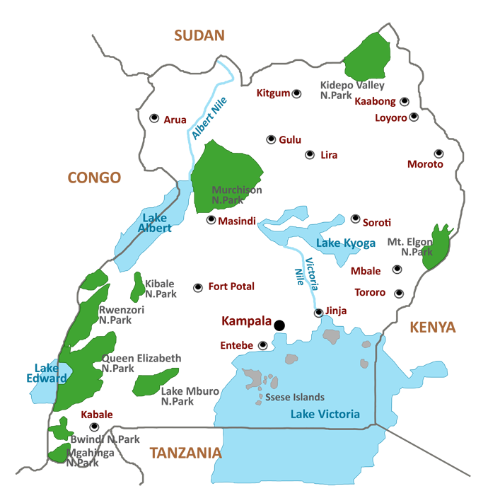

Importance of game parks
- Attract tourists
- Provide jobs
- Preserve wildlife
- Used for study and research purposes
- Leads to development of remote areas
- Leads to development of infrastructure like roads, railway lines

Problems facing game parks
- Poaching – this is the illegal hunting of animals in game parks
- Wild bush fires
- Prolonged drought
- Animal diseases
- Shortage of water and pasture

Solutions to above problems
- Poaching – enforcing laws against poaching
- Animal disease – providing veterinary services in game parks
- Wild bush fires – educating people about the dangers of wild bush fires

Tourism
Tourism is the business of providing services to tourists
A tourist is a person who visits a place for pleasure or study purposes

Services provided to tourists
Accommodation, entertainment, security, transport, banking, health

Why is tourism called an industry?
- Tourism is a source of income
- Tourism provides services to people
- Tourism provides employment to people

Why is tourism called an invisible trade?
Tourism does not involve exchange of physical goods.

Tourist attractions in Uganda
Culture, wildlife, historical sites, scenery, climate, vegetation

Why is tourism called an invisible export?
It earns foreign exchange yet it doesn't involve physical exchange.

Examples of invisible exports
- Tourism
- Hydro electricity

Tourism centres
- Kasubi tombs
- Uganda museum
- UWEC etc

Problems facing the tourism industry in Uganda
- Poaching
- Poor road network
- Insecurity in some parts
- Shortage of modern hotels/ poor accommodation.
- Shortage of tourism centres

How can the tourism industry be promoted in Uganda
- By fighting poaching in game parks
- By improving on security in Uganda
- By putting up more modern hotels
- By putting up more tourism centres
- Improving on transport network
- By marketing the tourism industry abroad

Human resource
- How is man a resource?
- Man manages other resources
- Man exploits other resources
- Man provides services
- Man provides labour

Types of labour
Skilled labour – this is trained labour force such as teachers, lawyers, doctors etc
Unskilled labour – this is untrained labour such as casual labour like sweeping, digging etc

TERM II

THE PEOPLE OF PRECOLONIAL UGANDA
The Stone Age period
The period during which early man used stone tools to do his work

Archaeology
This is the digging out and studying of remains of early man.
Fossils
Are the remains of early life, they include tools (weapons)
Archaeologists
Are people who dig out and study the remains of long ago.
Examples
Dr. L.S.B Leaky who found the oldest human skull in East Africa at Olduvai George in Tanzania

Stages of Stone Age
- Early Stone Age (old)
- Middle Stone Age
- Late Stone Age (new)
Early Stone Age
- People lived a wild life
- Food was obtained by gathering, hunting, animals and collecting honey
- Ate raw meat
- Used simple tools of stones and sticks like bolas, spear heads, clubs of wood, a hand axe, cleaver

Middle Stone Age
- The most important discovery of early man was fire
- This marked the end of early atone age and the beginning of middle stone age.

How early man made fire
- He rubbed dry sticks fixed in a hole of a piece of wood through friction fires resulted.
- Man had a well developed brain
- Early man was able to tame the dog during the middle stone age.
- The dog gave man protection, it helped him to hunt animals.
- Late, other animals e.g. sheep, goats, were tamed.

Importance of fire to early man
- Roasting meat
- Scaring away dangerous wild animals
- Provided light in caves
- Provided warmth on cold days and nights

New Stone Age
- It is also called Neolithic stage. The most important discovery in this period was farming.
- Farming marked the end of the middle stone and beginning of the new Stone Age.
- Farming enabled to live a settled life
- Man started living in communities and law were made to maintain order.
- The discovery of iron led to the end of the Stone Age and beginning of the Iron Age.

Stone Age sites
These are places where earlyman is believed to have lived.

Stone Age sites in Uganda
- Magosi
- Nsongezi
- Nyero (rock paintings
- Paraa
- Sango bay
- Luzira

Importance of Stone Age sites
- They are tourist attractions
- They are used for study and research
- They provide employment

Why is it important to study about Stone Age sites?
- To know how early man lived
- To know the activities and the tools an used

The people of Pre-colonial Uganda
- The inhabitants of Uganda before the coming of different ethnic groups wre the bushmen

Map of Uganda showing the coming of ethnic groups.

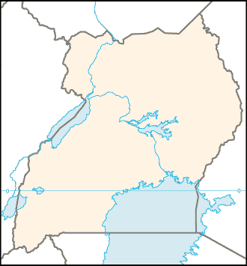

A – Bantu
B – nilotics
C – Nilohamites
D - HAmites

What is an ethnic group?
An ethnic group is a group of people with different tribes sharing the same origin and speak related languages.

A tribe
Is a group of people with same beliefs, customs and languages.

Culture
This is the acceptable behavior in a given society.

Norms
This is an expected behavior in a given society.

Major ethnic groups in Uganda
- The bantu
- Nilotics
- Nilo-hamites
- Hamates
- The Sudanic

The Bantu
Who were the Bantu?
- Bantu were the people who speak related languages with a common syllable “ntu”
- Bantu were the first group of people to come to Ugnda.
- Bantu are said to have migrated from Cameroon highlands.
- The main occupation of the Bantu was farming
- The Bantu entered Uganda from the western direction.
- Bantu settled in the interlacustrine regions
Interlacustrine region
Was the area between the great lakes of East Africa

Why did the Bantu settle in the interlacustrine region
- presence of fertile soils for farming
- Favourable climate
In which way did fertile soils influence Bantu to settle in Uganda?
The fertile soils encouraged them to carry out agriculture.

Tribes that belong to Bantu
Baganda
Banyankole
Basoga
Batoro
Bakiga
Bakiga
Banyoro
Bagisu
Bafumbira
Batawa
Baruri
Banyara
Bakonjo
Bamba

Reasons why the Bantu migrated from their homeland
- Attacks from wild animals
- Harsh climate
- Wars on the way
- Shortage of food
- Presence of thick forests
- Our break of epidemic diseases
- Presence of mountains and rivers
- Rough terrain
Qn: How did thick forests, mountains and rivers affect the ethnic groups during their movements.
It is difficult to cross them

Effects of Bantu migration
- The population increased
- They introduced new culture
- Some Bantu formed kingdoms
- They introduced new crops like banana

Reasons why the Bantu were able to form Kingdoms
- They were united
- They were organized
- They lived settled life
The river lake Nilotes (Nilotics)
They were said to have migrated from Bahr-el-Ghazel region in south Sudan

The Nilotes are divided into three main groups
- River lake Nilotes
- Plain Nilotes
- Highland Nilotes
Qn:
- Name the Nilotic tribe that lives in eastern Uganda (Tororo district)
Japadhola
- Name the Nilotic tribe that is found in Kenya
Jaluo

Movement of River Lake Nilotes into Uganda
- They entered Uganda from the Northern direction following River Nile
- They first settled at Pubugu present day Pakwach
- The Nilotes were cattle keepers (pastoralists)
- The Acholi and Alur practice de-toothing on the lower jaws.
Causes of their migration
- They were looking for pasture and water
- Love for adventure
- They were over population
- They were running away from civil wars
- Out break of famine
- Outbreak of epidemic diseases
- Long drought seasons
Results of their migration
- They introduced new language called Luo
- They introduced pet names e.g. Akiiki, Abwoli, Adyeri, Apuli etc.
- The population increased
- They introduced short horned cattle
- They led to the formation of the Luo Babito dynasty.

Why did the Nilotes change from cattle keeping to mixed farming
- Presence of fertile soils for farming
- Favourable rainfall for farming
- They settled in areas with reliable rainfall for agriculture.

The plain Nilotes
- They originated from west of L. Turkana
- They entered Uganda from the north East direction.

Examples of plain Nilotes
- Iteso
- Karimojong
- Kumam
- Jie
The major occupation of the plain Nilotes was cattle keeping

Highland Nilotes
- They entered Uganda from north East
- They settled around the foothills of Mt. Elgon in the present day Kapchorwa
- They highland Nilotes in Uganda include the Sabiny
- Highland Nilotes were cultivators (crop growing)

Qn: Why did the highland Nilotes settle on the slopes of Mt. Elgon?
- Presence of fertile volcanic soils
- Presence of reliable rainfall

Crops grown by the Sabiny
- Wheat
- Finger nails
- Maize
- Beans
- Irish potatoes
Today wheat is the major crop grown in Kapchorwa.

Reasons for the success of wheat growing in Kapchorwa
- Presence of fertile soils
- Presence of reliable rainfall
- Presence of cool climate

Reasons why the highland Nilotes migrated
- Love for adventure
- Outbreak of famine
- Long drought season
- They were over populated

Results of highland Notes and plain Nilotes
- They introduced new culture
- The population increased
- The plain Nilotes introduced new breeds of cattle
- The plain Nilotes introduced cattle rustling which created insecurity in the neighbouring districts.
The Sudanic people
- They are found in west Nile
- They were crop farmers and fishermen
- Their origin started in Juba.

Sudanic tribes in Uganda
- Lugbara
- Madi
- Okebu
- Kakwa
- Lendu

Reasons for their migration
- Running away from civil wars
- Outbreak of famine

The hamates
- They entered Uganda from the south west They include:-
  - Bahima
  - Basita
  - Batutsi

Legends Myths and events
These are stores which tell people about the past.

Why legends are important to us
- We learn the different origins of other communities
- We learn ways early people lived
- We learn the origin of people and places
- Helps to identify some of he ancestors of different communities
- It makes our traditional values richer
- It promotes morals

Types of values
- Personal values
- Family values
- Community values
- God fearing
- Cleanliness
- Law abiding
- Helpfulness

Myth
Is a story that is told to explain about the mysteries of a world. Such stories tell how the earth and life began, the origin of death, day and night, rain drought

Factors that influence the settlement patterns of ethnic groups
- Land
- Vegetations
- Climate
- Water

Influence of occupation
- Fisherman settled near lakes
- Traders settled in trading areas
- Crop farmers settled in areas with reliable rainfall and fertile soils.
- Pastoralists settled in areas with enough grass
- Forested areas were avoided due to dangers animals and pests

Occupation of ethnic groups
Bantu - cultivation
Nilotes - pastoralism
Highland Nilotes - cultivation

Migration
Is the movement of people from one place to another for settlement.

Forms of migration
- Internal migration
- External migration

Internal migration
Is the movement of people from one place to towns for settlement

Causes of rural –urban migration
- Looking from employment in towns
- Looking for better medical services in towns
- Looking for better education services
- To look for better security

Problems caused by rural urban migration in towns
- It leads to high crime rate
- Easy spread of diseases
- Unemployment in towns
- Poor sanitation
- Shortage of food

Rural Rural migration
Is the movement of people from one village to another for settlement

Causes of rural-rural migration
- Need for water and pasture for animals
- Need for fertile soils for agriculture in
- Insecurity
- Natural disasters

Land fragmentation
Is he dividing u of land into small pieces due to over population

How is land fragmentation affecting villages
There is low food production

External migration
Is the movement of people out of the country

Causes of emigration
- Political instability
- Search for better employment

Immigration
Is the movement of people into the country

Causes of immigration
- Political instability
- Civil wars
- Search for better employment
- For investment

Advantages of immigration
- It creates employment
- It increases the government revenue
- The natural resources are put into use
- Importation of skilled labour

Disadvantages of immigration
- Leads to shortage of land
- Leads to importation of bad cultures
- Leads to over exploitation of natural resources

Reasons why people leave Uganda for other countries
- Searching for chances of employment
- For further studies
- For adventure
- To get medical treatment

Recent immigration into Uganda
- Rwandans
- Congolese
- Sudanese
- Indians

Reasons why people migrate today
- To look for better medical care
- To look for employment
- To look for better entertainment
- To search for better education

Ways the government can encourage people to go back to villages
- Improving on security in villages
- Modernizing agriculture
- Improving on medical care in villages
- Building better hospitals in villages

Contribution of immigration to Uganda development
They have built industries
They have served as doctors and engineers

Political organisation of pre-colonial societies
- Pre-colonial period was the period before Uganda was taken over by the British.

Types of organization include:
- Kingdoms
- Chiefdoms
- Clans

How did Ugandans rule over before the coming of Europeans
- They ruled themselves under kingdoms
- There was a government led by a chief
- They ruled themselves under clans

Why is it wrong to say that there was no government before the British came
- It was governed by a king
- It was governed by a chief
- It was governed by a clan member
Kingdoms in Uganda
A kingdom
Is an area ruled by a king
Chiefdom
Is an area ruled by a chief
An empire
Is an area ruled by an emperor

Bunyoro Kitara Empire
- It was the earliest pre-colonial state in Uganda
- It was founded by the BAtembuzi
- The first king of Abatembuzi was Isaza interlacustrine region
- The Bachwezi replaced the Abatembuzi
- The first king of Bachwezi was Ndahura the grandson of Isaza.
- The last king of Bachwezi was Wamala
- The Bachwezi were displaced by the Luo Babito dynasty.
- Both the Batembuzi and Bachwezi are said to be demigods.

Causes for the decline of Bunyoro Kitara
- It was too big to be ruled by one king
- The death of their beloved cow Bihogo
- Internal and external wars
- The coming of the Luo Babito
- Outbreak of epidemic disease
- Outbreak of famine

Contributions made by the Bachwezi
- They introduced long horned cattle
- They introduced iron smelting
- They introduced backcloth making
- They introduced coffee growing
- They introduced pottery

Social contributions
- They introduced new games like Omweso

Examples of royal regalias
- Royal spear
- Royal drums
- Royal tombs
- Royal stools
- Royal arrows
- Royal shields
Qns:
- How did the size of Bunyoro kitara lead to its decline?
- How did climate affect Bunyoro Kitara?
- How did the coming of Luo Babito affect Bunyoro Kitara?
- It led to the collapse of Bunyoro Kitara
- Bigobyamugenyi was the headquarters of Bachwezi

Importance of Bigobyamugenyi to Uganda
- It acts as he tourist attraction
- It creates employment to people
- It is used for research purposes
Kingdom/chiefdom | Title of the leader
Buganda | Kabaka
Bunyoro | Omukama
Ankole | Omugabe
Toro | Omukama
Basoga | Kyabazinga
Teso | Emunmon
Acholi | Rwot
Alur | Rwoth

Buganda kingdom
- It started as a very small kingdom on the northern shores of L Victoria
- It broke away from Bunyoro Kitara
- It was founded by Kato Kimera.

Factors that led to the growth of Buganda Kingdom
- Had a strong leader
- Had a strong army
- Had plenty of food
- It was small in size
- It had fertile soils
- It received reliable rainfall

Advantages of kingdoms
- They promote peace and unity
- They promote culture
- Mobilize people for development

Disadvantages of kingdoms
- Promote dictatorship
- Promote the interest of the minority

Ankole kingdom
- Ankole kingdom was formed in south western
- It traces the origin of the period of Batembuzi
- British colonialists combined other kings together to form Ankole

Examples of such states were
- Kajara
- Igara
- Mpororo
- Buhweju
- It then got its new name Ankole
- Its king was called Omugabe

Toro kingdom
It broke away from Bunyoro Kitara
It was founded by Prince Kaboyo in 1830
Kaboyo was the oldest of the Omukama

Reasons why Omukama Kasagama of Toro welcomed Capt. F.D. Lugard
- He wanted to be restored to his throne
- He wanted protection against his enemies.

How did Omukama Kasagama benefit from the coming of Captain Lugard
- He restored him to his throne
- He gave protection against Omukama KAbalega
- He drove Kabalega out of Toro kingdom

Chiefdoms
A chiefdom is an area ruled by chiefs
Busoga is a chiefdom
The title given to a chief is Kyabazinga
Kadhumbula Wilberforce was the Kyabazinga of Busoga at the time of Uganda’s independence in 1962.
He mobilized his people to support the struggle for independence.
He later became Uganda’s first Vice President.

Social organisation of pre-colonial people
- People related by clans were organized
- The children belong to the clans of their fathers
- On the side of religion, spirits received much attention
- Traditional religious leaders such as rain makers, medicine men and fortune tellers got a lot of respect.
- Education was passed through stories
- They had language, names, customs, clans, totems, values, games

Economic organisation of pre-colonial rule
- People grew their food
- People reared their animals
- People practiced barter trade on a small scale
- People made their clothes from the bark of trees

Barter trade
Is the exchange of goods for goods or goods for services

Advantages of barter trade
- It doesn’t involve money
- It promotes friendship

Disadvantages of barter trade
- It is difficult to get a customer
- It is difficult to carry bulky goods

Barter trade items included: -
- Bark cloth
- Salt

Long distance trade
Was the trade carried out between the people of the interior and the people on East African Coast.

Tribes that participated in long distance trade in Ugnda
- Baganda
- Banyoro

Foreign influence in Uganda
Foreigners are people who are not citizens to a particular country
A citizen is a person who enjoys civil constitutional and human rights of a nation or a country.
Foreigners in Uganda came from two continents that is Asia and Europe

Groups of foreigners in Uganda
- Traders
- Explorers
- Missionaries
- Administrators

Traders
These were the first group of foreigners to enter Uganda. Traders came in two groups
- Asians
- European traders
Asian traders
Asian traders came to Uganda in two groups. These were;
- Arab traders
- Indian traders

Arab traders
- Arabs were the first group of foreigners to enter Uganda
- They came from Saudi Arabia, Persia, Yemen, Oman in the continent of Asia
- They used their boats called DHOWS to cross Indian ocean.
- The monsoon winds helped them to blow their dhows to the coast of East Africa.
- The Arabs first settled at the coast of East Africa.
- They settled in places like;
- Kilwa
- Mogadishu
- Mombasa
- Lamu
- Malindi
- Zanzibar and
- Sofala
- The Arabs named the land at the coast the “Zenji” empire
- The word Zenji means the land of the black people
- The Arabs entered Uganda through Tanganyika present day Tanzania
- They passed through places of Tabora and Karagwe.

Why the Arabs entered Uganda through Tanganyika and not Kenya
- They feared to face the hostile people in Kenya
- The first Arab traders to come to Uganda were led by Ahmed Bin Ibrahim. Ahmed Bin Ibrahim therefore was the first Arab trader to come to Buganda in 1844.
- Kabaka Sunna II of Buganda received the first Arab traders in Buganda.
- The Arabs came to Uganda majorly to carry out trade.
- They later spread Islamic religion.

Goods (items) brought to Uganda by Arabs to Uganda
- Cloths
- Cups
- Mirrors
- Necklaces
- Beads
- Guns
- Glasses
- Some crops

Goods taken by Arabs from Uganda
- Slaves
- Ivory
- Salt
- Iron
- Skins
- Food stuffs

The Arabs used barter trade system
- Barter trade is the exchange of goods for goods or goods for services.
- The Arabs later introduced cowrie shells.
- Cowrie shells were later used as a medium of exchange
- Another group of Arabs entered Uganda from the north in 1841.
- These Arab traders came from Sudan and Egypt.
- These were called the Khartoumers
- They raided the areas of Acholi, Bunyoro and Lango.
- In Buganda the traders were moving in big groups called caravans

Effects of the coming of Arabs in Uganda
Positive
- They introduced cowrie shells which was used in trade as the first form of money.
- They introduced new goods (e.g. cloths, beads, etc)
- They introduced Islam.
- They introduced new crops (e.g. mangoes, rice etc)
- They introduced new culture (dressing styles)
- Trade activities increased.
- They developed trade routes in Uganda
- Chiefdoms developed into kingdoms and empires.
- They introduced Swahili language.

Negative
- They introduced slave trade in Uganda
- Slave trade increased wars among communities in Uganda
- People lost their lives through slave trade
- They caused disunity among people

Why Islam took long to spread in Uganda
- The Arabs were more interested in trade
- The Arabs were hated for being slave traders
- Islam was preached in foreign language which proved hard to the natives.
- Arabs were not favoured by the colonialists
- People feared the practice of circumcision

Slave trade and slavery
Slave trade is the buying and selling of human beings.
Slavery is the illegal owing of a person by another person

How slaves were obtained by Arabs
- By raiding villages
- Through inter tribal wars
- By direct buying(barter trade)

Why slave trade developed in Uganda
- There was need for labour at the coast and the other countries
- The Arab traders and African chiefs wanted money
- The African chiefs wanted guns for defense and expansion
- Disunity among communities in Uganda

Why slave trade took long to come to an end
- Chiefs and kings were benefiting a lot
- African chiefs and kings supported it

Effects of slave trade in Uganda
- Population decrease
- Uganda lost strong men and women
- A lot of suffering and death was experienced
- Property was destroyed
- Families split up
- It led to famine
- Slave trade caused wars

Positive
- Kingdoms developed
- New crops were introduced
- New items were introduced

Indian traders
- This was another group of Asian traders
- Indian traders came from India
- They came to carry out trade
- Alidina Visram was the first Indian trader to open up a shop in Kampala
- Indians introduced Rupees as a form of money
- Rupees replaced the cowrie shells that was introduced by the Arabs

Other important Indian traders include
Mehta khalidas
- He established the first sugarcane plantation in Uganda at Lugazi in 1924.

Muljibai Madhvan
- He started Kakira sugar plantation at Jinja
- Later other Indians came to build the Uganda railway.
- These were the Indian coolies (prisoners)

Effects of Indians in Uganda
- They introduced rupees in Uganda
- They started sugarcane growing in Uganda
- They started the banking system (Banyans / Indian money lender )
- They set up sugar factories in Uganda
- They set up ginneries
- They increased business in Uganda
- They controlled all the economy of Uganda

The Indians were later expelled from Uganda by President Idi Amin Dada in 1972

The coming of Europeans to Uganda
Europeans came to Uganda in four groups these groups were
- Explorers
- Missionaries
- Traders
- Colonialists

The European explorers came to Uganda
The explorers were the first European group of people to come to Uganda

Why the explorers came to Uganda
- They came to look for the source of river Nile
- They came to know more about Uganda
- River Nile was the major physical feature that attracted most of the European explorers
- Most of these explorers were sent by the Royal geographical society (RGS)
- The Royal Geographical Society funded (financed) the explorers’ journeys in Uganda

John Speke
- John Speke made two journeys to Uganda
- His two journeys were sponsored by the Royal Geographical Society

John Speke and Richard Burton 1856 – 1858
- They came to look for the source of the Nile
- They reached Tabora in 1857
- They reached Lake Tanganyika in February 1858.
- They became the first European explorers to see L. Tanganyika in Tanzania.
- They visited chief Kamweri of Usambara
- John Speke left Burton at Tabora and moved north words
- John Speke reached the shores of lake Victoria on 30th July 1858
- He named it after Queen Victoria of England
- Before John Speke the lake was called Lake Nyanza in Tanganyika, Nalubaale in Uganda
- He proved that this lake was the source of the Nile
- John Speke became the first European explore to see the source of the Nile
- He was also the first European explorer to come to Uganda
- On returning home they developed a disagreement about the source of the Nile.

John Speke and James Grant (1860 – 1863)
- John Speke made his second journey with James Grant
- He came to confirm his discovery of the source of the Nile on Lake Victoria
- They were escorted by two gunmen from the coast
- These escorts were MwinyiMabruki and Sidi Bombay
- They passed through the kingdom of Karagwe
- They were received by king Rumanika of Karagwe
- Grant fell sick and was left behind by Speke
- John Speke arrived at KabakaMuteesa’s palace at Banda in 1862.
- John Speke reached the source of the Nile on 28th July 1862.
- He named the falls at the source the Ripon falls.
- He named the falls after Lord Ripon the president of Royal Geographical Society in Britain at that time.

Sir Samuel Baker ( The Baker)
- He was the first European explorer to look for the source following it from the source
- He came with his wife
- He was the first European explorer to come with his wife
- John Speke and James Grant met Sir Samuel Baker at Gondokoro in south Sudan.
- They told him that they had discovered the source of river Nile
- He changed his journey
- He went to West and reached OmukamaKamurasi’s palace in Bunyoro
- He became the first European to see Lake Mwitanzigye
- He named it lake Albert after the husband of Queen Victoria of England
- He also became the first European explorer to see the Murchison falls in 1864.
- He was later sent as the first governor of the equatorial province by Khedive Ismail of Egypt
- The equatorial Province was the region between south Sudan and northern Uganda
- He established his headquarters at Patiko in northern Uganda where he helped so much in the fight against slave trade.
- Sir Samuel Baker gave guns to the people of Acholi to protect themselves against slave traders.
- Other forts built by Baker include Padibe and Foweira

Ways how sir Samuel baker helped the people of acholi land
- He fought slave trade in northern Uganda

Henry Morton Stanley
- He was sent by new Herald and British Daily telegram
- He made three journeys to Africa
- He entered Uganda through Tanganyika
- One his first journey he was sent to look for Dr. David Livingstone
- On his second journey he came to complete the work of other explorers.
- Stanely went westwards and named mountain Rwenzori the mountains of the moon because snow looked like a rising moon.
- He circumnavigated (sailed) around Lake Victoria
- He wanted to prove if it was the source of River Nile
- Stanley visited the Kabaka of Buganda (Muteesa I)
- Muteesa I requested Henry Stanley Morton to write a letter on his behalf inviting missionaries to Uganda
- Stanley came for the third time to rescue Emin Pasha

Why did Muteesa I invite missionaries to Uganda
- To teach his people reading and writing
- He expected missionaries to give him guns for protection
- To teach his people Christianity
- Stanley moved towards western Uganda and became the first European to see Mt. Rwenzori, L. Edward and L. George

Problems faced by explorers
- Language problems
- They experienced shortage of supplies like drugs, food etc
- They were attacked by tropical diseases
- They were attacked by unfriendly tribes
- Poor means of transport and communication
- Harsh climatic conditions

Effect of the coming of the explorers
- Their reports encouraged traders and administrators to come to Uganda
- Brought new goods in form of special gifts
- They made Uganda known to outside world.

Missionaries
- These were the second group of Europeans to come to Uganda
- A missionary is a person who leaves his land to go to a foreign land to spread the word of God

They came in two major groups
- Protestants
- Catholics

Protestants missionaries
- They were the first group to come to Uganda
- They were sent by the church missionary society (CMS)
- They are also called Anglican missionaries
- They were led by C T Wilson and Shergold Smith and O’Neil
- They arrived here in 1877.
- Alexander Mackay was carpenter, builder, teacher and was the leader of C.M.S
- He brought the first printing press in Uganda
- Other importation protestant missionary include

Dr Albert Cook
- He built the first missionary hospital in Uganda at Mengo
- He tried to control the spread of sleeping sickness aroud the shores of lake Victoria

Kenneth Borup
He introduced the fast growing cotton seeds called American upland variety in 1903.

Robert Ashe
Brought the first Raleigh bicycle

Bishop Hannington James
- He died in Busoga on his way to Buganda under the order of Mwanga
- He was killed because he used a wrong route while entering Buganda
- He was killed by chief Luba’s palace

Apollo Kivebulaya
- He was a Muganda missionary
- He spread Christianity in western Uganda and eastern Democratic Republic of Congo.

The Roman Catholic missionaries (white fathers)
- They came from France and arrived in Uganda in 1879.
- They were led Father Simon Lourdel and Brother AmansDelmas
- They were later joined by Fr. Leon, Livinchac and LudoricGirault and Fr. Leon Barbot
- They were sent by Cardinal Kavengerie of missionaries of Africa and Algeria

Other groups of catholic missionaries included
- Holy ghost father
- Mill hill fathers

Persecution of Christian converts
Before Muteesa I died, he had developed a dislike towards missionaries

Why Muteesa I developed a dislike for the missionaries
- They disobeyed his orders
- They preached against the traditional practices and culture
- They never brought for him guns as he expected.

Who is a martyr?
- This is a person who dies for his or her faith.
- The first three Christian martyr were killed at Natete near Busega
- These were;
  - Makko Kakumba
  - Nuwa Sserwanga
  - Yusufu Lugalama

Write down a list of the Christian martyrs
- The massive killing of the martyrs was at Namugongo
- The largest number of martyrs was killed on 3rd June
- This is why Christians in Uganda and neighbouring countries commemorates
(remember) the 3rd June every year.
- King Mwanga of Buganda ordered for the killing of the Christian converts.
Why?
- They disobeyed his orders
- The chief executioner was Mukajjanga

Pope Paul VI came to Uganda in 1969 to coronise the Uganda Martyrs
- Arch Bishop Luwumu was also killed in 1972 by Iddi Amin Dada
- He was declared a martyr by the Anglican church of England
- Bishop was the first African Anglican bishop in Uganda
- He is the last martyr to be killed.

Positive effects of missionary work
- They introduced Christianity
- They introduced formal education
- They introduced new crops e.g. cotton
- They built hospitals
- They built schools

Negative effects
- They preached against traditional cultures
- They led to religious wars
- They paved way for the coming of colonialists
- They led religious divisions

Formal education
This is the type of education introduced by European. It replaced the informal type.

Informal education
This is the type of education that existed before the coming of Europeans

European Traders
These were the third group of Europeans to come to Uganda
They came to carryout trade.

William Mackinnon
He was a British trader
He formed the imperial British East African Association in 1888.
The Association got a charter in 1888 and became the imperial British East Africa Company (IBEACO)
It had its headquarters at Machakosin Kenya

Captain Fredrick Lugard
- He was a British trader
- He was sent to Uganda to represent IBEACO in 1890.
- He set up his headquarters at Old Kampala
- He built for Edward on Old Kampala hill.
- He signed a partition treat with KabakaMwanga
- He signed a friendship agreement with OmugabeNtare of Ankole in 1890.
- Lugard restored OmukamaKasagama of Toro to his throne
- Lugard brought the Sudanese soldiers to Uganda
- He wanted them to help him fight wars and ensure stability and peace in Buganda

Why IBEACO was formed
- To promote trade in the main land
- To protect British interests in Uganda
- To stop slave trade
- To develop communication and transport network in Uganda
- To promote peace and security

IBEACO collapsed because it became bankrupt

Why IBEACO ran bankrupt
- It lacked a reliable and potential source of income
- It got so involved in the political administration which was costly
- The territory controlled was too large to be maintained properly
- It employed many personnel that needed big pay.
- Before the company left Bishoop Alfred Tucker asked for funds from the Church Missionary Society to keep it operating in Uganda
- William Mackinnon suggested the need to build the Uganda railway

Colonialists
- This was the fourth group of Europeans to come to Uganda
- They came from Europe
- The first European country attempted colonizing Uganda was Germany
- Germany sent Carl Peters to Uganda who signed a treaty with Mwanga demanding to have full control over Uganda 1890.

Sir Gerald Portal
- He was sent to make a report on how best Uganda could be ruled in 1893
- He built forts in Toro (Fort Portal) and at Entebbe (Fort Alice)
- He established his headquarters at Entebbe making it the first capital city of Uganda
- He declared Uganda a British protectorate in 1894

Colony
This is a country where foreigners, settle, develop and take full control of Administration

Colonist
A person who settles in an area that has become a colony.

Colonialism
This is where a more powerful country controls another country

Protectorate
A country ruled by a foreign power temporally to protect their interests

Methods of acquiring colonies
- Signing treaties
- Using force
- Using company rule
- Using missionary work
- Using agents

Systems of colonial administration
- Indirect rule
- Direct rule
- In Uganda the British used Indirect rule
- Captain Lugard proposed the idea of using indirect rule
- Indirect rule was the type of rule where colonialists used African leaders to rule on their behalf.
- In Uganda indirect rule was used in the kingdoms of Toro, Buganda, Ankole

Why did the British use indirect rule
- It was cheaper than direct rule
- It reduced rebellions
- It solved the problem of language barrier
- It did not interrupt cultural practices
- They lacked enough manpower

Disadvantages of indirect rule
Native leaders lost full control of their territories
Native leaders were used as puppets
It caused division among natives

Direct rule
This is where colonialists did not use local chiefs to administer on their behalf.
In Uganda direct Rule was used in areas which did not have local leaders and those areas which resisted e.g. Bunyoro, Kigezi,

Reaction’s resistance
- Resistance through staging rebellions
- Collaboration through signing treaties or agreements

Kabalega’s resistance
- Never wanted British rule in his kingdom
- Wanted to protect Bunyoro’s independence
- He used his army of the Abarusula but they were defeated by Colonel Henry Colville
- Kabalega was arrested and exiled to Seychelles islands in the Indian Ocean
- While on his way back in 1992 he died on the way at Mpumudde near Jinja.

Mwanga’s revolt
- He was not happy with Uganda’s involvement in the politics of his kingdom
- He wanted to send away the missionaries who were dividing his people and making his subject disobey his orders.
- Mwanga was defeated by the British captured and exiled with Kabalega to Seychelles island
- The British replaced him with his young son DaudiChwa II
- He later died in 1907 while in exile

Lamogi rebellion 1911 – 1912
This was staged by the people of Acholi against the British
It was led by chief Awich of Payera

Causes
The Acholi never wanted to register their guns
Awich wanted to protect his independence

Nyangire rebellion
- The word Nyangire means “I have refused”
- It was staged by Bunyoro
- The Banyoro never wanted Baganda agents to rule them.
- Banyoro fought the Baganda agents who fled to Hoima
- Finally governor Henry Colville sent troops and they defeated Bunyoro

Agreements
The 1900 Buganda Agreement
It was signed between the Buganda kingdom and the British protectorate government
Sir Harry Johnston signed on behalf of the British government
Sir Apollo Kaggwa signed on behalf of the Buganda kingdom
The agreement was signed during the rule of KabakaDaudiChwa II
DaudiChwa II did not sign the agreement because he was very young of about 3years old
He was ruling under regents (helpers)
The helpers were;
Sir Apollo Kaggwa (prime minister)
Stanslas Mugwanya (chief justice)
Zakaria Kisingiri (treasurer)

Terms (issues) of the agreement
- Land
- Taxation
- Government / administration

Effects or results or outcomes of the 1900 Buganda agreement
- Land was divided into mailo and crown land
- Buganda’s land was divided into 20 counties
- Buganda’s boundaries were fixed.
- Hut and gun taxes were introduced
- Kabaka’s powers were reduced
- The lukiiko was given more powers

How did Toro benefit from the 1900 buganda agreement
It confirmed Toro’s independence from Bunyoro

Toro agreement of 1900
It brought Toro under the British protectorate

Ankole agreement (1901)
- It was signed between the British and OmugabeKahaya of Ankole
- Ankole was given the counties of Buhweju, Igara, Bunyaruguru and Kajara in 1898.
- NuwaMbaguta was the prime minister at that time

Collaborators
- Nuwa Mbaguta
- He helped to fight illiteracy in Ankole
- He started the building of roads in Ankole
- He planted trees in Ankole to improve on the environment

Semei Kakungulu
- He extended the British rule in Eastern and northern Uganda
- He signed treaties with the native chiefs in eastern Uganda
- He built his headquarters at Budaka
- He helped the British to arrest Kabalega and Mwanga
- He planted Mvule trees to improve on the environment
- He built roads in Eastern Uganda

Fixing the boundaries of Uganda
- Uganda was declared a British protectorate in 1894.
- Present day Uganda is smaller compared to Uganda before 1900.

A map of Uganda showing evolution of Uganda

Why some parts were removed or given to Uganda
- Nyanza province was given to Kenya in 1902
- To have the Nandi and Masai under one government
- To put the Uganda railway under one administration
- To allow Uganda concentrate on the development of north – eastern region
- West Nile from Sudan to Uganda in 1914
- To have maximum control over the Nile
- North eastern part from Uganda to Kenya 1926
- To separate the Karamojong and the Turkana
- Lado enclave from Uganda to Sudan 1914
- To separate the Sudanese from the Acholi

Negative effects of fixing boundaries
- Tribes were separated for example there are Luo in Kenya and Uganda
- Families were split

Effects of colonial rule
Positive
- Encouraged cash crop growing
- Built roads and railways
- Built schools
- Built hospitals
- Built modern industries
- Taught people modern administration
- Encouraged the respect of human rights

Negative
- Loss of natives’ independence
- Put unjust laws
- They over exploited Uganda
- Racial segregation
- Promotion of divide and rule
- Loss of major elements of culture

Reasons for the introduction of crop growing in Uganda
- To get raw materials for their industries
- To enable Ugandans to get income to pay taxes

Commissioners
Colonel sir Henry Colville
- He fought and defeated Kabalega
- He brought Bunyoro under British rule

Sir Harry Johnston
- He was last British commissioner in Uganda
- He signed the 1900 Buganda agreement on behalf of the British government

British governors
Sir Hesketh Bell
- He was the first governor in Uganda
- He encouraged the growing of cash crops
- He introduced the first ford car in Uganda
- He linked the railway line from Jinja to Namasagali
- He constructed ports on lake Victoria, Albert, and Kyoga.

Sir Fredrick Jackson
- He ruled during the first world war
- He started the construction of Mulago hospital
- He overcame the Lamogi rebellion

Sir Robert Thone Coryndon
He established the legislative council in 1921

Sir Geofrey F. Archer
He opened Makererecollege

Sir William Gowers

Sir Philip mitchel
He turned Makererecollege into a university to promote higher education

Sir Charles dundas
He governed Uganda during the world war two

Sir John hathon mall (1944 – 1952)
Africans joined Legco during his reign
The first political parties were formed during his term in office

Sir Andrew cohen (1952 – 1957)
He exiled KabakaMutesa II in 1953
Nyanza textile was built during his time
Owen falls dam was completed during his term of office
He started the construction of parliamentary building and radio Uganda

Sir Fredrick Crawford
He organized the first general elections in 1958
He completed the construction of parliamentary building

Sir waltercoutts
He was the last colonial governor of Uganda
He organized the last general elections to independence

THE ROAD TO INDEPENDENCE IN UGANDA
- Independence means putting the highest laws of a country into the hands of citizens
- It may mean freedom from political control from other countries.

Characteristics of colonial system
- Foreign laws / colonial laws
- Taxation
- Segregation
- Colonial economy
- Forced labour
Foreign laws
These are some of the laws introduced by
Colonialist
- No Africans were allowed to own or carry a gun
- Africans were to give labour whenever the government needed it.
- Africans were not to export cash crops
- Registration of the birth, death and marriage

Taxation
- Hut tax of rupees was to be paid by each homestead
- Gun tax was to be paid by gun owners
Qn. Why did the colonialist introduce taxes?

Segregation
- Discrimination of people according to race, sex or social status
- Segregation in Uganda during colonial rule appeared
- The whites and Asians had better services than Africans.

The colonial economy
The colonial system changed Uganda’s economy to a cash economy.
Qn:
State reasons why the British introduced cash crop growing
- They wanted raw-materials
- To get income
- They wanted to stop Uganda from depending on Britain.

Give any two results of introducing cash crops to Uganda
It led to industrialization
It led to the extension of the Uganda railway to different parts of Uganda.

The independence of Uganda
- Independence in Uganda was obtained peacefully
- A series of conferences were organized in London but some Ugandans attended
- Mr. JV Wild chaired the committee which organized the first general elections
- Uganda got self government in 1961 led by Ben Kiwanuka
- The London conference was organized in 1961
- On 9th October 1962 Uganda attained independence
- He was the first prime minister of independent Uganda
- In 1963 Edward Muteesa II was appointed first non executive president of Uganda and deputized by Nadiope Wilberforce.
- DP, UPC and UNC participated in the first elections
- The duke of Kent handed over the instruments of power to elected prime minister Milton Obote
- Uganda attained her independence through forming political parties
- UPC and KY made an alliance to win DP in the elections that brought Obote as the first prime minister of Uganda

Formation of the legislative council
- It was formed in 1921 to make laws for Uganda during Governor Robert Corydon
- At first Africans were not represented until 1945
- It was composed of Asians and Europeans.
- In 1945 the first three Africans were appointed from the regions of Uganda
- These were
  - Central region – Kawalya KAggwa
  - Western region – Petero Nyangabyaki Akiiki
  - Eastern region – Yokania Zirabamuzaale
- In 1946, Yokosofati Innyon was nominated to represent the northern region.
- The first Africans were nominated / appointed to LEGCO on 1945 during the region of governor Sir John Hathon Hall
- Most of its members were of British and Asians
They feared that the British would merge Uganda and Kenya to make East African Federation.

How Africans demanded for independence
- They staged demonstrations
- They organized riots and strikes
- They formed political parties and trade unions

Kabaka crisis
- In 1953 Sir Andrew Cohen the governor of Uganda by then sent Mutesa II in exile
- He was exiled for;-
  - Demanding of Buganda’s separate independence
  - Rejected the idea of proposed East African Federation
  - He refused the Lukiiko to send representatives to the LEGCO
- This led to political unrest in Uganda

How Buganda demanded to the return of the Kabaka from exile
- The Uganda National Congress and Uganda National Movement Organized demonstrations and boycotts.
- They sent petitions to the government in Britain
- They boycotted European goods and British cars
- In 1954, Sir Keith Hankock came from the British government held meeting with the British government
- Michael Kintu signed on behalf of Buganda
- Keith Hancock signed on behalf of British
- The Namirembe slightly changed the Buganda agreement of 1900
- His ministers were chosen by the Lukiiko so long as the governor agreed to them.
- The Saza councils would now elect members of the Lukiiko and Buganda agreed to send members to the LEGCO.

Formation of political parties
- A political party is an organization whose members have the same aims and ideas.
- Many political parties were formed in 1950’s

Why
- They were mainly formed to unite Ugandans’ so s to demand for independence
- The first National Political party was formed in 1952 by Ignatius Kangave Musaazi
- It was called Uganda National Congress (UNC)

UNC (Uganda National Congress)
- It was first National Political paraty to be formed
- It was formed by Ignatius Kangave Musazi
Why?
- To unite Ugandans and demand for Uganda’s independence
- To promote democracy in Uganda.
- Later it collapsed and its members formed other parties
- I K Musaazi is a national Hero
- He died in 1990 and his body was buried at Heroes ground Kololo air Strip

Other heroes buried at Kololo
Yusufu Kironde Lule

Democratic Party
- It was started in 1954 also to demand for Uganda’s independence
- It was mainly dominated by Catholics
- It was founded by Joseph Kasolo
- In 1956 Matayo mugwanya took over leadership
- 1n 1958 Benedicto Kiwanuka became the leader of DP
- DP won the first general elections in 1961 and Ben Kiwanuka became the first chief minister of Uganda before independence.

United congress party (U C P)
- It was formed by David Lubogo
- It supported the federal system of government
- UCP was a splinter group of the UNC

Uganda people’s Congress (U P C)
- It was founded March in 1960
- It was led by Dr. Apollo Obote
- It’s main objective was to unite Ugandans and lead them to independence.
- In 1962 general elections, UPC won DP after making an alliance with Kabaka Yekka.
- Obote became the first Prime minister of Uganda and later the first executive president of Uganda.
Kabaka Yekka
- It was formed to promote the interests of Buganda and the Kabaka
- It was formed in 1961 by S. Masembe and Augustine Kamya
- KY made an alliance with UPC which gave more strength to UPC when Uganda got independence Mutesa II became the first President of Uganda without executive powers.

The independence of Uganda
- Independence in Uganda was obtained peacefully / diplomatically
- A series of conferences were organized in London but some Ugandans attended
- Mr. Wild chaired the committee which organized the first general elections
- Uganda got self government in 1961 led by Ben Kiwanuka
- The London conference organized in 1961
- 0n 9th October, 1962 Uganda attained independence.
- Milton Obote was the first Prime Minister of independent Uganda
- In 1963 Edward Mutesa II was appointed first executive president of Uganda and Nadiope Wilberforce the vice president

Presidents of Uganda
Kabaka Muteesa II 1963 – 1966( first president of Uganda without executive powers
Milton Obote 1966 – 1971 / 1980 – 85
- first executive president of Uganda
- declared Uganda a republic
Amin Dada 1971 – 1979
- took power through a military coup
- expelled all Asians
Yusuf Kironde Lule April 1979 – June 1979
- ruled Uganda for the shortest period
Lukongwa Binaisa June 1979 – 80
- was put under house arrest
Paul Mwanga May 1980 – December 1980
- organized ellections
Tito Okello Lutwa July 1985 – Jan 1986
- took power through a coup from Obote II
Kaguta Yoweri Museveni January 1986
- wdged a guerilla war against the Govt.

Uganda as a nation
A nation is a group of people with the same language, culture and history under one government
A state is an organized political community under one government

Characteristics of a state
It has a national leader
It has its own citizens
It has clearly marked boundaries

Symbols of a nation
According to the constitution, the major symbols of a nation are:-

National anthem
National flag
National coat of arms
National seal
National emblem

National anthem
It was composed by George William Kakoma
It has three main parts called stanzas
Teachers should tell learners to write the anthem

Stanza I
It shows that Uganda is a God fearing country
It shows that Ugandans are united and have liberty.

Stanza II
Ugandans are friendly
Ugandans are peaceful
Uganda is a land of freedom

Stanza III
Uganda has fertile soils
Uganda is the pearl of Africa

Respect of the anthem
Whenever it is being sung all people must stand upright
If unable to stand, one should raise his or her right hand upright

When to sing the anthem
- At school assemblies
- National day celebrations
- Burial of a ruling president
- Opening of parliamentary sessions

National flag
- It was designed by Late Grace Ibingira
- It has three colours i.e. black, yellow and red
- In the middle of the flag there is a white circle with a crested crane
- The crested crane always faces the flag pole
- It stands on one leg to show that Uganda is moving forward in development

Why the crested crane was chosen as Uganda’s emblem
- It is peaceful and gentle
- It is a humble bird
NB When it is raining the national flag should not be left outside

Places where the flag is raised
- Government offices
- Parliamentary building
- School compounds
- Air ports
NB: the flag is raised at half mast on the declared day of national mourning
When a calamity has befallen a country

Meaning of colours
Black: it shows that Ugandans are black Africans
Red: it shows brotherhood
Yellow: abundant sunshine
Tropical climate
Lies along the equator

Importance of the national flag
It is a symbol of independence and unity
It is for identification

Coat of arms
It was designed by Paul Mukasa
It is a symbol of independence and unity
It has the Uganda Motto

Significances of symbols on the Uganda coat of Arms
- The Uganda Kob – represents wildlife
- Crested crane – represents the peaceful nature of Ugandans
- Sun – represents Uganda’s abundant sunshine
- Coffee and cotton – Uganda is an agricultural country and Uganda’s main cash crops
- Blue strips – signify Uganda’s abundant water sources and the mighty source of the Nile
- Landscape with green – represents the green colours of Uganda
- Spears and shield – represents readiness of the Ugandans to protect and defend themselves in case of enemy attacks

National emblem
- The crested crane was chosen as Uganda’s emblem because
- It’s peaceful
- It’s gentle
- It’s used on government official documents and things like national flag currency etc

Functions of kampala as a city
- It is an educational centre
- It is a commercial centre
- It is an administrative centre
- It is a communication centre

Types of nations
Monolithic nation: is a type of nation with a common origin, common language, history, desires, territories and cultural institutions e.g. Rwanda, Burundi, Japan etc
Heterogeneous nation: is a nation with different groups of people with different culture, origin and languages but share the same territory e.g. Uganda, Kenya and Tanzania.

The government
A government is a group of persons ruling or controlling a country
Systems of governments
- Democratic government
- It is a government whose leaders are elected by the people

Military government
This is a government formed after army takeovers

Federal government
It’s a government where powers of the government are shared between the central government and he local government units called states

Multi party government
It is a government formed after many political parties campaign for state power and elected

Single party government
It is a government led by one political party

Types of government
- Local government
- Central govt.

ORGANS OF GOVT.

Executive
It's headed by the president
Its made up of president ministers, civil servants
Ministers collectively are called cabinet
Permanent secretary is the highest civil servant

Functions of the executive
- It implements government policies
- It monitors service provisions to the public

Legislature / National assembly
It’s also the parliament of Uganda
It’s chaired by a speaker
It’s made up of people’s representatives

Functions of the legislature
- It makes new laws and amends the old ones
- It discusses and approves the national budget
- It checks on the government’s expenditure
- It discusses international relations

Judiciary
It's headed by the chief justice
It’s made up of judges, magistrates and lawyers

Functions of the judiciary
It settles disputes
It punishes law breakers
It interprets the law

How a government is formed
A government is formed through
- Elections
- Hereditary
- Alliance
- Violence e.g. coup de tats

Elections in Uganda
This is when people vote to elect a leader for an official position

Types of elections in Uganda
General elections
These involve the election of members of parliament and the president

Local elections
Here local government leaders are elected e.g. LCV, LCIII, councilors, mayors etc

Bye elections
Are elections held to fill a vacant seat

Referendum
A type of elections organized to decide on a political issue

Organization of elections
In Uganda elections are organized by the body called Electoral Commission

Duties of the Electoral commission in Uganda
To conduct and supervise elections
To demarcate constituencies
To declare election results
To compile and update voter’s registers
To carryout civic education

Election terminology
Constituency: this is a voting district / an area/part of district represented by an MP
Returning officer: a person in charge of elections in a district.
Voters’ register: this is a list of voters
Polling stations: these are places where voting takes place
Presiding officer: a person in charge of elections at a polling station
Polling assistant: a person at a polling station who assist a presiding officer
Polling day: it’s the day when elections are held
Polling agent: a representative of a candidate at a polling station

Qualifications of a president
Should be a citizen of Uganda
Should be 35years and not more than 75years of age
Should be a registered voter

Qualifications of Member of Parliament
Person of unsound mind
An electoral commissioner (any person involved in organizing elections
A cultural leader
A person declared bankrupt
A person sentenced to death or imprisoned without court fine

NB: a person who heads the electoral commission in Uganda is the chairman electoral commission
Mention any four special groups of people represented in the parliament

Duties of a central government
Protects citizens and their property
Defends the country from foreign attack
Provides employment to its people
Keeps law and order
Building and maintaining main roads
Building a strong economy
Looking after the welfare of its people

Constitutional development in Uganda
A constitution is the supreme law governing a country

Importance of a constitution
- To have regulations governing a society
- It empowers a group of people in a society
- It checks the powers of leaders
- It lays down ways to make other laws
- It sets the limits of governmental powers
- It limits misuse of government offices

Uganda’s constitutions
The 1900 Buganda agreement it had provisions of the constitution e.g. land administration, taxation, boundaries, political administration
Uganda internal self government constitution 1961
Independence constitution of 1962.
The 1966 constitution Pigeon Hall Constitution
The 1967 constitution
The 1995 constitution made by the constituent assembly
NB: It was promulgated on 8th October 1962 at the constitutional square.
It’s the constitutional day in Uganda

BUDGETING AND TAXATION
A national budget is a coutnry’s estimated income and expenditure for a given financial year.
The two major parts of a budget are income and expenditure
Uganda’s financial year begins in July and ends in June the following year.

Types of budgets
Balanced budget
It’s a type of budget where the income is equal to the expenditure

Surplus budget
It is a type of budget where expenditure is less than the income

Deficit budget
It’s a type of a budget where expenditure is greater than the income.
Diagrams illustrating the three types

Disadvantages of a deficit budget
- It leads a country to debts
- It encourages dependence on foreign donations
- Government fails to provide services to its people
- It may lead to political interference by financial donors

Long term solutions to a deficit budget
Diversifying the economy
Widening the tax base
Privatization of the economy

Importance of budgeting
- It avoids unnecessary spending
- It helps one identify sources of income
- It ensures enough money for the required essentials
- It helps to plan how to spend its income

Sources of revenue
Revenue means income of a government
Sources of income include;
- Taxes - Airport charges
- Loans - Tourism
- Grants - Parastatal bodies
- Court fines
- Donations

TAXATION
A tax is a sum of money paid by the people of the country to the government

Types of taxes
Direct taxes
These are taxes which the government gets directly from tax payers e.g. PAYE, income tax

Indirect taxes
These are taxes incurred on spending e.g. VAT, Customs duty, and excise duty.

Customs duty: it’s a tax levied on imports and exports
Excise duty: it’s a tax levied on locally manufactured goods.

VAT – value added tax charged on goods and services

Why people pay taxes
- To construct roads
- To construct schools
- To pay civil servants
- To construct and maintain hospitals
- To cater for security services

Why people don’t pay taxes
- Lack of tax information
- High tax rates
- Corruption among tax collectors
- Most tax information is written in English

Rights and responsibilities of the citizens
A citizen is a person who enjoys full, civil, democratic and human rights in a country

Ways of becoming a citizen in Uganda
By birth: is a person whose parents or grand parents were members of the indigenous communities when Uganda’s boundaries were drawn in 1926.

A foundling is an abandoned child of unknown parents. If found and is less than five years, that child qualifies to be a citizen by birth.

Registration
A person may become a citizen of Uganda by registration under the following ways
- An adopted child under the age of 18years
- A person who has lived in Uganda continuously since independence
- A person married to a Ugandan citizen for a period of 3years
- Legal and voluntary migrants who have lived in Uganda for at least 10years

By naturalization
This is where a person from another country is made a citizen of a specified country

Dual citizenship
Is the possession of citizenship of two different countries at the same time

Loss of citizenship in Uganda
A person may lose citizenship in Uganda under the following grounds;
- Spying against Uganda
- Acquiring citizenship unlawfully
- Serving in an army of a hostile country to Uganda

Duties of the national citizenship and immigration board in Uganda
- Registration of citizens
- Issues national identity cards
- Issues Uganda passports and other travel documents
- Granting and canceling citizenship by registration and naturalization
NB: this board is under the ministry of Internal Affairs
The body handling this is the Directorate of citizenship and immigration

Duties of a citizen
- Pay taxes promptly
- Keep law and order
- Register for electoral purposes
- Protect and preserve public property
- Respect other people’s rights and freedom
- Defend Uganda at all times
- Take part in self help projects
- Take children and other vulnerable persons against any form of abuse

Rights of a citizen
- Human rights are basic rights and freedom any human being is entitled to
- They include;
- Freedom of protection to life
- Freedom of speech
- Freedom of worship
- Freedom of assembly
- Right to clean and healthy environment
- Right to privacy
- Right to belong to a tribe, clan and lineage
- Right to access public information

Population size and distribution in Uganda and their relationship to economic planning and development
Population is the number living in an area at a particular time

Population distribution
Population distribution refers to the way people are spread in an area

Factors that affect population distribution
- Relief of the area
- Rainfall availability
- Soil drainage and fertility
- Presence of mineral deposits
- Historical factors e.g. slave trade
- Employment opportunities
- Presences of social services
- Biological factors e.g. fertility in women
- Political stability
- Urbanization and industrialization
NB: Explain how each factor affects population growth

Population and resources
The number of people in Uganda varies according to the natural resources in that area

Uganda is classified as a developing country because of the quality of its citizen

Signs of Uganda’s backwardness
- Ignorance
- Illiteracy
- Poverty
- Diseases
- Hunger
- Low life expectancy
- High infant mortality rate
- Belief in superstitions

The above indicators show that Uganda’s population cannot top its resources to the full utilization

Population growth
This refers to the increase of people in an area

Factors affecting population growth
- Birth rate
- Death rate
- Migration rate
- Early marriages
- Peace and political stability
- Good medical services etc

NB: explain how each factor affects population growth

Natural population increase
This is the difference between the number of births and the number of deaths

Problems of population growth
- Food scarcity
- Easy spread of epidemic diseases
- Lack of accommodation
- High crime rate
- Lack of proper social services
- Land shortage
- Land fragmentation
- Environmental degradation
- Development of slums

Ways of controlling population growth
- Family planning campaigns
- Tax benefits for small families
- Education benefits
- Act of parliament or government decree
- Sensitizing the masses
- Legalising abortion

Hazards which check on population growth
Hazards are bad things that check on population growth

Natural hazards
- Pests and diseases
- Floods
- Earth quakes
- Lightening
- Strong winds
- Drought
- Volcanoes
- Wars
- Pollution
- Transport accidents

Ways of reducing population hazards
- Providing proper medical services
- Practicing scientific agricultural methods
- Advancement in communications
- Technological advancement

Advantages of population growth
- Ready market for produced goods
- Cheap labour force
- Full utilization of resources
- Enough skilled labour force
- Good security services
- Enough tax collection base

Problems of low population
- Under utilization of resources
- Low labour force
- Low market for manufactured goods
- Low tax collection
- Low skilled labour force
- Poor security services

Population census
This is the general counting of people in an area
In Uganda it is held every after ten years

Reasons for a population census
- To know the birth and death rates
- For proper planning for the population
- For proper allocation of services
- To know the age structure.

Difficulties involved in population census
- It is expensive
- Lack of skilled enumerators
- Wide spread illiteracy
- Poor civic education
- Walking long distances
- False information by the population
- Ignorance among the people

Population terminologies
Population density: this is the average number of people per square kilometer
Population density = total population = number of people per square kilometer
Area
Over population: this is when the population of an area is greater than its resources
Under population: this is when the population of an area is less than its resources
Sparse population: this is when an area has few people compared to the size of the land
Dense population: this is when an area has many people compared to the size of the land.
Even population: this is when the number of people per square kilometer is almost the same.
Moderate population: this is when an area hasn’t many people and very few people
Optimum population/ population explosion: this refers to the number of people which can be supported by an area according to its resources
NB: the population department is under the ministry of finance planning and economic development

NB: A TEACHER IS ADVISED TO USE ATLAS (NEW EDITION) AND DRAW MAPS OF UGANDA WHERE NECESSARY.

