SHALOM PRIMARY SCHOOL PRIMARY SEVEN TERM II SCIENCE REVISION WORK SET I

Set ONE
SECTION A
1. Give one of the five senses of the body.
……………………………………………………………………………………………
2. What special name is given to the young one of a rabbit?
……………………………………………………………………………………………
3. State one use of proteins in the body.
……………………………………………………………………………………………
4. In the space provided below, draw a well labeled diagram to show that air has weight.

5. Name the natural source of heat in the environment.
……………………………………………………………………………………………
6. Why should sick people be given special care?
……………………………………………………………………………………………
7. Of what importance is a lateral line to a fish?
……………………………………………………………………………………………
8. Write any one common example of a communicable disease in our community.
……………………………………………………………………………………………
9. Identify the structure that joins bones to muscles.
……………………………………………………………………………………………
The diagram below shows a simple circuit. Use it to answer questions 10 and 11.
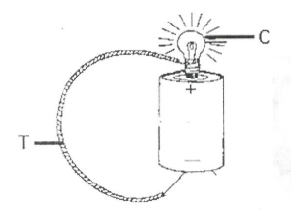
10. Using arrows, show the direction of flow of the electric current along the wire marked T.

11. Apart from light, which other form of energy is produced at C?
…………………………………………………………………………………………...
12. Explain the term “magnetization”.
…………………………………………………………………………………………...
13. Why should you apply grease or oil in moving parts of a machine?
…………………………………………………………………………………………...
14. Of what importance is perspiration on the health of human beings?
…………………………………………………………………………………………...
The diagram below shows a glass of water with a straight ruler in it. Use it to answer question 15.
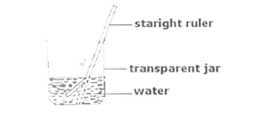
15. Why does the ruler in the jar above appear bent?
……………………………………………………………………………………………
16. Identify any one structure which helps plants with weak stems to climb other plants.
……………………………………………………………………………………………
17. Name any one ungulate mammal.
……………………………………………………………………………………………
18. Mention one disease that affects both poultry and rabbits.
……………………………………………………………………………………………
19. Write clown any one energy resource from animals,
……………………………………………………………………………………………
20. State any one way by which sound can be stored.
……………………………………………………………………………………………
21.In which part, of the body are lungs found?
……………………………………………………………………………………………
22. Give any one characteristic of an image formed through a pin-hole-camera.
……………………………………………………………………………………………
23. Which part of an insect has a similar function as of stomata on leaves of plants?
……………………………………………………………………………………………
Study the diagram below and use it to answer the questions that follow.
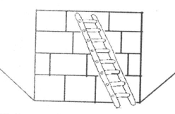
24. Identify the type of machine drawn above.
…………………………………………………………………………………………….
25. Give one example of a non-biodegradable waste material in our environment.
……………………………………………………………………………………………
26. Write down one disease that affects both the muscles and the bones of the skeletal system.
……………………………………………………………………………………………
27. What name is given to the arrangement of the seven colours that appear when a ray of light is refracted through a triangular prism?
…………………………………………………………………………………………….
28. Give one way methods used in the preservation of fish and millet differ.
…………………………………………………………………………………………….
29. Why is the handle of an flat iron box usually made of wood or plastic?
…………………………………………………………………………………………….
30. Identify any one disease that affects human kidneys.
…………………………………………………………………………………………….
31. Define the term vices in poultry rearing.
…………………………………………………………………………………………….
…………………………………………………………………………………………….
Study the diagram and answer the questions that follow.
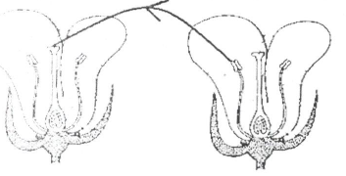

32. Name the type of pollination shown in the diagram above.
……………………………………………………………………………………………..
33. Monition one measure used by the government of Uganda to fight against the spread of malaria.
……………………………………………………………………………………………..
34. Give one example of anti-social behaviourpracticed in your school.
……………………………………………………………………………………………
35. State one way by which friction can be increased.
……………………………………………………………………………………………
36. Why is it advisable for parents to keep drugs out of reach of children?
……………………………………………………………………………………………
37. Francis planted a bean seed and after three days, it germinated, What type of change did the seed undergo?
……………………………………………………………………………………………..
38. Suggest one reason why animals move.
……………………………………………………………………………………………..
39. Mention one function of teeth in food digestion.
……………………………………………………………………………………………..
40. Which type of gas is contained in a fire extinguisher?
…………………………………………………………………………………………….
Section B
41(a) Give one example of each of the following:
(i) artificial source of light ………………………………………………………………
(ii) natural source of light ………………………………………………………………
(b) Why is the moon said to be non-luminous object?
……………………………………………………………………………………………
(c) State one way in which reflection is useful to man.
……………………………………………………………………………………………
42(a) Convert 77˚F into the Centigrade scale.
……………………………………………………………………………………………
(b) Give two ways a clinical thermometer is adapted to measuring human body temperature.
……………………………………………………………………………………………
……………………………………………………………………………………………
(c) Why doesn’t the scale of the clinical thermometer go beyond 39°C?
……………………………………………………………………………………………
13. The diagram below shows a method of making a magnet. Use it to answer the questions that follow.
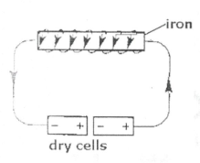
(a) Name the method of making magnets shown in the diagram.
……………………………………………………………………………………………
b) What would YOU do to the dry cells in order to increase the strength of the magnet?
……………………………………………………………………………………………
(c) Apart from the method shown in the diagram, name any other two methods of making magnets.
……………………………………………………………………………………………
44. Match the diseases with the germs that cause them.
……………………………………………………………………………………………

DISEASE | GERM
Typhus fever  Elephantiasis  Malaria  Trachoma | Plasmodium  Bacterium chlamydia  Filarial worm  Bacterium rickettsia

(a) typhus fever …………………………………………………………………………..
(b) elephantiasis ………………………………………………………………………….
(c) malaria ………………………………………………………………………………..
(d) trachoma …………………………………………………………………………….
45(a) Identify any two living components of the environment.
……………………………………………………………………………………………
(b) Mention two ways people depend on each other.
…………………………………………………………………………………………….
46a) Name the organ that removes urine from the body.
……………………………………………………………………………………………
b) To which body system does the body organ belong?
……………………………………………………………………………………………
c) Where is urine collected before it is removed from the body?
……………………………………………………………………………………………
d) Name one dangerous substance found in urine.
……………………………………………………………………………………………
47 a) What is mulching?
……………………………………………………………………………………………
……………………………………………………………………………………………
b) Give two advantages of mulching.
……………………………………………………………………………………………
c) How can mulching be dangerous to a farmer?
……………………………………………………………………………………………
48. The diagram below is of a human tooth. Use it to answer the questions that follow.
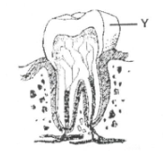
a)Name part marked Y.
……………………………………………………………………………………………
b) State the function of the part marked Y on the diagram above.
……………………………………………………………………………………………
c)Mention one health problem that can affect human teeth.
……………………………………………………………………………………………
d) Suggest any one way you can care for human teeth.
……………………………………………………………………………………………
49. Use the diagram to answer the questions that follow.
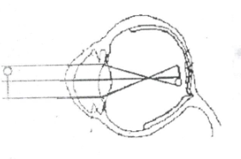
a) What eye defect is illustrated in the diagram above?
……………………………………………………………………………………………
b) How can the eye defect above be corrected?
……………………………………………………………………………………………
c) Apart from the eye defect illustrated in the diagram, name two other eye defects.
……………………………………………………………………………………………
The diagram below is of a simple machine. Use it to answer the questions that follow.
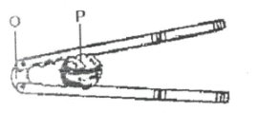
(a) Name the points of the machine marked O and P.
……………………………………………………………………………………………
(b) To whichclass of levers does the machine belong?
……………………………………………………………………………………………
(c) Using arrows show the direction of the effort applied when the machine is being used.

51(a) Identify two common causes of sickness in a home.
……………………………………………………………………………………………
……………………………………………………………………………………………
(h) Write down two ways we can prevent sickness in a home without using drugs.
……………………………………………………………………………………………
52(a) Write STD’s in full.
……………………………………………………………………………………………
b) Suggest any two ways through which a p. 7 candidate can avoid contracting STD’s.
……………………………………………………………………………………………
(c) Apart from having sexual intercourse with an infected person, give any other way of contracting HIV /AIDS.
……………………………………………………………………………………………
53(a) Write AI in full as used in animal reproduction.
……………………………………………………………………………………………
(b) Give one advantage of AI in animal reproduction.
……………………………………………………………………………………………
(c) Define the following terms:
(i) gestation period
……………………………………………………………………………………………
(ii) quarantine
……………………………………………………………………………………………
54(a) Name any two ways plants can reproduce.
……………………………………………………………………………………………
(b) Mention the method of propagation used in reproducing the following plants.
(i) banana
……………………………………………………………………………………………
(ii) sugarcane
……………………………………………………………………………………………
55(a) What name is given to the smallest unit of matter that can exist alone with the basic r2perties?
……………………………………………………………………………………………
(b) Give state of matter.
……………………………………………………………………………………………
(c) How does volume of a solid differ from its mass when subjected to different temperatures?
……………………………………………………………………………………………
(d) Mention one change of state that takes place with heat loss.
……………………………………………………………………………………………

END

