SCHEME OF WORK FOR NUMBERS FOR TOP CLASS TERM I 2017

LEARNING AREA: DEVELOPING AND USING MATHEMATICAL CONCEPTS IN MY DAY TODAY EXPERIENCES

WK | PD | LEARNING OUTCOME | COMPETENCIES | CONTENT / SUGGESTED DEVELOPMENT ACTIVITIES | METHODS | ACTIVITIES | INSTRUCTIONAL MATERIALS | REF | RM
1 | 1 to 5 | Recognizing describing and representing numbers and their relationships and solving mathematical problems with competence and confidence | I can recognize numerals 1 - 10 | - Oral counting of objects and pictures 1 up to 10.  - Singing number songs  - Reciting rhymes  - Number games e.g one crocodile………, One yellow duck……., 1, 2, 3 its time to tea etc  Write number 0 – 10 in order | Demonstration  Explanation  Question and answer | Counting objects  Writing numbers  Matching numbers to pictures | Flash card  Chart  Real objects  Paper work  Exercise books  BB illustration
2 |  | Recognizing describing and representing numbers and their relationships and solving mathematical problems with competence and confidence | I can recognize numerals 1 - 20 | - More introduction of number  - count and write  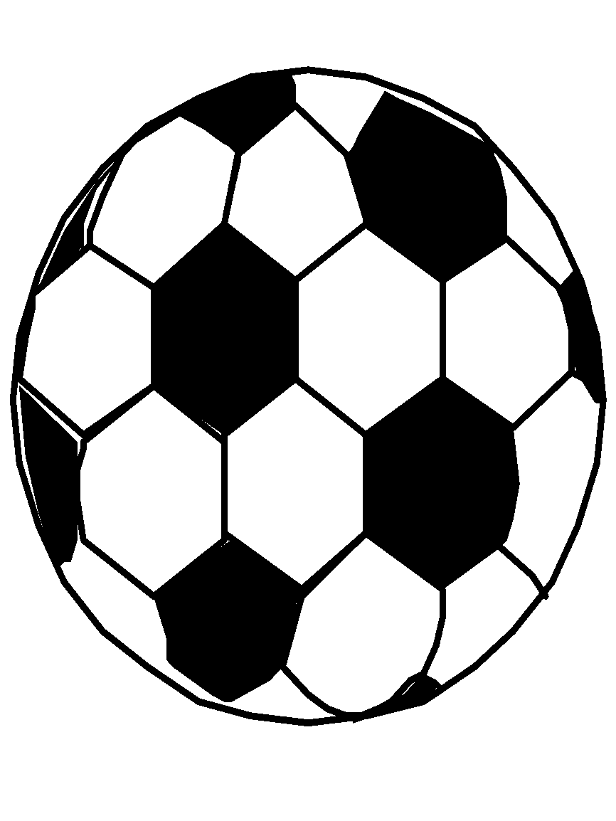  - Identifying numbers 0 – 10  - write numbers in order 0 – 20  - Counting objects and writing numbers 0 – 20.  = 3  = 2  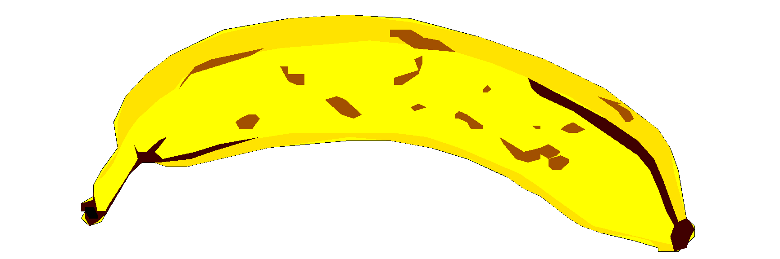 = | Discussion  Explanation  Question and answer | Oral counting  Counting objects and circle  Writing numbers  Count the pictures  Write numbers  0 – 20 | Cards  Objects  Pictures  Printed work  Charts  Exercise books
3 |  | Recognizing describing and representing numbers and their relationships and solving mathematical problems with competence and confidence | I can recognize numerals and enumerate them | Application of quantitative e.g.  Make 4s  4 2 3 =  2 3 4 =  Make 2s  0 2 1 =  Draw pictures for the numbers  4 =  6 = |  | Counting objects  Writing numbers  Matching numbers  Drawing objects of the given numbers  Ticking  Circling  Underline  Ring  Cross | Flash cards  Real objects  Paper work  Exercise books  Pencils  BB
4 |  | Recognizing describing and representing numbers and their relationships and solving mathematical problems with competence and confidence | I can perform activities involving adding. | Arranging numbers in order  0, 1, 2, 3, 4, 5, 6, 7, 8, 9, 10  3, 0, 1, 2 =  3, 2, 1, 0 =  1, 4, 2, 3 =  Filling in the missing numbers  1 ____ 3 _____ 5  6 ____ 8 _____10  0 ____ 2 _____ 4  Write the number after  2 = ______  4 = ______  7 = ______ | Demonstration  Discussion  Explanation  Question and answer | Counting numbers  Writing numbers  Filling in the missing  Arranging numbers in order | Cards  Real objects  Exercise books  Chart  Pencils  BB
5 |  | Recognizing describing and representing numbers and their relationships and solving mathematical problems with competence and confidence | I can add using objects up to 10. | - Introduction of plus sign and equal sign.  - Addition of objects  + =  + =  + =  v v + v v v =  x x x + x = |  | Counting objects and writing numbers  Drawing pictures  Adding pictures | Flash cards  Real objects  Counters e.g. sticks and bottle tops
 |  |  |  | Addition of objects 6 – 10  \ \ \ + \ \ \ \ = \ \ \ \ \ \ \  O O O + O O O =  C C C C + C C = 6 |  | Oral work  Counting following proper sequence  Adding pictures  Drawing pictures | Real objects  Pencils  Blackboard  Paper work  Exercise books
6 |  | Recognizing describing and representing numbers and their relationships and solving mathematical problems with competence and confidence | I can add objects with numbers up to 10 | - Introducing addition of numbers using pictures.  Δ Δ + Δ Δ = Δ Δ Δ Δ  2 + 2 = 4  b b b + b b = b b b b b  3 + 2 = 5  Δ Δ + Δ = ___  ___ + ___ = ____  Add these  d d + d = ddd  2 + 1 = 3  c c c + =  3 + 0 = | Explanation  Demonstration  Discussion  Question and answer | Oral work  Counting following proper sequence  Adding of pictures  Drawing pictures  Count the pictures | Real objects  Pencils  BB illustrations  Paper work  Exercise books
7 |  | Recognizing describing and representing numbers and their relationships and solving mathematical problems with competence and confidence | I can add things and numbers up to 10. | Addition of numbers with balls 0 – 10  2 + 3 =  3 + 3 =  1 + 1 =  Addition of numbers  2 4 1  +2 + 1 + 0  __ ___ ___ | Explanation  Discussion  Question and answer | Oral work  Counting following proper sequence  Adding picture  Drawing pictures | Real objects  Pencils  BB illustrations  Paper work  Exercise books
8 |  | Recognizing describing and representing numbers and their relationships and solving mathematical problems with competence and confidence | I can show relations among things/numbers in a serial order. | Circle the greater number  Tick, ring, cross, underline  4 2  Finding the less number  7 10 | Demonstration  Explanation  Question and answer | Practical work using objects  Identify and show the greater / less number | Printed paper work  Blackboard
9  10 |  | Recognizing describing and representing numbers and their relationships and solving mathematical problems with competence and confidence | I can perform activities involving adding and taking away.  I can recognize and add numbers. | Write the number before;  _____ 2  _____ 6  _____ 3  _____ 1  Revision of after  Write the number after  1 _____  0 _____  5 _____  Write the number between  3 ____ 5  4 ____ 6  1 ____ 3  Add these  3 + 1 =  1 + 1 =  3 4 0  + 3 + 1 + 0  __ ___ ___ | Explanation  Discussion  Demonstration  Question and answer | Writing the number after  Writing the number before  Identify the number  Writing the number between | Number  Chart  Cards  Counters  Exercise books  Pencils
11 |  | Surveying, knowing and distinguishing the attributes of objects. | I can collect objects according to stated features. | Read and match to the shape  A rectangle  A circle  A star  A square  A triangle  An oval | Demonstration  Explanation | Matching  Drawing  Naming  Identify the shapes  Write names for the shapes
SCHEME OF WORK FOR NUMBERS FOR TOP CLASS TERM II 2016
LEARNING AREA: DEVELOPING AND USING MATHEMATICAL CONCEPTS IN MY DAY TODAY EXPERIENCES
WK | PD | LEARNING OUTCOME | COMPETENCE | Content / suggested development al activities | METHODS | ACTIVITIES | INSTRUCTIONAL MATERIALS | REF | RM
1 |  | Surveying, knowing and distinguishing the attributes of objects. | I can identify relationship and differences between different objects and shapes | - Read and draw  A circle A square  A star An oval  Rectangle Triangle  Zig zag Kite | Explanation  Discussion  Demonstration  Question and answer | Reading  Drawing | Real objects  Cut out of shapes  Paper work  Exercise books and pencils  Blackboard
 |  |  |  | Name the shapes  Read and match  Circle  Star  Oval  Cone  Modeling the shapes  Pasting shapes with torn papers/ cereals  Painting / tearing the shape | Explanation  Discussion  Demonstration  Question and answer | Naming shapes  Identifying | Real objects  Cut out of shapes  Paper work  Exercise books and pencils  Blackboard
2 |  | Surveying, knowing and distinguishing the attributes of objects. | I can identify relationship and differences between different objects and shapes | Find the missing letters of the shape names  sq___re  cir___le  train___le  ov___l  re___tangle  zi___ zag  s___ar  Making patterns using the shapes  Forming objects using the patterns e.g. house, boat, girl, car | Explanation  Discussion  Demonstration  Question and answer  Ticking  Underlining  Circling  Crossing | Naming shapes | Real objects  Cut outs of shapes  Paper work  Exercise books and pencils  Blackboard
3 |  | Recognizing describing and representing numbers and their relationships and solving mathematical problems with competence and confidence | I can recognize numbers 1-20 | - Counting numbers 0 – 30 orally  1, 2, 3, 4, 5, 6, 7, 8, 9, 10, 11, 12, 13, 14, 15, 16, 17, 18, 19, 20, 21, 22, 23, 24, 25, 26, 27, 28, 29, 30  Copying numbers  Find the missing number  - Write numbers 0 – 30  0, 1, 2, ….., 4, ……, 6, …., 8, 9, …….11, 12, ….., 14, 15, ………20, 21, 22, … 24…, 26, ……28, 29, ……  Finding the next number using what number comes just after  13, ___,  1 5, ___,  17, ___, etc  What number comes before  ____21  ___, 29  ____, 14 | Explanation  Discussion  Demonstration  Question and answer | Counting numbers  Writing numbers  Subtract numbers  Identifying the numbers  Arrange the number | Flash cards  Real objects  Books and pencils  Work cards  Blackboards  Calendars
4 |  | Recognizing describing and representing numbers and their relationships and solving mathematical problems with competence and confidence |  | Number rhyme / song involving subtraction  Take away using objects  c c c c c = 3  a a a a a =  o o o o o =  ΔΔΔ =  Take away involving numbers  ΔΔΔΔΔ  5 – 1 = 4  O O O O  4 – 2 = 2  V V V  3 – 0 = 3  - Take away  O O O O O =  ____ - ___ =  =  ___ - ___ =  3 ^{OOO} 2^{OO} 5 /////  - 2 - 0 - 5  __ ___ ___ | Explanation  Discussion  Demonstration  Question and answer | Subtracting objects  Subtracting numbers  Drawing objects  Counting correctly  Writing correctly  Count the objects  Draw objects  Write the number correctly | Flash cards  Real objects  Books and pencils  Work cards  Blackboard
5 |  | Recognizing describing and representing numbers and their relationships and solving mathematical problems with competence and confidence | I can count, add and takeaway things up to twenty | Reciting a number rhyme involving additon Adding three addend numbers  1 + 1 + 1 = 3  4 + 2 + 4 =  3 + 1 + 2 =  6 + 3 + 1 =  4 + 1 + 2 =  5 + 2 + 4 =  3 + 3 + 3 =  Adding vertically  3 5 4  3 2 2  +1 + 6 + 1 | Explanation  Discussion  Demonstration  Question and answer | Counting  Adding numbers  Drawing counters e.g. balls  Arranging numbers  Writing numbers correctly | Flash cards  Counters  Books  Charts  Real objects  Exercise books and pencils  Blackboard
6 |  | Recognizing describing and representing numbers and their relationships and solving mathematical problems with competence and confidence | I can show relations among things in cereal order | - Use of full, empty, half, more, less  ______ ______ _______  - Read and match  full  empty  half  -  Less  B A  Which tin has less water?  Tin ___ has less water than tin ____.  K F  Which tin has more milk?  Tin F has more milk than tin K. | Discussion  Demonstration  Question and answer | Reading words  Drawing pictures  Filling containers with water  Matching correctly  Identify tines  Comparing  Writing words  Underline, circle, ring, tick, cross | Flash cards  Counters  Books  Charts  Real objects  Exercise books and pencils  Blackboard
 |  | Recognizing describing and representing numbers and their relationships and solving mathematical problems with competence and confidence |  | Comparing the length of objects  New words:  Short, shorter, shortest  Long, longer, longest  N T    Pencil ____ is shorter than pencil _____.  B C    Tree _____ is longer than tree ______. | Explanation  Discussion  Question and answer  Comparison | Finding length of objects using strings in group.  Identifying objects  Draw objects  Writing statements | Real objects  Flash cards  Black board  Illustration  Exercise books and pencils
 |  | Recognizing describing and representing numbers and their relationships and solving mathematical problems with competence and confidence |  | - Comparing of heights using different objects .  Use of tall, taller, tallest  Mary Sarah     Tall taller tallest  ______ is taller than _____.  - Use of short, shorter, shortest  Z B    Tree ______ is shorter than tree _______. | Demonstration  Explanation  Question and answer | Use of tall, taller and tallest  Use of short, shorter and shortest  Finding heights of objects using strings  Drawing  Comparing  Identifying  Writing  Naming | BB illustration  String  Paper work  Pictures  Meter rulers  Exercise books and pencils
7 |  | Recognizing describing and representing numbers and their relationships and solving mathematical problems with competence and confidence | I can tell more equal less quantities | Finding the greater number 8, 3, 4, 7  10, 2, 3, 1  Finding the less number  4, 2, 1, 6  3, 7, 6, 5 | Explanation  Demonstration  Question and answer | Finding the greater number  Finding the less number | Cutout of numbers Exercise books and pencils  blackboard
8 |  | Recognizing describing and representing numbers and their relationships and solving mathematical problems with competence and confidence | I can show one to one correspondence | - Introducing number words  Zero – ten  Zero, one, two, three  - Matching words to figures  Zero 8  One 7  Two 6  Three 5  Four 0  Five 1  Six 2  Seven 3  Eight 4  - Read and draw the beads  one two  Read and draw pictures  one =  three cats  two balls =  four cups =  six stones =  five brooms =  eight chairs =  seven apples = | Explanation  Discussion  Question and answer | Reading words  Matching words to figures  Drawing pictures for the number words  Writing for numbers  Count and write in words | Real objects  Flash cards  Black board  Illustration Exercise books and pencils
9 |  | Recognizing describing and representing numbers and their relationships and solving mathematical problems with competence and confidence | I can show one to one correspondence |   Count and write numbers in words  = ……ballls  = …….trees  = ….sweets  = …..book  = ……..baskets | Explanation  Discussion  Question and answers  Demonstration | Reading words  Counting objects  Drawing pictures  Identifying the words | Real objects  Flash cards Exercise books and pencils  Blackboard
10 |  | Recognizing describing and representing numbers and their relationships and solving mathematical problems with competence and confidence | I can show one to one correspondence | Addition of number words  Three and two is five  3 + 2 = 5  Six and four is ……..  Five and one is …….  Three and nine is ……  Two and two gives  Five plus two equals…  Two bananas plus one banana equals…..bananas | Explanation  Discussion  Question and answers | Reading words  Counting objects | Real objects  Flash cards Exercise books and pencils  Blackboard

SCHEME OF WORK FOR NUMBERS FOR TOP CLASS TERM III 2016
LEARNING AREA: DEVELOPING AND USING MATHEMATICAL CONCEPTS IN MY DAY TODAY EXPERIENCES
WK | PD | THEME  LEARNING OUT COME | COMPETENCE | SUGGESTED DEVELOPMENTAL ACTIVITIES | METHODS | ACTIVITIES | INSTRUCTIONAL MATERIALS | REF | RM
1 | 1 to 5 | Recognizing  Describing and representing numbers and their relating and solving mathematical problems with competence and confidence | I can count , add and take away things up to 10 | Revision of addition of numbers both horizontally and vertically Addition of 3 addends  6 + 1 + 0 =  2 + 1 + 1 =  4 + 0 + 2 =  4 6 2  1 1 1  +2 +0 +1  ____ ____ _____  Revision of subtraction of numbers both horizontally and vertically  4 - 1 =  3 – 0 =  7 – 4 =  5 4 6  - 2 - 0 - 2 | -Explanation  -Illustration  - Question and answer  Finding less | - counting numbers  - Writing numbers  - Finding correct answers by adding and subtracting  - Addition  Subtracting | Counters  -Chalkboard  - Books  -Pencils  - Charts  -Flashcards
2 |  | Recognizing , describing and representing numbers and their relating and solving mathematical problems with competence and confidence | I can tell more, equal and less quantities | Identifying the operation used to find the correct answer.  Circle the greater numbers  Ring the less numbers  Finding the answer using balls  8⁰⁰⁰⁰⁰⁰⁰⁰ 2⁰⁰  4 7  10 2  -Ring the less number  4  6  9 | -Explanation  -Discussion  - discovery  -Question and Answer | Writing numbers  Finding the less numbers  Ring the greater number  Finding the answer  Showing the operation used  Counting  Using ticking, circling, ringing, underlining, crossing | Objects  Work cards  Counters
3 |  | Recognizing , describing and representing numbers and their relating and solving mathematical problems with competence and confidence | I can show one to one correspondence | Introducing number words zero – ten  Zero, one, two, three  Writing numbers for the words  -Matching word to numbers  Zero 2  One 3  Three 0  Two 1  -Read and draw beads  Zero = One =  Four = Three =  -Read and draw  Two tins =  Four cups =  Three cats =  -Count and write in words  = three balls  = four sticks  = two chairs | -Explanation  -Discussion  -Questions and answers  Demonstration | -Matching  - Drawing  -Circling  Writing  Ticking  Underline  Ringing  Finding  Identifying | -Flashcards  -Charts  -BB  Paper work  Exercise books and pencils
4 | 1 to 5 | Recognizing describing and representing numbers and their relating and solving mathematical problems with competence and confidence | I can show one to one correspondence | reading word statements with addition  Three plus two equals five  One plus one equals two  Two plus one equals three  Plus means add  Equals means all  Put together | Explanation  Discussion  Discovery  Practical method | Reading and understanding the statements  Understanding the operation used  Writing the statements  Counting the drawn balls  Finding the answers | Counters  Real objects  Blackboard  Books and pencils
5 |  | Recognizing describing and representing numbers and their relating and solving mathematical problems with competence and confidence | I can represent numbers for number words | Identifyign figures for words  Drawing balls  Counting balls  Writing words for the numbers  Finding the answers  Three plus one equals four  3 + 1 = 4  One plus one equals two  1 + 1 = 2  Zero plus one equals one  0 + 1 = 1 | Discussion  Explanation  Question and answer  Interpretation | Reading and comprehending the statements  Adding and finding the answers  Drawing balls for the number words | Counters  Real objects  Chalk board
6 |  | Recognizing describing and representing numbers and their relating and solving mathematical problems with competence and confidence | I can show one to one correspondence | Reading and understanding of new words  Plus Altogether  Colected Joined  Put together  How many?  Reading and interpreting the statements correctly  Writing the words correctly  Counting and adding numbers to find the answer  Daddy has a hen  Mum has three hens  How many hens do they have altogether?  1 + 3 = 4  They have four hens | Explanation  Question and answer  Discussion  Interpreting statements  Illustrating the context read with pictorial work | Finding sums using the number words  Adding numbers  Counting  Identifying  Drawing | Real objects  Counters  Blackboard  Books and pencils
7 | 1  To  5 | Recognizing describing and representing numbers and their relating and solving mathematical problems with competence and confidence | I can tell more and less quantities  I can show one to one correspondence | Identifying the less number  e.g. Circle/ cross/ tick/ underline the less number  7 3  1 9  6 2  Reading new words to represent (-)  Take away, remain broken, fell down, flew, away, left, how many?  Read and interpret the short stories.  Draw balls and cross the less number  Identify numbers for words  Musa had 3 cows  He gave 2 cows to Ali. How many cows remained?  3 – 2 = 1  One cow remained. | Explanation  Discussion  Discovery  Practical  Question and answer  Story telling | Writing numbers  Drawing balls for the numbers  Circle the less numbers etc  Reading stories  Drawing balls  Crossing the balls for the less numbers  Interpreting the story | Chalk board  Counters  Books and pencils  Number work cards  Blackboard  Books and pencils  Counters  Number work cards
8 | 1 to 5 | Recognizing describing and representing numbers and their relating and solving mathematical problems with competence and confidence | I can subtract and tell the difference between numbers | identifying the answers  identifying the less number  subtracting the less number from the gtreater number  Find the answer  3 + = 7  7 – 3 = 4 | Explanation  Illustration  Discussion  Discovery  Questions and answer | Identifying the greater and less numbers  Subtracting the less number from the greater number  Drawing balls  Crossing balls for the less number  Finding the answer to be put in the box | Counters  Blackboard  Plain papers  Pencils  Books and pencils  Number work cards
8 | 1 to 5 |  | I can count add and take away things up to 10 | Revision of subtraction of numbers both horizontally and vertically  7 – 3  7  – 3 | Explanation  Illustration  Discussion  Discovery  Questions and answer | Drawing balls  Crossing balls for less number  Finding the answers | Books and pencils  Blackboard  Number work cards
9 |  | Comparing and ordering things according to different attributes | I can show relations among things in serial order | Comparing and sorting objects into two groups basing on a particualr criteria  big / small  tall / short  hard/ soft  half/ full  rough / smooth  loud/ soft  long/ short  wide/ narrow  heavy / light etc  Arranging several thhings in order along some dimensions and dscribing relationship e.g.  long – longer – longest  big – bigger – biggest  Small – smaller – smallest  Note: You can include any revision of concept that seemed difficult for the pupils | Group work  Discovery  Explanation  Illustration  Question and answer  Practical method  Demonstration | Comparing objects in the environment  Drawing pictures  Filling containers  Measuring using different dimensions  Sorting  Matching  Arranging things in order  Describing the relations | Use of class and environment  Containers  Ropes and strings  Books pencils  Papers etc  Rulers
10 | 1 to 5 | Understanding and using the concept of time | I can describe sequence of events by telling the time | 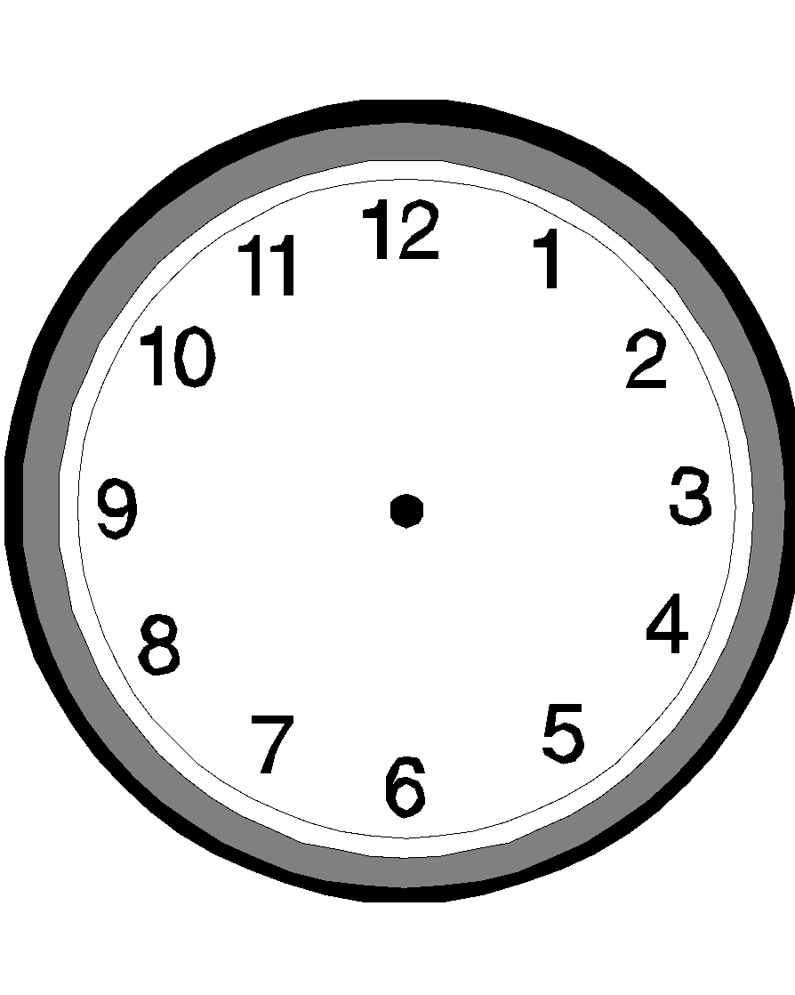  Telling the daily routine activities  Role playing of daily routine activities  Describing things I do before and after an action  Reciting rhymes about time  Naming days of the week  Naming months of the year  Observing and talking about the clock face  Telling the use of the clock face  Telling the use of time, hands of clock face (long and short hand)  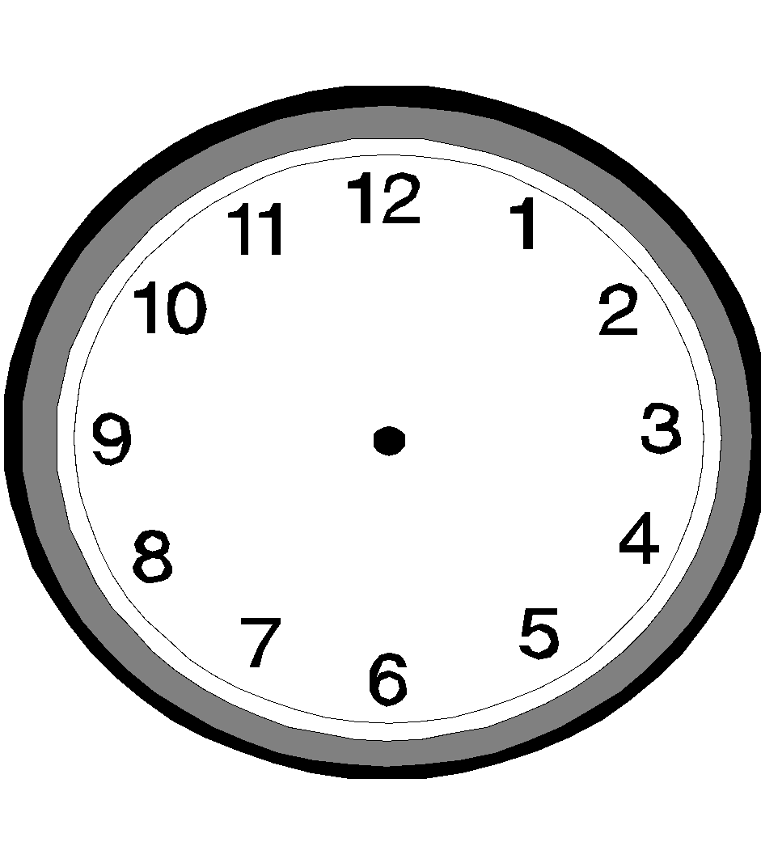  Showing and telling time on a clock face  e.g.  it is _______o’clock  it is _____o’clock  It is _____o’clock  drawing clock faces  play – lets about time  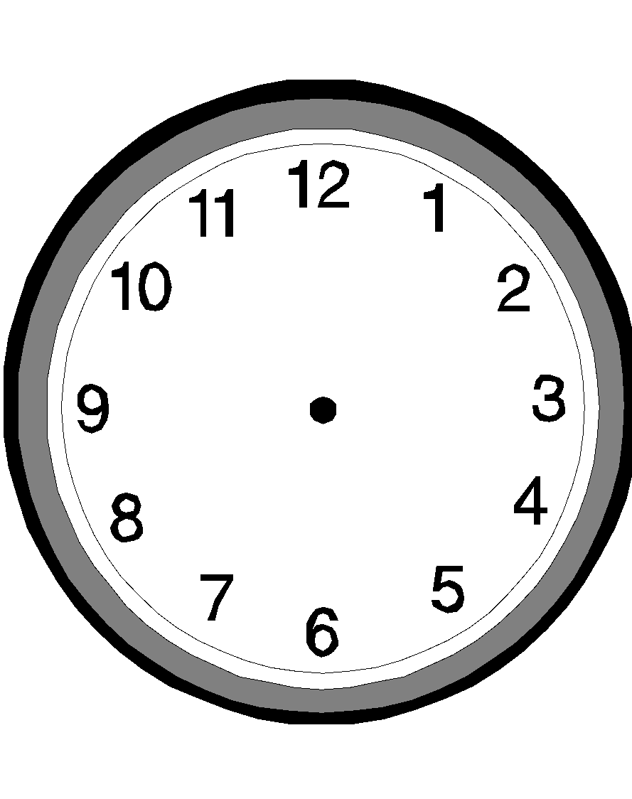  showing time  It is 4 o’clock  It is 11 o’clock | Explanation  Discussion  Question and answer  Illustration  Demonstration  Role play | Reciting rhymes  Discussion of proper sequence of activities done for each day, month, year  Naming days of the week  Naming months of the year  Talking about the clock faces  Identifying the use of the two hands  Showing time of drawn clock faces  Writing the time shown on clock faces | A clock face  Chalkboard  Exercise books  Pencils
11 | 1 to 5 |  | Have many revision exercises for this week | Play many number games e.g dominoes, jigsaws, lotto etc  Inlcude singing of number songs, reciting of rhymes, constructing , modelling , drawing  Shapes  Tearing, cutting, threading, building, measuring shouldn’t be be neglected  Following direction to move or place self within class room e.g. at the back between at the front

