KIBOGA PROGRESSIVE SECONDARY SCHOOL
Uganda Advanced Certificate of Education
S.5 BIOLOGY
PAPER 2
2 HOURS 30 MINUTES

INSTRUCTIONS TO CANDIFDATES:
- This paper consists of sections A and B.
- Answer question one in section A plus three questions from section B.
- Candidates are advised to read the questions carefully, organize their answers and present them precisely and logically, illustrating with well labeled diagrams where necessary.

SECTION A (40 MARKS)
Question 1 is compulsory

1. Figure 1 shows the effect of temperature variation on the rate of photosynthesis and respiration in leaves of the same plant. The given adequate amounts of light with other factors kept constant.
Figure 2 shows the effect of temperature variation on the amount of carbon dioxide absorbed by two plant species; A and B. Plants A and B each uses a different carbon dioxide fixation pathway.
Study the two figures and answer the questions that follow.
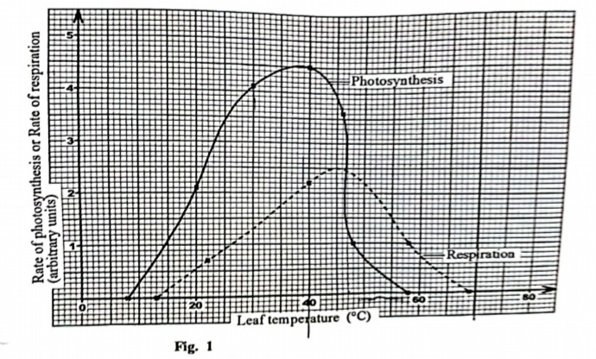
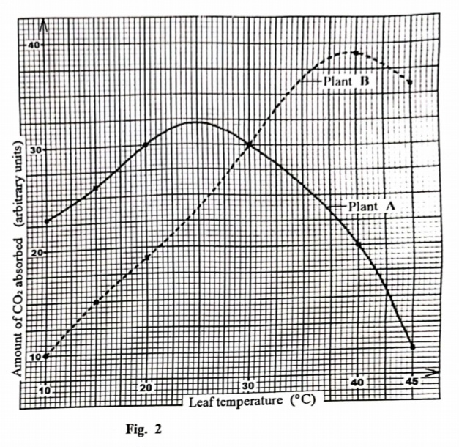
- From figure 1:
- Describe how the rate of photosynthesis varies with temperature of the leaf. (04 marks)
- Explain how the rate of respiration varies with temperature of the leaf. (05 marks)
- Explain the difference in the rates of photosynthesis and respiration between leaf temperatures of 40ºC and 70ºC (08 marks)
- Explain the relationship between respiration and photosynthesis. (04 marks)
- Compare the amounts of carbon dioxide absorbed by each of the two plants A and B in figure 2 (07 marks)
- From figures 1 and 2, suggest the plant species whose rate of photosynthesis was studied in figure 1. Give reason(s) for your answer. (04 marks)
- Explain any two other factors that can affect the rate of photosynthesis. (04 marks)
- Describe how carbon dioxide from the atmosphere is fixed in the bundle sheath cell. (04 marks)

SECTION B (60 MARKS)
Answer any three questions from this section.
Any additional question(s) answered will not be marked.

2 (a). Describe the structure of haemoglobin molecule (04 marks)
(b) .Explain why the affinity of haemoglobin for oxygen increases when it already possess oxygen molecule. (04 marks)
(c).State how the oxygen dissociation curve for myoglobin is related to that of haemoglobin and point out the physiological significance of this relationship (05 marks)
(d).Explain how each of the following affects the efficiency of oxygen transport in living organisms
(i). Increasing carbon dioxide tension (04 marks)
(ii). Increasing carbon monoxide concentration (03 marks)

3 (a).Explain how stomata opening occur according to;
(i). Starch-sugar inter-conversions (08 marks)
(ii).Photosynthetic theory (06 marks)
(c).Briefly explains factors that affect the rate of gaseous exchange at the respiratory surfaces of organisms (06 marks)

4 (a). Describe the process of swallowing food in humans. (07 marks)
(b) Explain the role of gastric juice during food digestion in adult humans (06 marks)
(b).How is the ileum adapted to its function of absorption of food (07 marks)

5 (a). With examples, discuss the mode of action of hormones (12 marks)
(b). How is the secretion of aldosterone controlled (08 marks)

6 (a). Describe what happens to the end product of glycolysis during
i) Lactate fermentation (04 marks)
ii) Alcohol fermentation (06 marks)
b) Describe the significance of Kreb’s cycle (05 marks)
c) How is oxidative phosphorylation different from photo phosphorylation? (05 marks)
THE END
@Dr BAM
MERRY X-MASS AND HAPPY NEW YEAR 2025

