Students Name: …………………………………………………………………
School Name:…………………………………… Index Number ……………
612/1
FINE ART
PAPER 1
Nov/Dec 2020
2 ½ Hours
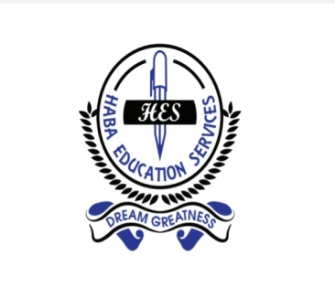
HES MOCK EXAMINATIONS 2020
UGANDA CERTIFICATE OF EDUCATION
FINE ART
IPS ART AND CRAFTS
STUDIO TECHNOLOGY
PAPER 1
2 hours

INSTRUCTIONS:
Answer all the questions
Drawing and diagrams should be used where necessary.
Credit will be given for their explanatory value

- (a) Define the term studio as used in art? (1 mark)
(b) Name any 3 disciplines of art? (3 marks)
(c) Mention any 4 studio etiquettes (4 marks)
- (a) What is a motif? (2 marks)
(b) Describe the procedure of relief printing. (6 marks)
- (a) What is balance? (2 marks)
(b) Describe the different forms of balance (6 marks)
- (a) What is rhythm (2 marks)
(b) Explain the methods of creating rhythm (6 marks)
- (a) What is sculpture? (2 marks)
(b) What are the different types of relief sculpture? (6 marks)
- Of what importance is basketry production in your community (8 marks)
- (a) What is puppetry? (2 marks)
(b) Give any three types of joints used puppetry (3 marks)
- (a) What is weaving (2 marks)
(b) Using illustrations explain the following weave structures
- Turkish knot (2 marks)
- Twill 3 x 1 (2 marks)
- Twill 2 x 2 (1 marks)
- Explain any three methods of fabric decoration (8 marks)
- What is the importance of using clay as a production material for sculpture as a beginner (6 marks)
END

