BEGINNING OF TERM II 2018 EXAM
S.3 COMPUTER
PAPER TWO
TIME : 1 HOUR 15 MINUTES
Answer ALL questions
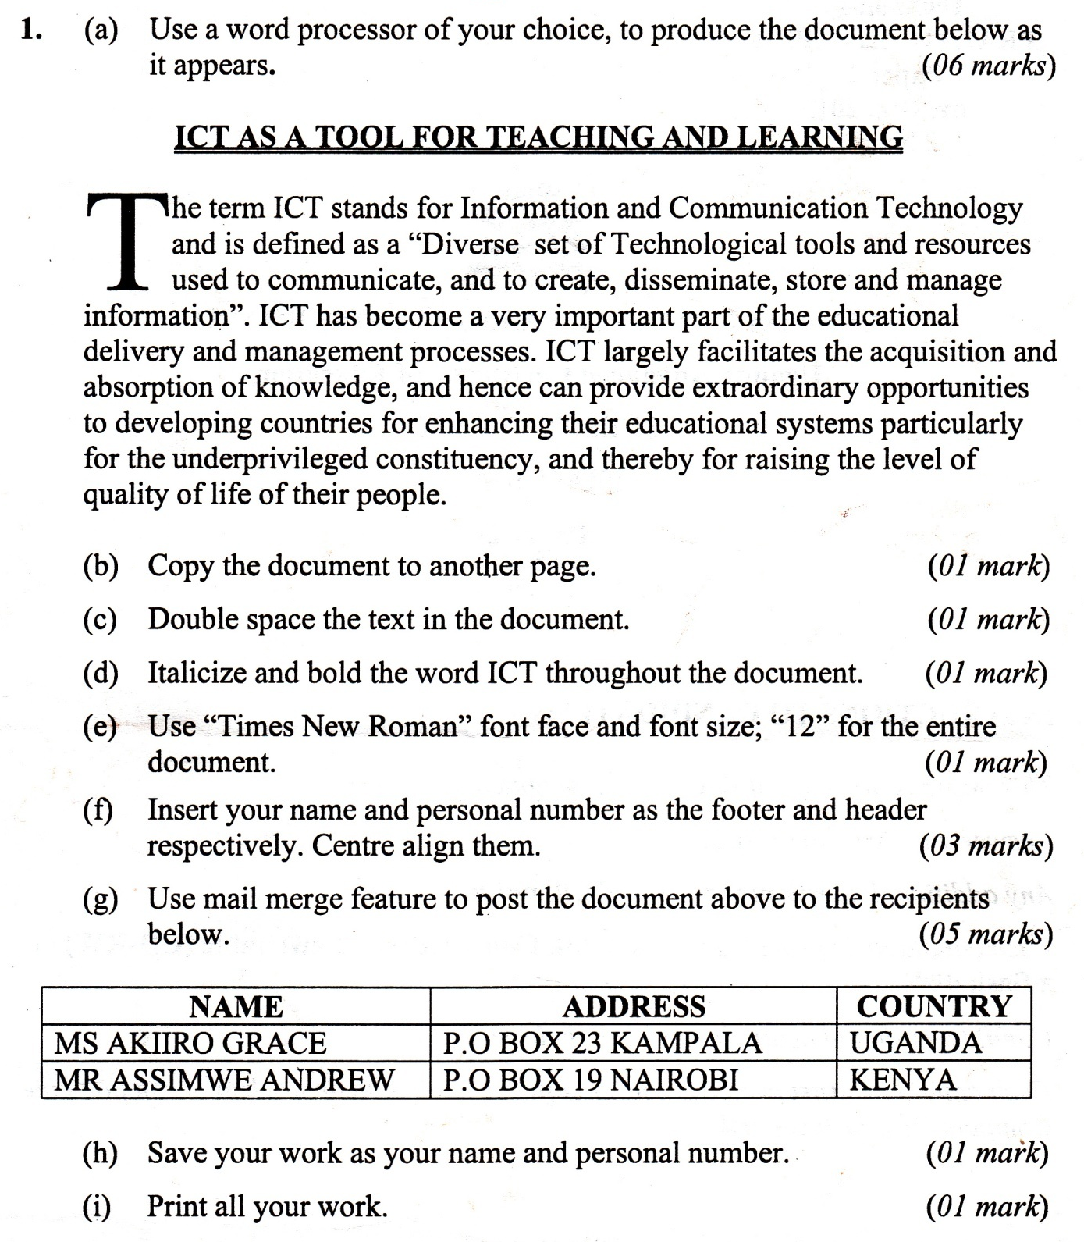

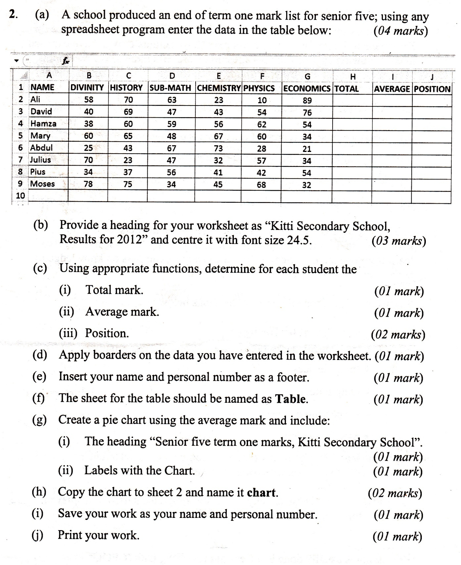

END

