BEGINNING OF TERM I 2018
S.3 BIOLOGY
553/1
TIME :2½ HOURS

NAME: ......................................................................................... STREAM:.....................

INSTRUCTIONS
- Attempt ALL questions in section A and B
- Answers to section A must be filled in the appropriate column in table 1 below.
- Answers to section C must be written on a separate answer sheet.
- Attempt only two questions in section C

TABLE FOR SECTION A
Qn. | Alternatives |  |  |  |  | Qn. | Alternatives
Qn. | A | B | C | D |  | Qn. | A | B | C | D
1 |  |  |  |  |  | 16
2 |  |  |  |  |  | 17
3 |  |  |  |  |  | 18
4 |  |  |  |  |  | 19
5 |  |  |  |  |  | 20
6 |  |  |  |  |  | 21
7 |  |  |  |  |  | 22
8 |  |  |  |  |  | 23
9 |  |  |  |  |  | 24
10 |  |  |  |  |  | 25
11 |  |  |  |  |  | 26
12 |  |  |  |  |  | 27
13 |  |  |  |  |  | 28
14 |  |  |  |  |  | 29
15 |  |  |  |  |  | 30

SECTION A

- Which one of the following insects belongs to order dipteral?
- Cockroach B. Mosquito
- Honey bee D. Termite

- Which one of the following organisms carries out photosynthesis?
- Paramecium B. Amoeba
- Rhizopus D. Spyrogyra

- 20cm³ of soil was added to 20 cm³ of water in a measuring cylinder. After stirring the final volume of the mixture was 30 cm³. Calculate the percentage air content of the soil sample.
- 50% B. 10%
- 25% D. 33%

- Which one of the following cells of the ovule fuses with the male nucleus to form the endosperm of the seed?
- Antipodal cell B. Ovum or egg cell
- Secondary nucleus D. Synergid cell

- Which one of the following insects does not under go complete metamorphosis?
- Cockroach B. House fly
- Honey bee D. Mosquito

- The process by which nitrogen is lost to the atmosphere is known as;
- Nitrification B. Putrification
- Nitrogen fixation D. Denitrification

- Which one of the following plant structures is used to conduct water and mineral salts?
- Xylem B. Phloem
- Cortex D. Epidermis

- Which one of the following farming practices is used to prevent soil erosion on steep slopes?
- Mulching
- Terracing
- Growing cover crops
- Crop rotation

- Which of the following plant species have leaves that store food for the plant?
- Cassava
- Onions
- Potatoes
- Beans

- Which one of the following organisms belongs to class arachinida?
- Spider
- Centipede
- Crab
- Locust

- Which of the following layers of a dicot leaf has a lot of air circulation?
- Upper epidermis
- Lower epidermis
- Palisade mesophyll
- Spongy mesophyll

- Which one of the following insects is the vector for the filarial worm?
- Aedes mosquito B. Culex mosquito
- Tsetse fly D. Anopheles mosquito

- Which one of the following fruits is an example of a schizocarp?
- Tridax B. Bean
- Desmodium D. Bidens

- Which one of the terms below means placing food into the mouth of an organism?
- Absorption
- Ingestion
- Assimilation
- Egestion

- Which part of the drupe is succulent and edible?
- Epicarp
- Endo carp
- Mesocarp
- Seed

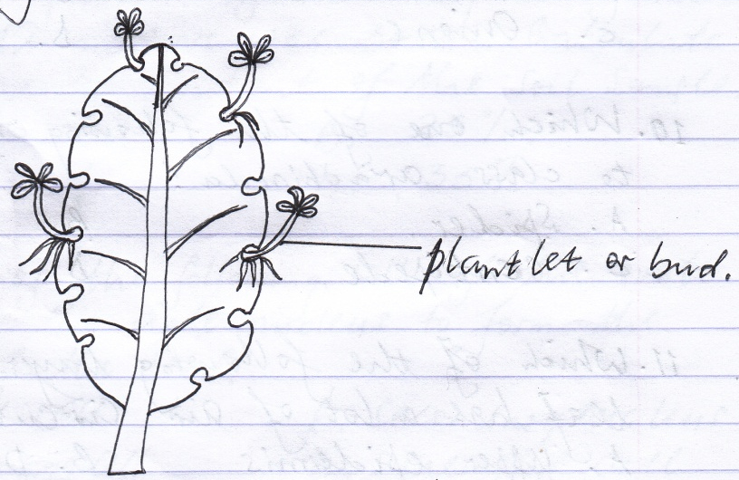
- The diagram below shows a plant leaf, the features labeled on the leaf show that it is used for;

- Propagation
- Support
- Photosynthesis
- Food storage

- Which of the following is not a major feature of a plant leaf?
- Lamina
- Leaf base
- Petiole
- Apex

- Which of the following is not a correct characteristic of insects?
- Possess three main body parts
- Possess a segmented abdomen
- Possess a pair of antennae
- They possess 6 pairs of legs

- The most destructive stage in the life cycle of a butterfly is;
- Eggs
- Pupa
- Larva
- Imago

- Which one of the following is not a major feature of all plant stems?
- Leaves B. Nodes
- Internodes D. Buds

- Which of the following is a correct pair of parts that form the androecium of a flower?
- Stigma and style
- Style and anthers
- Anthers and filaments
- Stigma and filaments

- Double fertilization occurs in flowers when;
- Male nucleus fuses with secondary nucleus
- Male nucleus fuses with egg cells
- Male nuclei fuse with ovum and secondary nucleus
- Male nucleus fuses with two synergid cells

- Which of the following food nutrients is used to generate heat in the body?
- Carbohydrates
- Vitamins
- Proteins
- Lipids

- Which of the following is not a reducing sugar?
- Sucrose
- Glucose
- Maltose
- Fructose

- Which of the following laboratory reagents is used to test for vitamin C?
- DCPIP
- Benedict’s solution
- Iodine
- Millon’s reagent.

- Which of the following soil samples has the highest drainage rate?
- Loam soil B. Sandy soil
- Clay soil D. Silty soil

- Fruits that dehisce along two satures are known as;
- Follicles
- Capsules
- Schizocarps
- Legumes

- Which of the following Biological processes removes carbon dioxide from the atmosphere?
- Combustion
- Photosynthesis
- Respiration
- Denitrification

- A fruit that developes from a flower where the calyx persists to form hooks is;
- Cypsela
- Caryopsis
- Samara
- Schizocarp

- Which of the following forms the hardest layer of the mammalian tooth?
- Cement
- Dentine
- Pulp cavity
- Enamel

SECTION B
Answer ALL questions in this section

- The table below shows the different rates of soil erosion in different vegetation cover. Over a given catchment area of steep slopes. Study the data and use it to answer the questions which follow:

Vegetation type (cover) | Rate of soil erosion (tones / year)
Forest cover | 03
Maize plantation | 15
Sweet potato cover | 07
Cassava plantation | 18
Pasparam cover | 06
Bare ground | 30

- Which type of vegetation cover has;
- Lowest rate of erosion. (01 mark)

...................................................................................................................................
- Highest rate of erosion. (01 mark)

...................................................................................................................................
- Give one reason to support each of your answers given in (a) above.
(02 marks)
- Reason for lowest rate of erosion.

...................................................................................................................................
...................................................................................................................................
...................................................................................................................................
...................................................................................................................................
- Reason for highest rate of erosion.

...................................................................................................................................
...................................................................................................................................
...................................................................................................................................
...................................................................................................................................
- (i) Compare the rate of soil erosion in the maize plantation and sweet
potato cover. (02 marks)

...................................................................................................................................
...................................................................................................................................
...................................................................................................................................
(ii) Give an explanation for the difference in the rates of erosion given in (c) (i) above. (02 marks)

...................................................................................................................................
...................................................................................................................................
...................................................................................................................................

- (i) Compare the rate of soil erosion in the cassava plantation and pasparam
cover. (02 marks)

...................................................................................................................................
...................................................................................................................................
...................................................................................................................................
(ii) Give an explanation for the difference in the rates of erosion given in (d) (i) above. (02 marks)

...................................................................................................................................
...................................................................................................................................
...................................................................................................................................
- List down (4) agents that accelerate the rate of erosion on bare ground.
(04 marks)
...................................................................................................................................
...................................................................................................................................
...................................................................................................................................
...................................................................................................................................
...................................................................................................................................
- State (4) ways in which soil can be conserved on a bare ground area.
(04 marks)
...................................................................................................................................
...................................................................................................................................
...................................................................................................................................
...................................................................................................................................
...................................................................................................................................
- The diagram below shows the longitudinal section of a hibiscus flower. Study it and answer the questions which follow:
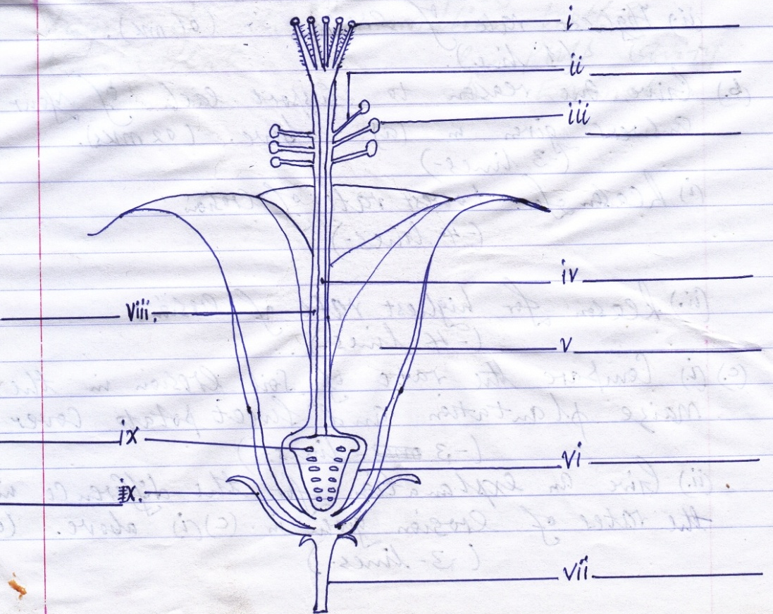

- Name the parts of the flower on the diagram. (05 marks)
- State one function of the following parts of the flower. (05 marks)

- ..............................................................................................................................
(iii) ..............................................................................................................................
(v) ..............................................................................................................................
(vii) ..............................................................................................................................
- ..............................................................................................................................
- (a) Define the seed germination. (01 mark)

...................................................................................................................................
...................................................................................................................................
(b) State the two types of seed germination. (01 mark)

...................................................................................................................................
...................................................................................................................................
(c) State the conditions necessary for seed germination. (03 mark)

...................................................................................................................................
...................................................................................................................................
...................................................................................................................................
(d) Define the term seed dormancy. (01 mark)

...................................................................................................................................
...................................................................................................................................
...................................................................................................................................

(e) State any four causes of seed dormancy. (02 marks)

...................................................................................................................................
...................................................................................................................................
...................................................................................................................................
...................................................................................................................................

(f) State any (2) ways of breaking seed dormancy. (02 marks)

...................................................................................................................................
...................................................................................................................................
...................................................................................................................................
...................................................................................................................................

SECTION C (30 MARKS)
Answer any two questions in this section

- (a) Define the term pollination. (01 mark)
(b) State the characteristics of flowers pollinated by the following agents.
(06 marks)
- Insect pollination
- Wind pollination
(c) State the differences between insect pollinated and wind pollinated flowers.
(08 marks)
- (a) Define seed and fruit dispersal. (01 mark)
(b) State the agents of fruit and seed dispersal. (03 marks)
(c) List down four characteristic features of fruits and seeds dispersed by;
(i) Water
(ii) Wind
- Animals (12 marks)

- Describe the process of digestion of food from the mouth to the ileum. (15 marks)
END

