NAME…………………………………………………..…………..STREAM…………………..
ST THOMAS AQUINAS KAWEMPE
Time: 1 hour
S1 COMPUTER INTERGRATION EXAM
Identify the following ICT tools and their roles (20 marks)
 | ICT TOOL | NAME | role
 | 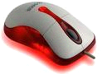 | mouse | Clicking folders on the computer
 | 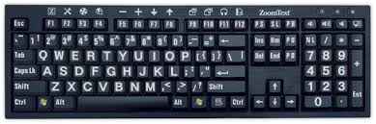
 | 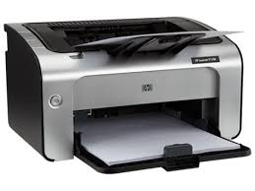
 | 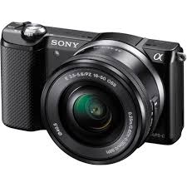
 | 
 | 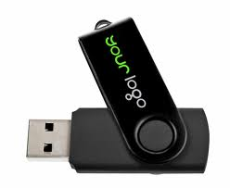
 | 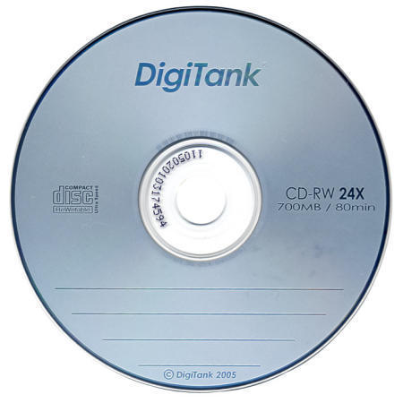
 | 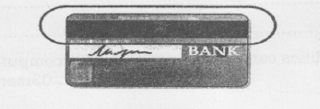
 | 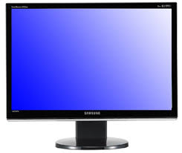
 | 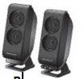
 | 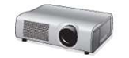

2. Explain one way how ICT tools are used in the following areas (10 marks)
- Home ……………………………………………………………..
- School……………………………………………………………..
- Entertainment……………………………………………………..
- Security ………………………………………………………….
- Hospitals ………………………………………………………….
- Transport ………………………………………………………….
- Agriculture ………………………………………………………..

Show one way ICT tools are helpful in a super market.
……………………………………………………………………………………………………………………………………………………………………………………………………………………….
Explain the function of the following tools in the computer laboratory
Dust blower
Air conditioner

END

