NAME………………………………………………………………………………………………………….SIGN…………………………
ST THOMAS AQUINAS SS KAWEMPE JINJA KALOORI
SENIOR I ICT ACTIVITY 2 2021
1 HOUR
ATTEMPT BOTH QUESTIONS
- In the table below put A to mean allowed on items or activities that are allowed in the computer lab and N to mean not allowed on items or activities that are not allowed in the computer lab.
Two examples have been done for you. (10 marks)
ITEM OR ACTIVITY | A/N
Mineral water
Asking computer related questions
Food | N
Running inside the lab
Mopping the computer lab
Bags
Repairing damaged computers | A
Dismantling computer hardware without teacher’s instructions
Shouting in the lab
Blowing off dust from the computers
Smuggling of flash disks in the lab
Playing games when allowed by the ICT teacher.

- (a) Below is a list of hardware devices. circle on only five devices that Opio can use to store on his music videos at home. (05 marks)
Mouse CD Monitor
DVD Keyboard Tape
VGA Flash UPS
DVD-ROM

(b) How many songs of 8MBs each can the storage device below hold. show your working.
(05 marks)
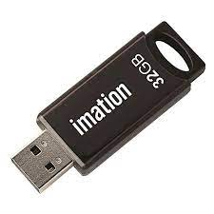……………………………………………………………..

- (a) Match the common desktop hardware with there respective functions .Use a pen(05 marks)

Hardware Function
Mouse Displays images and video output
Keyboard Enables processing of data
Monitor Produces hardcopy output on paper
System Unit Helps to move the cursor on screen
Printer Helps in Typing of words

(b) Here are the steps that take place when starting a computer. Rearrange the steps in the correct order. (05 marks)
(a) Desktop appears after login
(b) Login screen appears
(c) Power on Self-Test (POST) starts
(d) Operating system starts
(e) Welcome screen appears
…………………………………………………………………
…………………………………………………………………
…………………………………………………………………
…………………………………………………………………
…………………………………………………………………

- (a) Use you pencil to show how you would connect the given peripheral devices of a desktop computer properly to make a complete working computer. (05 marks)

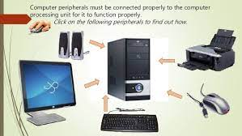

(b) Identify any five apps found on a smartphone. (05 marks)

…………………………………………………………………
…………………………………………………………………
…………………………………………………………………
…………………………………………………………………
…………………………………………………………………

- (a) Answer true or false on the statements in the table below. (05 marks)
Statement | True/False
Digital camera is input device used to take photographs
MS Word is a hardware.
Twitter is an online social networking and blogging service.
Logging off a computer means turning on a computer
Right mouse key opens an item

(b) In the Venn diagram below. in circle RSI indicate two health problems kawooya is likely to get when using a computer for a long period of time.In Circle Solutions, in indicate two solutions to the mentioned heath problems . in the middle oval shape indicate RSI in full. (05 marks)

SOLUTIONS
RSI



END

