GHS
March, 2020
S.3 CHEMISTRY
QUESTIONS ON CARBON AND ITS COMPOUNDS
You are required to read Carbon and its compounds (Carbon dioxide, carbon monoxide, carbonates and hydrogen carbonates) and answer the following questions.
1 (a) (i) Draw a labeled diagram of the set-up of the apparatus that can be used to prepare a dry sample of carbon dioxide in the laboratory.
(ii) Write an equation that leads to the formation of carbon dioxide.
(b) Burning magnesium was lowered into a jar of carbon-dioxide.
- State what was observed.
- Explain the observation in b(i).
(c) Water was added to the product in (b) and the resultant mixture tested with litmus. State what was observed.
(d) When a solution of sodium hydroxide was exposed to air, a white solid was formed on the surface.
- Name the white solid.
- Write an equation to show how the white solid is formed.
2. (a) (i) Draw a labelled diagram to show how carbon dioxide can be prepared in the laboratory.
(ii) Write an ionic equation for the reaction leading to the formation of carbon dioxide
(b) Carbon dioxide was passed through calcium hydroxide solution. Describe and explain the reaction that took place.
(c) (i) State what would be observed if burning magnesium ribbon was lowered into a jar of carbon dioxide.
(ii) Write equation for the reaction that takes place in (c) (i).
3.(a) (i) Define the term allotropes.
(ii) Name one example of an element that shows allotropy other than carbon.
(b) (i) Give the allotropes of carbon.
(ii) State two properties of one of the allotropes of carbon you named in (i)
(iii) Explain how the allotrope is used due to its properties named in (b) (ii) above.
4. Element X belongs to group II in the periodic table.
- Write the formula of the carbonate of X.
- The carbonate of X was heated strongly until no further change.
- Write the equation for the reaction.
- Name one reagent which can be used to identify the gaseous product.
- The residue in (b) was added to excess dilute nitric acid and warmed.
- State what would be observed.
- Write the equation for the reaction.
5. The figure below shows an experimental setup to investigate the effect of heat on lead (II) carbonate.

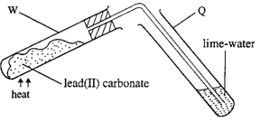
- Write the equation for the reaction taking place in test-tube W.
- State what is observed in test-tube Q.
- What is observed in test-tube Q if lead (II) carbonate is replaced with sodium carbonate? Give a reason for your answer.

6. (a) Write the equation for the reaction that would take place if
  - Dilute hydrochloric acid is added to sodium hydrogen carbonate.
  - Sodium hydrogen carbonate is strongly heated.
(b) State what would be observed and write equation for the reaction that would take place if magnesium sulphate solution is added to a solution containing
(i) Carbonate ions.
(ii) Hydrogen carbonate ions
7 (a) Draw a labeled diagram of the set-up of the apparatus that can be used to prepare a dry sample of carbon dioxide in the laboratory
(b) Write an equation that leads to the formation of carbon dioxide
(c) Write an ionic equation for the reaction leading to the formation of carbon dioxide

8 (a). Carbon dioxide was passed through calcium hydroxide solution. Describe and explain the reaction that took place.
(b) i)State what would be observed if burning magnesium ribbon was lowered into a jar of carbon dioxide
ii) Write equation for the reaction that takes place

9. (a) Describe the structure of graphite
(b) State two properties in which graphite differs from diamond
(c) Graphite was heated in excess air and the gas given off passed through aqueous calcium hydroxide for a long time
i) State what was observed
ii)Write equations for the reaction (s)

10) a) Name the element present in pure charcoal
(b) Explain why it is dangerous to use charcoal stove in a poorly ventilated room.
(c) Write an equation for the reaction between charcoal and heated iron (III) oxide.
11) The figure below shows an experimental setup to investigate the effect of carbon monoxide on oxides of metals.
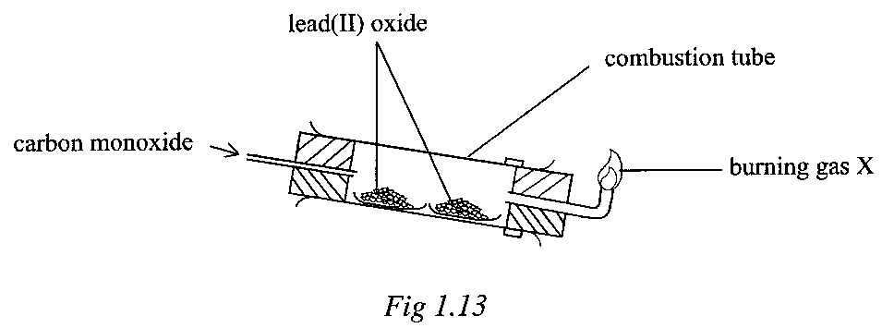

    - State the conditions for the reaction taking place in the combustion tube.
    - Write the equation for the reaction taking place in the combustion tube.

    - Name the gas X being burnt at the jet.
    - Why is it necessary to burn gas X?
    - Write equation for the combustion of gas X.
  - Name any other oxide that can be used instead of lead(II) oxide.
  - What would you expect to happen if lead (II) oxide was replaced with magnesium oxide? Give a reason for your answer.

12(a) State what would be observed if sodium carbonate solution was added to:
  - Aqueous calcium hydroxide.
  - Dilute sulphuric acid.
(b) Write ionic equations for the reactions in (a) (i) and (ii).
13. A mixture containing copper (II) sulphate and copper (II) carbonate was shaken with water and filtered.
(a) Identify the residue.
(b) To the residue was added dilute sulphuric acid.
- State what was observed.
- Write the equation for the reaction.
14 (a) Zinc carbonate was strongly heated in a test-tube until no further change.
(i) State what was observed.
(ii) Write the equation for the reaction which took place.
(b) The residue formed in (a) above was added to dilute sulphuric acid and heated.
(i) Write the equation for the reaction.
(ii) State what was observed.

15(a) Define allotropy.
(b) Give the three allotropes of carbon.
(c) Give two examples of other elements which show allotropy and name their allotropes.

16(a) Name two common reagents used in the laboratory preparation of carbon dioxide.
(b) State what is observed when carbon dioxide is bubbled in fairly concentrated sodium hydroxide solution for some time.
(c) Write the equation(s) of the reaction(s) that take(s) place.

17(a) Describe the structure of graphite.
(b) Explain why graphite conducts electricity whereas diamond does not.
(c) State any two uses of diamond.
(d) Describe how you would show by a chemical test that graphite is made up carbon atoms.

18. Carbon monoxide was passed over strongly heated copper (II) oxide.
(i) State what was observed.
(ii) Write the equation for the reaction.
(iii) Name any other oxide that shows similar reaction with carbon monoxide.

19(a) Draw a well labeled diagram for preparation of sodium carbonate in the laboratory.
(b) (i) What is observed when washing soda (Na2CO3.10H2O) is exposed to atmosphere for some time.

20(a) Copper (II) carbonate was heated strongly until there was no further change.
(i) State what was observed.
(ii) Write an equation for the reaction.
(iii) Name one reagent which can be used to identify the gaseous product.
(b) Excess dilute sulphuric acid was added to the residue in (a) and the mixture warmed.
(i) State what was observed.
(ii) Write an equation for the reaction.

21(a) (i) How can calcium oxide (quicklime) be obtained on large scale?
Diagram not required.
(ii) Write equation for the reaction that occurs.
(b) (i) What would be observed when fresh calcium oxide is added to water in a beaker?
(ii) Write equation for the reaction that would occur.
(c) Dilute hydrochloric acid was added to calcium oxide.
(i) State what is observed.
(ii) Write the equation for the reaction that occurs.

22. (a) To the product in (c) was added a solution of carbonate ions.
(i) State what would be observed.
(ii) Write the equation for the reaction that occurs.
(b) State any two uses of calcium oxide.

23(a). 10g of a saturated sodium chloride solution was evaporated and 6g of solid sodium chloride was left. Calculate
(i) Solubility of sodium chloride (Ans = 150g)
(ii) The percentage of sodium chloride in a saturated solution (Ans = 60%)
(b) 75g of a saturated solution contains 30g of a salt. Calculate its solubility. (Ans = 66.67g/100g of water)
(c)The solubility of X is 40g/100g of water. Calculate the mass of X that can be dissolved in 60g of water to give a saturated solution (Ans = 24g)
(d)The table below shows the solubilities of salt P in water at different temperatures
Temperature /ºC | 10 | 20 | 30 | 40 | 50 | 60
Solubilities (g/100g of solvent) | 18 | 20 | 24 | 30 | 38 | 50
- Plot a graph of solubility of P
- Use your graph to determine solubility of P at 25ºC (Ans =22g/100g of water)
- Calculate the mass of P that would dissolve in 45g of water at 25ºC (Ans =9.9g)

Reading Materials (References)
- Certificate Chemistry by Atkinson
- Certificate Chemistry by Holderness and Lambert
- Understanding Chemistry by Livingstone Kawesi.
- And any other chemistry textbook that is recognised by NCDC and UNEB.

END

