P.6 LESSON NOTES FOR TERM TWO

TOPIC TO BE COVERED
- Classification of plants
- Keeping cattle
- Resources in our environment
- Respiratory system
THEME : THE WORD OF LIVING THINGS
TOPIC : CLASSIFICATION OF PLANTS
WEEK 1
LESSON 1: FLOWERING PLANTS.
- Plants are living components of the environment
- A plant is a green growing living thing on the earth’s surface
- Plants are the primary sources of food to both animals and people
Classification of plants
Classification of plants means grouping plants according to their different characteristics.
Plants are classified into two;
- Flowering plants
Flowering Plants
Non-flowering plants
Plants
- Non-flowering plants.

Monocotyledons Dicotylyedons Algae Mosses Ferns
(cereals) (Legumes)

Maize Wheat Beans Peas Liverworts Conifers
Sugar Cane Others Mangoes Others

FLOWERING PLANTS
Flowering plants are plants that bear flowers and reproduce by means of seeds.
Flowering plants are made up of two systems
- Shoot system
- Root system
Shoot system is the part that develops from the plumule. It grows above the ground.
Flowering plants are sub-divided into two;-
- Monocotyledonous and
- Dicotyledonous.
Characteristics of dicotyledonous plants.
- They have a tap root system.
- Their seeds have two cotyledons.
- Their seeds undergo epigeal germination
- They have network leaf venation.
Characteristics of monocotyledonous plants.
- The seeds of monocotyledonous plants have only one cotyledon
- They have a fibrous root system.
- They have a parallel leaf venation
- Their seeds undergo hypogeal germination.

Learner’s activity
- In one sentence state what you understand by the term classification of plants
- Name the two groups of plants
- Apart from root system, identify any other system of a flowering plant
- Write one way under which roots are useful to;
- People
- Plants
- Give two differences between cereals and legumes
LESSON 2 : PARTS OF A FLOWERING PLANT
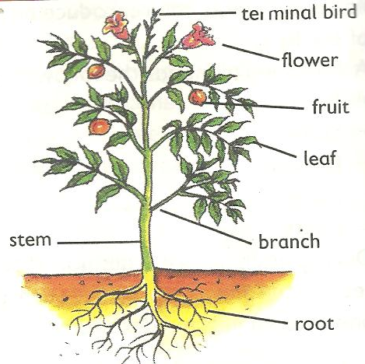

Shoot system

Root system

- Flowering plants have both root system and shoot system
- The root system is the part that grows in the soil
- The root system involves main root, lateral roots, root hair and the root cap.
Types of root systems.
There are basically two types of root systems namely;
- Tap root system and
- Fibrous root system
- Tap root grows directly from the radical of the germinating embryo
- They are commonly found in dicots.
- Fibrous roots grow without a tap root or main root.
- They are commonly found in monocots.
Draw structures showing parts of a tap root and fibrous root systems.
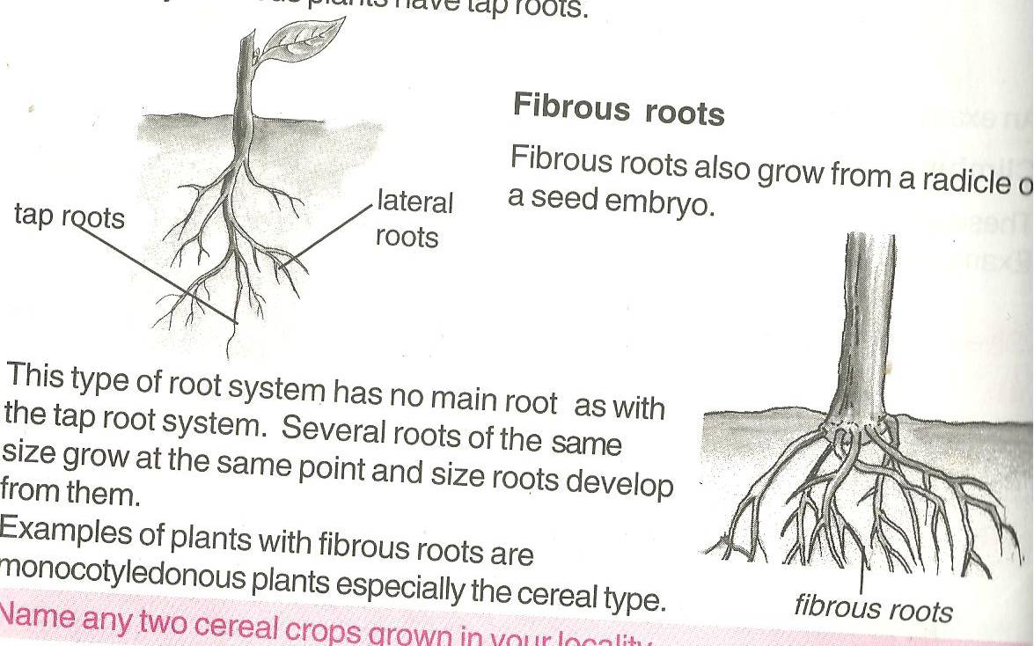  Tap root system | Fibrous system

Function of roots to a plant
- Roots hold the plant (shoot system) firmly in the soil
- Root hairs absorb water and mineral salts from the soil
NB: Mineral salts enter by a process called active transport.
- Some plants store their food in swollen roots.
- Prop roots provide extra-support to plants
- Breathing roots absorb oxygen especially in the mangroves.
- Root nodules of legumes store nitrogen-fixing bacteria that improves soil fertility.
Importance of roots to people:
- Swollen roots with stored food are sources of food to people e.g. Cassava, Sweet potatoes,& Carrots.
- Some plant roots acts as herbs to cure some diseases e.g. Mangoes, Blackjack, Muringa plant, etc.
- Big dry roots acts as source of wood fuel to people.
- Some big roots can be used in making craft items.
Learners Activity
- How useful is a shoot system to a plant?
- In the space below, draw the structure of a tap root system
- Apart from making craft items, state one way in which roots are useful to people
- In one sentence, show the meaning of a flowering plant.
- Give two examples of flowering plants

LESSON 3 : TYPES OF ROOTS
There are basically two types of roots names:
- Primary roots and
- Secondary rots
- Primary roots are roots that grows directly from the radical of a seed. Tap roots and fibrous roots are the examples of primary roots
- Secondary roots are roots that develop from the other parts of a plant like the stem and leaves.
- They mainly grow to give extra support to the plant with weak stems.
Examples of secondary roots include;
- Prop roots
- Aerial roots
- Breathing roots
- Roots of rhizomes and corms.
- Buttress roots
- Clasping roots
- Stilt roots
- Prop roots are common to plants such as, maize, millet, sorghum and wheat.
- They mainly grow to provide extra-support to the plant especially at the flowering stage.
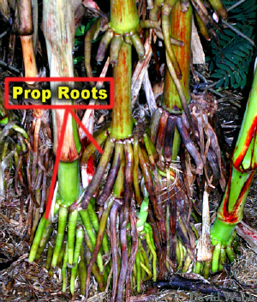
A structure showing the prop root system.

- Clasping roots enable plants with weak stems climb other plants and rap sunlight energy.
- Stilt roots are found on plants which commonly grow in muddy or swampy areas. They are also known as breathing roots.
- They take in air for respiration of roots. This is because soil with a lot of water does not have enough air
A structure showing clasping roots & Breathing roots
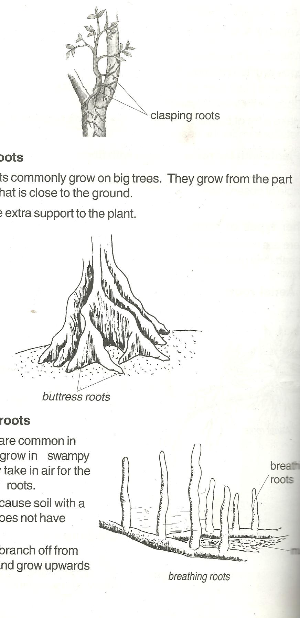

Note: some plants have swollen roots which store food for the plant.
They have terminal buds surrounding their leaf bases.
Learners Activity:
- In one sentence explain the following terms
- Primary roots.
- Secondary roots
- Give two examples of secondary roots
- Draw a structure of prop roots
- State the importance of prop roots to a plant

LESSON 4:PLANT STEMS.
- The stem is the biggest part of the shoot system of a plant.
- It holds leaves, flowers, fruits, branches and terminal bud
Types of stems
- Upright stems:
- Underground stems
- Climbing stems.
- Examples of upright stems include paw-paws, mangoes, maize, beans etc
- Examples of underground stems are; stem tubers, bulbs and corms.
Climbing stems are weak stems of plants that cannot support themselves upright.
Plants climb others for support in order to get light

How plants climb others
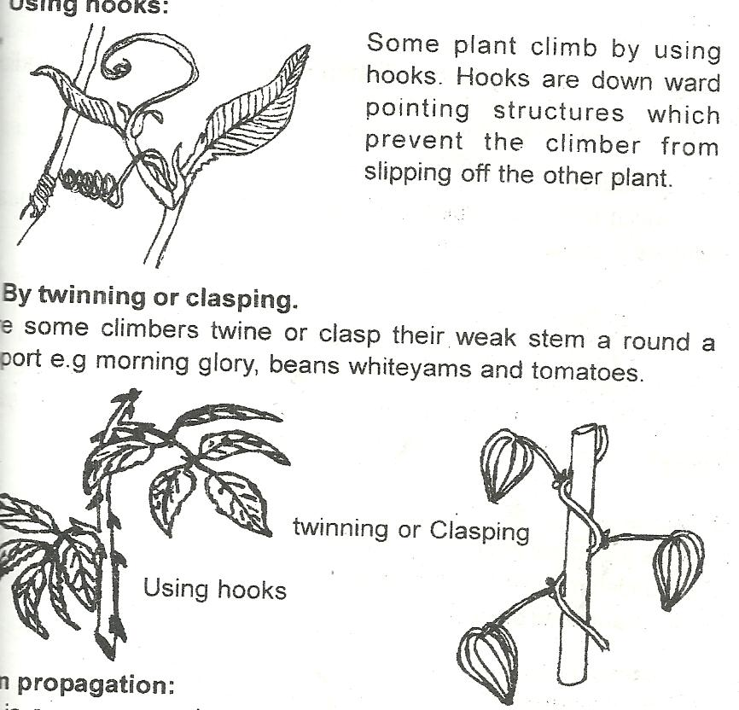
Plants with weak stems climb other by;
- Use of tendrils

- Use of hooks

- Twining or clasping

Note:
- Stem tubers are crops with underground swollen stems which store food.
- Plants with such include; cocoyam and Irish potatoes
- Rhizomes commonly grow horizontally under the ground with stored food. E.g. ginger and canalilies.
- Corms grow vertically under the ground with stored food rich in carbohydrates.
Functions of stems to a plant
- They hold and space out leaves to receive the sunlight energy
- Stems transport water and mineral salts from the roots to the leaves
- Green stems help in the process of photosynthesis
- Stems conduct manufactured food in the leaves to all other parts of the plants.
- Stems hold flowers and fruits for easy pollination and dispersal
- Some plant stems have thorns for protection
Functions of stems to people.
- Some plant stems act as a source of food to both people and animals
- Big stems provide people with timer and poles for construction
- Plant stems act as a local medicine to cure some animal diseases
- Some plants are harvested to provide wood fuel to people
- Some plant stems are used for propagation ie cassava, sugarcanes and some flowers.
Learners activity:
- In one sentence explain why plants climb others.
- Using a diagram, show how plants climb others by clasping
- Explain the term stem tubers
- Apart from ginger and zoysia grass, mention any one other example of a rhizome.
- Write any two ways in which stems are useful to;
- Plants
- People

LESSON 5 : PLANT PROPAGATION
- Propagation is artificial methods used to obtain new plants
- Some plants are propagated by the use of stems with terminal buds
Examples of plants propagated by the use of their stems include;
- Cassava
- Sugarcanes
- Sweet potatoes
- Some plants are propagated using bulbs such as onions, garlic and spider lily.
- Onions are involved in our diets to provide iron to our bodies.
- Some plants are propagated using suckers such as banana plants, pineapples and sisal plants.
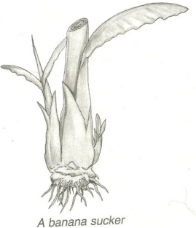
Draw a structure showing a sucker of a banana plant.

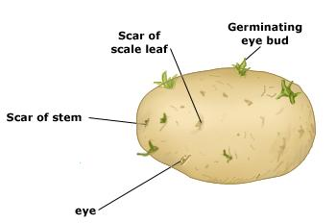
- Some plants are propagated using tubers such as; Irish potatoes, cocoyam.
A structure showing parts of stem tuber.

- Some plants are propagated with the help of corms (kind of underground stems) e.g coco yams, gladiolus and crocus.

Draw a structure showing coco yam and an Irish potato
Coco yam | Irish potato
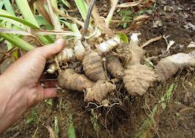 | 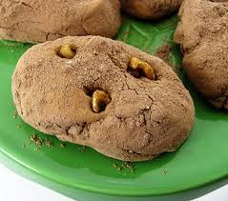

Some plants are propagated using the rhizomes.
- Rhizomes are swollen underground stems with stored food and grow horizontally.
Example include, ginger canalily, zoysia grass and turmeric.
Learners activity
- State what you understand by the term plant propagation
- Give two methods of plant propagation
- State how the following plants can be propagated;
- Sweet potatoes
- Sisal
- Give two advantages of vegetative propagation over seed propagation.
- Name any one crop raised in a nursery bed

LESSON 6: PLANT LEAVES
- Leaves are the green parts of a plant with stomata for gaseous exchange.
- Leaves have chlorophyll to trap sunlight energy and manufacture its starch.
- Leaves also form the shoot system of a plant.
- A leaf is fixed between two internodes on a plant stem or branch.
PRACTICAL ACTIVITY ABOUT DIFFERENT TYPES OF LEAVES (COLLECTING AND OBSERVING DIFFERENT LEAVES FROM THE ENVIRONMENT)

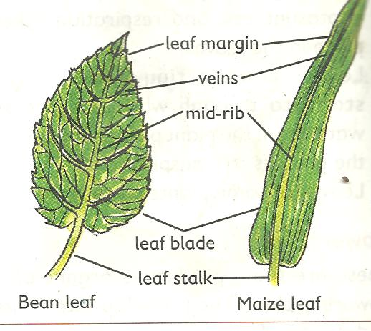
A drawn structure showing a leaf.

Functions of the above parts.
- It has a surface area for easy trapping of sunlight energy by the help of chlorophyll
- It’s where the stomata are found.
- It helps in the manufacturing of starch
Stomata
- It’s called stoma for singular and stomata for plural.
- They are small holes on the leaf where gaseous exchange takes place.
- They also open to allow water escape during the process of transpiration.
- The stomata also let in carbondioxide by diffusion during day time and oxygen during night time.
Leaf veins.
- They are hollow to allow distribution of water and nutrients within the leaf
Leaf apex.
- It’s the sharp tip part of a leaf to provide protection to the leaf
Leaf stalk / petiole
- This provides attachment of the leaf to stem or a branch.
Note: there are mainly two processes that take place in plant leaves namely;
- Photosynthesis and
- Breathing
Learners Activity
- Identify two important processes that take place in plant leaves.
- Draw and name parts of a leaf
- State the functions of the following parts of a leaf;
- Veins
- Chlorophyll
- Petiole
- How can plant leaves be useful to people?
WEEK : 2
LESSON 1 : TYPES OF LEAVES
Types of plant leaves
- There are two types of plant leaves which include;
- Simple plant leaves
- Compound leaves
Simple leaves
Simple leaves are leaves completely not divided.
Examples of simple leaves include;
- Simple serrated leaf
- Simple palmate leaf
- Simple divided entire leaf
- Simple lobed leaf
- Simple entire leaf.
Dawn structure showing different examples of simple leaves
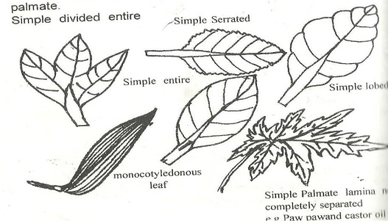

- Compound leaves are characterized with a divided lamina
- Compound leaves have more than one leaf-let on one leaf blade or stalk.
- A compound leaf has completely separate portions called leaflets
- Each leaflet has a small stalk which is attached to a common leaf stalk.
Examples of compound leaves;
- Compound trifoliate e.g. Beans leaves
- Compound pinnate e.g. Jacaranda leaves/ mimosa plant
- Compound digitate leaf e.g. Silk cotton leaves
- Compound pinnate e.g. acacia leaves /eucalyptus
Drawn structures showing examples of compound leaves
Bipinnate | Pinnate | Trifoliate | Digitate
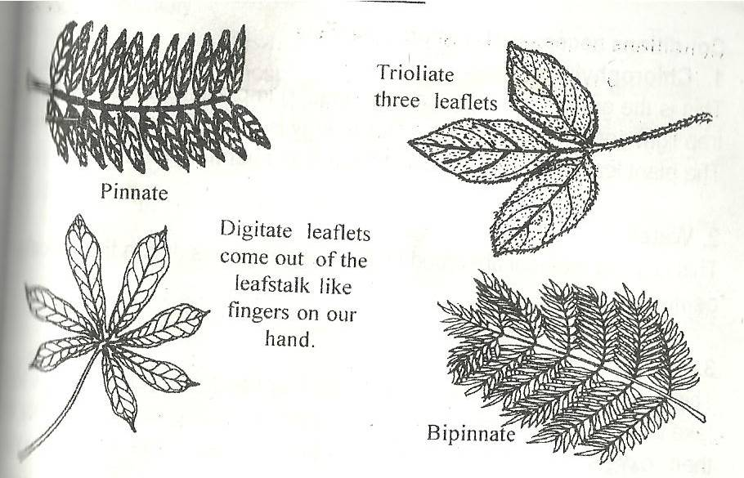

LESSON 2 : USES OF LEAVES AND LEAF VENATION
Leaf venation
- Plant leaf venation refers to the arrangement of veins in a leaf.
- Veins in a plant leaf help in the circulation or distribution of water and mineral salts.
Types of leaf venations:
- There are basically two types of plant leaf venation namely;
- Network leaf venation
- Parallel leaf venation
- Plants with a network leaf venation have a structure in the lamina like a net in their leaves
- Network leaf venation is a characteristic of dicotyledonous plants.
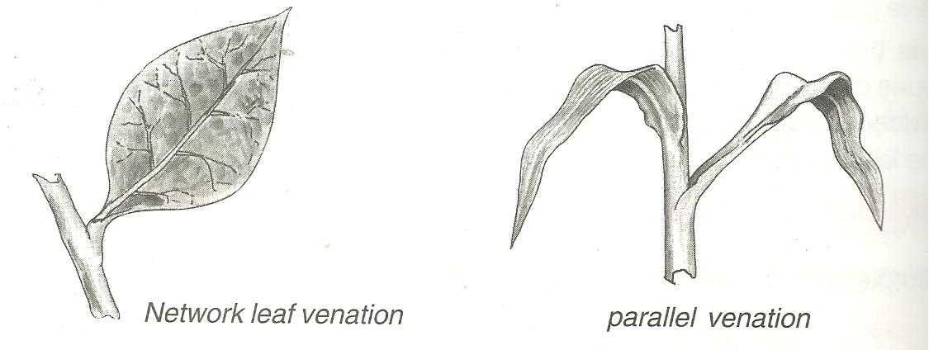
A drawn structure showing a network leaf venation of a plant leaf.

Note:
- Network leaf venation is common in both simple and compound leaves.
- Parallel leaf venation is where leaves have veins running parallel from the leaf stalk to the tip or apex.
- Parallel leaf venation is a characteristic of monocotyledonous plants.
Drawn structure showing a leaf with parallel leaf venation.

Note:
- Parallel leaf venation is mainly found in simple entire leaves.
Learner’s activity
- Write one sentence to show the meaning of the following;
- Venation
- Parallel venation
- Draw the structure of a simple lobed leaf
- Give two examples of compound leaves
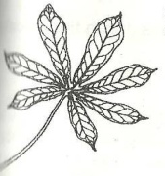
- 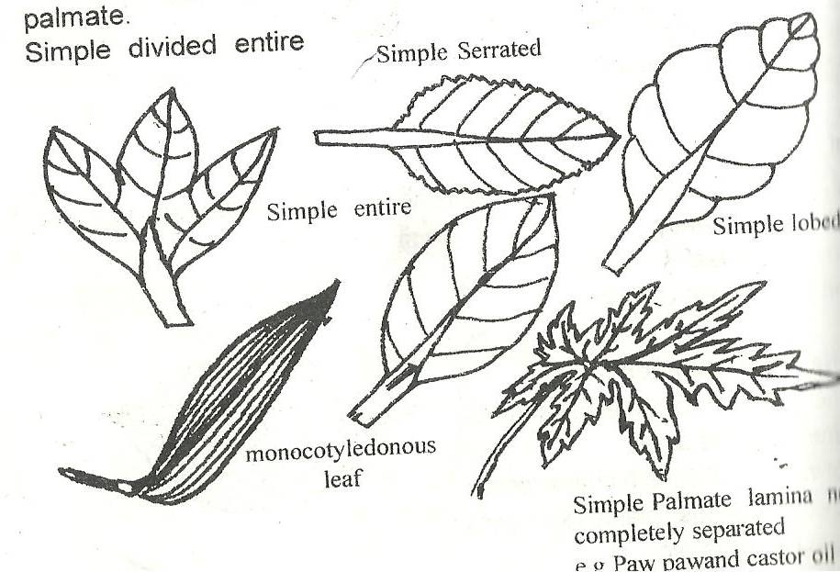Which of the leaves A and B is a compound leaf?
A B

LESSON 3 : PHOTOSYNTHESIS IN PLANTS
Photosynthesis in plants
- Photosynthesis is the process by which plants manufacture their own food.
- The word “photo” means light, “synthesis” means to make or “buildup”
Raw materials needed
There are two raw materials needed during the process of photosynthesis.
Water
- To dissolve the mineral salts in a leaf.
- Also to make the leaf soft for easy diffusion of starch.

Carbon dioxide gas
- This is synthesized to make carbon
- Both water and carbon dioxide combine to build up glucose stored in the plant leaves as starch.
Conditions necessary for photosynthesis
- Chlorophyll – to trap the sunlight energy
- Sun light energy – helps in the breaking down of the water into hydrogen to speed up the formation of the starch.
Note:
- Oxygen is a by-product of photosynthesis while starch is the main product.
- Animals get oxygen from the process of photosynthesis.
- Photosynthesis cannot take place at night due to the absence of the sunlight energy.
- Photosynthesis is a chemical change in plants.
Learner’s activity.
- Write one word to refer to the process by which plants make their own food
- Write any one raw material for the process above
- State one way in which the following can be useful during photosynthesis;
- Sunlight
- Water
- Apart from oxygen, mention any other product of photosynthesis
- Briefly explain why photosynthesis cannot take place at night.

LESSON 4 : TRANSPIRATION IN PLANTS
- Transportation is also a process in plants that take place in the leaves and some stems.
- Transpiration is the process by which plants lose water as vapour into the atmosphere
- Transpiration takes place in plants through the stomata of leaves, lenticels and in the cuticle of stems
Note: Let the learners participate in carrying out an experiment under the guidance of the teacher
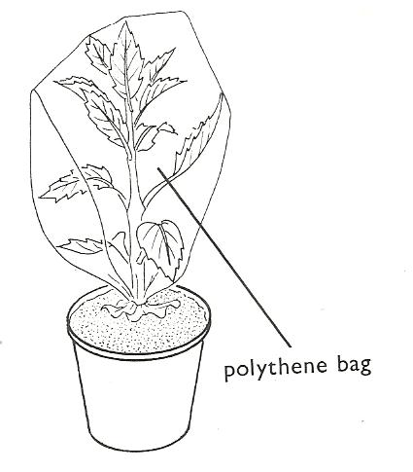Illustration showing transpiration in plant leaves.

Water droplets

How plants benefit from the process of transpiration (importance);
- Plants are able to absorb water and mineral salts from the soil through their roots up to the rest of the plant parts.
- Transpiration helps in cooling the plant during a hot day.
Note:
The transpired vapour from the plants helps in the formation of rain.

Dangers of transpiration
- Plants lose even the useful water they need during a dry season. This may make plants dry up to death
- It lowers the crop yields due to less water left in the plant.
Ways plants reduce the rate of transpiration.
- Some plant leaves are modified into thorns
- Some plant leaves have few stomata and distributed at the lower part of the leaf.
- Some plants have leaves with a small surface area to reduce the rate of water loss
- Some plants reduce the rate of transpiration by shedding their leaves especially during dry season e.g. deciduous plants (Mvule,Oak & fig trees)
- Leaves have a wax-like layer to cover their stomata to limit the water loss.
- Stems have tough cuticles and lenticels to guard against water loss.
Factors that affect the rate of transpiration in plants;
The following are the conditions that either increase or decrease the rate of transpiration;
Wind
Wind blows off the water molecules on the plant leaf giving chance or space for more vapour to come out. This increases the rate of transpiration.

Humidity:
- Humidity is the amount of water vapour in the atmosphere.
- High rate of humidity lowers the rate of transpiration and vice versa.
Temperature:
High temperature during hot days causes plant leaves to lose a lot of water than on cool days.
Sunlight:
Heat from the sun causes the opening of the stomata, lenticels and cuticle hence creating more chances of losing water.
Surface area of the leaf:
Plants with small surface area of their leaves lose water at a lower rate than those with larger leaf surface area.
Number of stomata:
Plant leaves with fewer stomata have a low rate of transpiration
The higher the number of stomata, the higher the rate of transpiration
Some leaves have stomata at the lower side of the leaf
NB: Most transpiration takes place in leaves
Learner’s activity.
- Briefly explain the term transpiration
- Cite out any two factors that affect the process of transpiration
- Give two ways in which transpiration can be useful to a plant
- Explain any two ways in which transpiration can be a disadvantage to a plant.
- Make an illustrative drawing to show that a plant shoot transpires
“A PRACTICAL LESSON ABOUT TRANSPIRATION IN PLANT SHOOT’’ (Through excursion)
LESSON 5 : FLOWERS
- The flower is the reproductive part of a plant. Therefore, it’s where the process of reproduction takes place.
- The flower has both the female and male gametes
- A gamete is a reproductive cell
A flower has got two parts namely;
The female part called pistil (gynoecium) and male part called stamen (androecium)
Pistil is made up of stigma, style, ovary and ovules
Stamen is made up of the filament and anther head.
The male reproductive cells are the pollen grains and female are the ovules.
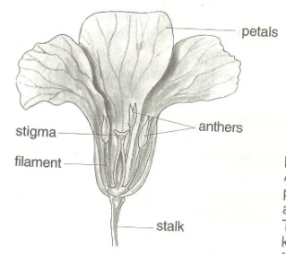
Drawn structure showing parts of a flower.

Functions of the parts
Petals, the brightly coloured petals help to attract pollinating agents such as insects.
A group of petals is called corolla
Sepals- Green sepals help to manufacture food for the plant.
- Protect the inner parts of the flower at an early stage (bud stage)
A group of sepals is called calyx
Style: is a passage of the pollen grains to the ovary
The style also supports / holds the stigma in position
Ovary. It produces the female gametes called ovules
A mature fertilized ovary turns into a fruit
Filament. Holds the anther heads in position
Anther heads. Produce male gametes called pollen grains.
Stigma. It’s strictly to receive pollen grains without falling off.
Learner’s activity.
- What scientific name is give to a group of;
- Petals
- Sepals
- Of what importance are brightly coloured petals to a plant
- Give two uses of flowers to human beings
- Draw and name parts of a female part of a flower

LESSON 6 : POLLINATION
- Pollination is the transfer of pollen grains from the anther heads to the stigma of a flower on a plant.
- Pollination helps to allow fertilization in plants
- Fertilization is the union of both female and male gametes to form a zygote.
- The pollen grains are the male gametes while the ovules are the female gametes in plants.
Types of pollination.
There are two types of pollination namely;
- Self pollination
- Cross pollination
Self pollination is the transfer of pollen grains from the anther heads to the stigma of the same flower
Flowers with self pollination have shorter stigma compared to their anther heads.
They also have brightly coloured petals to attract pollinators

Note:
Some flowers are adapted to self pollination by:
Both the anther and stigma maturing at the same time.
Their flowers remain closed until self pollination takes place

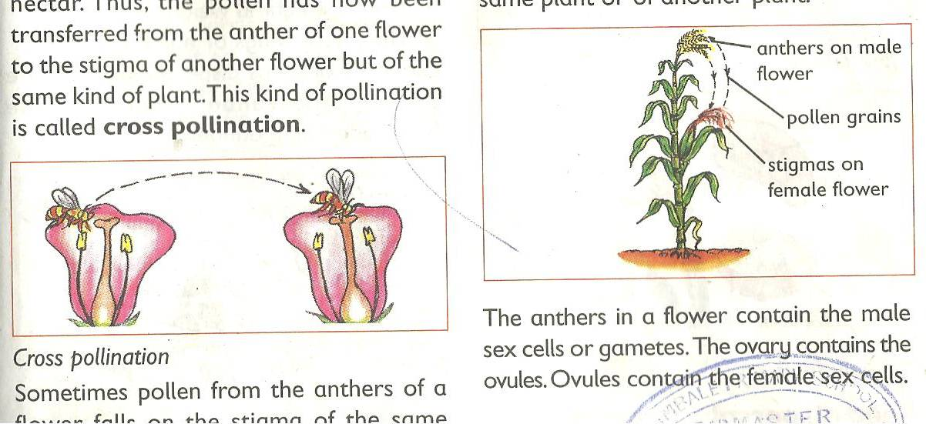
Structure illustrating self-pollination.

Cross-pollination is the transfer of pollen grains from the anther heads of one flower to the stigma of another flower but of the same type or species.
In cross–pollination, the anther heads are shorter than the stigma.

Flowers are able to carry out cross-pollination by;
- Maturing of anther heads and stigma at different times.
- Having one productive gamete on each plant i.e. paw-paw plants
Illustration showing cross-pollination.

Note: Agents of pollination refers to the factors that are responsible or cause pollination to take place. These include; - wind, insects, birds, people etc.
Insects-pollinated flowers have scent, brightly coloured petals, produce sticky pollen grains / have sticky stigma.
Wind pollinated flowers produce a lot of pollen grains, have no scent, dull petals with no nectar.

Learner’s activity.
- Briefly explain the term pollination
- Name the agents of pollination
- Identify two factors that favour;
- Self-pollination
- Cross-pollination
- Give any one difference between insects and wind pollinated flowers

WEEK : 3
LESSON 1 : NON-FLOWERING PLANTS
Non-flowering plants are groups of plants that do not bear flowers.
Non-flowering plants are subdivided into three namely;
- Spore producing.
- Coniferous plants.
- Algae
- Spore producing plants are groups of non-flowering plants that reproduce by means of spores.
- A spore is a single cell that can develop into a new plant under favorable conditions.
Examples of spore producing plants include; liverworts, mosses and ferns.
- Ferns are the most advanced group of spore producing plants with proper leaves, stems and roots.
- Mosses are small green cushion-like and grow commonly on house roof verandas, tree trunks, and in damp soils.
- Liverworts have leaf like structures and commonly grow in wet moist places.
Illustrations showing different examples of spore producing plants.
Fern plant | Mosses plant | Liverwort plant
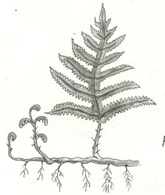 | 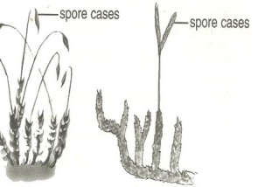 | 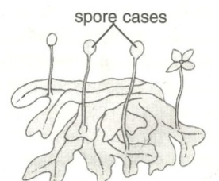

Note:
All spore producing plants are green and therefore able to make their own food.
Coniferous plants are true non-flowering plants that do not bear flowers but reproduce by means of seeds protected in hard structures called cones.
Conifers have roots, stems and small needle shaped leaves
Examples of coniferous plants include

- Pines
- Cedar tree
- Podo tree
- Cypress
- Fir tree
- Ginko
Economic importance of conifers
- Some are planted in compounds to provide shade and also act as wind breaks.
- Some conifers are planted around the compounds and farmers to act as live fences
Algae
These are simple plant like organisms which grow in water and in other dump places.
They differ from plants in that their cells are not clearly organized into tissues for a specialized function.
Examples of algae include;
- Spirogyra, which looks like long green threads.
- Sea weeds
- Algae reproduce by cell division
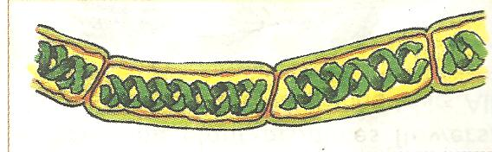
A diagram of a spirogyra

NB: Green algae are found in a variety of habitats including fresh water, the sea, soil, tree trunks but the majority are aquatic.
Uses of algae to people
- Sea weeds like red algae can be eaten.
- Sea weeds provide a number of important food additives
- They also provide an agar used for growing micro-organisms
- Algae are used in the production of biofuels.
Learner’s activity.
- In one sentence show the meaning of non-flowering plants
- Mention the two main groups of non flowering plants
- Conifers cannot bear flowers. How do they reproduce?
- State two ways in which coniferous plants can be useful to people
- Briefly explain why algae are not classified as plants.
- How can algae be useful to an industrialist who deals in food processing?

LESSON 2 : SEEDS
A seed is a mature fertilized ovule.
A seed develops into a young plant or a seedling under favourable conditions.

Seeds are classified into two;
- Dicotyledonous seeds
- Monocotyledonous seeds
- Dicotyledonous seeds are seeds with two cotyledons
These seeds can be split into two equal parts of the cotyledons
Examples include:
- Bean seeds
- Peas
- Groundnut seeds
All dicotyledonous seeds undergo epigeal germination.

A drawn structure showing parts of external and internal parts of a bean seed.
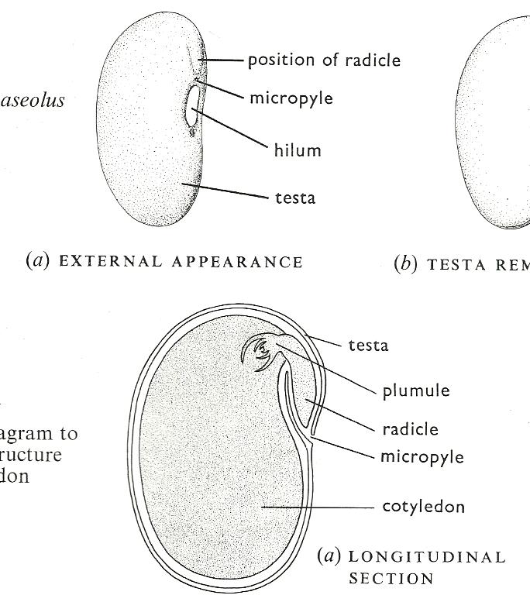  External Parts | Internal parts

APRACTICAL ABOUT OBSERVING INTERNAL PARTS OF A SEED (BEAN/MAIZE GRAIN)
- Monocotyledonous seeds are seeds with only one cotyledon.
- They are mainly grains or fruits.
Examples include; maize, millet, sorghum, etc.
- Monocotyledonous seeds undergo hypogeal germination.

Drawn structures showing external and internal parts of a maize grain.
External parts | 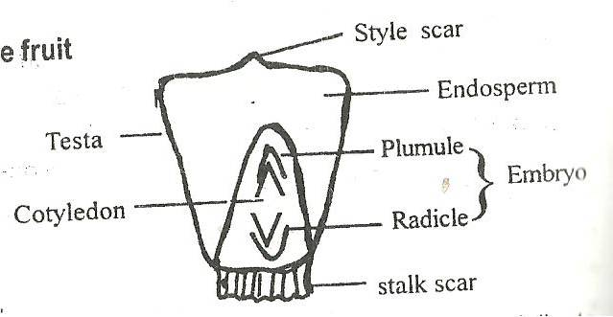  Internal parts
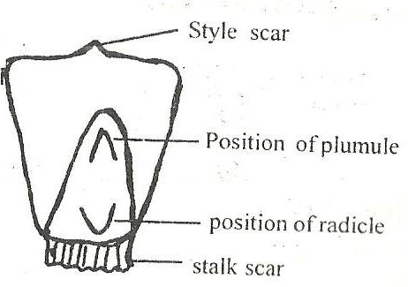

Functions of the above parts.
Seed coat (testa)
- It protects the inner delicate parts of the seed.
Cotyledon
- Store food in the dicotyledonous seed
- Absorbs stored food from the endosperm to the embryo during germination.
Endosperm
- Stores food in monocotyledonous seeds.
Plumule
- It grows into shoot system
Radicle
- Grows into the root system.
Micropyle
- Is a passage of air and water to the embryo.

Learner’s activity.
- Why a maize grain is called a fruit?
- Use two ways in which seeds are useful to people
- Draw and name the following parts of a bean seed.
- Micropyle
- Hilum / scar
- Testa
- State the functions of the following parts of a maize grain.
- Endosperm
- Cotyledon
- Stalk scar
- Write any one difference between monocotyledonous and dicotyledonous seeds

LESSON 3 : GERMINATION IN PLANTS
- Germination is the development of a seed embryo into a seedling under favourable conditions.
- During germination, the Radicle grows into the root system to support the seedling firmly into the soil.
- The radicle also grows root hairs to absorb water and mineral salts from soil.
Types of germination.
There are basically two types of germination
- Epigeal germination
- Hypogeal germination
Epigeal germination is a type of germination where the cotyledon comes out of the ground.
Epigeal germination is a common characteristic of dicotyledonous seeds eg. Beans, soy beans, groundnuts.
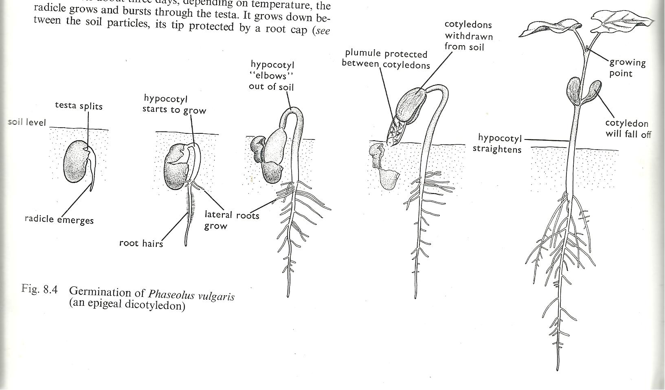Drawn structure showing the different stages in Epigeal germination.

Hypogeal germination:
This is a type of germination in which the cotyledon remains under the ground
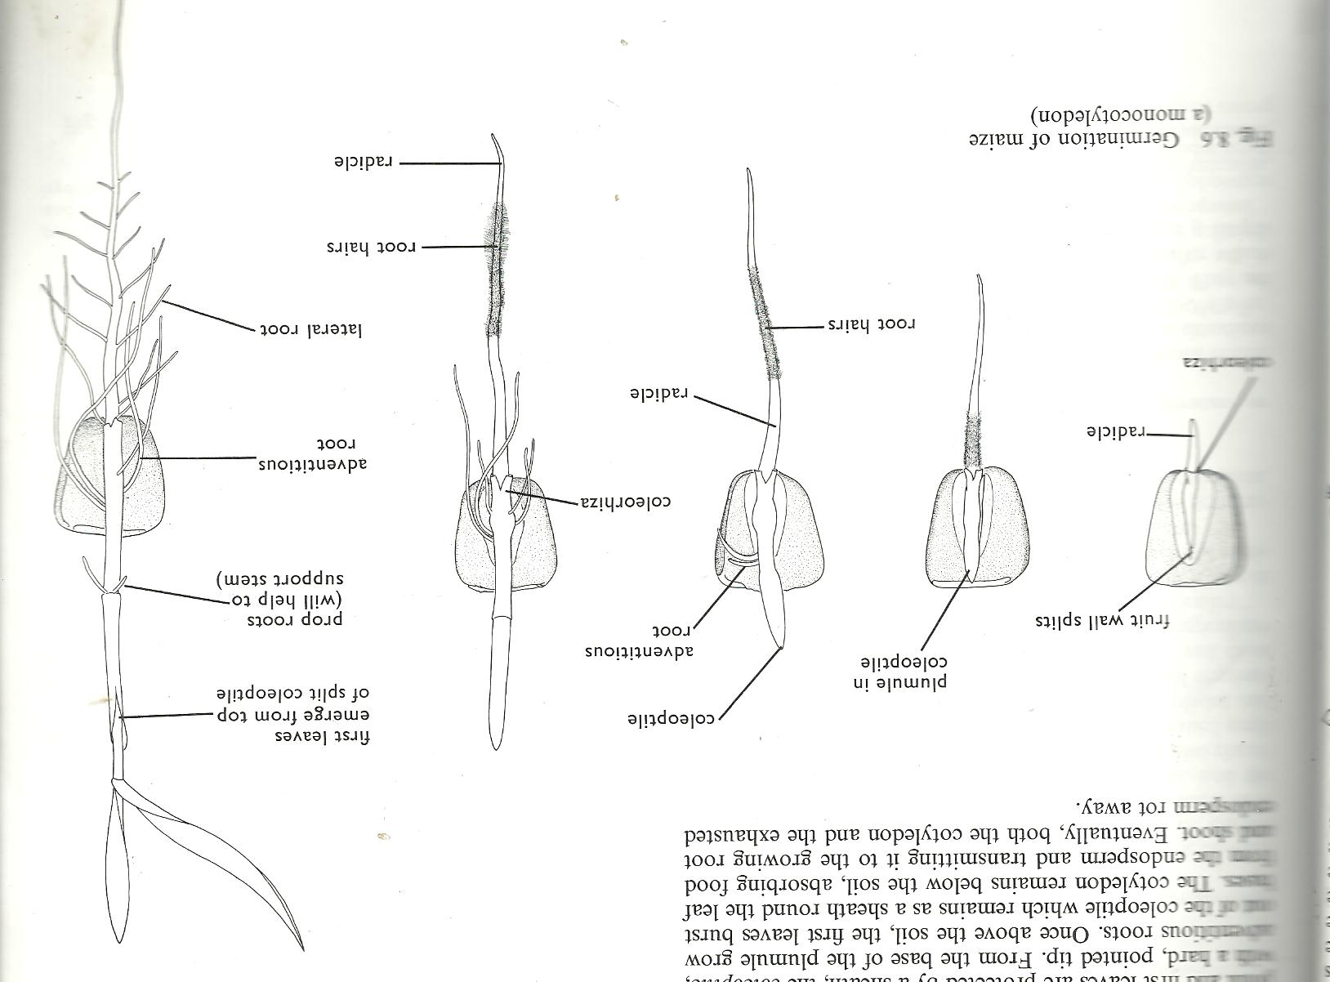This type of germination is a common characteristic of monocotyledonous seeds.
Examples include; maize, millet, rice, sorghum etc.
Stages involved in Hypogeal germination.

Conditions necessary for seed germination.
- A seed will only germinate under favourable conditions such as, oxygen, water and warmth.
Seed viability is the ability of a seed to germinate under favourable conditions.
A viable seed should be;
- Mature and dry
- Whole without a hole / wrinkles
- Health and of a good variety
Learner’s activity.
- State what you understand by germination of seeds
- Point out any two conditions necessary for seed germination.
- Using diagrams, show the different stages of a germinating bean seed
- List any two characteristics of a viable seed
- If a seed is not viable, it’s said to be dormant. What does seed dormancy mean?

LESSON 4 : FRUITS
- A fruit is a mature fertilized ovary
- A fruit is any structure in flowering plants that contains mature fertilized ovules.
- A fruit has two scars i.e. style scar and stalk scar.
Fruits are divided into two;
- Juicy fruits (succulent fruits)
- Non juicy fruit (dry fruits)
Juicy fruits are groups of fruits with juicy pericarps and are eaten.
These include berries, pomes and drupes
Berries are fruits with many seeds like guavas, tomatoes, oranges etc.
Drupes are fruits with only one seed such as avocado fruit and mango fruit.
Pomes are fruits with few seeds like an apple.

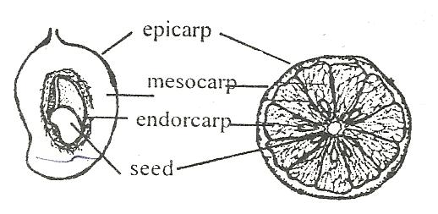
Drawn structure showing the different parts of a juicy fruit (mango and orange)

Dry fruits
These are fruits whose pericarp is usually dry hard and woody.
They are divided into two namely;
- Splitting (dehiscent fruits)
- Non-splitting (indehiscent fruits)
Splitting fruits have capsule or pods that split to disperse their seeds when dry. E.g. Beans, peas and castor oil.
Non-splitting fruits have one seed only.
Their pericarp does not split to disperse the seeds but have structures for their mode of dispersal. Eg. Black jack, maize, sunflower, tridax etc.
Note:
- Some fruits develop from one flower. They are called simple fruits.
- Sometimes all flowers on a stalk make one fruit. Such fruits are called compound or multiple fruits eg. Pineapple.
- Some fruits are not formed from the ovary of a flower but from some other parts of a flower. Such fruits are called false fruits. E.g. an apple which develops from a receptacle
Learner’s activity.
- Briefly explain the following terms;
- A fruit
- Dehiscent fruits
- Multiple fruits
- Cite out one example of a false fruit
- Write one way in which black jack is different from castor oil.
- List two functions of fruits to plants
- Give two examples of juicy fruits
A PRACTICAL LESSON ABOUT THE INTERNAL PARTS OF A FRUIT (ORANGE & MANGO)
LESSON 5 : SEED AND FRUIT DISPERSAL
Dispersal is the scattering of a seed or fruit from the mother plant to other area.
In some plants only seeds are dispersed while other plants it’s the fruits.
Importance of seed and fruit dispersal
- Dispersal enables plants to colonize new areas
- Dispersal reduces competition for light and the nutrients among plants.
- Dispersal increases the chance of the plant survival.
Agents of seed and fruit dispersal
There are basically four agents or factors responsible for seed dispersal and these are;-
- Animals, wind, running water and self mechanism
Types or mechanisms of seed dispersal are;
- Wind dispersal
- Animal dispersal
- Water dispersal
- Explosive mechanism.
Characteristics of seeds dispersed by animals
- They are heavy and have juicy mesocarps
- Some have hook-like structures to enable them attach themselves on the animals’ bodies
- Some have hard seed coats to protect them from the digestive juices.
Examples of seeds dispersed by animals are;
- Mango fruit
- Guava fruit
- Jack fruits
- Avocado fruit etc.
Characteristics of seeds dispersed by wind
- Many are small and light to be easily carried by wind.
- Some like jacaranda seeds have wing-like structures for floating in air.
- Some like a dandelion have a parachute hair structure
Seeds dispersed by self mechanisms split their pods when ripe and disperse their seeds.
These include; castor oil, peas and beans.
Seeds dispersed by running water are of plants that grow on water or near river banks.
Examples include;
Water lilies and coconut fruits.
Learner’s activity.
- Write one word to mean the scattering of seeds from one mother plant to other areas
- Write any two methods of seed dispersal
- Give two ways in which seed dispersal can be useful to plants
- List two differences between wind and animal dispersed seeds
- Draw the structure of a tridax

THEME SCIENCE IN HUMAN ACTIVITIES AND HUMAN OCCUPATION
TOPIC : KEEPING CATTLE
LESSON6 : IMPORTANCE OF KEEPING CATTLE

- Keeping cattle refers to the act of rearing bulls, cows, calves, buffalos and heifers.
- Animal husbandry refers to the act of rearing farm animals or livestock.

Farm animals include;-
Pigs, sheep, goats, cattle, and rabbits.
A drawn structure showing the external features of a cow and a bull.
Cow Bull
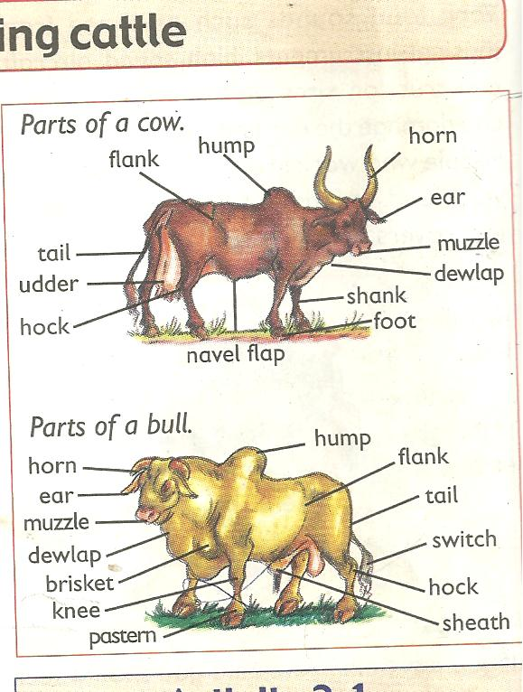

Importance of keeping cattle.
The following are the reasons why people keep cattle;
- Cattle provide people with milk and meat which are sources of proteins.
- Waste materials (dung) from cattle acts as natural manure used to improve soil fertility
- Hooves and horns are used to make enamel items like plates and cups.
- Hides from cattle are used in making leather products.
- Cow dung can be used in building local houses and making biogas
- Keeping cattle is a source of employment.

Learner’s activity.
- Write one sentence to show the meaning of the following terms;
- Keeping cattle
- Animal husbandry
- State one reason why many Ugandan have taken up cattle keeping as a business
- What is the importance of horns and hides to an industrialist

WEEK : 4
LESSON 1 : TYPES OF CATTLE
A type of cattle is a class of cattle kept for a specific purpose. Specific purpose may be;
- For milk production
- For meat (beef) production
- For provision of animal labour
- For both milk and meat production
Examples of types of cattle
There are basically three types of cattle namely;
- Dairy cattle for milk production
- Beef cattle for beef (meat) production
- Dual-purpose cattle for the both milk and meat.
Characteristics of dairy cattle.
- They have a thin body that carries little meat
- They have a wide and well set hind limbs
- They have big udders with four medium teats and produce a lot of milk.
- They have triangular body shape and usually docile/humble.
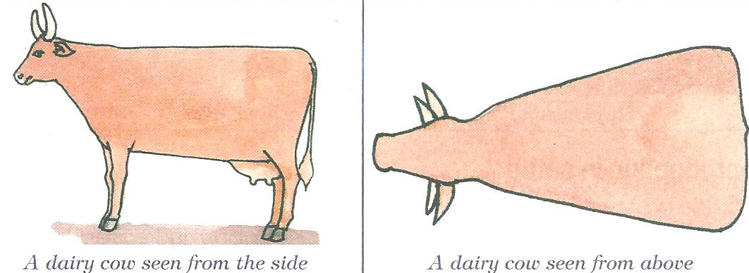
A drawn illustration showing body shape of dairy cattle.

Examples of dairy cattle include.
Friesian, ayrshire, Guernsey, jersey, Jamaican hope and brown swiss cattle.
Lesson 2 : BEEF AND DUAL PURPOSE CATTLE
Beef cattle are groups of cattle kept for meat (beef) production.
Examples of cattle kept for meat production include;
- Aberdeen angus (weighs 720-900kgs)
- Here ford (weigh about 1000kgs)
- Charolais (creamy in colour)
- Short horn,
- Galloway (it’s small and long haired black)
- American beef master
Characteristics of beef cattle;
- They have abroad rectangular body shape
- They mature quickly and give plenty or high quantity of meat
- They are very stubborn with no horns
- They have thick muscles.
An illustration showing the body shape of beef cattle.
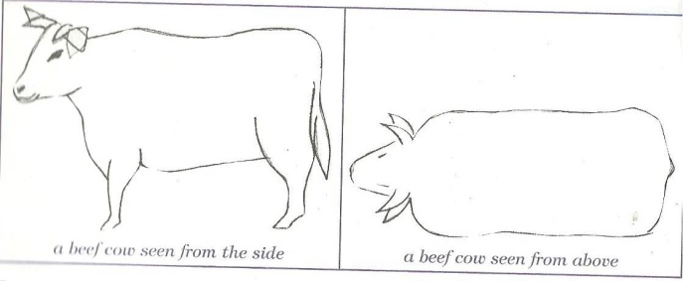

Dual purpose cattle
- These are groups of cattle kept for both milk and meat production
- They are mainly local meat products.
Examples include
- Sahiwal (its brown –red in colour and large in size)
- Red poll (has a medium size with no horns)
- Milking short horn (don’t grow very fast like others but produce hard meat)
Note:
Dual Purpose Cattle have characteristics of dairy cattle and beef cattle
Learner’s activity
- What do you understand by the term type of cattle?
- List any two types of cattle
- Identify the type of cattle with a rectangular body shape
- Give two examples of dairy breeds of cattle
- Name the commonest exotic dairy breed of cattle reared in your locality

LESSON 3: BREEDS OF CATTLE
A breed of cattle is a family of cattle having specific characteristics.
Specific characteristics may include;
- Colour of cattle
- Size of the animals
- Productivity of the animals.
Breeds of cattle include;
- Local breeds of cattle (indigenous)
- Exotic breeds of cattle
- Cross breeds
Local breeds or indigenous cattle are breeds of cattle that have lived in East Africa for a long time. They are also called the native breeds kept for both milk and meat production.
Examples include;
- Small east African zebu
- Boran cattle.
- Nsagala or sanga cattle
- Ankole cattle
Characteristics of local breeds of cattle.
- They are resistant to tropical diseases
- They have the ability to walk long distances
- They produce good naturally flavoured products
- They can survive on poor pasture and tropical weather conditions.
Disadvantages of local breeds of cattle
- They produce less meat and milk
- They have a slow growth rate

Exotic breeds of cattle
- These are groups of cattle breeds imported into East Africa.
- They are either dairy, beef or dual-purpose cattle

Characteristics of exotic breeds of cattle.
- They grow quickly with no horns
- They are not resistant to diseases.
- They need a lot of attention or care.
- They produce high quantities of milk and beef
- Their products are not as sweet as for the local breeds of cattle
Note:
Cross breeds are obtained after mating a local breed with an exotic breed.
This is the best way of improving upon the poor local breeds of cattle.
Learner’s activity.
- Give the difference between a breed of cattle and a type of cattle
- Mention any two breeds of cattle commonly kept in Uganda
- Identify a breed of cattle you would prefer to keep in your locality
- Give a reason for your answer in (3) above
- Cite out the best way of improving on our local breeds of cattle

A DOCUMENTARY ABOUT THE TYPES & BREEDS OF CATTLE
LESSON 4 : BREEDING IN CATTLE
Breeding is the act of maintaining or improving the desired characteristics in cattle.

Desired characteristic may include;
- Size of the animal.
- Resistance to diseases.
- Animal’s skin colour
- Productivity of the animals
Types of breeding
There are basically five types of breeding namely;
- Line breeding
- Inbreeding
- Cross-breeding
- Out breeding
- Upgrading
Line breeding is the act of mating closely related animals such as cousins.
This type may result into poor production in animals
Inbreeding is the act of mating closely related animals such as a brother and a sister
This method if not properly practiced, it may also produce poor quality animals.
Out breeding is the practice of mating related animals but from different flocks or herds.
This method helps to restore the qualities in cattle that may be disappearing from a flock.
Cross breeding is the practice of mating a local breed with an exotic breed of cattle.
After cross breeding, a cross-breed is obtained or a hybrid.
Cross-breeding helps to improve animals with poor qualities
Upgrading: this is the act of improving upon the qualities of one breed.
This is done by mating breeds of superior qualities several times to obtain good breeds in the herd.

Learner’s activity
- In one sentence show the meaning of breeding as used in cattle keeping
- List down two types of breeding in cattle
- State why inbreeding is discouraged in the management of cattle breeding
- How can a local farmer improve on his local breeds of cattle
- Briefly describe how a hybrid is obtained
LESSON 5 : REPRODUCTION IN CATTLE
- Reproduction is the ability to increase in the number of a species of living things
- Cattle reproduce naturally when bulls mate with cows on heat.
- Cows undergo sexual reproduction which involves mating and production of gametes.
- A gamete is a reproductive cell. In animals the male gametes are called sperms. While the female gametes are called ova (plural) and an ovum (singular)
The reproductive system of a cow.
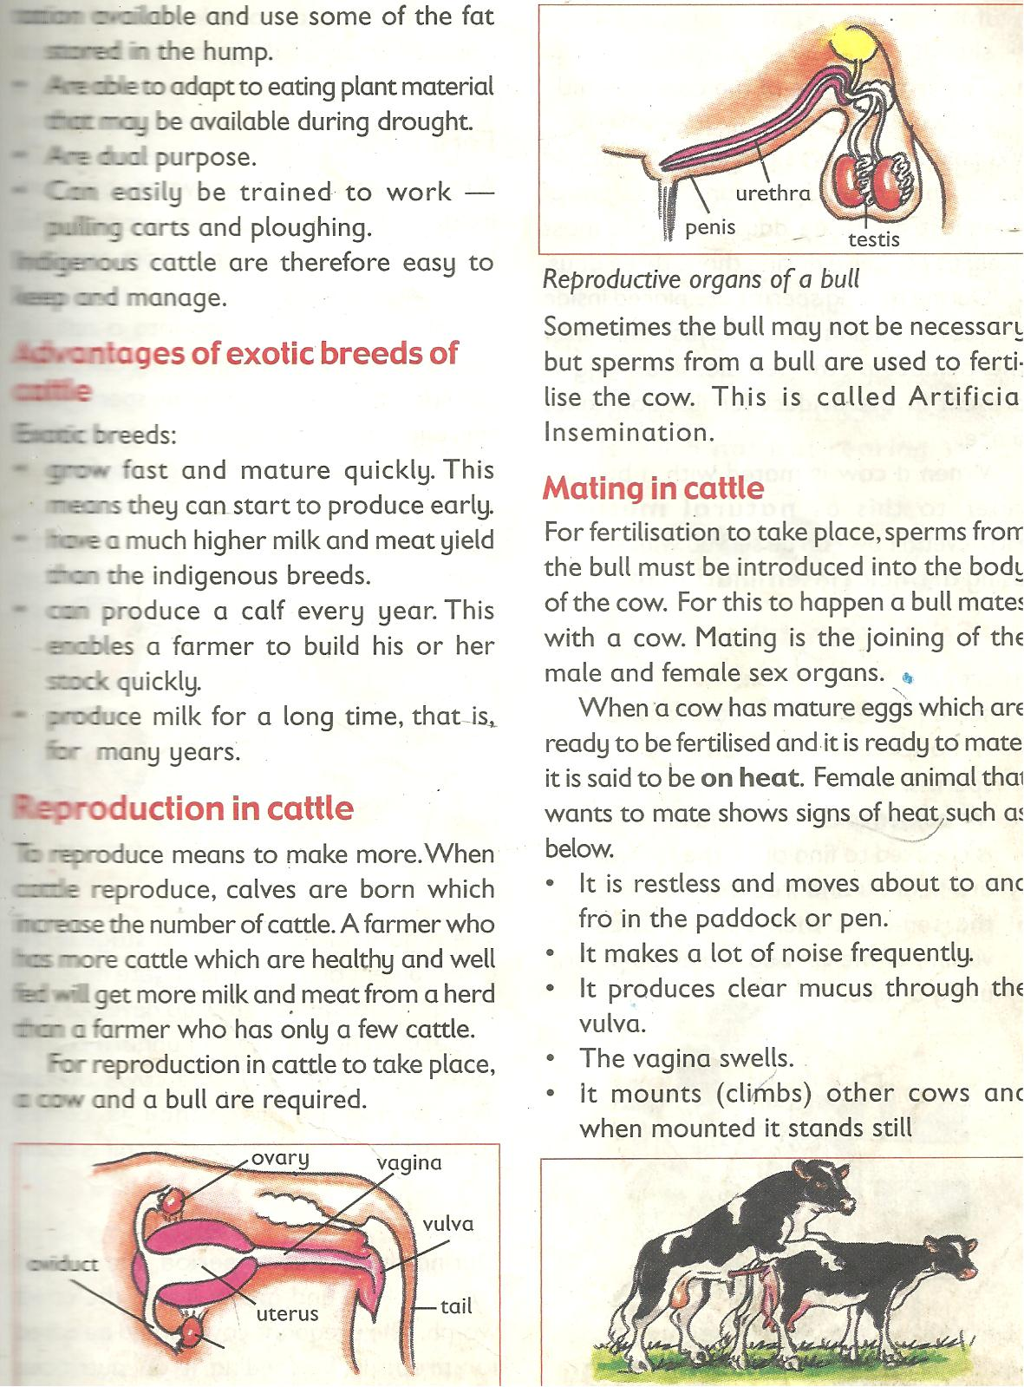

Functions of different parts
Vulva: receives and guides the penis
Vagina: it’s where semen is deposited
Cervix: closes the lower end of the uterus during pregnancy
Ovary: produces the ova and hormones that help to control the sexual cycle
Ova: are the reproductive cells produced by the ovary
Oviduct/fallopian tube: Is the place where fertilization takes place.
Uterus: it’s where implantation takes place (development of the foetus)
Reproductive system of a bull

Sperm duct

Functions of parts
Testes- produce sperms
Sperm ducts – carry sperms
Urethra – passes out urine and sperms
Penis – delivers semen in the vagina of a cow
Learners Activity
- Draw the female reproductive system of a cow and name the following parts
- Oviduct
- Vulva
- Uterus
- Using an arrow, show on your diagram the part where implantation takes place.
- Write the function of the following parts of the system;
- Cervix
- Testis
- Ovary
LESSON 6: HEAT PERIOD AND INSEMINATION (SERVICES)
Heat Period
This is the time when a cow is in need of a bull for mating.
Mating takes place only when a cow is on heat.
Signs of a cow on heat
- It becomes restless
- It mounts other cattle
- It stands while others are lying down
- It urinates frequently
- It puts its tail on the side to enable its vulva to be seen
- There is a mucus discharge from the vulva
- Its vulva swells and changes its colour
- There is a drop in its milk production
- The cow makes a lot of noise (Bellows frequently)

Insemination (service)
Insemination or service is the act of depositing sperms into the female reproductive organ of the cow.
For insemination to take place, the cow or a heifer should be on heat i.e. after showing signs
Types of insemination
- Natural insemination
- Artificial insemination
Natural insemination involves the use of a bull to mount the cow on heat in order to deposit the sperms into the vulva.
Advantages include;
- Natural insemination saves time
- It does not need a trained inseminator in order to carry it out.
Disadvantages
- More sperms are wasted in one cow.
- It’s very expensive to buy and maintain a bull
- Stronger bull can cause injury to weak cows
- Once the bull dies, sperms are also lost.

Artificial insemination
Refers to the act of introducing sperms in the vagina or vulva of a cow by the help of a trained veterinary officer.
Semen used is got from health bulls and with desired characteristics.
Sperms are injected into the vagina using an insemination syringe.
Advantages
- It reduces the cost of keeping many bulls on the far,
- It’s cheaper to buy semen than buying and maintaining a bull.
- It prevents injury to small cows and heifers by bigger or heavy bulls.
- It helps to control inbreeding and unwanted pregnancies in cattle
- It promotes selective breeding.
Disadvantages;
- It’s difficult and expensive to maintain proper storage of sperms.
- It can’t be applied to animals whose signs of heat can’t be easily identified.
- It requires a trained experienced inseminator
- Animals are denied chance to enjoy sex.
Learner’s activity
- Briefly explain the term insemination
- Give two ways in which natural insemination can be dangerous to a livestock farmer
- How does artificial insemination control unwanted pregnancies on a farm.
- Identify three signs of a cow on heat
A DOCUMENTARY ABOUT BREEDING IN CATTLE

WEEK : 5
LESSON 1: OTHER PRACTICES CARRIED OUT ON CATTLE FARMS
Castration
Castration is the removal of the essential male sex organs called testes. The main aim of castration is to make the bull unable to fertilize a cow.
Methods of castration
- Open castration method.
- Closed castration method
- Use of the loop or elastrator method.
In a closed castration method, an instrument called a burdizzo is used to crush the tubes leading to the scrotum.
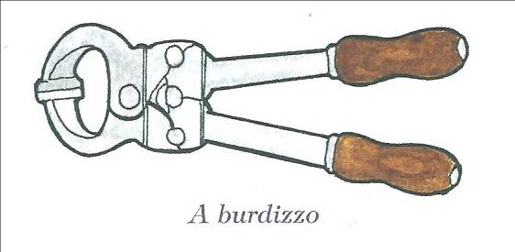
We can also use a rubber ring to seal the sperm ducts and thus killing the epididymis
A drawn structure showing a burdizzo

Note:
When the jaws of the burdizzo are closed, the spermatic cord is crushed destroying the spermatic nerves.
Advantages of castration:
- Castrated bulls grow faster and fatten
- Castrated bulls are calm, humble and easy to handle
- Castration helps to prevent inbreeding (unwanted pregnancies in the herds)
- Castration also helps to prevent diseases on a farm

Disadvantages of castration
- Animals are denied chance to enjoy natural sex.
- There is loss of blood from the animal leading to anaemia.
- The wounds may become septic and animal may die if not treated well.
Note:
The use of the ring prevents blood from flowing into the testis that will cause them to shrive and fall off.
In an open castration, the scrotum is cut open using a razorblade or a sharp knife and the testes are removed.
Learner’s activity.
- Briefly explain the term castration
- Give two reasons why livestock farmers castrate farm animals
- Cite out any two methods of castrating animals
- Why do you think bulls which are not castrated usually get STDs?
LESSON 2 : DEWORMING AND DEHORNING.
Deworming is the act of giving drugs to animals to kill internal worms.
Deworming is done in two ways:
- Drenching is the act of giving liquid medicine to animals through the mouth. It can be by using a drenching gun.
- Dozing. Is the act of giving solid medicine to animals in order to kill internal worms.
Importance of deworming
- Deworming kills internal parasites like tape worms etc.
Dehorning: is the removal of horn buds from the calf to prevent growth of horns.
Dehorning should be done when the calf is about 2-3 months.
Methods of dehorning
- By use of chemical (done between 3-14 days)
- By use of a hot iron (between 7-30 days)
- Use of spoon dehorners. (between 1-2 month)

Advantages of dehorning
- It makes the animal easy to handle
- It increases the space in kraals, milking shades and in vehicles during transportation.
- Many animals can be kept in a small space
- It reduces the risk of injury among cows.
Learner’s activity
- Give a difference between drenching and dozing
- State a reason why livestock farmers should deworm their animals
- State the importance of dehorning from animals

LESSON 3 : STEAMING UP AND CALVING
Steaming up is the act of feeding in calf-cow on feeds rich in proteins.
In calf-cow is one which has shown up signs of pregnancy such as;
- The udder increases in size and filled up with milk.
- There is mucus discharge around the cervix
- The uterus enlarges in size between 2-3 months
Lactation period is a period when a cow produces milk after giving birth.
Calving is the act of giving birth by a cow

Advantages of steaming up.
- It enables the foetus to grow well
- It helps to increase the period of lactation.
- It also prepares the cow for calving.
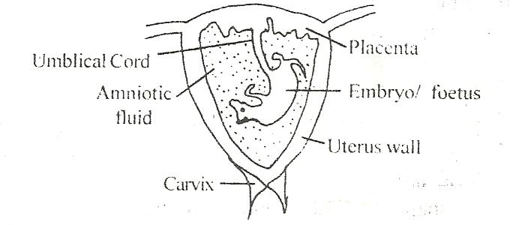
An illustration showing developing foetus

Note:
The placenta stores oxygen and digested food before reaching the foetus.
Umbilical cord is a passage of food and oxygen to the foetus
Umbilical cord also transports wastes from the foetus to the placenta.
Amniotic fluid acts as a shock absorber for any external pressure.
Calving
Calving is the act of producing calves by a cow.
Signs of calving in cows
- Discharge of a lot of fluids from the vulva
- Restlessness
- Loss of appetite
- Labour pains
- Isolation

Colostrum
Colostrum is the first milk produced by a cow after calving.
Importance of colostrums
- Open the digestive tract of a calf
- Provide a calf with a balanced diet
- Boosts the immunity of a cow
Fertilization
This is the union of a male and female gamete to from a zygote. This takes place in the oviduct or fallopian tube.
Learner’s activity.
- Briefly explain the following terms

- Steaming up
- Drying off
- Calving
- How is colostrum important to a calf.
- Why do you think a cow should be separated from the herd before calving?
- List down any two signs of a cow on heat
LESSON 4 : MILKING IN CATTLE
Milking. Is the method of obtaining milk from the cow’s udder.
- Milk is got by squeezing the teats of cow
- Milk is secreted from the mammary glands of a female animal.
- Milk contains over 85% water and 15% proteins fats, calcium, phosphorous

Types of milking
- Hand milking
- Machine milking
Hand milking: is the act of squeezing the teats of a cow using hands.
This method can be used to 1-3 animals.
Machine milking is the act of using a machine to squeeze the teats of cow.
Machine milking is the best for more than five animals.
Note:
A cow can hold up or hide milk if it’s disturbed.
Disadvantages of machine milking
- Needs a trained person to operate machine.
- The machines are expensive to buy.
- The udder may be injured in case of a machine fault.
Ways of obtaining clean milk.
- Prepare the milking place clean and free from dust.
- Wash all the milking containers clean.
- Wash the teats of the cow with warm water to stimulate milk let down.
- Tie the hind legs of the cow and give the cow some feeds to keep busy and relaxed.
- After milking, filter the milk and use a strip cup to detect mastitis in milk.
- Put the milk in clean containers and cover.
Note:
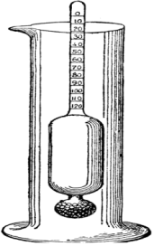
A lactometer is used to detect the presence of water in milk and separates fats from milk.

Structure of a lactometer.

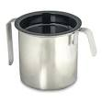
A drawn structure showing a strip cup.

- Before actual milking is done, the milker should smear milk jelly or cream to the teats to prevent them from cracking.
- A cow having mastitis should be milked last and its milk should be poured as treatment goes on.
Learner’s activity
- Identify the type of milking commonly used in your locality
- State how the following equipments are useful to a live stock farmer
- A Strip cup
- A lactometer
- List down three ways of obtaining clean milk
LESSON 5: PRESERVATION OF MILK AND MILK PRODUCTS
Milk products
The following are the products got from well processed milk.
Milk products | How it’s made | Usage
Cheese | Made by sour milk then thickening it by salting | Milked into dishes
Fresh milk | Boiling and refrigerating | Drunk and added to dishes
Skimmed milk | Separating fats from milk | For frying foods
Yoghurt | Turning milk after removing fats | Used to be mixed into rice and other foods
Ghee | Made by boiling butter | For frying foods

Preservation of milk
- Milk should be protected from contamination by bacteria for future use.

This can be done by;
- Pasteurization
- Sterilization refrigeration
- Boiling and quick covering
Sterilization involves killing bacteria in milk with maximum boiling followed by covering it on cooling.
Pasteurization involves strong heating and sealing milk before germs enter.
This method was discovered by Louis Pasteur.
Note:
- Boiling is not preferable method because some milk is lost during evaporation.
Reasons why farmers should keep milk.
- To know the amount of milk produced per a cow at a certain period of time.
- It enables a farmer to select animals with less productivity rate for treatment.
Learner’s activity
- State what you understand by the term milk preservation.
- Give two ways of preserving milk.
- State how yoghurt is made from milk .
- State the importance of the following milk products to people
- Cream
- Ghee
- Butter
- Give two reasons for preserving milk.

LESSON 6 : CATTLE PARASITES
A parasite is an organism that depends on another organism for food and shelter without killing it.
Cattle parasites are divided into two;
- External parasites (ecto-parasites)
- Internal parasites (endo-parasites)
External parasites (ecto parasites)
These are parasites that live outside the body of the animal. They suck blood from the animal.
Examples include:
Ticks, lice, mites, tsetse flies, fleas etc.
Ticks suck blood from the animals and spread tick borne diseases such as;
- East coast fever
- Red water
- Heart water.
- Anaplasmosis
Tsetse flies spread germs that cause Nagana or trypanosomiasis to cattle.
Internal (endo) parasites
These are parasites that live inside the body of the animals and mainly in the intestines.
They suck blood and feed on the digested animal’s food.
They are mainly worms.
Examples include;
- Hook worms feed on blood
- Tape worms feed on digested food
- Liver flukes live in the bile duct or liver.
Ways of controlling cattle parasites
- Spraying the animals using acaricides
- Practicing rotational grazing to avoid tick borne diseases
- Dipping cattle into chemicals
- De-worming cattle to kill intestinal worms
Learner’s activity
- What do you understand by the term parasites?
- Name the two types of parasites
- How do parasites gain entry into the animal’s body?
- Give two examples of external cattle parasites
- Briefly explain two ways of controlling parasites on a farm

WEEK : 6
LESSON 1 : CATTLE DISEASES
Cattle diseases are classified into three groups according to the causative agents i.e.
- Bacterial diseases
- Viral diseases
- Protozoan diseases
Causes of sickness in cattle
- Lack of essential nutrients in their feeds
- Unhygienic conditions like dirty feeding troughs.
- Overcrowding of animals
- Physical injuries and infections caused by micro-organisms
Signs of a sick animal include;
- Animals appears gloomy and restless
- Body temperature may be high or low
- It may pass out urine with strange colours
- Difficulty in breathing or even coughing
- Diarrhea or scouring may occur
Name of disease | How its spread and caused | Signs and symptoms | Prevention control and treatment
Bacterial diseases
Anthrax | - Caused by Bacteria  - Spreads through body contacts and contaminated feeds | - High fever  - Loss of appetite to graze.  - Sudden death  - Blood stained dung | Bury deeply dead animals  Burn the dead animals  Vaccinate animals every year  Separate infected animals
Mastitis | - Caused by bacteria  - Spreads through body contact with an infected animal | - Milk with blood stains or pus  - Swollen and painful teats and udder.  - A cow refuses to be milked and suckled | Early treatment by using antibiotics  Use a strip cup regularly
Pneumonia | - Caused by bacteria  - Spreads from contaminated air and dirty living pens | - Difficult breathing, coughing,  - Nasal discharge  - Loss of appetite  - High fever | Use well ventilated dry and clean pens.  Treat the animal at the early stage of the disease
Tuberculosis | - Breathing in air with tuberculosis bacterial  - Spreads through milk of infected cows | - Coughing  - Loss of weight  - Loss of appetite | Kill infected animals  Separate infected animals from health ones  Have proper sanitation  Early treatment using antibiotics
Viral diseases
Foot and mouth disease | - Spreads through sharing feeding containers  - Through body contacts with infected animals | - Swollen teats and lameness  - Blisters on top of hooves and mouth (muzzle)  - Loss of appetite to graze  - High temperature  - Reduction in milk production | Separate sick animals  Vaccinate after every 6months  Application of a quarantine.
Rinderpest | - Spread through body contact with an infected animal | - Soars in the mouth  - Sunken eyes  - Nasal discharge  - Tears from eyes  - High temperature  - Diarrhea with blood stains | Separate sick animals  Regular vaccination  Slaughter the infected ones
- Protozoan disease
Nagana (trypanosomiasis) | - Spreads through the bites of infected tsetse flies | - Loss of weight  - Anemia  - Loss of appetite  - High fever | Spread the tsetse flies using insecticides
East coast fever | - Through bites of infected ticks  (brown ear tick) | - Nasal discharge  - Diarrhea  - Loss of appetite  - High temperature  - Weakness | Dipping and spraying animals with acaricides to control ticks
Heart water | - Through bites of infected ticks  (brown ear tick) | - Animals walk in circles.  - Animals place their heads on objects  - When the animal falls, legs keep paddling in air | Dipping and spraying animals with acaricides to control ticks  Treat early cases with tetracycline antibiotics and sulphadilimidine
Red water | Spread through tick bites (red ticks Spreads through tick bites (red tick) | - High fever  - Reddish urine due to damaged liver.  - Animal licks soil | Vaccinate regularly.  Dip and spray with the acaricides to kill ticks.

Learner’s activity
- Give a difference between viral and bacterial diseases
- Point out any one cause of sickness in cattle
- Identify the infection of cattle that attacks
- Udder and teats
- Respiratory system of the animal
- Give two ways of controlling cattle diseases
LESSON 2 : GRAZING /FEEDING IN CATTLE
Methods of grazing
There are three main methods of grazing cattle namely;
- Rotational grazing
- Zero grazing
- Herding or free range system
Rotational grazing
This is the type of grazing in which animals graze on one portion of pasture at a time. This can be done using the following systems;
- Paddocking
- Strip grazing
- Tethering

Paddocking
This is when a farmer feeds his animals on a big pasture land divided into paddocks.
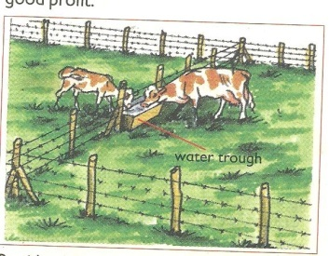
Cattle are fed on grass in a paddock and when the grass is no longer enough they are moved to another paddock.
An illustration of paddock grazing

Advantages of paddock grazing
- Paddocks help to avoid overgrazing
- Paddocking controls pests and diseases
- Paddocking enables the animals to have grass all the time.
- It lessens the labour used to look after the animals after setting up paddocks.
- Paddocks help to control the spread of diseases
- The dung and urine of the animals are evenly distributed.
This allows for new grass to grow well in all paddocks.
Disadvantages of Paddocking
- The materials needed are expensive
- Animals have no choice of the type of plants to eat
- It requires a big portion of land
- The barbed wires can tear the skin of the animals
Strip grazing
This is where small sections called strips are created using temporary electric wires to restrict movements of animals.
Animals graze in gazetted area.
Advantages
- Pasture is evenly used
- Diseases and vectors are controlled
- Labour is reduced on the farm
Disadvantages
- It’s expensive to start and maintain
- It requires few animals to be kept

Tethering
This involves tying the animal on a tree or a peg using a rope to graze in a limited area
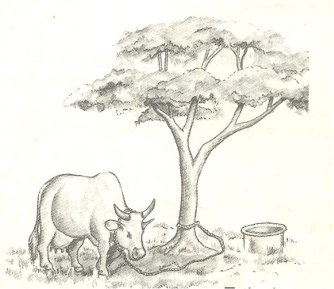
This is the most common method used in East Africa .
A structure showing tethering method

Advantages of tethering method.
- It’s cheap and appropriate to maintain
- No fencing is required
- Pasture chosen by the farmer is always the best
Disadvantages
- It can only work best for few animals
- Animal feeding is only limited to areas around the peg.
- It requires the farmer to keep transferring the animals when pasture is over.
Learner’s activity
- One sentence, show the meaning of the phrase rotational grazing
- Give two advantages of rotational grazing
- Identify any two methods of rotational grazing
- Briefly explain how strip grazing can be a disadvantage to a livestock farmer
- Give two advantages of paddock grazing to a farmer
LESSON 3 : HERDING AND ZERO GRAZING
Herding (free range grazing)
This is a system where animals are left free to graze on different types of pasture as monitored by a herdsman.
This system is mainly practiced by Normadic pastoralists
Advantages
- Animals are able to do some exercises as they graze
- It does not require any fencing
- The animals graze on different pastures of their choice
Disadvantages
- Animals need a herdsman to look after them all the time
- Animals can easily stray and destroy farmer’s crops
- Inbreeding is difficult to control
Zero grazing
This is a system where animals are kept under a special structure and water or feeds are provided.
Small cubicles are made for resting of the animals or feeding.
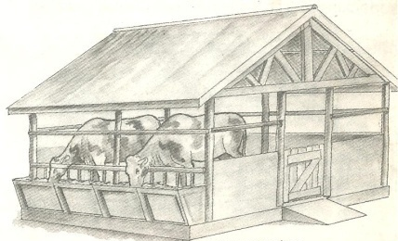
An illustration of zero grazing

Advantages of zero grazing
- It’s easy to collect manure (Farm Yard Manure)
- Animals are easy to control and monitor
- Feeds are not wasted since animals are given only what is enough.
- Animals are protected from bad weather like sunshine and heavy rains
Disadvantages of zero-grazing
- It’s very expensive to start and maintain
- The farmer gets over worked
- There is easy spread of diseases and pests
- It involves of either buying feeds or growing fodder crops
- Much labour is required to feed and monitor the animals
Learner’s activity
- Explain the following terms;
- Herding
- Zero grazing
- Outline any three advantages of herding
- How can zero grazing be a disadvantage to a farmer?

LESSON 4 : HOUSING OF CATTLE AND FENCING
Like any other animals, cattle need good housing. They should be provided with shelter for the following reasons;
- To protect them from bad weather like heavy rain and strong sunshine.
- To protect cattle from thieves and attacks by wild animals
- To maintain their health and ease their feeding
Qualities or characteristics of a good house of cattle
The house for cattle is called a byre / kraal.
It has the following characteristics;
- Well ventilated for free air circulation.
- Has a strong floor made of concrete for easy cleaning.
- Has a slanting to enable urine drain out.
Materials used to build cattle houses include
Wood, concrete, metals, bricks, plastics, stones etc
Fencing
A fence is a barrier of life or dead materials divided in areas of land
There are two types of fences namely;
- Planted fences
- Constructed fences
Planted (natural) fences are made by planting certain types of plants along margins of a given piece of land.
Constructed (artificial) fences, are fences were people-made materials are used to create a barrier along a particular piece of land.
The materials used when constructing artificial fences include;
- Treated poles
- Bubbled wires
- Bricks
- Wire nets
- Chain links, etc
This type of fence is the most popular one.
Importance of fencing
- Natural fences act as wind breaks thus controlling soil erosion
- Natural fences can maintain soil fertility by adding humus to soil
- Fencing controls the spread of pests and diseases to animals
- It also prevents animals from destroying people’s crops
- It allows proper use of pasture and makes culling easy
Learner’s activity
- Give two reasons for housing cattle
- What name is given to the house for cattle
- List any two qualities of a good house for cattle
- What do you understand by the term “fence”?
- Identify any two reasons for fencing farm animals

LESSON 5: STARTING A LIVESTOCK FARM
Livestock refers to the animals kept on a farm. These may include;

- Poultry
- Goats
- Sheep
- Pigs and
- Cattle

Livestock farming is the rearing of farm animals.
It’s important to people in the following ways;
- It’s a source of income when animals and their products are sold
- It’s a source of food
- It provides employment opportunities to people

Requirements for starting a livestock farm.
Land this is a place on which the farm is started. It may be obtained in the following ways;
- By buying
- Through inheritance
- From donation
Capital, this is the money used to buy things needed to start a farm. Some of the things the money may be used for include;
- Buying land if it is to be bought
- Constructing animal houses, stores, office and stationery.
- Preparation of pasture
- Bringing water on the farm
- Paying workers and experts for the treatment an vaccination of the farm animals before the farm starts producing.
- Buying drugs, acaricides and necessary equipments for the farm.
Labour, this includes people who do activities on a farm both skilled and unskilled workers.
Market, in live stock farming, marketing refers to the demand for cattle or their products.
Demand for cattle products means the desire and ability to pay for the products.
Therefore, it’s important to know whether people are ready to buy the products from the farm.
The type of livestock, the farmer needs to identify which animals he or she wishes to keep.
Learner’s activity
- Give a difference between livestock and livestock farming
- Today in Uganda, many people prefer livestock farming to crop growing. Give two reasons for this.
- Identify any two ways of obtaining land for starting a livestock farm.
- List any two activities done by skilled and non-skilled worker on a farm.
- Give two ways in which capital can be used in starting a livestock farm
THEME : THE HUMAN BODY
TOPIC : RESPIRATORY SYSTEM
LESSON6 : ORGANS OF THE RESPIRATORY SYSTEM
The respiratory system:
Respiration is the process by which the body uses food and oxygen to release energy, heat, carbon dioxide and water vapour.
Respiration takes place in the body cells.
Organs/ major parts of the respiratory system.

- Nose
- Trachea Or Wind Pipe
- Bronchus
- Lungs
- Diaphragm

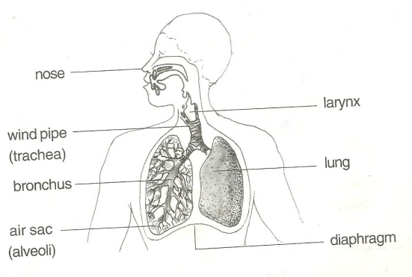
A drawn structure showing the respiratory system.

Functions of the parts
The nose:
- It contains mucus and tiny hair (cilia)
- Cilia traps dust that enters with air
- Mucus helps to moisten and warm air.
- The wind pipe/trachea
- It’s made up of soft bones called cartilage to keep it open all the time
- It also contains hair and mucus
The epiglottis:
- Closes to prevent the food from entering into the wind pipe on swallowing.
The lungs:
- This is the organ where gaseous exchange takes place.
- It has got air sacs (alveoli) with a net work of blood capillaries to absorb oxygen and pass out carbon dioxide.
Rib cage:
- Protect the lungs and heart against external harm.
- It’s also covered with a pleural fluid to prevent friction between the thorax and lungs to the ribs.
Note:
Gaseous exchange takes place at the air sacs.
Learner’s activity
- State the importance of respiration to the body
- Give a reason why it’s not advisable to breathe through the mouth
- How are cilia useful to people during breathing?
- State the importance of the following organs of the respiratory system;
- Nose
- Rib cage
- Epiglottis

WEEK : 7
LESSON 1: BREATHING
Breathing is the act of taking in of oxygen and sending out of carbon dioxide from the body.
Breathing involves exchange of gases in an organism
Breathing starts from taking in air through the nose to the lungs.
Types of breathing:
There are two types namely;
- Inspiration (inhalation) and
- Expiration (exhalation)
Breathing in / inspiration / inhalation.
Inspiration is the act of drawing in air into the lungs through the nose.
The air we breathe in contains more oxygen than carbon dioxide.
We breathe in to increase oxygen supply in the body
Oxygen is used by the body to burn food and produce energy during respiration
Respiration is the oxidation of food to produce energy in the body cells
Events during inhalation / breathing in.
- The diaphragm moves downwards. (Diaphragm contracts and flattens)
- Ribs move upwards and out wards.
- Lungs expand
- The chest increases in volume
- Air is drawn into the lungs.

Expiration / breathing out / exhalation
This is the act of taking out of air from the Lungs through the nose.
- We breathe out to reduce carbon dioxide in the body.
- Air we breathe out contains more carbon dioxide than oxygen
- During breathing out, we also lose excess heat and vapour from the body.
Events during expiration / breathing out / exhalation
- The diaphragm moves upwards to its domed shape.
- The ribs move down wards and inwards
- The lungs reduce in size
Note:
- Carbon dioxide dissolved in the blood plasma diffuses from the capillaries into the alveoli and exhaled out.
- Abrupt coughing is caused when an external matter enters the trachea or wind pipe
Learner’s activity
- Differentiate between breathing and respiration
- State what happens to the following parts during breathing in
- Diaphragm
- Lungs
- Intercostals muscles
- By what process does carbon dioxide move from capillaries to lungs?

LESSON 2: ADAPTATION OF THE AIR SACS TO THEIR WORK
Gaseous exchange in the alveolus
Gaseous exchange takes place in the alveoli and in the air sacs of lungs.
When blood reaches the alveoli, carbon dioxide is lost and oxygen is added to blood.
Oxygen is able to be added to blood and carbon dioxide is lost by a process called diffusion.

An illustration showing gaseous exchange at the alveoli.
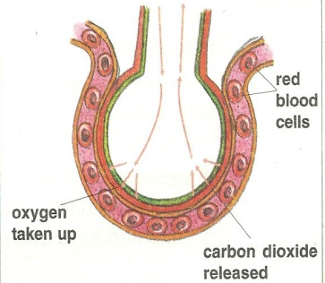

Note:
- Alveoli are plural while alveolus is singular.

How are air sacs suitable for gaseous exchange
- They are thin walled to allow gaseous diffusion through.
- They are surrounded by a network of blood capillaries.
- They are many in number to provide a large surface area to ease gaseous exchange.
Summary of the composition of inhaled and exhaled air
Gas | Inhaled air | Exhaled air
Oxygen | 21% | 16%
Carbon dioxide | 0.03% | 4%
Nitrogen | 78% | 78%
Water vapour | Less | More
Rare gases | 0.97% | o.97%
Note:
- As we breathe out, more carbon dioxide is expelled because some is added from the body cells.
- Nitrogen is left unchanged because it is not necessary in the body.
- We breathe out less oxygen because most of it is used by the body during respiration process.
Learner’s activity.
- State two ways in which air sacs are adapted for exchange of gases.

- Study the table below and answer the questions that follows;
Component | Inhaled air | Exhaled air
Oxygen | 21% | 16%
Nitrogen | 78% | 78%
Carbon dioxide | 0.03% | 4%
Briefly explain why;
- Exhaled air contains little oxygen
- Concentration of nitrogen remained unchanged
- Exhaled air contains more carbon dioxide

LESSON 3 : DISEASES OF THE RESPIRATORY SYSTEM.
Respiratory diseases are diseases that affect people’s respiratory organs i.e. the lungs, trachea, nostrils, and bronchioles.
- Some respiratory diseases are communicable diseases spread through contaminated air while others are non-communicable caused by smoking.
- Some respiratory diseases are hereditary spread from parents to the babies.

Diseases of the respiratory system.
Diseases | Signs and symptoms | Prevention / control
Lung cancer (caused by smoking) | - Chest pain  - High fever  - Coughing | - Avoid smoking tobacco  - Seek medical treatment
Influenza (flu)  (caused by virus) | - Difficulty in breathing  - Constant coughing and sneezing | - Drink a lot of fluids
Pneumonia caused by either bacteria or virus | - Difficulty in breathing  - Coughing  - Fever | - Wear warm clothes during cold weather.  - Treat using antibiotics.
Bronchitis (caused by bacteria) | - Difficulty in breathing | - Avoid smoking  - Avoid staying in ventilated places.
Tuberculosis. (caused by bacteria) | - Coughing for a longtime  - Thick mucus spitting with spotted blood  - Chest pain | - Isolate the infected ones  - Immunise using children BCG  - Vaccine  - Avoid drinking unboiled milk.
Whooping cough  (caused by bacteria) | - Blocked nose  - Coughing spasm  - Difficulty in breathing  - Running nose | - Drink fluids rich in vitamins  - Immunise children with DPT vaccine.  - Avoid overcrowded and poorly ventilated houses/places.
Asthma (allergies) | - Difficulty in breathing  - Body weakness during cold weather.  - Mucus flow | - Go for medical attention  - Keep away from sources of allergies e.g. cold pollen grains.
Diphtheria (caused by bacteria) | - Sore throat  - Convulsion | - Immunise the infants using DPT vaccine  - Go for medical treatment in time.

Learner’s activity.
- Identify any two diseases of the respiratory tract
- Describe any two ways of keeping the respiratory system in a healthy working condition.
- Draw the structure of the respirator system and name the parts;
- Trachea
- Left bronchus
- Diaphragm
- Lung
WATCHING DOWN LOADED INFORMATION ON HOW LUNGS/ ALVEOLI WORK (PRACTICAL)

THEME : THE ENVIRONMENT
TOPIC : RESOURCES IN THE ENVIRONMENT
LESSON 4 : DESCRIPTION OF RESOURCES
Resources
- A resource is any material used for certain purpose.
- A resource is anything that can satisfy people’s needs.
- A resource can be any object or living component of the environment.
Types of resources
- Renewable resources / inexhaustible resources
- Non- renewable resources / exhaustible resources
Renewable resources are resources that can be replaced naturally when used up.
Renewable resources include;

- Water
- Plant
- Animals
- Air
- Soil
- Sunshine

Importance of plants as resources.
- Some plants are eaten as food.
- Plants provide wood fuel to people when dried
- Some plants are used as herbal medicine to cure animal diseases.
- Plants provide raw materials for furniture and crafts
- Plants help in the rain cycle through transpiration.
Non-renewable resources. These are resources that cannot be replaced naturally when used up.
These resources can be exhausted in case they are not properly handled and preserved.
Examples include;

- Rocks
- Petroleum
- Minerals
- Sand
- Clay Soil

Ways people use animals a resource
- Animals products (meat and milk) are good sources of proteins to people’s diets.
- Animals provide labour such as pulling carts, ploughing and for transport.
Examples of such animals include;

- Horses,
- Camels,
- oxen.
- Donkeys.

Learner’s activity
- Differentiate between renewable and non renewable resources
- Give two examples of renewable resources in your environment
- Write one sentence to explain why copper is regarded as a non renewable resource.
- Stat one way in which the following can be used as a resource.
- Water
- Soil

LESSON 5: NON LIVING THINGS AS RESOURCES
Non-living components in the environment are used by people for certain purpose.
These include: air, water, soil, sun and minerals.
- Water is a renewable resource because it can be replaced naturally through the rain cycle.
- Air is also a renewable resource because it can’t get exhausted in the environment.
- Air is a mixture of gases such as, oxygen, carbon dioxide, nitrogen, argon, krypton, neon etc.
- Wind is air in motion caused due to difference in temperature of places.
Ways air is used as a resource in the environment.
- Air from the environment is breathed in by people and animals
- Oxygen from the atmosphere helps in the processes of germination, burning and rusting.
- Carbon dioxide gas is also used as a preservative gas for tinned or canned foods.
- Carbon dioxide is used in fire extinguishers.
Ways water is used as a resource.
- Fast flowing water helps in turning turbines used in generation of hydro-electric power.
- Water serves as a habitat for aquatic life 9fish, amphibian, marine mammals etc)
- Water helps in plant processes such as germination and photosynthesis.
- Water is used as a raw material in industries and for cooling machines.
- Water is used for domestic activities.

LESSON 6 : NON LIVING THINGS AS RESOURCES
Minerals in the environment
- Minerals are resources dug from underground
- Minerals were formed from the remains of animals and plants that lived many years ago after their death and decomposition.
- Minerals are non-renewable resources in the environment
Examples include;
Oil, clay, chalk, copper, gold, petroleum, uranium, coal, rocks, tin etc
- Minerals from which metals are made are got from ores which contains more than one metal.
- Coal and oil are used to provide fuel in many ways. Coal can also be burnt to produce thermal electricity.
- Crude oil is taken to refinery to obtain pure oil by a process called fractional distillation.
Products obtained from petroleum.

- Petrol
- Diesel
- Oil
- Kerosene

A rock is made up of many minerals tightly packed to form a solid.
Fossils are remains of plants and animals that had lived many years ago.
Their remains include; bones, teeth, roots, stems or leaves.
Fossils are mainly found in stone quarries
Uses of rocks
- Rock contains minerals
- Rocks describe the earth’s history
- Rocks are used as raw materials for construction work
Learner’s activity
- Write any one way in which each of the following can be used as a resource;

- Water
- Sun
- Soil
- Air
- How can rocks be useful to people? (Give one way)
- Briefly explain the term fossils
WEEK : 8
LESSON 1 : ALLOYS
Alloys
An alloy is a mixture of two or more metals
Examples of alloys include;

- Brass
- Bronze
- Cupronickel
- Solder
- Dentist amalgam

Importance of making alloys
- Alloys make the metal harder
- Alloys lower the melting points of metals.
- Alloys make the tear or wear of metals difficult

Metals used to make alloy include;

Copper
Zinc
Tin
Mercury and lead

A table showing an alloy, how it’s made and its use.
Alloy | Combination | Importance
Brass | Copper and zinc | Decorating the ornaments  Making wires, tubing cases of bullets
Bronze | Copper and tin | Decorating metals  Making coins
Solder | Leas and tin | Filling dental cavity in the teeth
Cupronickel | Copper and nickel | Making silver coins
Manganese steel | Iron and manganese | Making garden gates etc.

Note:
Fuels are materials that can burn to give out heat and light.
Examples of fuels include; charcoal, coal oils, fire wood (petroleum)
Learner’s activity
- Briefly explain the term alloy
- Give two examples of alloys
- State then importance of the following alloys;
- Brass
- Manganese steel
- Cupronickel
- Point out any two uses of alloys in our society

LESSON 2 : CONSERVATION OF RESOURCES
Conservation is the protection of the resources in the environment from exhaustion.
Conservation involves caring for the resources to avoid the exhaustion for future use.
Man uses resources from the environment to obtain useful energy.
Plants from the environment provide fibres such as sisal, jute, cotton and linen.
A fibre is any material from plants or animals that is made up of threads and can be used as a resource.
Examples of plant fibres
Sisal, cotton wool, banana fibres, raffia, helm etc
Examples of animal fibres
Silk, mohair, wool, fur etc
- Animals provide energy for pulling carts and ploughing e.g oxen
- Animals Also provide transport e.g. donkeys, horses and camels.
- We need to conserve plants, animals, minerals, water, soil, wildlife etc.
- Wildlife refers to animals and plants in the entire environment outside our homes.

Ways of conserving resources in the environment.
- Use of modern farming practices such as terracing, inter cropping etc.
- Enforcing laws against bush burning and swamp drainage.
- Gazetting and protecting swamps and forests.
- Practicing agro-forestry, reafforestation and afforestation.
- Use of other alternatives to wood fuel such as use of solar electricity.
Learner’s activity
- What do you understand by the term conservation of resources?
- Give two ways of conserving the following resources in our environment
- Wild life
- Soil
- Minerals
- Briefly explain the term fibre
- Give two examples of plant fibres

