SECTION A (40 MARKS)
1. Name the major source of water in your environment.
_________________________________________________________________________
2. Give one source of food.
_________________________________________________________________________
3. Mention the organ of the body used for seeing.
_________________________________________________________________________
4. State one way of keeping ourselves clean.
_________________________________________________________________________
5. What is a habitat?
_________________________________________________________________________
6. Which direction does the sun rise from?
_________________________________________________________________________
7. Mention one animal kept at home.
_________________________________________________________________________
8. From which component of the environment is the item below made?

____________________________________________________
9. Give one use of water at home.
_________________________________________________________________________
10. Which insect pollinates flowers at night?
_________________________________________________________________________
11. How are toilets important at school?
_________________________________________________________________________
12. Besides a mosquito, mention one other insect that undergoes a complete life cycle.
_________________________________________________________________________
13. Which part of a flower protects it in bud stage?
_________________________________________________________________________
14. Which gas do animals need during respiration?
_________________________________________________________________________
15. Why do school children wash hands before eating?
_________________________________________________________________________
16. In the space below, draw an egg.

17. A car can move. Why is it not regarded to as a living thing?
_________________________________________________________________________
18. Give any one example of an aquatic animal.
_________________________________________________________________________
19. How can we promote sanitation at school?
_________________________________________________________________________
20. Which clouds gives man rain?
_________________________________________________________________________
21. What is food preservation?
_________________________________________________________________________
_________________________________________________________________________
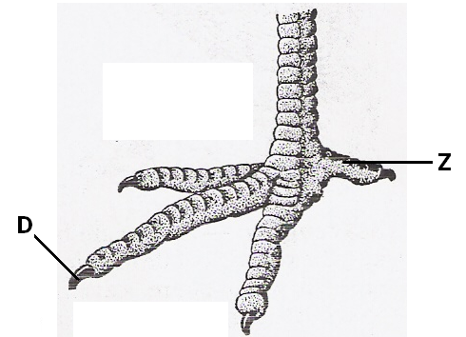22. Name part marked X of hen’s leg below.

_____________________________________________________
23. Why isn’t a mushroom regarded to as a plant?
_________________________________________________________________________
24. How is a fire extinguisher useful at home?
_________________________________________________________________________
25. ____________________are to spider as gills are to fish.
26. Why do birds move from place to place?
_________________________________________________________________________
27. Give one agent of pollination.
_________________________________________________________________________
28. How are houseflies able to carry disease germs?
_________________________________________________________________________
29. Give one type of germination.
_________________________________________________________________________
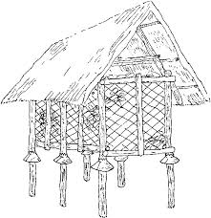
30. Name part marked Y on the diagram below.

y
_____________________________________________________
31. How useful is part Y above to the granary?
_________________________________________________________________________
32. Identify one responsibility of a child at home.
_________________________________________________________________________
33. Inwhich way is electricity helpful at home?
_________________________________________________________________________
34. Write P.H.C in full.
_________________________________________________________________________
35. Which activity is done after eating food to keep teeth healthy?
_________________________________________________________________________
36. How can you make water safe for drinking?
_________________________________________________________________________
37. Mention one way of caring for crops.
_________________________________________________________________________
38. What is the use of a trowel to a farmer?
_________________________________________________________________________
39. Which eye disease is spread by a housefly?
_________________________________________________________________________
40. _____________________are to animals as stomata are to plants.
SECTION B (60 MARKS)
41. a) What are vectors? _____________________________________________________
_________________________________________________________________________
b) Give any two examples of vectors.
i) _________________________________ ii) ______________________________
c) How can we prevent mosquitoes at home?
_________________________________________________________________________42. Name the parts of a flower below.
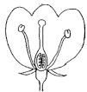
X X ___________________________
T ___________________________
T V ___________________________
Q ___________________________
V
Q
43. a) Define personal hygiene.
_________________________________________________________________________
_________________________________________________________________________
b) Identify one activity done to promote personal hygiene.
_________________________________________________________________________
c) Draw and name any two items used to promote personal hygiene.

44. Match the following.
A B
kidding rabbits i) kidding ______________________
calving sheep ii) calving ______________________
lambing goats iii) lambing ______________________
kindling cows iv) kindling ______________________

45. Study the diagram below carefully.
V
K

a) Name the processes marked.
i) K _________________________________ ii) V _________________________
b) Identify the function of the sun to the above process.
_________________________________________________________________________
c) Mention any one example of a water source.
_________________________________________________________________________
46. a) Besides oxygen and moisture, state any other requirement for a seed to germinate.
_________________________________________________________________________
b) Mention any two types of germination.
i) _________________________________ ii) ______________________________
c) Which part of a seed grows into a seedling?
_________________________________________________________________________
47. a) Tom left his hoe outside for a night. Later in the morning, he found the reddish
brown coating on his metal. Name the reddish brown substance.
_________________________________________________________________________
b) Give any two ways of preventing the above reddish brown substance.
i) ____________________________________________________________________
ii) ____________________________________________________________________
c) Identify the similarity between rusting and germination.
_________________________________________________________________________
48. a) Give one reason why food is preserved.
_________________________________________________________________________

b) Give any two methods of preserving food.
i) _________________________________ ii) ______________________________
c) Identify one way how seeds are preserved.
_________________________________________________________________________
49. a) What isan accident?
_________________________________________________________________________
_________________________________________________________________________
b) Identify any two common accidents at school.
i) _________________________________ ii) ______________________________
c) How is the structure below useful to a firstaider?
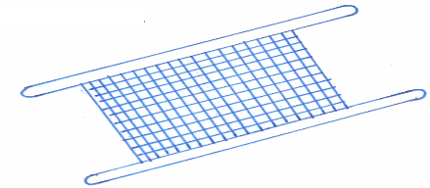
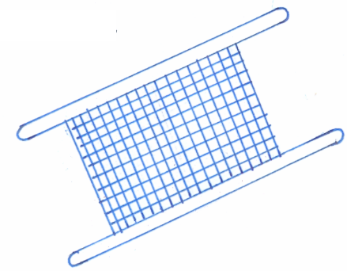
x
________________________________________________
50. Weeding is the removal of unwanted plants from the garden.
a) Give two examples of such plants.
i) _________________________________ ii) ______________________________
b) Which garden tool is used for weeding?
_________________________________________________________________________
c) Besides weeding, identify any one other activity done to care for crop.
_________________________________________________________________________
51. Study the weather instrument below.
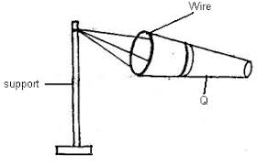
a) Name the instrument above.
_________________________________________________________________________
b) Identify the major function of the instrument above to farmers.
_________________________________________________________________________

c) Which element of weather is measured by the above weather instrument?
_________________________________________________________________________
d) Give one danger of wind to people.
_________________________________________________________________________
52. a) What is air? __________________________________________________________
_________________________________________________________________________
b) Mention any three gases that make up air.
i) _________________________________ ii) ______________________________
iii) _________________________________
53. a) What name is given to the food made by plants?
_________________________________________________________________________
b) Mention any two requirements needed by plants to make the above food.
i) _________________________________ ii) ______________________________
c) What is given out during the process of photosynthesis?
_________________________________________________________________________
54. a) What are germs?______________________________________________________
_________________________________________________________________________
b) Mention any two types of germs.
i) _________________________________ ii) ______________________________
c) Identify one place where germs are found.
_________________________________________________________________________
55. Give the habitat of the following animals.
a) fish _________________________ b) rabbit ___________________________
c) pig __________________________ d) dog ____________________________
Success!

