456/2
Mathematics
Paper 2
XXXXXX
2 ½ hours

Uganda Certificate of Education
MATHEMATICS
Paper 2
2 hours 30 minutes

INSTRUCTIONS TO CANDIDATES:
Answer all the questions in Section A and any five from Section B.
Any additional question(s) answered will B not be marked.
All necessary calculations must be shown clearly with the rest of the answer.
Silent, non-programmed scientific calculators and mathematical tables with a list of formulae may be used.

SECTION A (40 MARKS)
Answer all questions in this section.
- Evaluate without using tables or calculators $\frac{8×{10}^{11}×{(2×{10}^{-3})}^{4}}{3.2×1.6×{10}^{8}}$ (4marks)
- The line $y=mx+c$ passes through the points $A(0, -2)$ and$B(-5, 4)$. Find the values of $m$and $c$. (4marks)
- Mukasa borrowed $sh. 400,000$ from a bank, for construction of rental houses, at 18% interest per annum. He spends $sh. 4,000$ every year on other expenses on the house. Determine how much he has to charge as monthly rate, if he also has to save $sh. 11000$ per month. (4marks)
- Find the unknown values in the arrow diagram for the mapping
X 2(x+1)
Given below
5
p
q
11
13
12
16
22
24
r

- The functions $f\left(x\right)=$ $\frac{x}{3}-\frac{3x-7}{5}$ and $g\left(x\right)=$ $\frac{x-2}{6}$ Find the value of $x$ for which $f\left(x\right)=g\left(x\right).$ (4marks)
- Without using tables or calculators, solve the equation:
$\log\left(5x-4\right)=\log\left(x+1\right)+\log{4.}$
- In a class of 40 students, 12 enrolled for both English and German. 22 enrolled for German. If the students of the class enrolled for at least one of the two subjects, then how many students enrolled for only English and not German? (4marks)
- Given that $A\left(5, -3\right)B$ and $(11, 15)$ are two points on a plane. Determine the position vector of the point C which divides AB in the ratio $1:2$ . (4marks)
- Use logarithms to solve for $x;$ $3^{x+1}=18.72$ (give your answer correct to 3 significant figures) (4marks)
- On your answer sheet, tabulate the information in the graph below.(4marks)

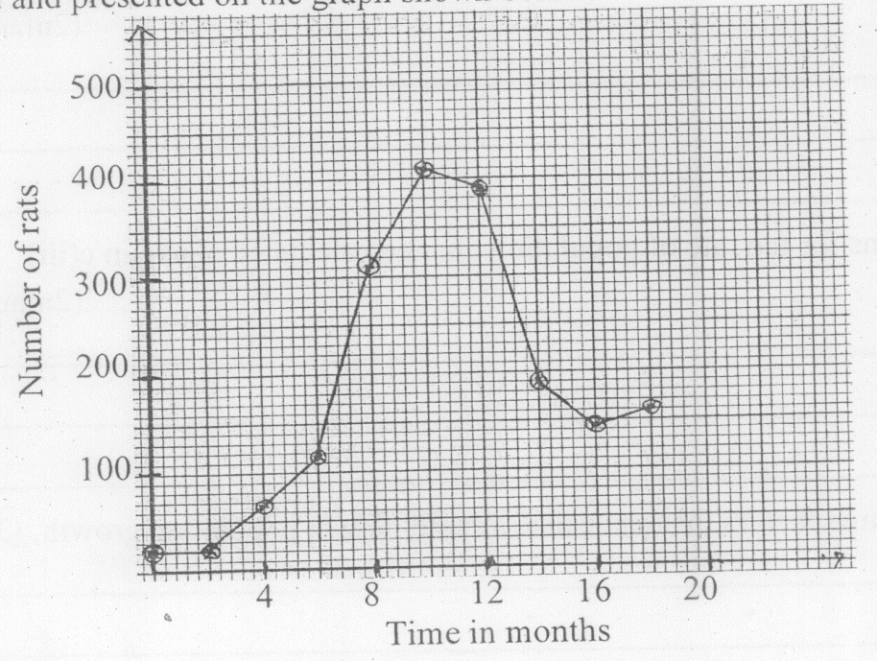

SECTION B (60 MARKS)
Attempt any five questions in this section. All questions carry equal mark.
- The figure below shows a cuboid with sides $AP=10 cm, AB=20cm$and
$BC=8 cm$. The points $K, L, M$ and $N$ are the midpoints of $AD, AB, PQ$ and $PS$ respectively. (4marks)
B
A
L
D
K
C
M
R
Q
P
S
N

- Calculate $\left|KL\right|$ (4marks)
- Calculate the angles between the faces $ABQP$ and the plane $KLMN.$(4marks)
- Point $O$ is the point of intersection of the diagonals $AC$ and$BD$. Calculate $\left|RO\right|.$ (4marks)
- Given that $f\left(x\right)=5x+4$ and $g\left(x\right)=$ $\frac{x}{3-2x}$
- $fg(x)$
- $g^{-1}\left(2\right)$ (6marks)
- The value of $x$ for which $g^{-1}f\left(x\right)=0$ (6marks)
- On his journey to Masaka, Kato rides a bicycle for 45 km from Kampala to Mpigi at a speed of $22\frac{1}{2}$ to catch a staff bus. He waits for the bus for 15 minutes. The bus sets off at exactly $09:00 am$ from Mpigi and it is restricted to an average speed of $68 kmh^{-1}$. A non – stop staff mini bus sets off at $08:40 am$ from Masaka to Kampala, 130$km$ apart, where it arrives at $10:20 am.$
- Determine the time Kato sets off from his home in Kampala (2marks)
- Represent the journeys on a distance time graph and use it to determine;(6marks)
- The distance form Masaka where the two buses meet. (2marks)
- The time at which the bus from Mpigi arrives at Masaka. (2marks)
- Thirty four first year university girls were asked to choose their favorite colour from black (B), red (R) and green (G). 20 chose Black. 16 chose Red. 22 chose Green. 2, 1 and 3 girls chose only black, red and green respectively. 6 girls chose all the three colours. The number of girls who chose red and green only was the same number that did not choose any of the three colours.
- Use a Venn diagram to represent the given information. (4marks)
- Find the number of girls that chose;
- none of the three colours.
- green and black only
- black and red only (5marks)
- What is the probability that a girl chosen at random from the group chose at most two colours. (3marks)

- (a) A triangle ABC is right angled at B. Given $A\left(1, 3\right), B\left(1, 5\right)$ and $C(-3, 5)$, determine vectors AB and BC. Hence find the area of the triangle ABC (6marks)
(b) Given vectors $a$ and $b$, find the values of $m$ and $n$ such that:
$m\left(2a+b\right)+n\left(3a+b\right)=3a+2b$ (6marks)
- (a) Given that $\log_{10}{2}=0.301$ and $\log_{10}{5}=0.699$, use these values to find $\log_{10}{6.25}$ (6marks)
(b) If $5^{x}×5^{4y}=1$ and $3^{x}×3^{3y}=3^{-2}$ calculate the value of $x$ and $y$ (6marks)
- (a) Kato bought a bicycle at shs. 345,000 at the beginning of 2015. The bicycle depreciates at a rate of 15% per annum. If Kato sold the bicycle at a loss of 30% at the beginning of 2018, determine the price at which he sold the bicycle. (6marks)
(b) A motorcycle is being sold in cash and hire purchase. The cash value is $shs. 1,935,000$. On hire purchase, a 45% of the cash value is made and followed by equal monthly installments of 8.5% of the cash value for 9 months. Calculate the money saved when one buys in cash rather than hire purchase.(6marks)
END

