UGANDA CERTIFICATE OF EDUCATION
GEOGRAPHY 273/ 2
MARKING GUIDE
- (a) A sketch map of Nigeria showing selected features
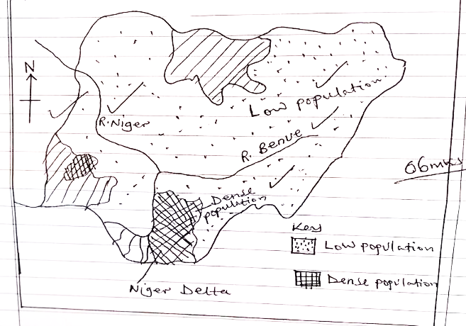
b) (i) Population density is the total number of people per unit area. (02mrks)
(ii) Explain the factors which have influenced population distribution in Nigeria
- Presence of fertile alluvial soil in the delta area attract dense settlement, the northern part of Nigeria has unproductive soil hence sparse population.
- Presence of rainfall in the southern part of the country attract dense settlement
- The northern and central parts experience dry conditions which discourage settlement hence are sparsely populated.
- Some parts of the delta area are poorly drained therefore are associated with low population
- Presence of pest and diseases in some parts of the delta and northern Nigeria has left areas un inhabited
- Presence of large mineral deposits especially oil in the delta region attract many people for employment. 1d max 3 exp max3 /6mks
c) Outline the problems caused by high population density in Nigeria
- Land fragmentation leading to decline of food production
- High rate of crime due to unemployment problem leading to poor standards of living to people
- Poor sanitation due to overcrowding of people
- Easy spread of diseases due to scarcity of health facilities hence loss of lives.
- Shortage of land due to high population leading to land fragmentation
- Development of slums due to limited accommodation
- Overcrowding of people
- Unemployment problem leading to low standard of living to people. Max (06 mrks)

d) Explain the measures being taken to control the problems in © above
- Promoting land consolidation to solve the problem of land fragmentation
- Importation of food from other countries to supplement on what can be produced.
- Vertical building to create more accommodation facilities for people
- Encourage use of family planning method to control population growth
- Establishment of more health facilities to control diseases.
- Deploying security in the area to create peace. Max 5mrks
- (a) A sketch map of Egypt showing R. Nile, canal, mining areas and towns.
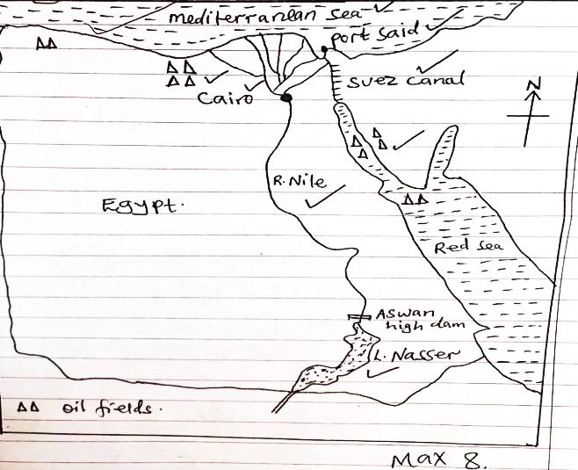
b) (i) Describe the process involved in the extraction of oil.
- Mining of oil starts with explolation/prospecting/survey to establish the presence of the mineral
- After its discovery, they install oil rigs or derricks
- This is followed by drilling into oil seams in the sedimentary rocks underneath.
- After reaching the oil seams they instal oil pumps which are to be used for pumping out the oil.
- The crude oil is then pumped out of the oil seams.
- This is followed by transportation of the crude oil through pipes, fuel tankers. Max (4mrks)
(ii) Explain the factors which have influenced the oil mining sector in Egypt.
- Presence of productive oil fields that have made the oil sector sustainable
- Availability of large sums of capital provided by government to buy the necessary oil drilling equipment
- Advanced technology has enabled the extraction of oil from deep in the interior of the earth
- Presence of large market for the oil both local and foreign market
- Availability of skilled labour provided by large population in Egypt to work on the oil fields
- Availability of efficient transport means esp. pipelines that ensure safe delivery of the oil
- Positive government policy that supports oil mining through provision of capital.
- Presence of large oil reserves near the earth surface.
- Presence of relatively flat landscape making oil mining less costly (Max. 6mrks)
(c) Outline the benefits of oil mining to the economy of Egypt
- Provision of employment opportunities to people leading to improved standard of living
- Improved standards of living through increased income
- Source of government revenue through taxation leading to development of economy
- Diversification of the economy as an alternative source of foreign exchange
- Development and growth of towns such as Suez, Part Said etc.
- Generation of foreign exchange from exports of oil leading to development of social services.
- Development of infrastructure such as roads, railways
- Promotion of internationals relations through international trade
- Provision of raw materials such as crude oil
- Development of industries such as oil refining Max (04mrks)
(b) State the problems facing oil mining sector in Egypt
- Competition for market with other producers e.g. Libya, Algeria
- Shortage of skilled labour to work in oil fields leading to low output
- Price fluctuation in the international market leading to reduce income
- Inadequate capital to invest in oil mining fields
- Exhaustion of oil leading to low output
- Political instability which disrupts mining activities
- Profit repatriation by foreign mining companies leading to low income
- Labour unrest due to demands for improvements in their working conditions.
- High taxes which discourage investors. (Max = 3mrks)
3(a) A sketch map of Africa showing Rivers, Lakes and Highlands.
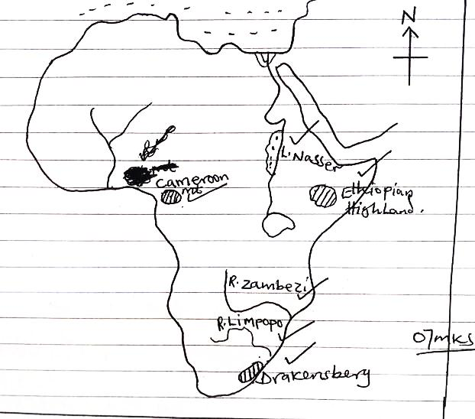
- Formation of Mt. Cameroon/Ethiopian/Drakensberg
- Formed by the process of volcanicity
- Molton rock from the interior of earth is forced onto the earth’s surface through a vent
- On reaching the earth’s surface it cools and solidifies around the vent into layers of ash and lava
- Some of the molten rock reaches the surface through subsidiary vents hence create s subsidiary/ parasitic cones.
- After mountain building a crater remains on top of the volcano (Max 3mks)
Diagrammatic illustration
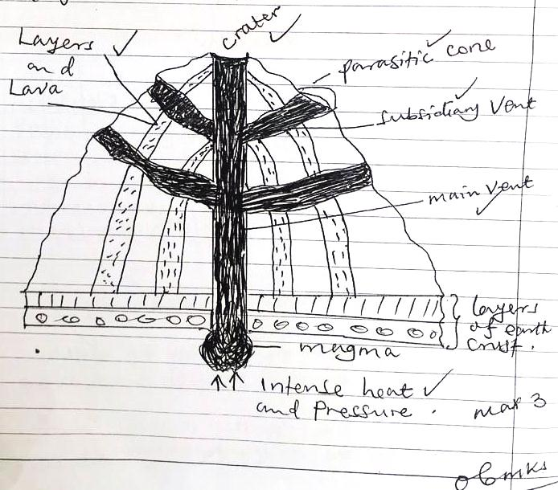
(06 mrks)
c) Explain the contribution of any one high land to the development of the country where it’s located e.g. Ethiopian highland.
- Source of valuable minerals such as diamonds, gold hence earns foreign exchange
- Water catchment areas e.g. R. Omo from the Ethiopian highland
- Tourist attraction which earn foreign exchange to the country
- Gentle slopes support growth of forests which provide wood fuel and timber
- Promote arable farming e.g. growing of Arabica Coffee due to presence of fertile soils
- Modification of climate formation of the rainfall on the windward side to support agriculture.
- Settlement on the lower slopes because of the cool temperatures.
- It is centre for education and research purposes. (Max 06 mrks)
d) (i) Outline the problems faced by people living in the highland areas of Africa
- Steep slopes restrict human settlement
- Highlands limit agricultural mechanization
- Highlands are a barrier to construct transport and communication network
- Hot temperatures and shortage of rain fall on the leeward side which limits settlement
- Steep slopes accelerate soil erosion
- High land areas have dangerous wild animals
- Highland areas are very cold which limits human settlement. Max (03 mrks)
(ii) Outline the steps that should be taken to solve the problems above
- Terracing the hilly slopes
- Afforestation to control soil erosion
- Use of irrigation farming on the leeward side
- Use of underground tunnels to improve on transport means
- Relocation for the people for settlement
- Use of family planning to control population growth
- Deployment of security personnel
- Gazetting the areas for wild animals (Max 03mks)
4. (a) (i) The rivers marked
R1 - R. orange
R2 - R. Vaal
(ii) Dams marked
- Verwoerd dam
- Kalkfontein
(iii) Highland marked
C - Drakensberg
(iv) towns marked
3-Petrusville
4- Bethulie Max (07mrks)
b) Describe the conditions which influenced the development of the Orange River project.
- Presence of many rivers and its tributaries which provide water for both domestic and industrial use.
- Presence of hard basement rock providing a strong foundation for the dam construction
- Existence of a wide/abroad valley to accommodate the water reservoir
- Availability of extensive land to construct the dam and other related infrastructure
- Existence of many water falls providing a suitable site for HEP generation
- Presence of a narrow gorge ideal for the establishment of a dam.
- Presence of large sums of capital to invest in dam construction provided by foreigners.
- High levels of technology involving use of machinery to produce quality work
- Positive government policy that supported the project by providing the capital
- Presence of skilled and semi-skilled labour force to construct the dam and other infrastructure Max (08 mrks)
c) Explain the contribution of the Orange River project to the development of S. Africa.
- Provision of HEP for industrial and domestic use
- It has led to control of floods ensuring better agricultural output
- Source of employment opportunities who earn income leading to improved standards of living
- Growth of towns with its related advantages like trade and commerce
- Generation of income leading to better standards of living
- Development of infrastructure such as roads, railways
- The project provides water for irrigation hence increasing food production
- Provision of fresh water for domestic and industrial use.
- Development of industries which provide employment to people
- Source of foreign exchange through power exports leading to development of social services
- Source of government revenue from taxation of industrial related activities.
- Improved international relations with other countries through international trade.
- Diversification of energy sources leading to alternative power source and income
- Creation of a lake has led to improved navigation easing movement of people and gods.
Id max 3 Exp mas 6
d) Outline the problems affecting the development of river development of projects in Africa.
- Inadequate capital to invest river projects
- Seasonality of the rivers which lowers energy output
- Inadequate supply of skilled labour which delays work of the project
- Political instability which disrupts activities of the project
- In accessibility of the sites which delays construction materials.
- Flooding of the area limiting farming and settlement
- Shortage of land for the expansion of the project.
(04 mrks)

NORTH AMERICA
5. (a) A sketch map of British Columbia showing rivers, railway lines, mining centres
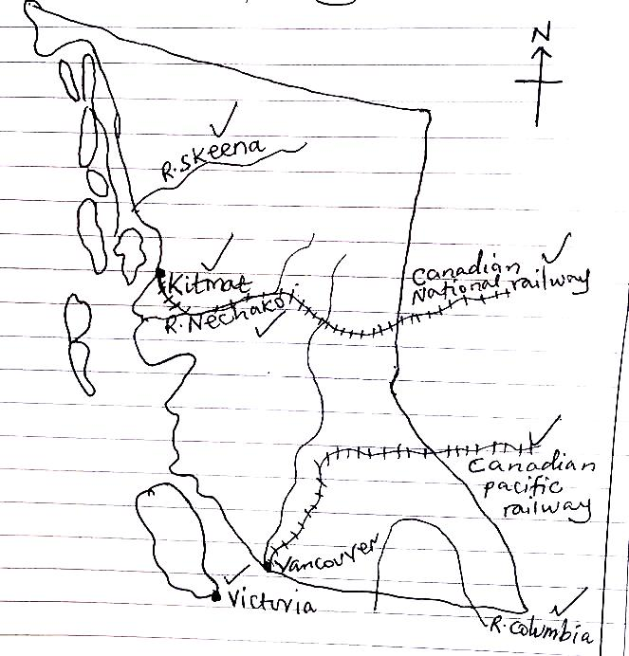

(b) (i) Name any two minerals extracted in British Columbia
- Coal
- Lead
- Iron ore
- Zinc
- Silver
- Copper
- Nickel
Any 2 (2mks)
(ii) Describe the factors which have influenced the development of mining in British Columbia
- Presence of large mineral deposits of value for commercial purposes such as copper, zinc, gold , lead and oil
- Availability of adequate capital to invest in mining activities provided by government of USA
- Well-developed transport network by roads, railway lines facilitated the movement of minerals to industrial centres
- Use of modern technology involving use of machinery ensuring quality products.
- Presence of wide /ready market for the viable minerals both local and foreign market
- Availability of skilled and semi-skilled labour to work in the mining sector.
- Availability of constant water supply used in processing minerals from many rivers like Skeena, D. Fraser and Nechako
- Presence of large quantities of power/ energy for processing the minerals
- Availability of a variety of minerals for diversification of mining activities.
- Occurrence of some minerals near the earth surface which makes exploitation of minerals easy.
- Positive government policy towards the development of the mining sect (Max 8mks)
c) Explain the benefits of mining in British Columbia
- Source of employment opportunities to people leading to improved standards of living.
- It earns foreign exchange from exports of minerals leading to development of the economy
- Provision of increased income hence better standard of living
- Development of industries which utilize minerals as raw materials
- Development of infrastructure such as roads, railways, schools etc.
- Diversification of the economy as an alternative source of foreign exchange
- Growth of urban centres with its related advantages like market and labour
- Source of government revenue from taxation
- Promotion of international relations through international trade. Max (05mrks)
b) Outline the effects of mining on the physical environment of British Columbia.
- Pollution of air, land and water from industrial wastes
- Loss of vegetation cover leading to los of bio diversity
- Creation of pits/hollows where mining is by open cast
- It accelerates mass wasting leading to landslides
- Destruction of the soil structure
- It accelerates soil erosion leading to loss of soil fertility
- Creation of barren lands/waste land. (Max 04mrks)
6. (a) A sketch map of California showing rivers, mountains, towns.
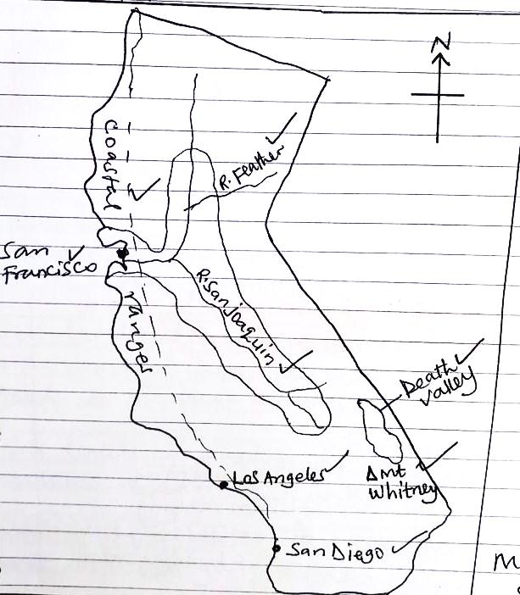
- (i) Name any two industries found in any one town mentioned in (a) (iii) above.

San Francisco
- Engineering
- Ship building and
- repair
- Textile
- Food processing
- Wine making
- Motor vehicle assembly
- Iron and steel industries
- Electronics
- Film making
- Oil refining.
- Chemicals
- Air craft

Los Angeles
- Space industry
- Food processing
- Tourism
- Machinery
- Air craft
- Oil refining
- Iron and steel
- Chemicals
- Engineering
- Film making
- Textiles
- Ship building and repair
San Diego similar to Los Angeles Any 2
(ii) Describe
e the conditions which have led to the development of industries in California
- Availability of reliable supply of raw materials both minerals and agricultural inputs
- Existence of reliable power supply especially oil, HEP from various dams to run industrial machines
- Presence of constant supply of water for industrial machines
- Presence of constant supply of water for industrial use as raw material/for cooling machines.
- Well-developed transport system by roads, railway for transporting both raw materials and finished goods to market centres.
- High levels of technology involving use of machines ensuring quality products produced.
- Availability of skilled and semi- skilled labour force to work in industries.
- Availability of wide market for industrial products both at home and abroad
- Presence of sunny conditions which support the tourist and film industry
- Positive government policy which support industrialization
- Availability of large tracts of land for expansion and establishment of industries
- Availability of adequate capital to invest in the industrial sector provided by government of USA. (Max 06 mrks)
c) Explain the major challenges to industrial expansion in California
- Competition from other industrial regions of the world
- Shortage of fresh water for industrial use
- Exhaustion of minerals leading to low output
- Pollution of air, water and land from industrial wastes
- Traffic congestion leads to delay in delivering of raw materials and finished products
- Shortage of skilled labour disrupts social prices for goods produced
- Limited home market for the industrial goods
- Congestion in the industrial centres. (Max 06 mrks)
d) Outline the steps being taken to address the challenges in (c) above
- use of raw material saving technology
- Use of strong advertising to widen marked base for produced goods.
- Importation of raw materials to supplement the locally produced goods
- Recycling of industrial raw materials
- Relocation of industries to other parts of California to reduce congestion
- Human resource training to increase on manpower
- Modernization of transport by the use of electrified railway system
(Max 3mrks)
7. (a) (i) Land use types in areas marked
- Beef cattle rearing
- Citrus fruit growing
(ii) Water body marked
- L. Okeechobee
(iii) Mineral extracted from area marked
Phosphates
(iv) Towns marks
- Miami
4 – Palm beach (Max 06 mrks)
b) Describe the factors which have influenced toe land use marked B on the map
- presence of fertile soil that support the growth of fruits
- Presence of a humid sub- tropical climate ideal for the growing of citrus fruits
- Availability of large market both local and foreign
- Skilled labour provided by large population
- Presence of large sums of capital to invest in fruit farming
- Presence of efficient transport means especially air transport ensures timely delivery of fruits to market
- Use of advanced technology especially use of green houses
- Presence of relatively flat landscape for easy establishment of farms
- Favourable government policy by providing large capital base to farmers (07mrks)
c) Explain the contribution of land use in area marked B to the development of Florida
- Provide raw materials for juice making industries/food processing
- Generation of foreign exchange from exports of fruits
- Source of employment opportunities to people hence better standards of living
- Generation of increased income leading to improved standard of living
- Provision of government revenue from taxation leading to development of the economy
- Development of towns such as Pal beach, Tampa and Stanford with its related advantages like trade and commerce.
- Diversification of the economy as an alternative source of income which reduces over dependence on one sector
- Development of infrastructure like roads, railway, schools etc.
- Promotes international relations through international trade. (Max 06mrks)
d) Outline the problems hindering the development of land use identified in (b) above
- Soil exhaustion leading to low output
- Winter frost which affects growing activities
- Price fluctuation on the international market which reduce income
- Competition with other producing areas e.g. California.
- Shortage of labour especially during harvesting period
- High costs of production
- Easy spread of pests and diseases which attack the fruits leading to low output
Max 5
RHINELANDS
- a) (i) physiographic regions marked
A - Oesling Highlands
B - Guit Land/Lowland
(II) Rivers marked
C -R. Our
D - R. Moselle
(iii) Industrial towns
- Differdange
- Luxembourg city
(iv) Country marked 3 – Belgium (7mks)
(b) (i) State any two types of industries found in each industrial town in (a ) above
DIFFERDANGE LUXEMBOURG CITY
- Iron and steel - Chemicals
- Chemicals - Engineering
- Food processing - Rubber industry
- Textiles - Food processing (Any 2)
b) (ii) Describe the factors which have led to the development of industries in Luxembourg
- Presence of abundant supply of raw materials e.g. iron ore for the iron and steel industries
- Availability of wide market for industrial products both local and foreign market
- Presence of skilled labour to work in industrial sector
- Availability of large quantities of fresh water to cool the industrial machines
- Use of advanced technology leading to production of high quality products
- Presence of adequate capital to invest in industries by purchasing land, machines etc.
- Presence of efficient transport network by roads, railway to ensure timely delivery of raw materials and finished product s
- Availability of extensive land for the establishment and expansion of industries
- Presence of reliable source of power especially HEP and coal used to run industrial machines.
- Supportive government policy towards industrial development like provision of loans and searching for market. (Max 06mrks)
c) Explain the importance of the industrial sector to the development of Luxembourg.
- Source of government revenue from taxation of industrial related activities
- Provision of employment opportunities to people leading to improved standard of living
- Source of foreign exchange from exports of manufactured products.
- Development of infrastructure like roads, railways etc.
- Development of industries such as Differ danger with its related advantages like market and labour
- Diversification of the economy as an alternative source of foreign exchange
- Generation of income to people leading to improved standard of living
- Promotes international relations through international trade
- Provision of consumer goods
- Provide market for agricultural and minerals which are used as raw materials.
(Max 5mks)
d) Outline the problems facing the industrial sector in Luxembourg
- Limited domestic market discourages production
- Shortage of skilled labour during winter season leads to reduction of production
- Exhaustion of raw materials limits production
- Competition for market with other developed countries limits market for industrial products.
- Limited land for expansion of industries limits out put
- Limited power sources have led to reliance on the imported coal and expensive HEP
- High costs of production
- Pollution of air, water and land from industrial wastes.
Max 3mks
9. (a) A sketch map of the Ruhr region of Germany showing rivers, towns, canal and coal fields
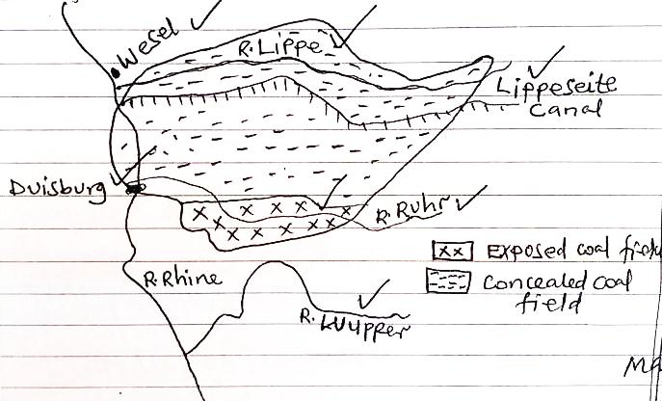
b) (i) Describe the processes involved in the extraction of coal in the Ruhr region Germany.
- Extraction of coal in the Ruhr region is by open cast.
- It involves removal of the over burden favoured by the loosening of the ore bearing rock using explosives.
- The coal then scooped/dredged out and loaded onto trucks and taken to processing centres (Max 3mks)
(ii) Describe the factors which led to the development of coal mining in Germany
- Existence of large quantities of coal i.e. exposed and concealed coal fields.
- Presence of large quantities of fresh water for the processing of coal
- Availability of large market offered by iron and steel industries in the Ruhr region
- Availability of adequate capital to invest in the mining equipment
- Advanced technology involving use of machines
- Presence of skilled labour to work in mining sector
- Positive government policy to developing through provision of mining contracts to potential mining companies.
- Well-developed transport network by roads, canals facilitating movement of mineral to industrials centres. (Max 6)
c) Explain the reasons for the decline of coal in the Ruhr region in Germany
- High costs of mining coal especially the concealed coal
- Depletion of high grade coal deposits in Ruhr region
- Competition from cheap imported coal
- Availability of sources of cheap energy like oil from OPEC countries
- Improved technology in the iron and steel industry which uses less coal
- Availability of other alternative sources of energy e.g. HEP, natural gas, solar etc.
(Max 4mks)
d) Outline the effects of mining on physical environment.
- Pollution of air, land and water from industrial gases
- Loss of vegetation cover leading to loss of bio diversity
- It leads to global warming
- It leads to creation of barren land
- It accelerates soil erosion
(Max 3mks)

10. (a) A sketch map of the Yssel – lake polders showing rivers, lakes , town canal
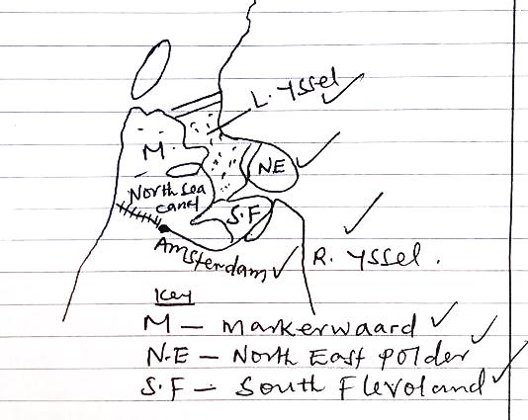(8mks)
B(i) Define the term polder
- A polder is a low lying area reclaimed from the sea and enclosed by dykes. (1mrk)
(ii) Describe the steps taken in creation of a polder
- Survey /exploration to establish the nature of rocks/soil depth is done
- Ring dykes are constructed around the areas to be drained using materials e.g. concrete blocks, and sand
- The water from the reclaimed areas is them pumped out using machines
- Ditches are then constructed to drain out water from the enclosed land
- A major central channel/canal is constructed to take the water from the drained area,
- Desalination of land using reeds and lime to remove excess salts from the land is done
- Irrigation is done using fresh water from the nearby rivers/water sources to further reduce the saline conditions.
- Deep ploughing /cultivation for further softening of the soil using deep ploughing equipment
- Pasture is then planted in the reclaimed land
- Polders are finally used for food production and animal rearing, settlement, recreation and industrialization. (Max 5)
c) Explain the factors which have influenced land reclamation in Netherlands
- Shortage of land in Netherlands made it necessary to reclaim land from the sea.
- Availability of skilled labour force to pump out water and construct dykes
- Presence of large sums of capital to pay workers and purchase draining machines
- Use of modern technology applied during construction of dykes
- Positive government policy through provision of loans
- Presence of reliable supply of raw materials like clay, sand etc.
D(i) Outline the problems faced by the people living on polders
- Flooding due to breakage of dykes destroys settlement
- Oil exhaustion limit the growth of crops
- Salination as a result of underground seepage which affect soil productivity
- Spreading of water borne diseases which destroy the peoples’ lives
- Siltation of canals leading to constant flooding that needs regular dredging which is costly
- Water logging conditions which lead to water borne diseases
- Pollution of land, air and water sources due to application of agro chemicals and fertilizers.
- Limited sources of fresh water for domestic and industrial use (Max 4)
D(ii) Outline the steps taken to solve the problems in d (i) above
- Construction of stronger and higher dykes
- Construction of canals to control floods
- Application of fertilisers to improve on soil fertility
- Desalination of the soil by planting reeds
- Spraying with chemicals to control pests and diseases
- Treatment of wastes to reduce pollution
- Use of greenhouse technology during winter
- Practice mixed farming to improve on food production.
(Max 3mrks)

CHINA
11. (a) A sketch map of China showing population distribution (7mks)
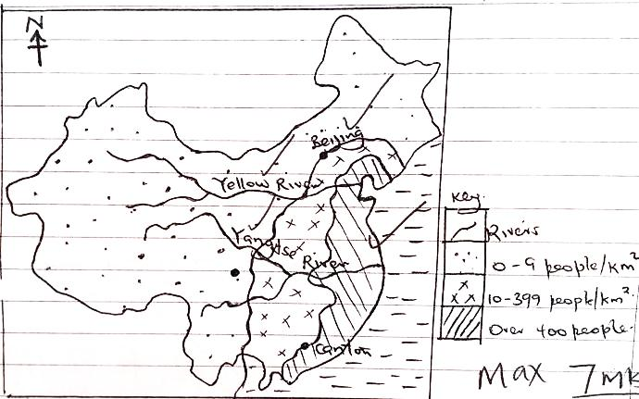
b) (i) For high population density:
- Warm ice free conditions at the coast of China suitable for farming attracted a dense settlement.
- Fertile soils along river valley suitable for farming
- Flat relief around the Man churien plains made it easy to construct infrastructure
- Adequate water supply from rivers such as R. Yangtze Kiang, Yellow river which provides water for domestic and industrial use
- High level of industrialization in Beijing, Shan gang attracted settlement seeking employment
- The development of urban centres such as Beijing, Kunming attracted many people for social amenities
- Various mineral resources that attract people to work in mines
- Well-developed transport and communication systems such as roads, railways increase accessibility leading to a dense population Max 4
ii) Conditions for low population density
- The climatic conditions in the Tibet are cold, harsh
- The rugged relief in the Tibet and Yunnan regions in Tibet limits settlement due to limited economic activities.
- Unreliable rainfall in the Tibet area affects economic activities such as farming limiting settlement.
- Remoteness of Yunnan, Tibet and inner Mongolia make them inaccessible leading to low population density (Max. 4)
c) Problems facing the people in densely populated areas of china
- Congestion of vehicles and people causing delays of services
- Unemployment leading to high crime rate
- Too much pressure on social services such as roads, schools, hospitals
- Shortage of food leading to famine and starvation
- High government expenditure on social services provisions
- Destruction of vegetation cover to provide land for farming and settlement hence less rainfall received.
- Increase the spread of diseases
- Shortage of land for farming activities hence land fragmentation. Max. 5
d) Solutions to the problems of dense settlement.
- Using family planning methods
- Importing food from areas of plenty
- Encouraging outward migration
- Vertical expansion to create more space
- Creating more green belts to improve on the environment
- Use of fertilizers to improve soil fertility to improve on productivity
- Strict laws against big families such as extra tax for big families.
- Diversification of the economy to provide alternative employment.
- Immunization to control diseases.
Max.5
12. (a) Towns.
1- Kunming
2- Canton (Guangzha)
3- Beijing/Peking
(ii) Water body: D – East China sea
(iii) Rivers: A - Hwang Ho/Ho
B - Yangtze Kiang
C - Sikiang
(Max 7mrks).
b) Steps taken by China to develop the Yangtze Kiang river basin
- Construction of strong dykes to cut off the east China sea invasions
- Construction of numerous canals to facilitate the flow of water to agricultural land for irrigation
- Establishment of many dams to provide water for hydro-electricity power generation for industrial and domestic use.
- Construction of numerous reservoirs to store flood water for irrigation during the dry period
- Development of many embankments to control periodic flooding
Regular dredging of some sections of the river to allow fast flow of water
- Construction of numerous bridges and culverts for easy communication
- Construction of modern roads. Railways to connect the basin to the parts of China.
(Max 6mrks)
c) Benefits of the Yangtze Kiang river basin to the people living in the surrounding areas.
- It provides water for extensive irrigation
- Opened up the interior of China through improving navigation on the river and associated canals.
- It has provided hydro- electricity power for industrial and domestic use
- It has allowed the growth of crops all year round thereby increasing food production.
- Has led to the growth of towns sue to the dense population attracted by the rich agricultural and industrial activities.
- Has led to the growth of industries and industrial centres which are sources of employment
- Attracted development of infrastructure like roads for easy transportation for people cargo
- Provide employment opportunities to people working on farms and processing industries
- Incomes earned have improved people’s standards of living
- It has led to fishing thereby increasing food stocks
- Floods have been controlled reducing on periodic loss of human lives and property.
- Has opened up formerly productive land to agriculture through provision of water for irrigation.
(Max 6mrks)
d) Problems resulting from the development of Yangtze Kiang River basins
- High costs involved in its development
- Pollution from industrial development
- Congestion of traffic and people in the area.
- Clearance of vegetation covers in the area.
- Loss of bio diversity in the area
- Urbanization and related problems
- Development of slums, high crime rate.
(Max 6mrks)
13. (a) (i) Rainfall totals
= 48+48+97+152+165+244+180+97+81+71+48+48
= 1279mm (2 mrks)
(ii) M.A.T - Temperature totals
12
= 207.3
12
= 17.2ºC/17.3ºC
(02 mrks)
(iii)
Annual temperature range
= (h – L)ºc
= 29.4 -4.6
= 24.8ºc (02mrks)
C) Explain climatic statistics of Manchuria
- Heavy rainfall of 1279mm
- Warm temperatures
- High temperature range of 24.8oC
- Cool and dry winter
- Hot and wet summer
- Hottest months are June and July with 29.4oC
- No marked dry season
- Wettest month is June with 244mm
- Coolest month is January with 4.6oC
- Driest months are November - February with 488 of rainfall
(Max. 5mks)
D(i) state influence of climate of human activities.
- Heavy rain and hot temperatures support agriculture
- Heavy rains and hot temperatures support the growth of forests leading to lumbering
- Heavy rains supports forestry which is a tourist attraction leading to tourism
- The heavy rains and hot temperatures that support agriculture and forestry lead to provision of raw materials for industrialization
- Heavy rains and hot temperatures support agriculture and forest that provide agriculture and forestry products for trade and commerce
- Heavy rains and hot temperatures support agriculture and forests that provide materials for transportation
- Heavy rainfall received leads to existence of many rivers and lakes thus fishing activities
(Max. 4mrks)
ii) Problems facing the people at the station.
- Heavy rains a suit into floods and destruction of property.
- Heavy rains at the station result into water borne diseases
- Cool temperatures between December and February result into delayed growth of crops
- One rainfall season result into one crop growing season (3mrks)
b) A combined bar and line graph showing the climate of Manchuria (7mks)
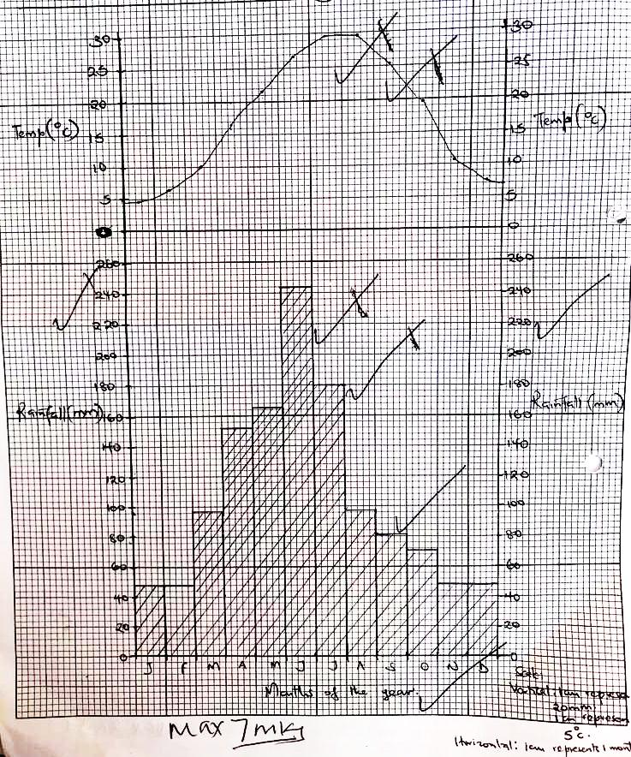

- Heavy rains result into destruction of transport routes
- Heavy rains and warm temperatures support the spread of pests
- Heavy rains support growth of forests that harbour wild animals.

END

