840/2
COMPUTER
STUDIES
PRACTICAL
Paper 2
2 ¼ hours

Uganda Certificate of Education

COMPUTER STUDIES

PRACTICAL PAPER

2 hours 15 minutes

INSTRUCTIONS TO CANDIDATES:

This paper consists of two Sections: A and B

Section A contains one compulsory question.

Section B contains three questions. Answer any two questions from this Section.

Each candidate shall be required to possess a blank CD-RW

Create a folder in your name and index number on the desktop where all your work should be saved first, and thereafter transferred to the CD provided.

Each candidate must produce a hard copy for each of their work to accompany the diskette or compact disc.

Software help wizards must not be used.

SECTION A (40 MARKS)
This section is compulsory

- (a) (i) Using a word processing application of your choice, Type the Geography handwritten guide below and save it as Geoguide-Your name-Personal number (e.g. Geoguide –Onen-001). (05 marks)

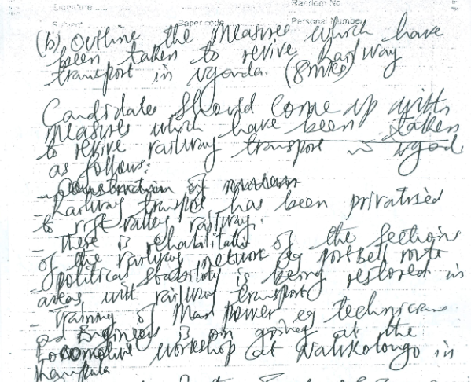

- Edit your work with correct spell check and grammar. (01 mark)
- Copy the text and paste it on page two (01 mark)

(Rest of formatting should be page on page two)

- Wave underline the word ‘is’ wherever it appears (02 marks)

- Bullet your first three answers in Roman numeral format. (02 marks)

- Change all your text to font style Mistral with font size 20.5
(02 marks)

- Insert a red horizontal watermark of your name and personal number with font style ‘Edwardian Script ITC’ (02 marks)

- Insert a page number using A, B, C format. (02 marks)

- Insert the word CONFIDENTIAL 273/1 in the header section (02 marks)

- Save and print your work. (01 mark)

(b) (i) Sources: Ministry of agriculture, Animal Industry and Fisheries (Online) 1995-2000. Rain pattern. Use it to attempt the following instructions.

YEARS | Feb | Mar | Apr | May | Aug | Sep | Oct | Dec
1995 | 53.5 | 188.5 | 251.2 | 148.9 | 21.8 | 170.3 | 197.9 | 30.0
1996 | 107.6 | 238.7 | 200.2 | 154.5 | 116.5 | 108.1 | 59.6 | 17.9
1997 | 5.4 | 80.4 | 194.6 | 87.6 | 72.7 | 34.9 | 191.4 | 259.3
1998 | 91.1 | 238.8 | 189.4 | 154.7 | 75.0 | 54.0 | 74.4 | 35.2
1999 | 27.2 | 246.3 | 237.4 | 193.2 | 86.3 | 117.5 | 133.5 | 144.5
2000 | 37.0 | 76.3 | 133.7 | 108.7 | 117.7 | 117.7 | 111.2 | 121.8

Instructions
- Using a spreadsheet program of your choice, tabulate the above information and Save your workbook as “rainfall” (05 marks)

- Copy and transpose this data onto sheet2 of your workbook and paste special (02 marks)

- On sheet2, Create four rows with titles of; total, minimum, maximum, and average rainfall per month. Hence compute total, min, max, and average rainfall using formulas. (04 marks)

- Using values of 1995 and 1998 create a line graph as an object of sheets 3 to represent variations in rainfall distribution for the two year above. (02 marks)

- Create a suitable title, and Legend at the bottom of your chart (02 marks)

- Rename sheet 3 as CHART (01 mark)

- Set your chat to rest on an A4 paper size and landscape layout.
(02 marks)

- Insert footer of your name and personal number. (01 mark)
- Print all your three sheets (01 mark)

SECTION B :( 60 MARKS)
Attempt any two questions from this section

- The table below is a record of CODE HIGH SCHOOL students.

STUDENT  NUMBER | NAME | SEX | AGE | CLASS | HOME DISTRICT
K0067 | Babirye | F | 18 | S.5 | Iganga
K0078 | Najjuka | F | 19 | S.3 | Masaka
K0045 | Aronda | M | 20 | S.4 | Mbale
K0043 | Nassuna | F | 25 | S.6 | Arua
K0140 | Sempa | M | 17 | S.2 | Masaka
K0134 | Mulira | M | 18 | S.6 | Zirobwe

Instructions

- Create a database called CODE -your name. e.g. CODE-Babirye (02 marks)

- Create a table of the data above and save as Student Table. (07 marks)
- Apply appropriate data types to the field names (03 marks)

- Under the sex field, apply a lookup wizard to select between F and M to quicken data entry (02 marks)

- Generate a form to return the records of the following fields: STUDENT, NUMBER, NAME, AGE and HOME DISTRICT. Save it as Students' form. (03 marks)
- Add a background color of your choice to the form created
(02 marks)

- Use a query to filter out student(s):
- From Masaka district. Save it as Masaka (03 marks)

- With the age above18.Save it as Age. (03 marks)

- Generate a report from the table. Save it as Students' report (03 marks)
- Print your work. (02 marks)

As a Computer student, you are required to sensitize people in Muhoro Town Council about Mobile banking and the venue is Muhoro T/C social hall.
- Using appropriate software, customize the file and save it as your name and Personal number.eg “Geofrey_065”. (02 marks)

Enhance the following features to enrich your presentation
- Maintain the formatting features of all your slides.
- Apply any transition scheme of your choice for all slides. (02 mark)
- Add Swivel Entrance animation effect to all your slide titles. (02 mark)
- Set your slides to automatically transit after 2 seconds. (02 mark)
- Insert automatically updating date and time to all your slides. (02 marks)
Tasks

- Slide 1: Should be introduction slide. Include the Title, Name of the presenter and the venue of the presentation. The text for venue should be a word Art (04marks) .
- Slide II: Include a definition of mobile banking and two examples . of service providers that render this service in Uganda. (04 marks)
- Slide III: Express at least two advantages of mobile banking . (04marks)
- Slide IV: Include at least two disadvantages of mobile banking.
(04 marks)
- Slide V: State a conclusion statement stressing out PIN fraud as the . . major security threat in mobile banking and people should avoid -------that. . (02 marks)
- Save and print your presentation as handout (02 marks)

4. Design a four page website for KAWOMERA RESTUARANT saved as restaurant to include the following information: (02 marks)

Page 1: To include a welcome message, historical milestone. Include a section for sending concerns to the webmaster. (04 marks)

Page 2: To include services provided by the restaurant. (05 marks)

Page 3: To include location of the restaurant to the possible visitors.
(05 marks)

Page 4: To include a simple photograph gallery. (05 marks)

Instructions:
- Add a uniform header for the four pages. (03 marks)
- Include a marquee reading: Yummy Yummy Yummy!!!!! (04 marks)
- Make sure that the website has active links. (02 marks)

END

