LESSON NOTES FOR ENGLISH FOR MIDDLE CLASS TERM III – 2017

WEEK ONE
Lesson one
TOPIC: Things in the classroom
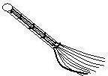
Activity: Name the things in class
________ ________ ________ ________
Learning aids: Teacher will use real materials in class.

TOPIC: Things in the classroom
Lesson two
Activity: Name things in class

Learning aids; teacher will still use real objects in class

Lesson three
TOPIC: Draw things found in class
duster _____________ charts ___________
table ____________ ruler ___________
rubber ____________ book ___________
Learning aids: Teacher will use cards

Lesson four
TOPIC: Things in our class (Common nouns)
Activity: Draw things found in a class

chalkboard _____
chalk ______
broom _____
pencil _____
chair _____
bag _____
Learning/Teaching aids: Teacher will use flash cards
Lesson five

TOPIC: Things in our class (Common nouns)
Activity: Matching same words and write
pen book ____
book pen pen
chair bag _____
bag chair _____
Learning/Teaching aids: Cards

WEEK II
Lesson one

TOPIC: Things in our class (Common nouns)
Activity: Match same words and write
box cupboard _____
boy girl _____
girl box _____
cupboard boy boy
Learning aids: Cards

Lesson two
TOPIC: Things in our class (Common nouns)
Activity: Draw things found in a class
chair | book | girl
Learning aids: teacher will use real objects.

Lesson three
TOPIC: Things in our class (Common nouns)
Activity: Draw and colour
Duster | Pen
Materials to be used: books, pencils, colours
Lesson four

TOPIC: Common nouns
Activity: Match words to pictures
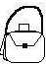
chair
book
bag
Learning aids: Real objects in classroom

Lesson five

TOPIC: Common nouns
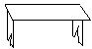
Activity: Match to the same and draw
book bench
duster book ______
bench duster______

WEEK THREE

Lesson one and two
TOPIC: Common words
Activity: Reading simple words then teacher will give listen and write
- pencil
- chair
- book
- boy, etc
Learning aids: books and pencils
Lesson three
TOPIC: Common words
Activity: Read and draw
book _____
ruler _____
chalk _____
Learning aids: Flash cards

Lesson four and five
TOPIC: Common words
Activity: Match to word and draw
book _____
table _____
pencil _____
Learning aids: Flash cards

WEEK FOUR

Lesson one
TOPIC: Common nouns/New words
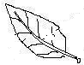
Activity: Match and write the words
cup cup
leaf _____
bottle _____
Learning aids: Flash cards

Lesson two and three
TOPIC: Common nouns
Activity: Circle the correct word
tin nit
blla ball
tea tae
Learning aids: Real objects

Lesson four and five
TOPIC: Common nouns
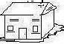
Activity: Circle the correct word
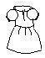
hsoue house
dress ssdre
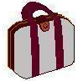
oshe shoe
bag abg
Learning aids: Real objects

WEEK V

Lesson one
TOPIC: Common nouns/New words
Activity: Underline the correct word
tree banana
banana tree
sun leaf

Learning aids: Real objects
Lesson two
TOPIC: Common nouns/New words
Activity: Underline the correct word
tin tomato
banana orange
apple beans

Learning aids: Real objects

Lesson four
TOPIC: Common nouns/ New words
Activity: Fill in the missing letter
s__n b—ttle g__rl

Learning aids using cards

Lesson three
TOPIC: Forming structures
Activity: Complete sentences
It is a __________
It is a _________
It is a __________
Learning aids: Flash cards and real objects

Lesson five
TOPIC: Forming structures
Activity: Read and draw
It is a banana___________
It is a table___________
It is a bed _______

Learning aids: Real objects

WEEK SIX

Lesson one
TOPIC: Forming structures
Activity: Make sentences using “It is a_____)
______________________
_____________________
Learning aids: Real objects

Lesson two
TOPIC: Common nouns/New words
Activity: Reading simple words after teacher will give listen and write
Learning aids: charts, cards, etc

Lesson three
TOPIC: Forming structures
Activity: Reading new words; a, is, it , here, that , this.
Teacher will use some words to form sentences orally.
Teaching aids: Charts, cards

Lesson four and five
TOPIC: Forming structures
Activity: Complete the sentence using the given structures e.g
It is a _____
It is a _____
Teaching/Learning aids: Flash cards
WEEK VII

Lesson one and two
TOPIC: Identifying the same pictures
Activity: Circle the same pictures
Learning materials, real objects e.g cup, ball, book, charts, flash cards, single letter

Lesson three to five
TOPIC: Identifying the same pictures
Activity: Colour the same pictures.

WEEK VIII

Lesson one
TOPIC: Reading new words
Activity: a, is, it , here, here, that, has, this, can
Teacher will use same new word to form a new structure orally
Teaching aid: Card, chart, chalkboard

Lesson two
TOPIC: Forming structures
Activity: Complete the sentences giving the given structure e.g That is _____
That is an _____
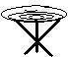
That is a ______
That is an ______
Learning aids Flash cards

Lesson three
TOPIC: Forming structures
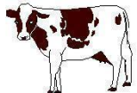
Activity: Read and draw e.g That is ……………
That is a _____
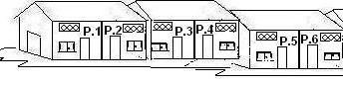
That is a _______
That is a ______
Learning aids: Charts, real objects

Lesson four
TOPIC: Forming structures
Activity: Make sentences using “That is _____
book __________________________
tin _________________________
balloon_________________________
food _________________________
Learning aid: Flash cards

Lesson five
TOPIC: Forming structures
Activity: Make sentences (That is ____________)
flower __________________
dress __________________
Learning aid: Flash cards

WEEK IX

Lesson one
TOPIC: Forming structures using learnt new words
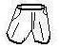
Activity: Read and draw
This is a __________________
This is a _________________
This is a _________________
Learning aids: Real objects

Lesson two
TOPIC: Form structures (Some of the learnt new words)
Activity: Read and draw
This is a __________
This is a ___________________
Learning aid: Real objects

Lesson three
TOPIC: Form structures
Activity: Make sentences using; “This is ……..”

____________________

_____________________

_____________________
Learning aids: Flash cards

Lesson four
TOPIC: Forming structure (Use the same words)
Activity: Complete the sentences
Here is a ______________
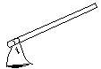
Here is an ______________
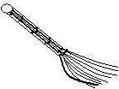
Here is a ______________
Learning aids: Flash cards, cards, real objects

Lesson five
TOPIC: Forming structures
Activity: Complete the sentences
Here is a _____________
Here is a _____________
Here is a _______________
Learning aids: Charts, cards, real objects

WEEK X

Lesson one
TOPIC: Forming structures
Activity: Read and draw
Here is an aeroplane _____________
Here is a car _____________
Here is a bicycle _______________
Learning aids: Charts, real objects

Lesson two
TOPIC: Forming structures
Evaluation activity: Make sentences
milk _________________
toy car__________________
tree __________________
Learning aids: Cards, real objects, books and pencils

TOPIC: Form structures
Evaluation activity: Learners will continue to make sentences
leaf __________________
egg ___________________
gun __________________
aeroplane ______________
Learning aids: card, charts

Lesson three
TOPIC: Important places
Evaluation activity: Learners will name important places orally.
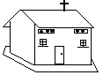
Teacher will draw for them pictures to colour e.g
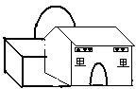

Learning aids: A chart

TOPIC: Important places
Evaluation activity: Match word to picture.
Learning aids: books, pencils, colours, papers
mosque

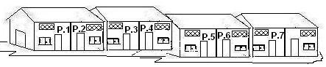

church

bank

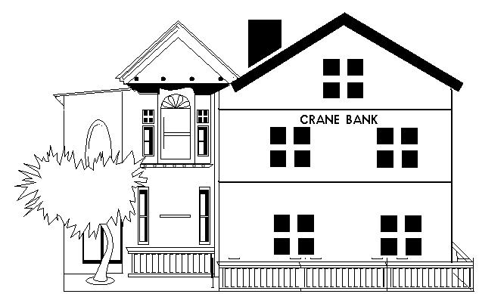

school

Learning aids: Charts, chalkboard

Lesson four
TOPIC: Important places
Evaluation activity: Learners will use a structure on new words learnt. e.g

I can see a __________

I can see a __________

Learning aids: charts

Lesson five
TOPIC: Important places
Evaluation activity: Learners will have to draw a market and colour.
Learning aids: books, pencils, colours, papers

TOPIC: Important places
Evaluation activity: Learners will continue with the structure of I can see…
Make sentences
_________________________

_________________________

