LESSON NOTES FOR ENGLISH FOR MIDDLE CLASS TERM I – 2017

WEEK I
(Observing different types of objects)
- Seeds e.g -
Maize
Cow peas
Beans etc.

- Shapes e.g
Circle
Triangles
Square, etc

- Teacher game (e.g ) greeting
Good morning, a cat and a rat
- Rhyme
- Twinkle twinkle little star
Activities

- Sorting
- Greeting
- Jumping
- Reciting
- Dancing

WEEK II
Lesson one
TOPIC: Things around the classroom.

Activity: Matching the same things in the class

Materials to be used
Real objects

Lesson two
TOPIC: Things around the classroom

Activity: Match and draw the same pictures.
Materials to be used: Real objects

Lesson three
TOPIC: Things around the class room
Activity: Colour the same picture
Materials to be used
Flash cards

Lesson four
TOPIC: Things around the class room.
Activity: Putting the missing part.
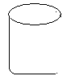

Learning materials: Real objects
Lesson five
TOPIC: Things around the classroom
Activity: Tick the odd man out

Materials to be used: Real objects, chart

WEEK III
Lesson one
TOPIC: Things at home
Activity: Colour me well

Teaching aids: Real objects

Lesson two
TOPIC: Things at home
Activity: Draw again

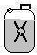
Teaching/learning aids: real objects

Lesson three
TOPIC: Things at home
Activity: Name these pictures
_________ _________
bed tin cup box
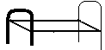
_________ ________

Teaching /Learning aids: real objects

Lesson four
TOPIC: Things at home (common nouns)
Activity: Cross the different word
tin tree tin tin
cup cat cup cup

Teaching/Learning aids: cards

Lesson five
TOPIC: Things at home
Activity: Cross the different picture

Teaching/Learning aids: Charts
WEEK V
TOPIC C: Things at home
Activity: Circle the correct word for the picture.
Materials to be used: Real objects flash cards
cup pcu
itn tin
box xbo
eert tree
Lesson two
TOPIC: Things at home
Activity: Underline the correct word for t he picture given
table chair box
tin table tap
ball bag box
fat flower fun
Materials to be used: real objects, flash cards
Lesson three
TOPIC: Things at home
Activity: Tick the different word.
cup box√ cup cup
mat tin tin tin
box box box bag
mug man mug mug
Materials to be used: Flash cards

Lesson four
TOPIC: Things at home
Activity: Match the same pictures and draw.

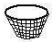

Lesson five
TOPIC: Things at home.
Activity: Match the same word and write it again.

mat pot _____
hen cat _____
rat cow _____
cow rat _____
cat hen _____
pot mat _____
Materials to be used: Flash cards , chalkboard, books and pencils

WEEK SIX
Lesson one
TOPIC: Things at home
Activity: Matching things at home and copy words
mat mat
chair _____
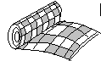
cup _____
bed _____
Teaching/Learning aids: Chart/real objects

Lesson two
TOPIC: Things at home
Activity: Matching things at home
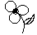
bottle

mug
spoon
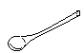
flower
Teaching/Learning aids: Real objects
Lesson three
TOPIC: Things at home
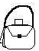
Activity: Circle the same pictures
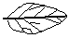
Teaching/Learning aids: Real objects
Lesson four
TOPIC: Things at home
Activity: Circle the same pictures

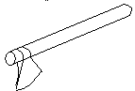
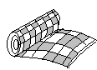 | 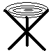
Teaching/Learning aids: Real objects

Lesson five
TOPIC: Comparing small/big
Activity: Colour the smaller picture

WEEK VII
Topic: Comparing big and small
Activity: Learners will tick the small pictures only.

Materials to be used: real objects and charts in class.
Lesson two
TOPIC: Comparing big/small
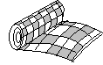
Activity: Pupils will learn, touch and shade/ colour the small picture

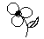
Materials to be used: Real objects

Lesson three
TOPIC: Comparing big/small
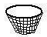
Activity: Learner will identify the big picture and cross it.

Lesson Four

TOPIC: Comparing big/small
Activity: Learner will underline the big picture.
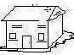

Learning materials: Real objects, chart in class

Lesson five
TOPIC: Comparing big/small
Activity: Learners will read and draw
Draw a big mat ______________
Draw a small ball ________________
Materials to be used: real objects, pencils and books

WEEK VIII
Lesson one
TOPIC: Missing part
Activity: Draw the missing part


Teaching/learning aids: Cut outs, jig saws
Lesson two
TOPIC: Missing part
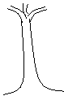
Activity: Draw the missing part
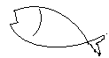
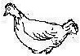

Teaching/learning aids: cut outs, jig saws

Lesson three

TOPIC: Belongings
Activity: Match to the belonging
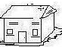

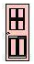
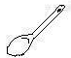
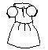
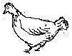

Lesson four
TOPIC: Belonging
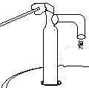
Activity: Match to the belonging

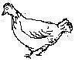
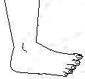
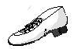
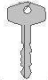

Lesson five

TOPIC: Belonging
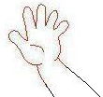
Activity: Match

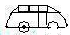
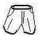
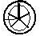
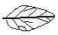

Teaching/learning aids: Real objects, e.g watch, hand, shorts, etc

WEEK IX

Lesson one
TOPIC: Common nouns
Activity: Learners will read the word correctly and draw the pictures.

tin | cup | ball | cat | cow
Materials to be used: charts, flash cards, books and pencils.

Lesson two
TOPIC: Common nouns
Activity: Learners will read the words correctly and tick the correct word for the picture given. E.g
Hat dog tin
hen√ door tea
hut duck tie

Learning materials should be: flash cards, chart in class, books a nd pencils.

Lesson three

TOPIC: Common nouns
Activity: learners will read and cross the correct word.
hen ehn neh
odg dog god

Lesson four

TOPIC: Common nouns/new words
Activity: learners will fill in the missing letter/word e.g
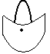
b__ok r__t b__g c__r

Materials to be used: Chart in the class, books and pencils

Lesson five

TOPIC: Common nouns/new words
Activity: Learners will continue to fill in the missing letter in a word.

Fill in the missing letter.
f__sh b__y m__g pe__
Learning materials to be used : Chart in the class, books and pencils.

WEEK X
Lesson one
TOPIC: Common nouns
Activity: Learners will cross out the different word e.g
Cow cow cat
cup tin cup
Teaching/learning aids: Card, charts

Lesson two
TOPIC: Common nouns
Activity: Learners will cross out the different word.
spoon spoon stool
car car can
Teaching/Learning aids: Card/ Charts

Lesson three
TOPIC: Common nouns
Activity: Learners will tick the correct word.
hne nhe hen
eye yee eey
mna nam man
Materials to be used: cards, dominos

Lesson four
TOPIC: Common nouns
Activity: Learners will tick the correct word
blla allb ball
dog gdo ogd
Teaching learning aids: cards

Lesson five

TOPIC : Common nouns
Activity: Learners will underline the correct word.
blla bkoo
ball boko
llab book

