KAMPALA JUNIOR ACADEMY
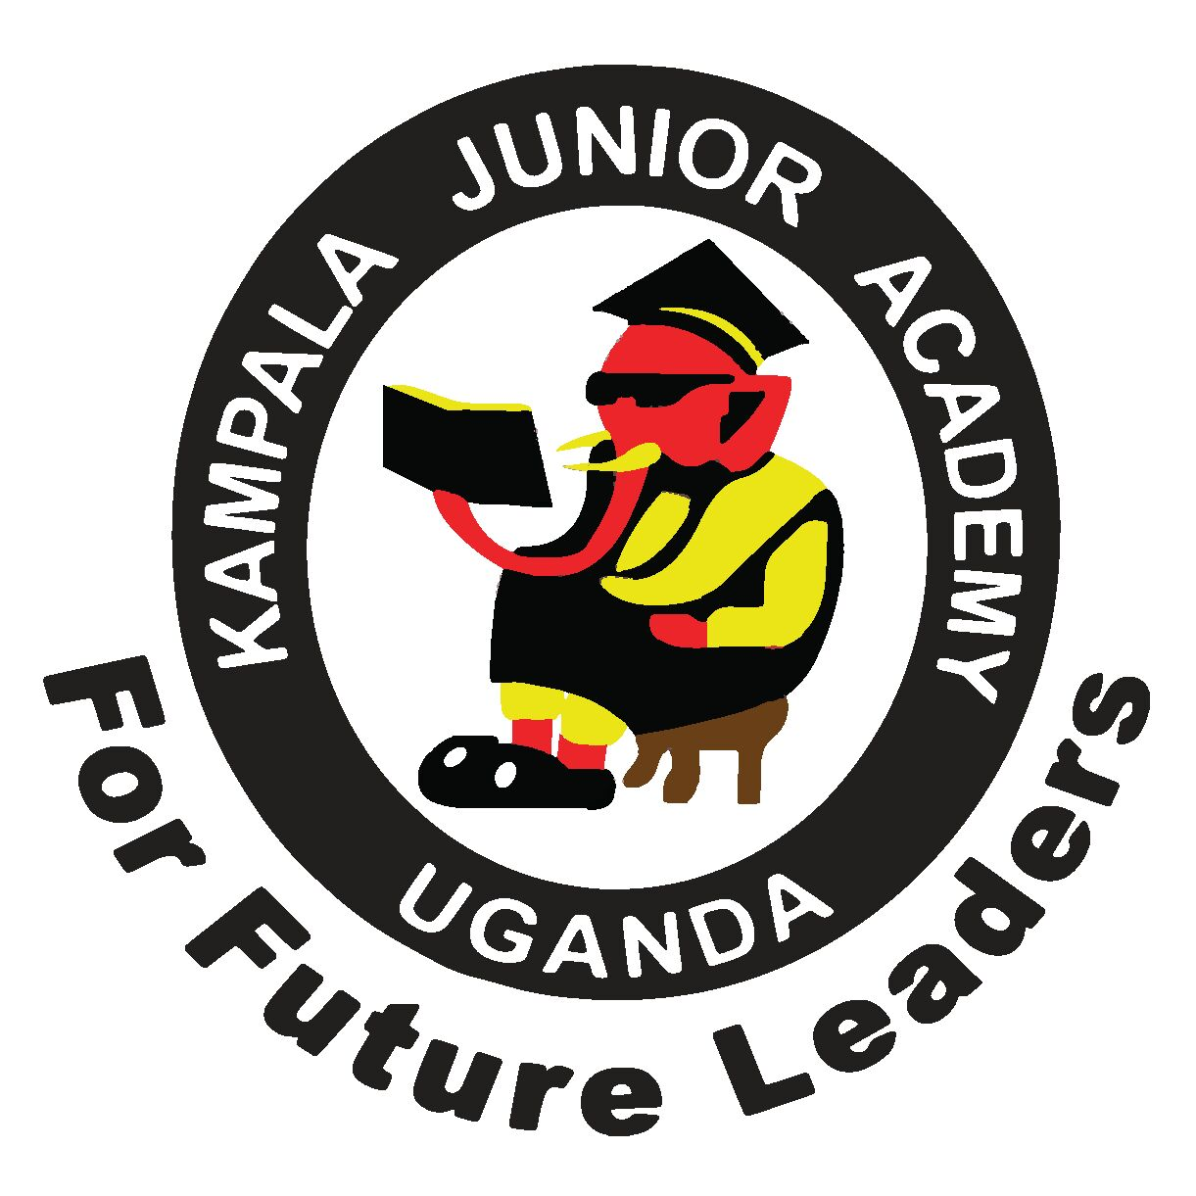
END OF AUGUST ASSESSMENT EXAMINATION
PRIMARY FOUR
SOCIAL STUDIES
NAME: ___________________________________ CLASS: _______
BRANCH: ________________________________________________
1.______________________is the study of man and things around him.
2. In which direction does a compass needle face while at rest?
_______________________________________________________
3. Name the major line of latitude marked 0º.
_______________________________________________________
4. Identify any one element of a good map.
_______________________________________________________
5. In which region is our district found?

6. How are hospitals important to people in our district?

7. Name this map symbol.

8. Write KCCA in full.

9. Which district neighbours Kampala in all the directions?

10. State the product got from limestone.
_______________________________________________________
11. Mention one important place in our district.

12. How do farmers in hilly areas control soil erosion?

13. Name the physical feature that covers the largest part of Kampala city.

14. On which hill is the main government referral hospital?

15. Who is the current Lord Mayor of Kampala city?

16. Write down any one water body found in Kampala city.
17. Why is the government of Uganda creating more districts?

18. Draw a map of a pot.

19. Identify any one way of locating places in our district.

20. Name any one island district in Uganda.

21. Identify the highest mountain in Uganda.
_______________________________________________________
22. What is altitude?
_______________________________________________________
23. On the globe below, draw a line to indicate the line of latitude marked 0˚ (Equator).

24. Identify any one similarity between a map and a picture
_______________________________________________________
25. Give the opposite direction to the East.
_______________________________________________________
26. Farah is moving towards the South. She turned 45˚ clockwise. What was her new direction?
_______________________________________________________
27. Identify any one group of people who use a compass in their work.
_______________________________________________________
28. At what time of the day is the shadow seen to be very long?
_______________________________________________________
29. What will happen to someone using a map without a key?
_______________________________________________________
30. Under which ministry are all districts?

SECTION B
31. What physical features?
_______________________________________________________
b) Give another word for physical features.
_______________________________________________________

c) Identify any one example of
a) (i) drainage feature
_______________________________________________________
(ii) Relief features
_______________________________________________________
32. What do we call the four major points on compass?

b) Name these points
N a
a)_______________________________
b b)_________________________________

c) Where does the sun rise from?

33. Name this line as drawn on globe.

0˚________________________
b). Identify any one city in Africa crossed by the above line.
_______________________________________________________
c). Mention any one district in Uganda crossed by the equator.
_______________________________________________________
d). Give the use of both lines of latitude and longitude.
_______________________________________________________
34.a In which district is your school found.
_______________________________________________________
b. Who is the political head of Kampala city?
_______________________________________________________
c. Write down any two important places in our district.

35. Match correctly.
Mount Rwenzori Summit

Mount Mufumbiro Wagagai

Mount Elgon Margherita

Mount Moroto Muhavura

Wish you all the best

