KAMPALA JUNIOR ACADEMY
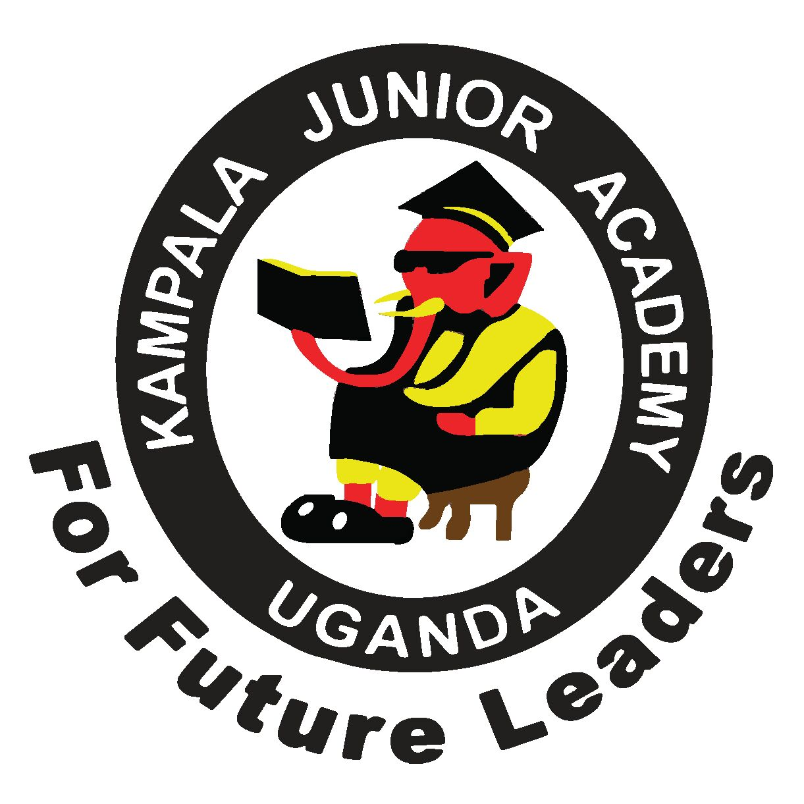
END OF AUGUST ASSESSMENT EXAMINATION
PRIMARY THREE
LITERACY B
NAME: ___________________________________ CLASS: _______
BRANCH: ________________________________________________
1. In which division is your school found?
___________________________________________
2. How many members are on the L.C 1 committee?
___________________________________________
3. Who heads a country?
___________________________________________
4. ___________________is a home and its surrounds. (home stead, environment )
5. Who heads a division?
___________________________________________
6. Identify any one thing found in our environment.
___________________________________________
7. ______________________________heads a school.
8. How many divisions are in Kampala?
___________________________________________
9. Write L.C in full.
___________________________________________
10. Mention any one important place in our division.
____________________________________________
11. Who are in charge of children affairs on local council committee?
____________________________________________
12. Identify one lake found in Kampala.
____________________________________________
13. What is a map?
____________________________________________
14. Which direction do we see the sun in the morning?
____________________________________________
15. Draw a map symbol for a cup.

16. Identify any one physical feature in our division.
____________________________________________
17. Name Uganda’s main referral hospital.
____________________________________________
18. Mention any one activity done on hills.
____________________________________________
19. Give the use of a map title on a map

20. Name this map symbol
N

21. Mention one semi – cardinal point of a compass.
_____________________________________________________
22._____________________is a low land between two hills.
23. On which hill is the biggest water tank?
___________________________________________________________________
24. Give another word to mean physical features.

25. Draw the shadow of a tree at midday.

26. What is the opposite direction to the East?
_____________________________________________________
27. Write down the motto of your school.
_____________________________________________________
28. Who is the current president of Uganda?
_____________________________________________________
29. Name any one neighboring division to ours.

30. Write KCCA in full.
_____________________________________________________
SECTION B
31. Name these points

a a______________________
b b______________________
C
c______________________
(b). what do we call the four major points on a compass?

___________________________________________________________________

32. Match people to their roles.
Parents obey rules
Priests provide family rules
Children preach the word of God
b) Give the importance of a teacher in our divison.

___________________________________________________________________

33. What is a picture?

___________________________________________________________________
b).Draw picture of a pot.

c) Write down any two qualities of a good map.
_____________________________________________________

_____________________________________________________

34. Match correctly.
Compass direction tells what a map is about.
Map key it encloses the map.
Map title it show the directions of places.
Map boundary give meaning of symbols used on a map.

35. Name the map symbols

b) Why are map symbols used on a map?
______________________________________________

