KAMPALA JUNIOR ACADEMY

END OF AUGUST ASSESSMENT EXAMINATION
PRIMARY THREE
LITERACY A
NAME: ___________________________________ CLASS: _______
BRANCH: ________________________________________________
SECTION A
1. Name any one domestic animal.
_______________________________________________________
2. Give any one way of caring for our bodies.
_______________________________________________________
3. Name one garden tool.
_______________________________________________________
4. What is air?
_______________________________________________________
5. Give the weapon used by a dog to protect itself.
_______________________________________________________
6. Name the property of soil in the diagram below

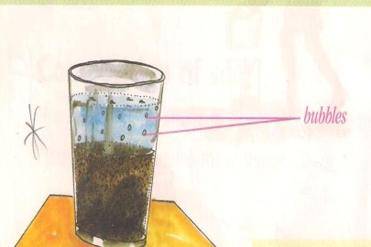

___________________________________________________________
7. What is the importance of a broom at home?
_______________________________________________________
8. Why do we boil water for drinking?
_______________________________________________________
9. Name the gas needed for burning?
_______________________________________________________
10. Give one layer of soil profile.
_______________________________________________________
11. Name any one component of soil.
_______________________________________________________
12. What do we call moving air?
_______________________________________________________
13. Mention any one example of a plant.
_______________________________________________________
14. Give one example of animals found in the swamp.
_______________________________________________________
15. What are wild animals?
_______________________________________________________
16. Draw and name one natural source of light below

__________________

17. Name one animal that can be used for transport.
_______________________________________________________
18. Name one example of a living thing.
_______________________________________________________
19. Identify any one animal that lives in water.
_______________________________________________________
20. Circle the example of natural change that occur in animals.
Drought, growth, floods, erosion

SECTION B

21a. What do we get from nimbus clouds?
_______________________________________________________
b. Which animal protects our homes from rats?
_______________________________________________________
c. Why do we brush our teeth?
_______________________________________________________
d. Give one reason why we eat food
_________________________________________________________
22. Fill in the correct word from the brackets.
a. A lion ___________________ when it is in danger. (roars, lowers)
b. We can make _______________ using banana fibres. (toes, toys)
c. A _________________ is the young one of a fish. (fly, fry)
d. Bees ________________ to protect themselves.
(bite, sting)
23.a)Underline the useful insects in our environment.
flies, white ants, mosquitoes, butterflies, bees
(b) The diagram below shows the body parts of an insect.
Name the parts marked a, b and c.
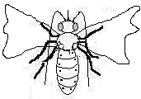
a _______________________
b _______________________
c _______________________
24. Match the material with its source.
material source
cement bush
clay swamp
grass factory

timber forest

25. Complete correctly.
(a) Cotton is to clothes as ____________ is to ropes.
(b) Shoes are from ____________ as sweaters are from wool.
(c) ____________ are to sugar as bananas are to juice.

skins sugarcanes sisal

26. Identify the garden tools below.
     |  |  | 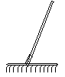

27. a) What is wind?
___________________________________________________________
b) Give any two uses of wind
- ________________________________________________________
- _______________________________________________________
- Write down any one danger of wind
________________________________________________________
28. Give one word for each group of words.
loam topsoil
(a) clay (b) subsoil
sand gravel
parent rock
___________________ _________________

