KAMPALA JUNIOR ACADEMY

END OF AUGUST ASSESSMENT EXAMINATION
PRIMARY FOUR
SCIENCE
NAME: ___________________________________ CLASS: _______
BRANCH: ________________________________________________
SECTION A
1. Name any one domestic animal.
_________________________________________________________
2. Why do we wash hands after visiting a latrine?
_________________________________________________________
3. What are flowering plants?
_________________________________________________________
4. Give any one use of water to people.
_________________________________________________________
5. Name the best type of soil for growing crops.
_________________________________________________________
6. What is mulching? _________________________________________
_________________________________________________________
Below is a diagram of a leaf. Use it to answer questions 7 and 8.
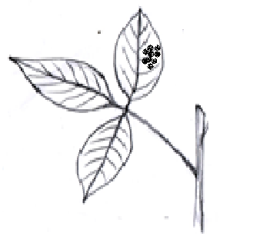

X

7. Name the holes marked X above._________________________
8. How useful are the holes marked X above to the leaf? ________________________________________________________________
9. State the use of eyes to a P.4 child.
_________________________________________________________
10. Give one way of caring for animals at home.
_________________________________________________________
11. Write any one reason why animals move from one place to another.
_________________________________________________________
12. Name any one example of non-flowering plants.
_________________________________________________________
13. What are vectors?
_________________________________________________________
14. Write one way animals benefit from the process of photosynthesis?
_________________________________________________________
15. Give one reason why goats are called living things.
_________________________________________________________
16. Which type of clouds gives us rain?
_________________________________________________________
17. Mention any one role of a mother at home.
_________________________________________________________
18. State any one use of flowers to people.
_________________________________________________________

19. What is sanitation?
_________________________________________________________
20. Write any one PIASCY message.
_________________________________________________________
21.In the space below, draw and name any one garden tool.

22. Why do some plants shed their leaves in a dry season?
_________________________________________________________
23. Give any one method of preserving fish.
_________________________________________________________
24. State any one way of caring for sick people.
_________________________________________________________
25. What component of air occupies the biggest percentage in the atmosphere?
_________________________________________________________
26. Mention the main natural source of water in the environment.
_________________________________________________________
27. What is transpiration?
_________________________________________________________
28. How is a female anopheles mosquito dangerous to people?

29. Name any one condition necessary for seeds to germinate.
________________________________________________________
30. Write any one disease spread by houseflies to people.
________________________________________________________
SECTION B
31a).What is photosynthesis?
__________________________________________________________________________________________________________________
b) Write any two requirements needed by plants to make their own food.
i) ____________________ ii) __________________________
c) Why can’t photosynthesis take place at night?
_________________________________________________________
32.a) Name the three main parts of an insect.
i)________________________________________________________
ii)_______________________________________________________
iii)_______________________________________________________
b) How are spiracles useful to insects?
_________________________________________________________
33.a) _________________________is the general cleanliness of the body.
b) Name any three items used to clean the body.
i) _______________________________________________________
ii) _______________________________________________________
iii) ______________________________________________________

34. Use the diagram below to answer the questions that follow.
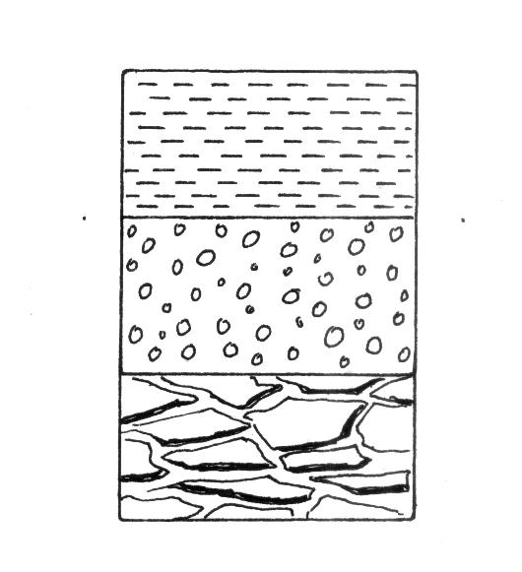
R
Q
P
- Name the layers marked.
- Q_____________________________________________
- R______________________________________________
- Why is layer “P” the best for growing crops
_________________________________________________
- State one way soil is formed.
_________________________________________________
35. Match the following items correctly.
- Cockroach sleeping sickness
- Female anopheles mosquito typhoid
- Tsetse fly rabies
- Rabid dog trachoma
Malaria
- Cockroach ________________________
- Female anopheles mosquito ________________________
- Tsetse fly ________________________
- Rabid dog ________________________

