P210/5
HISTORY.
(Theory of Government and
Constitutional development
and Practice in East Africa)
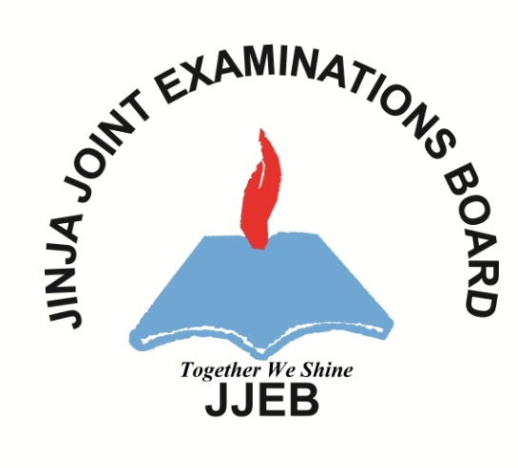
PAPER 5
AUGUST 2017
3 hours

JINJA JOINT EXAMINATIONS BOARD

Uganda Advanced Certificate of Education

MOCK EXAMINATIONS – AUGUST, 2017
History
Paper 5
(THEORY OF GOVERNMENT AND CONSTITUTIONAL DEVELOPMENT AND PRACTICE IN EAST AFRICA)
3hours

INSTRUCTION TO CANDIDATES:
- This paper consists of section A and B.
- Answer FOUR questions in all, taking at least one from section A and two from section B.
- All questions carry equal marks.
- Any additional question(s) answered will not be marked.

SECTION A
- Discuss the challenges faced by political parties in East Africa (25 marks)
- Explain how Fundamental human rights have been respected in East Africa
( 25 marks)
- Describe the features of a monarchical state and republicanism (25 marks)
- Explain the functions of Local government in East Africa (25 marks)
- Analyse the contribution of external powers in promoting the rule of law in East Africa (25 marks)
SECTION B
- Compare the Centralised and Non centralized societies in East Africa. (25 marks)
- Describe the composition of the legislative council in Uganda (25 marks)
- Explain the role of the legislature in promoting good governance in East Africa
(25 marks)
- Discuss the challenges faced by National armies in East Africa. (25 marks)
- Describe the structure of the East African community. (25 marks)

