ENGLISH LESSON NOTES FOR PRIMARY ONE TERM I
THEME: OUR SCHOOL
SUB THEME: PEOPLE IN OUR SCHOOL
Vocabulary
Afternoon, evening, good, morning, fine, how
Greeting/ structure
Good morning, David?
Good morning Anne – Response
How are you?
I am fine. Thank you – response
Hallo, Sarah?
Hallo, Jane – response
Hallo to you
Activity
Answer these greetings
- Good morning Andrew? Good ……..Kolo
How are you? I am…………………….
- Hallo, David? ………………..to you
- Good morning, class? ……………….morning, Sir.
How are you, class? We are …………….. Thank you
Vocabulary
Teacher, bursar, cook, secretary, head teacher, children
Structures
This is a ………..
These are …………….
Examples
This is a teacher.
These are children.
This is a bursar.
These are bursars
Activity
Fill in the missing letters
- Te___ch___r
- Coo___
- Se___ret___ry
- Burs__ ___

Complete sentences with correct words from the brackets
This is a …………….(teacher, teachers)
These are …………………….(child, children)
These are……………(secretaries, secretary)

Verbs
Verbs are doing words
Examples
Sweep, mop, arrange, write, cook, collect
Structures
The children are sweeping the classroom.
The teacher is writing on the chalkboard
Activity
Complete the sentences with the words in brackets
- The cleaner is mopping the …………………….(chalkboard, classroom)
- The children are arranging………………………..(classroom, roof)
- The teacher is writing on the ……………………(desk, book)

SUB THEME: THINGS IN CLASS
Pencils, books, tables, desks, chairs, chalk
Structures
This is a book
These are pencils.
Activity
Form sentences using these pictures

- These are books.
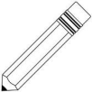
- This is a desk.
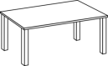
- ………………………………
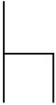
- …………………………………
- ……………………………………..
Fill in the missing letters
B__ __k
D__sk
Ch__ __rs
P__nc__ls
Ta__ __es
Structures
Is this a …………….?
No, it is not. It is a ………………… Or Yes, it is ……………………….
Are these ……………?
No, they are not. They are…………….Or Yes, they are ……….
Examples
Is this a book?
No, it is not. It is a pencil

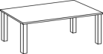
Are these tables?
Yes, they are tables.

Activity
Answer correctly

- Is this a pen?
- Are these pencils?

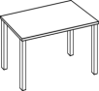
- Are these chairs?
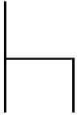

- Is this a chair?
Adjectives
Adjectives are words that talk more about a noun.
Examples of adjectives
Big, dirty, small, clean, white, long, short
Structure
The …………………..is………………
The ………………..are…………………..
Examples
- The table is dirty.
- The desks are clean.
- The book is big.

Activity
Form correct words from these letters
- ooksb ……………….
- eancl ………………..
- allsm ………………..
- rtydi ………………..
- itewh ……………….

Form sentences from the table
The | book  pens  tables  chair | is  are | clean  small  white  dirty  long  big

- ………………………………………………….
- ………………………………………………..
- ……………………………………………….
- …………………………………………………
THEME : OUR HOME
Sub theme: people found at home
Vocabulary
Mother, father, uncle, brother, sister, aunt, baby, grandmother, grandfather
Structures
Use of …….is……)
…………is cooking food. {……………….is………………} (mother)
Mother is cooking food.
Brother is fetching water.
Grandmother is sleeping.
Activity
Write these words correctly
- thermo ………………………
- atherf ……………………..
- stersi ……………………
- ntau ……………………..
- byba …………………….
Mother  Aunt  Father  Sister  Grandmother | is | cooking food  sweeping the compound  going to work  playing  weaving the baskets.

- ……………………………………
- ………………………………..
- …………………………………
- …………………………………..
- …………………………………….

Structures
Is ……….(mother, father) …………………..(cooking food)?
Yes, ………………is or No, ………………not.
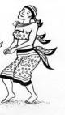
Examples
- Is sister dancing?
Yes, she is dancing.

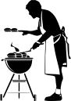
- Is mother sleeping?
No, she is not. She is cooking.

Activity
Answer correctly

- Is father sitting?

- Is sister cooking food?

- Is aunt fetching water?

SUB THEME: THINGS FOUND AT HOME.
Vocabulary
Saucepan, plate, cup, television, basin, bucket, brush
Structures
This / that is………………
These / those are………………
Examples
- This is a saucepan.
- That is a saucepan.
- These are plates.
- Those are plates
Activity
Fill in the missing letters
- Tele__ __sion
- B__sin
- T__ __thbrush
- Cu___
- Saucep__n
Form correct sentences
This  These  Those  That | is  are | a | television  plates  cups  basin  toothbrush

- …………………………………………….
- …………………………………………
- ………………………………………….
- ………………………………………….
- ………………………………………..

SUB THEME: PEOPLE IN OUR HOME
THE ALPHABET (Capital and small letters)
Aa Bb Cc Dd Ee Ff Gg Hh Ii Jj Kk Ll Mm Nn
Oo Pp Qq Rr Ss Tt Uu Vv Ww Xx Yy Zz
Changing letters from capital to small
Examples
G g E __________
B ________ A ___________
J ________ D ___________
K ________ C ___________
Changing words from small to capital letters
e.g
leg LEG
dog ________
hen ________
Ordering letters. Writing letters in abc order
d, a, c, b ____________________________
t, c, h, g ____________________________
l, i, j, k ____________________________
What letter comes after
b, _______ d, _______ a, _________ j, ________ x, _________ m, _______
What letter comes before?
_____, b _____, f ______, j _____, v _____, x _____, p
Lesson 3
Nouns
A noun is a naming word e.g
a) Names of people e.g. Mary, Jane, e.t.c
b) Name of schools e.g. Kampala city, Mengo Primary School
c) Names of objects e.g. spoon, table, chair, desk e.t.c
d) Name of lakes, hospital, animals, birds e.t.c
Lesson 4
Identifying nouns from the given sentences
1. I live at Mengo.
2. Mary is here.
3. The cat is running.
4. Lake Victoria is a big lake.
Lesson 5
Using article “an” before single nouns starting with vowels a, e, i, o u as shown below.
Example
an elephant, an eagle, an egg, an ox e.t.c
We use “a” before single nouns which begin with consonants.
Activity

Write a or an to fill the gaps
1. This is ________ book.
2. Show me _________orange.
3. She is eating ___________egg.
4. Musa has __________pen and ________ book.
5. Bring me ____________umbrella and __________book.
Lesson 6
Plurals of nouns adding s
Some words change to plural by adding s
e.g.
One hen - two hens
One pen - two pens
One ship - two ships
Note: similar means one and plural means more than one
Activity
Change the following nouns to plural
Singular plural
farm farms
school _________
home _________
ball _________
boy _________
table _________
flower _________
pen _________
dog _________
Activity
Complete the sentences correctly
1. Tom has one book but Mary has many ______________
2. One orange but many _______________
3. Seven girls but one _______________
4. One _____________ but six pencils.
Lesson 7
Plurals by addinges
Some nouns which end with x, o, ch, sh, s we add es to change to plural form
e.g.
one bus - two buses
onetomatoe - many tomatoes
one fox - many foxes
Activity 1
Change these nouns to plural form
box - __________ ranch _________
mango - __________ potato _________
ash - __________ bench _________
glass - __________ branch _________
Activity 2
Fill in the gaps with the plural of the word in brackets
1. Put the ____________in the basket. (tomato)
2. Are these ___________? (bus)
3. ______________are fruits?(mango)
4. ____________live in the bush. (fox)
Lesson 8
Use of is and are
Is is used for singular and are is used for plural
a) the girl _______________reading a book.
b) ___________this a dog?
c) This mango ___________sour.
d) The boys ___________playing football.
e) ___________those your books?
f) The mangoes ____________rotten.
Activity 1
Making sentences using “is” and “are” orally
Activity 2
Make sentences from the substitution table
She  The boy  These  This box | is  are | playing.  mangoes.  eating food.  full of apples.

Activity 3 structures (Are these __________?) (is this ______________?)
Lesson 9
Use of has and have
Has is used for one thing and pronouns she, it, he
Have is used for more than one thing and pronouns “I ” “you” “they” and “we”
Examples
a) I have a good bag.
b) The boys and girls have black shoes.
c) She has a car.
d) I have two ears.
Activity 1
Making sentences using “has” and “have”
Activity 3
Use “have” and “have” to fill the gaps correctly
a) Mary and Jane _____________ long hair.
b) She ____________a nice plate.
c) I _____________ a blue dress.
d) You _____________a good pencil.
Make sentences from the substitution table
She  They  I  We  Mary | has  have | a doll.  books.  a nice bag.  mangoes and oranges.
Lesson 10
Verbs
Verbs are words that can be acted
Examples
Look, eat, come, stand, clap, sit, go. Sleep, run, beat etc
Activity
Listening/ mentioning different verbs
Activity 2
Identifying verbs in sentences by underlining
a) I can eat slices of bread.
b) She walks slowly.
c) The baby is crying.
d) Who is sleeping?
e) Did she go home?
Lesson 11
The present Continuous Tense (Now tense)
We add “ing” to some verbs to change them to present continuous tense
Words ”is” and ”are” are used in the present continuous tense

Examples of present Continuous tense
Verb present continuous tense
reach ___________________
eat __________________
point __________________
look __________________
play ___________________
Activity 1
Making sentences using continuous tense orally
Activity 2
Fill in correctly using the verbs in the brackets
a) I am ___________________my teeth now. (brush)
b) Grace and Diana are _______________the floor. (sweep)
c) The milk is _______________. (boil)
d) We are _____________ hard (work)
e) Are they ________________. (eat)
f) Why are you ________________out? (go)
Lesson twelve
Dropping “e” and adding “ing” to the verbs
Examples
drive __________________ make _______________
dance __________________ close _______________
come __________________ bake _______________
like __________________ save _______________
Activity 1
Discussing the verbs which end with “e” orally
Activity 2
Change the verbs in brackets to present simple tense to fill the gaps
1. Daddy is ________________a car. (drive)
2. Is teacher ______________on the chalkboard? (write)
3. They are_______________ to visit us. (come)
4. Mummy is _______________cakes. (bake)
5. She is _____________very well. (dance)
6. We are __________________very fast. (move)
Lesson fifteen
Using “was” and “were”
We use “was” for one item or person.
We use “were” for more than one item or person.
Examples (was)
1. One egg was cracked.
2. The apple was in the basket.
3. Was it a good pen.
Examples “were”
1. The eggs “were” cracked.
2. The apples were on the table.
3. The oranges were sweet.
Activity 1
Make sentences using “was “ or “were” correctly (oral)
Activity 2
Fill the gaps with was or were correctly
1. The boys _______________reading their books.
2. The dress _______________beautiful.
3. _____________ the oranges ripe?
4. The birds _______________flying in the river.
5. The cat ______________playing with the kitten.
6. The apples _______________green.
Make sentences from the table below
The girl  The boys  Mary  He | was  were | Sleeping on the mat.  Reading books.  Eating food.  Saying prayers.
Lesson sixteen
Missing letters in verbs and nouns
ba __ke c____air tab____e fl____wer
s___nd co ___e sch ___ ____l pen___il
Lesson seventeen
Writing words correctly (jumbled letters)
bkoo __________________ husoe _______________
byo __________________ pecnil _______________
gril __________________ oen _______________

Lesson eighteen
Punctuation capital letters
Capital letters
a) Starting telling sentences
b) Starting asking sentences
c) Starting names of people, places, titles of books, plays, films etc.
d) Writing days of the week and months of the year.
Examples
1. Where do you live?
2. She is a good girl
3. Yesterday was a Tuesday
Activity 1
Write a capital letter where necessary
1. rose is a girl.
________________________________
2. her mother’s name is mary.
_______________________________
3. mengo is a big school.
_______________________________
4. My name is esther.
_______________________________
- Anita is my sister.
______________________________
Lesson nineteen
Punctuation (full stop)
A full stop is a dot which is put at the end of a telling sentence
Example
1. A dog is a domestic animal.
2. Butter is made from milk.
Activity 1
Constructing telling sentences orally
Reading sentences
Activity 2
Put a full stop at the end of each sentence
1. Sugar has a sweet taste.
2. Honey is made by bees.
3. A young cat is called kitten.
4. I am seven years old.
5. The boys are playing football.
6. The teacher is teaching.
Lesson twenty
Punctuation (Question mark)
Asking questions
Asking sentences ask questions
Examples
a) What is your name?
b_ Why are you crying?
c) Who is that?
* Every asking sentence must end with a question mark
Activity 1
* Forming asking sentences orally
Activity 3
Use a question mark (?) to punctuate the following
1. What is your name?
2. Why are you crying?
3. What do you do?
4. Have you seen the cat?
5. Which of these toys do you live???

Activity 3
Put a full stop, capital letter or question mark to punctuate these sentences
1. today is Monday.
2. my school is fairways primary school.
3. Who is your friend
4. Sunday is the first day of the week
5. alice is going to school.
6. we like going for trips.
Lesson twenty two
Opposites of adjectives and verbs
Tall - short go ______________
Big _____________ give ______________
Hot _____________ wet ______________
hot _____________ late ______________
poor _____________ give ______________
small _____________ dirty ______________
fat _____________ new ______________
good _____________ hot ______________
first _____________ quick ______________
wrong _____________ stand ______________
Activity 2
Given the opposite of the underlined words
1. Pretty is a fat girl. _________________
2. This is a big animal. ________________
3. Will you come home today?
4. The horse is a weak animal. _____________
5. A hot meal, A _____________meal
6. A poor man ______________________
7. A young man. ____________________
Lesson twenty six
A compound word is formed by joining together two or more words e.g
tea + pot - teapot
rail + way - railway
Activity 1
Join these words to make one work
arm + chair ___________ key + board ______________
bed + room ___________ hand + bag ______________
table + cloth ___________ match + box ______________
dust + bin ___________ butter + fly ______________
sick + bay ___________ school + bag ______________
Activity 2
Make one word by joining two underlined words
A pot used for tea is a ________________
A room for bath is a __________________
A bell used in a school is a ________________
Work to be done at home is called _____________
A man who brings milk at your home is a ______________
Lesson twenty seven
Prepositions
Prepositions are words that show positions
Examples
Under, on, in, over, behind, infront of, hear, between, to
Activity 1
Making correct sentences using the prepositions above
e.g The flower is in the pot.
Activity 2
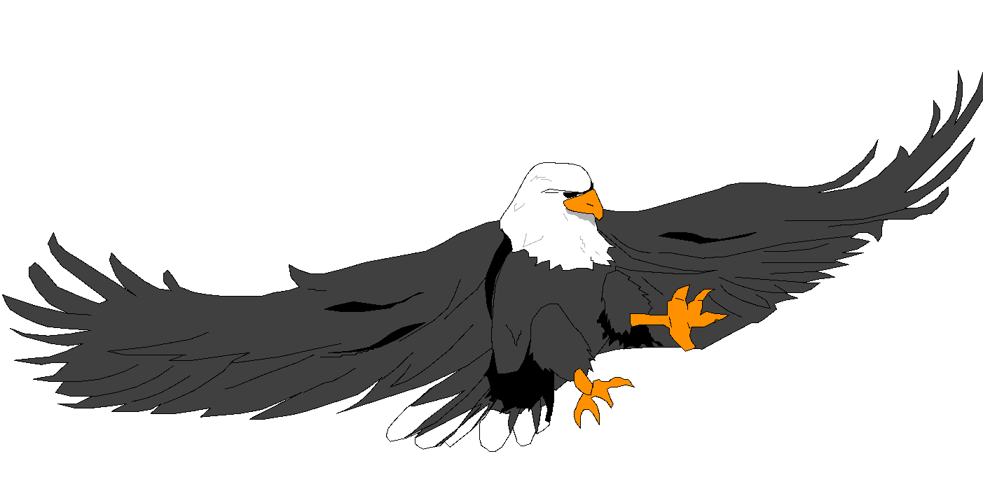
Filling in the correct preposition
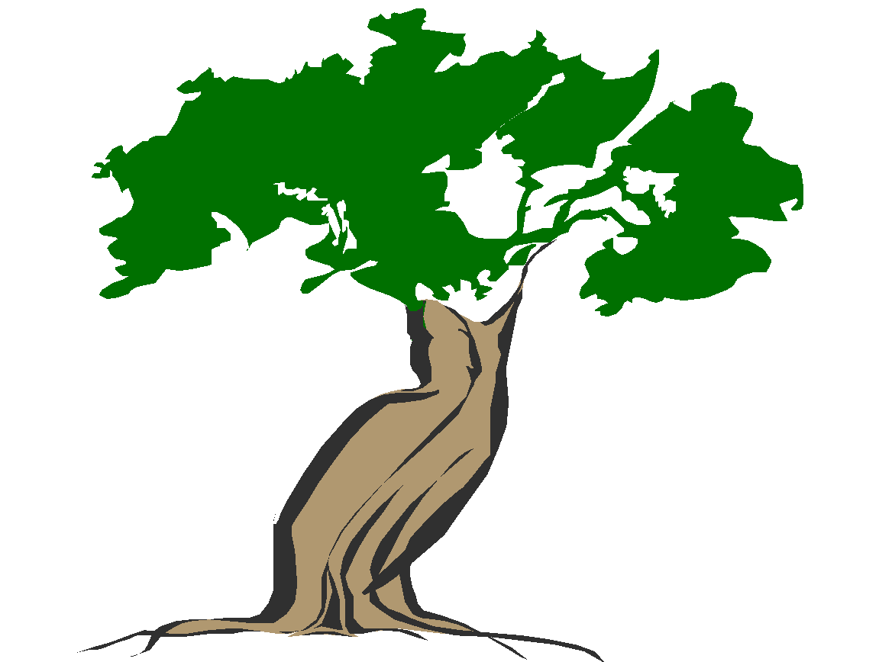
The bird is flying _____________the tree.
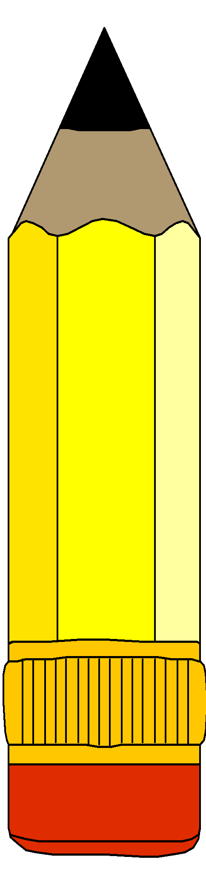
The pencil is ___________ the tin.
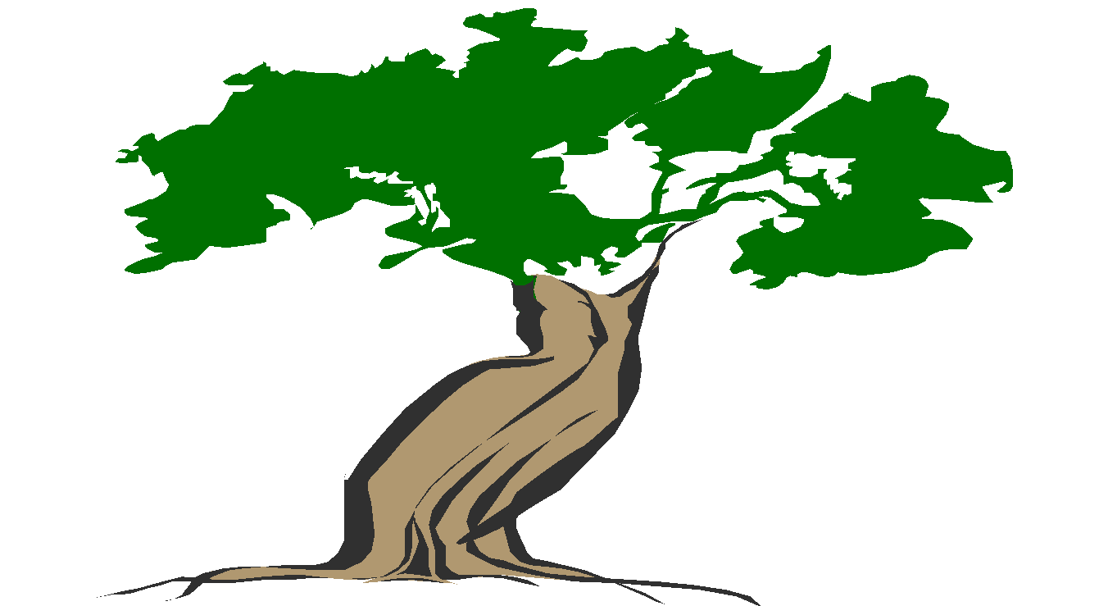
The tree is _____________the house.

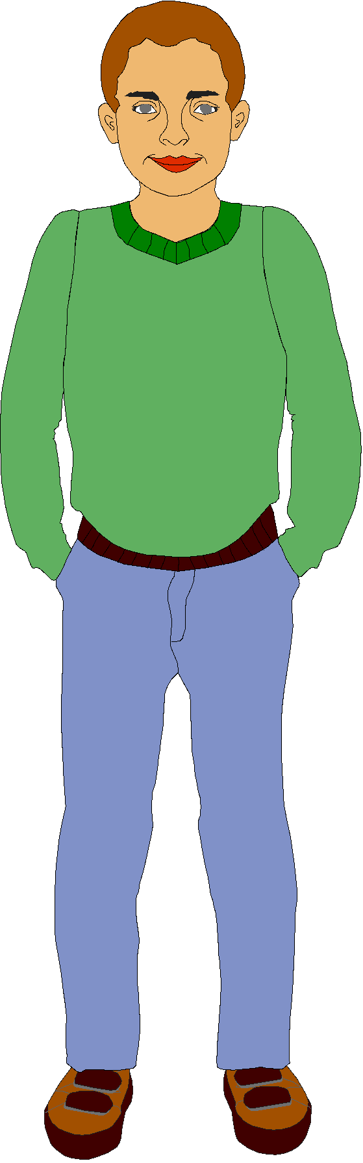
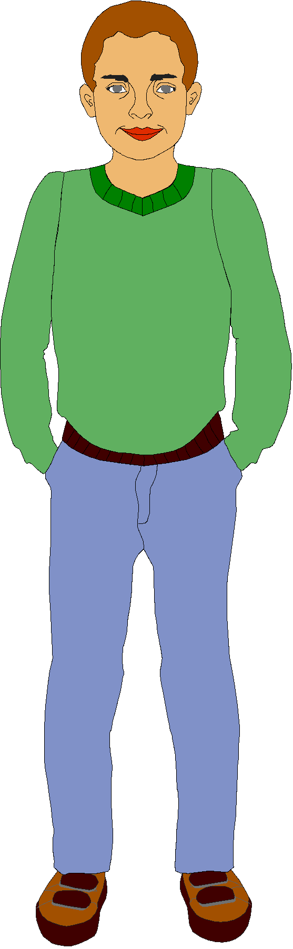
The ball is _____________the boys.

The cat is ____________the box.
Lesson twenty eight
Forming small words from big words
Examples - school girl prepositions positions
School girl - tea, her he doing do in
Teacher -
Office - off, ice, of pigeon pig, on
Compound - pound, un donkey do key
Afternoon - after, noon, on
Lesson twenty nine
Finding the odd word out
a) ear dress, leg hands
b) chair pen, orange, pencil
c) vest, shirt, dress, cup
TOPICAL REVISION QUESTIONS FOR TERM I P.1 2012 ENGLISH
The Alphabet
Write the missing
2. Write these letters in capital

S n r b d g
3. Write these letters in small
F H I M J L K
4. Arrange these letters in order
a) d, a, c, b _________________
a) f, e, h, g _________________
a) p , m, o, n _________________
a) v, x, u, w _________________
a) s, q, r, t _________________
a) l, i, j, k _________________
5. Write these words using capital letters
a) car __________________ b) teacher ________________
b) table __________________ e) cook ________________
c) cupboard __________________ f) bursar ________________
6. Write these words using small letters
a) PENCIL ________________ e) BENCH ________________
b) BOOK ________________ f) BOY ________________
c) DESK ________________ g WATER ________________
d) SCHOOL ________________ i) NAME ________________
h) MUG ________________
7. Which letter comes after
a) b, ______ c) v, _________ e) s,t, _____
b) f, ______ d) y, _________ f) p, ______
8. which letter comes before
a) ______, b d) _____, t g) _____, r
b) ______, h e) _____, o h) _____, m
c) ______, n f) _____, e i) _____, i
1. What is a noun?
__________________________________________________
2. Write their noun



____________ ___________ __________ __________

________________ ______________ ________________

3. Draw a line under the nouns from these sentences
a) Her name is Jane.
b) She lives at Kabaragara
c) Here is a book.
d) Today is Friday.
e) That is a river.
f) March comes before April.
g) Gertrude is sick.
h) I go to Sir Apollo Kaggwa Primary School.
i) There is Mulago Hospital.
j) Lake Victoria is large.
4. Read and draw
Teacher | tree | blackboard | cupboard | basket
1. Match the nouns with “a” or “an”
a) _____ ox e) ____ mango j) _____egg n) _____bicycle
b) _____ elephant f) ____ eagle k) _____bench o) _____bus
c) _____ ruler h) ____ umbrella l) _____owl p) _____school
d) _____ dog e) ____ book m) _____arrow q) _____inkpot
2. Fill in the sentences with “a” or “an”
a) That is ______________angel.
b) _______________orange is a fruit.
c) _______________ship sails on water.
d) Mary is eating _____________an egg.
e) Come with ___________apple and __________berry.
f) Show her _________dress and ________umbrella.
Nouns plurals of nouns
1. Fill in the table correctly
One Many
a) teacher ___________
b) class ___________
c) ___________ hens
d) ___________ boxes
e) glass ___________
f) watch ___________
g) ___________ umbrellas
h) cow ___________
i) tomato ___________
2. Give the plurals of the underlined word given in brackets
a) Mummy has two sweet ___________________from the garden. (potato)
b) We sit on ____________________in church. (bench)
c) There are eight ______________________on the tray. (glasss)
d) Are these ___________________ ? (bus)
e) __________________are examples of furniture. (chair)
f) One (flag) but ten _______________
g) One (cook) but four ______________
h) One (book) but ten ______________
i) There are thirteen _______________ (mango)
j) Those are two _______________ (anthem)
Use of is or are
Fill in the gaps with “is” or “are”
a) The teachers ____________eating food.
b) The boxes _______________broken.
c) My pencil __________________sharp.
d) This __________________ our guard at school.
e) These ________________cups and plates.
f) _______________this a secretary.
g) _______________ these nurses?
h) Here ____________the duster.
i) Mary and Justine _______________smart.
2. Make sentences from the substitution table below
She  These  Agnes  The boy and the girl  This tin  They | are  is | reading a book.  good flowers.  full of water.  running to school.  mangoes

a _______________________________________________________________________________
b _______________________________________________________________________________
c _______________________________________________________________________________
d _______________________________________________________________________________
e _______________________________________________________________________________
f _______________________________________________________________________________
g _______________________________________________________________________________
Use “has “ or “have” to fill the gaps
1. The bursar and the secretary _____________long hair.
2. I __________________ seven reading books.
3. Madina _________________ a pink skirt.
4. He _________________two brushes.
5. You _________________a good home.
6. Ritah and I ______________long skirts.
7. They ______________gone to school.
8. We ________________ a nice flower.
Use the substitution table to make correct sentences
She  We  They  Suzan  He | have  has | two dolls.  eaten sweet bananas.  a nice bag.  come late.
a _______________________________________________________________________________
b _______________________________________________________________________________
c _______________________________________________________________________________
d _______________________________________________________________________________
e _______________________________________________________________________________
f _______________________________________________________________________________
g _______________________________________________________________________________
What is happening?
_____________________________ ______________________
_____________________________ ______________________
_____________________________ ______________________
_____________________________ ______________________
Use the correct form of the verb in brackets
1. Mother is ________________ food. (cook)
2. The children __________________football yesterday. ()play
3. Mary _______________her teeth everyday. (brush)
4. They _____________to their new house last week. (move)
5. She is ________________to the market. (go)
6. Tom and Peter re ________________ . (dance)
7. The woman is _________________a lorry. (drive)
8. The bursar ____________________a lot of money yesterday. (save)
9. He ____________________to school everyday. (go)
Fill in the missing letters
Ba ____ket c____air da____ce
Tab___e flowe____ jum_____
Sch___ ____l c ___r c____me
Pen____il lor____y sw ____ ____p
W____ite l _____arn w_____ter
Lo____k t _____pe coll_____ct
Te____ch
2. Write these words correctly
Sarbur ________________ oen _____________
huose ________________ gril _____________
chertea ________________ iceoff _____________
earln ________________ oolsch _____________
omeh ________________ oonsp _____________
aicrh ________________ chben _____________
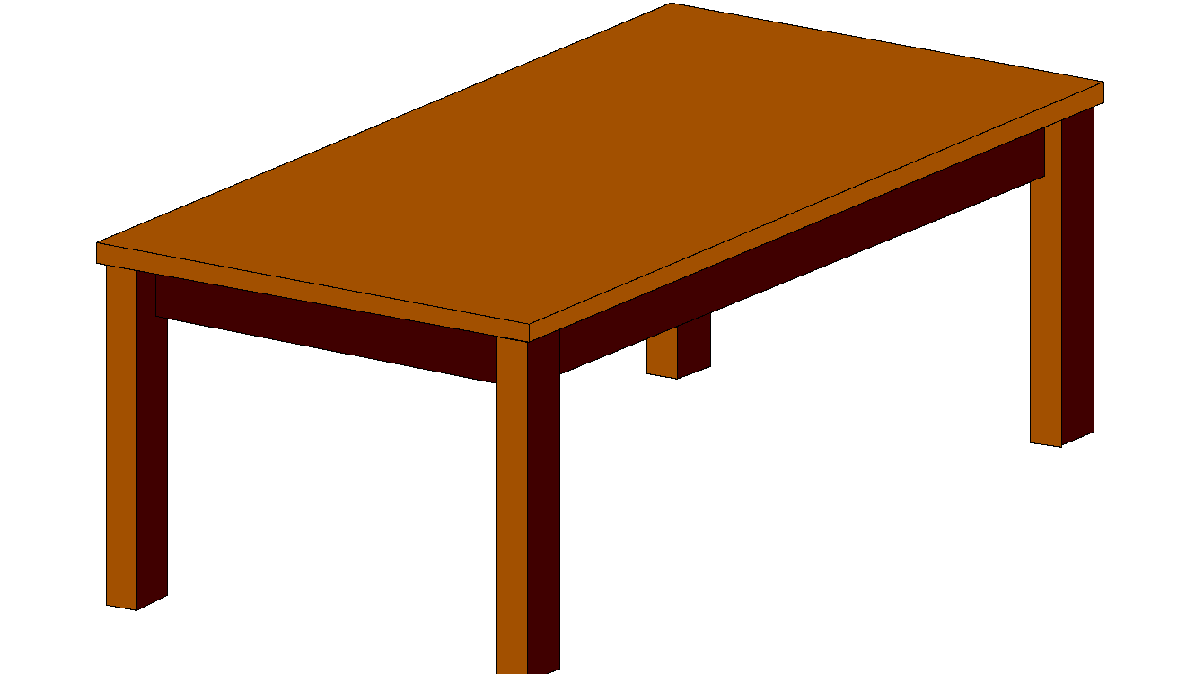
3. Name these objects

1+2 = 4
_____________ _______________ ________________

_____________ _______________ ________________
Punctuation
Use capital letters, full stops or question marks to punctuate correctly
1. where is your book.
______________________________
2. my name is nagayi.
______________________________
3. are you sick.
______________________________
4. Here is the school flag.
______________________________
5. i am going to town.
______________________________
6. how many days make a week.
______________________________
7. what is your name.
______________________________
8. which day comes after tuesday.
______________________________
9. today is friday.
______________________________
10. i live in mengo.
______________________________
11. she was born in december.
______________________________
12. wednesday comes before.
______________________________
Use “was” or “were” to complete the sentences correctly
- There _____________a fly in my porridge.
- Jane ____________given seven yellow dresses.
- There _________________many people in the room.
- The baby and the girls ________________sleeping.
- I _____________late to school yesterday.
- They _____________all green apples.
- _______________the exams passed well?
- The aeroplanes __________________flying over the school.
- ______________ he given the right dosage?
- The cat ________________playing with the kitten.
- _______________the oranges ripe?
- There _______________no water in the pot.
Use the substitution table below to make good sentences
We  The girls  Mary  He  Peter | was  were | sleeping on the mat.  reading books.  eating food.  saying prayers.
a _______________________________________________________________________________
b _______________________________________________________________________________
c _______________________________________________________________________________
d _______________________________________________________________________________
e _______________________________________________________________________________
f _______________________________________________________________________________
Opposites
Write the opposites of the listed words
Word opposite
- big __________________
- cold _________________
- poor _________________
- tall _________________
- give _________________
- empty _________________
- stand _________________
- cry _________________
- first _________________
- narrow _________________
2. Complete the sentences by giving the opposites of the words in brackets
a) It is too ___________________today. (cold)
b) Her sweater is ____________________(dry)
c) A chameleon is so ________________ (quick)
d) Grace has a ________________skirt. (old)
e) My daddy is _______________ (thin)
f) We were ___________________to school today. (late)
g) Satan is ___________________ (good)
h) Mad people are ever _________________(clean)
i) I shall ______________tomorrow. (come)
j) It is a _______________road. (narrow)
k) He is a _________________man. (poor)

Compound nouns
Join and form compound words correctly
- Dust + bin = _____________________
- Herds + man = _____________________
- Wall + chart = _____________________
- Butter + fly = _____________________
_________________________
bottle
bed
sick
school
arm

chair
boy
room
top
bag

_________________________
_________________________
_________________________
_________________________

2. Make one word by joining two underlined words
a) A cloth for the table is a ___________________________
b) A man who brings milk is a ________________________
c) A bell for school is a ______________________________
d) A vase for a flower is a ___________________________
e) A room for a bath is called a _______________________
f) A pot for tea is called a ___________________________
g) A bay for sick people is called a ___________________
Prepositions
1. Fill in the correct preposition
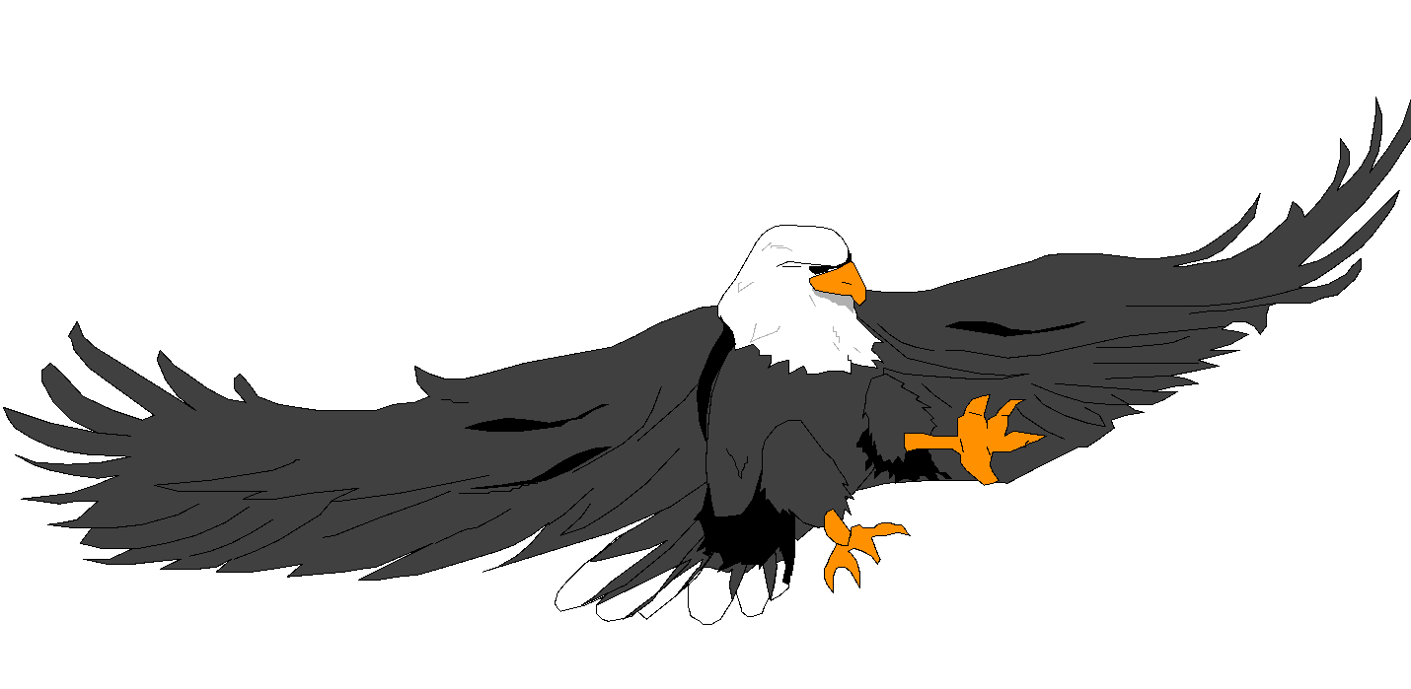
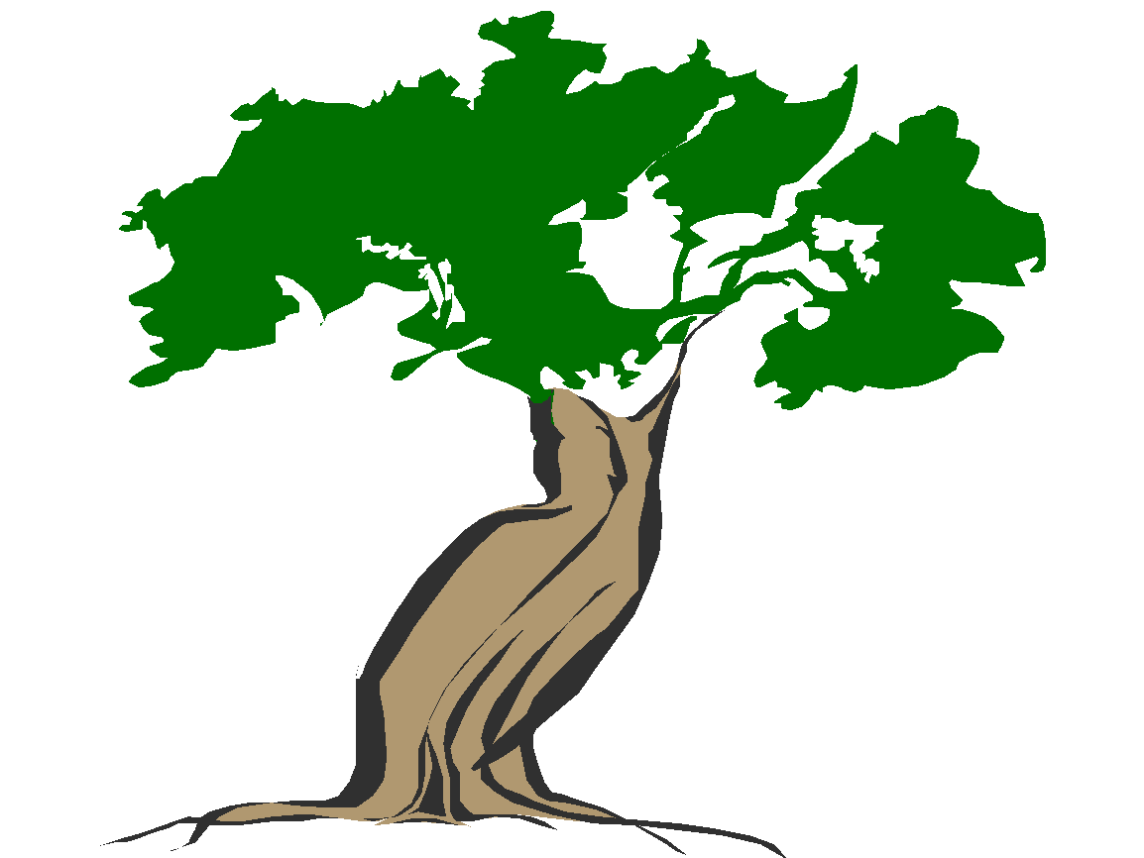
a) The bird is flying ________________the tree.

b) The ball is ______________the box.
c) The tree is _________________the house.

d) The ball is _________________the stone.

e) The chair is _________________the girls.
2. Underline the correct preposition in the sentences
a) The fish are swimming on, in, under water.
b) They are looking behind, off, at the thief.
c) The aeroplane is flying infront , over, under the house.
d) He goes to school on, by, at foot.
e) He is pointing to, at, over, the sun.
3. Make sentences about these pictures

_____________________________________________________________
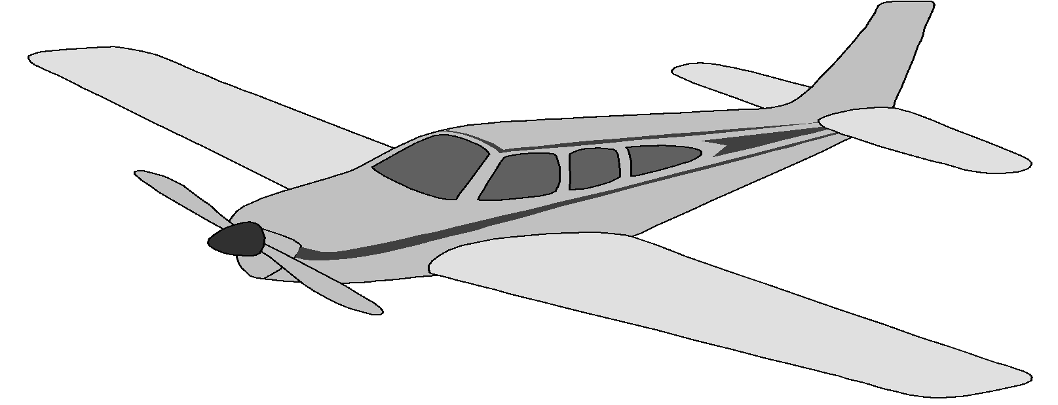

_____________________________________________________________

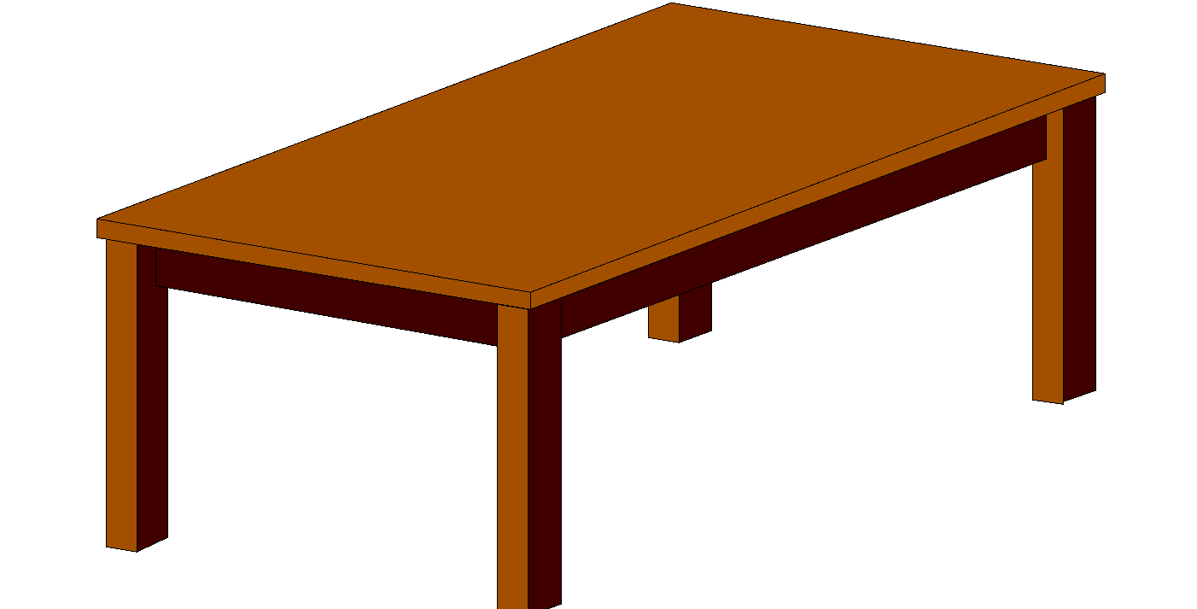
_____________________________________________________________
Find the odd one out
a) Flag, anthem, motto, name, pencil
b) ear, dress, leg, hands, nose
c) vest, shirt, dress, bottle
d) teacher, headmaster, milkman, cook
e) pot, mat, rope, hoe, chair
f) cassava, stone, chair, basket book
g) Jane, paul, Sarah, Agnes
h) bench, chair, stool, water
i) tent, bungalow, ruler, hut

PRIMARY ONE ENGLISH LESSON NOTES TERM II
THEME: WEATHER
Sub theme: elements of weather
Content: vocabulary
Sun, rain, clouds, wind
Structures
Is it……………? (raining)
Yes, it is …………………….. Or No, it is not………………….. It is………………
Examples
- Is it shining?
No, it is not. It is raining.

- Is it shining?
Yes, it is shining.

Activity
Answer correctly
- Is there wind?
- ………………………………
- Is it raining?
- ………………………………

Vocabulary (types of weather)
Windy, rainy, cloudy, sunny
Structures
What is the weather like?
It is …………………….
Is it …………………?
Yes, it is .
No, it is not.
Examples
- What is the weather like?
It is rainy.
Is it rainy?
Yes, it is
- What is the weather like?
It is sunny
Is it rainy?
No, it is not.
Activity
Answer correctly
- What is the weather like?
……………………………………………………………..
- Is it sunny?
……………………………………………………………….

Vocabulary
Water, axe, knife, panga, hoe, spade, rake
Structures
What is this / that?
It is a………………….
This / that is a ………………………
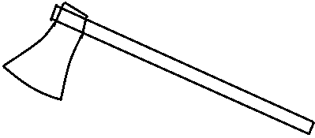
Examples
- What is this?
It is an axe.

- What is that?
It is a spade.

Activity
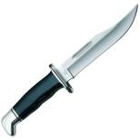
Answer correctly
- What is this?
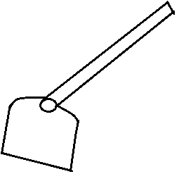
……………………………………….

- What is that?
…………………………………………..
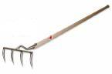
- What is this?
………………………………….

Vocabulary
Seed, plant, weed
Structures
Is he/ she ………………..(weeding)
Yes, he/ she is.
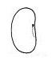
Examples
- Is it a seed?
Yes, it is a seed.
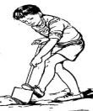
- Is he digging?
……………………………..

Vocabulary
Shirt, dress, sweater, hat, jacket, socks, umbrella, gumboots
Structures
What is this/ that?
This / that is a ………………………
It is a ……………………..
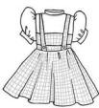
Examples
- What is this?
It is a dress.
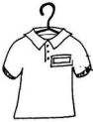
- What is that?
………………………….
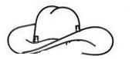
- What is this?
…………………………………………………………………..

THEME: ACCIDENTS AND SAFETY
Vocabulary
Pin, knife, fire, razorblade, stone, broken glass, needle
Structures
Show me a…………….
This is a ………………..
Don’t play with a ………………
That is a …………………..
Examples
- Show me a knife.
This is a knife.
- That is a broken glass.
Don’t play with a needle

Activity
Answer correctly
- Show me a stone.
- Show me a razorblade.
- Show me a broken glass.
Form a sentence using “That is a ………”
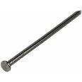
……………………….
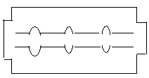

……………………….


………………………
Vocabulary hurt, cut, burn, poison, fall
Structures
…………………kills. (poison, juice)
A…………………. cuts. (razorblade, needle)
The tree is falling.

Vocabulary
Ill, sharp, prick, drown, fracture
Structures
Are you ill?
Is he hurt?
Activity
Answer correctly using the words in brackets
- Are you………………….? (ill, prick)
- Is it………….? (drown, sharp)
- Are you ………….? (hurt, hat)

THEME: LIVING TOGETHER
Vocabulary
Mother, sister, brother, father, baby, uncle, aunt, daughter, niece, nephew, son, grandfather, grandmother.
Structures
He is my……………..
Examples
She is my mother
He is my nephew.
Activity
Complete the sentences with the words in brackets
- Andrew is my …………………(sister, brother)
- Sanyu is Mrs. Kalule’s ………………(daughter, son)
- Arnold is Jane’s ……………..(nephew, niece)
- She is my ………………….(grandfather, grandmother)
Theme: food and nutrition
Vocabulary
Examples of food
Potatoes, fish, bananas, beans, millet, peas, eggs, hens

Structures
What are they?
They are ……………..
What are these?
These are…………….
Examples
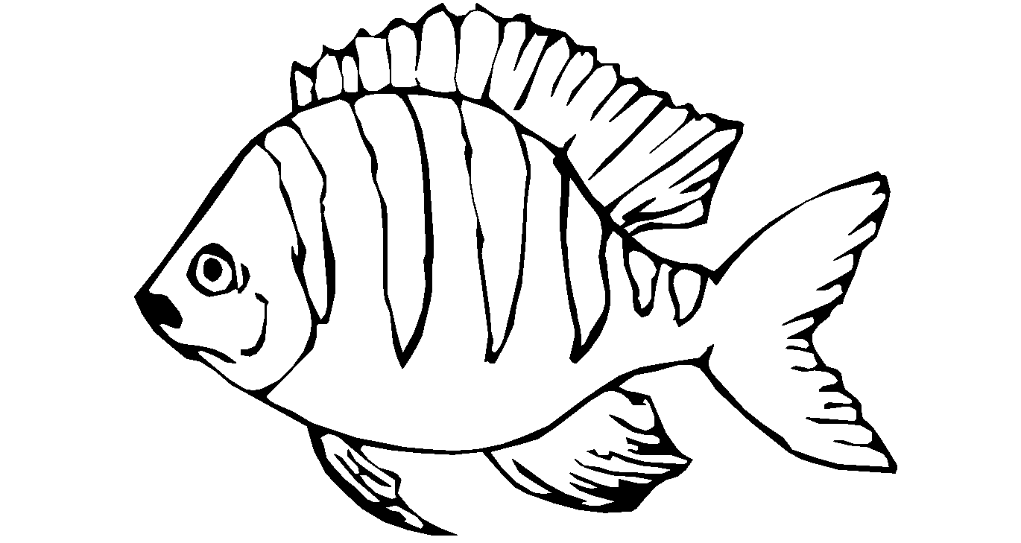
What are they?
They are fish.
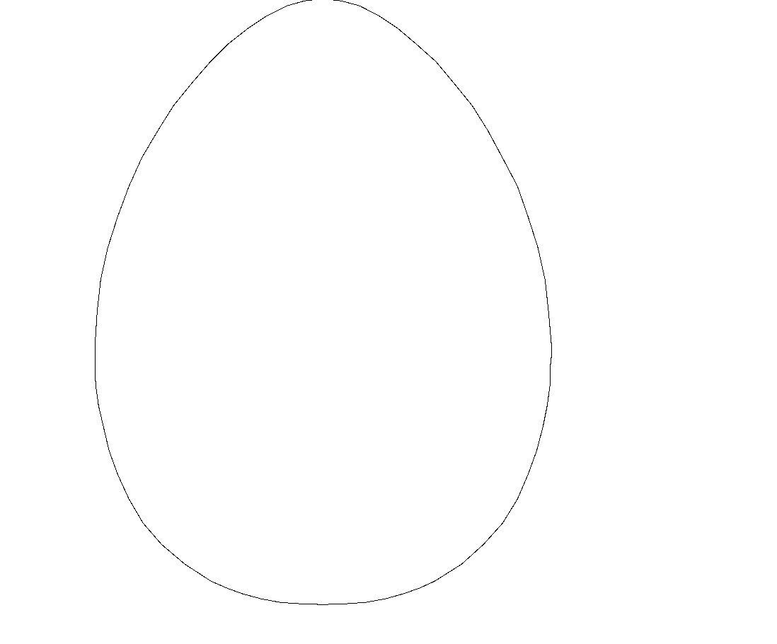
What are these?
These are eggs.
Activity
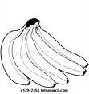
Answer correctly
What are they?
………………………
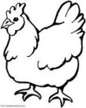
What are these?
…………………………….

Places where we get food
Vocabulary
Shop, market, garden, farm, lakes, animals, plants
Structures
Where do you get eggs?
I get eggs from hens.
Do you like fish?
Yes, I like fish, or No, I don’t like fish
Activity
Write these words correctly
- denrga ………………………….
- ketmar …………………………
- opsh ……………………..
- armf ………………………….
Answer correctly
- Where do we get beans?
- Where do we get fish?
- Do you like peas?
Vocabulary
Goat, cow, pig
Structures
This is a ……………..
That is a ………………..
Activity
Form correct sentences
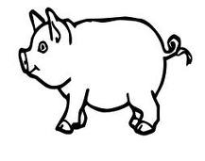
- ……………………………… (pig)
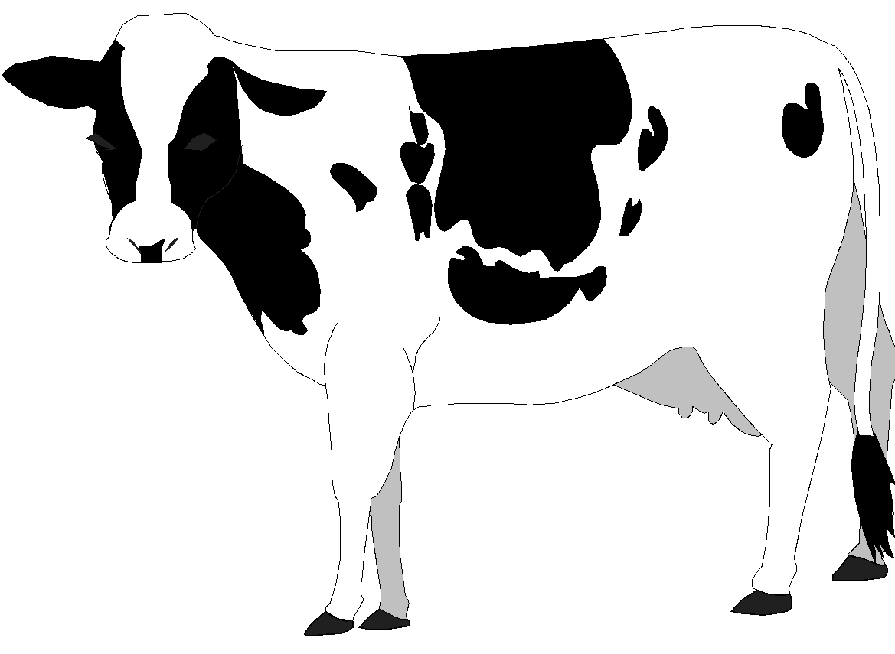
- ………………………………. (cow)

- go__t
- p__g
- co___

THE ALPHABET
Arranging letters in a b c order
Arranging words in alphabetical order or a b c order
Activity
Arrange these letters in a b c order
1. d , c, a 3. m, j, k, l
2. h, f, e, g 4. w, y, x, z
Arrange these words in alphabetical or a b c order.
a) cat, apple, bag
b) flower, dog, cow, boy
c) jug, hut, kennel, leaf
d) umbrella, zoo, web, yam, tree
PREPOSITION
in, on, under, over, near, next to.
Activity I
Fill in a correct word
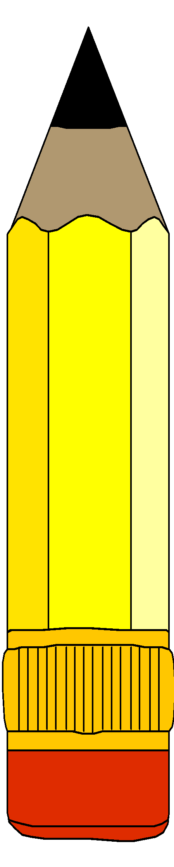
On, under, near, in over
a) The pencil is _________________the tin.

b) The bird is flying ________________the church.

c) The ball is ______________the box.

d) 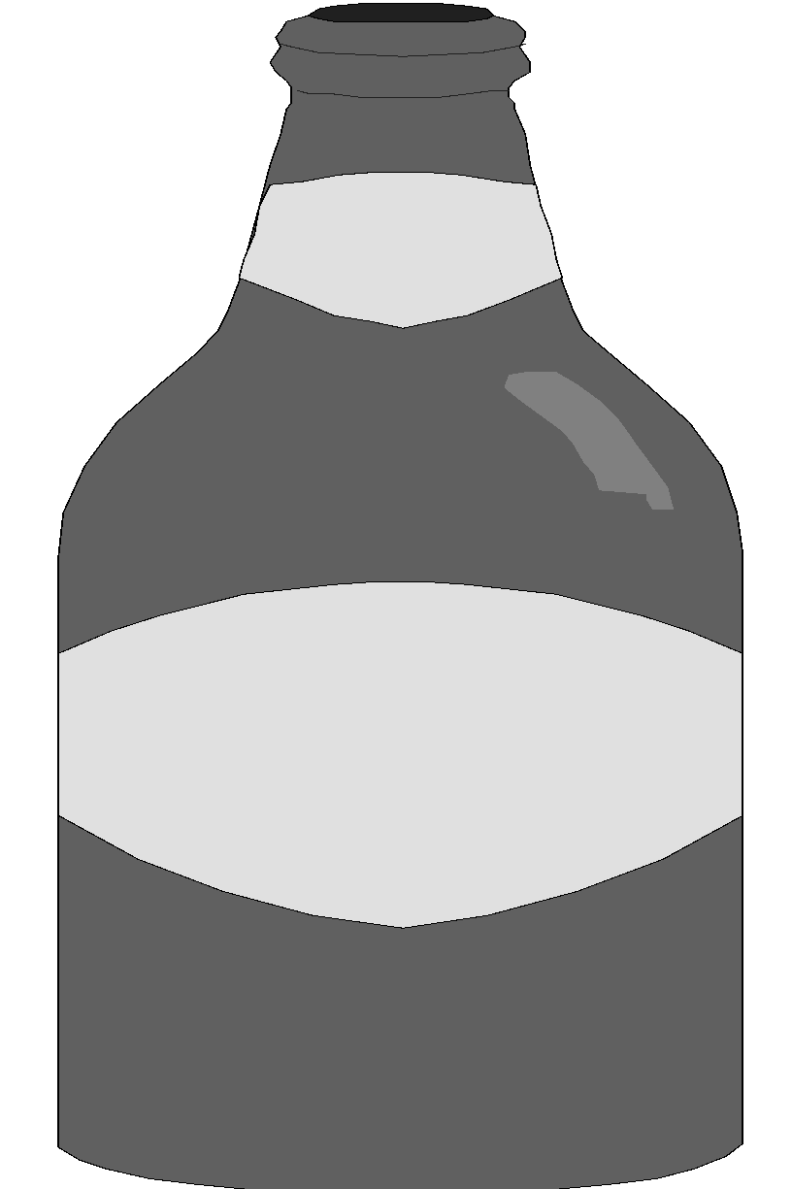 The basket is ______________the bottle.

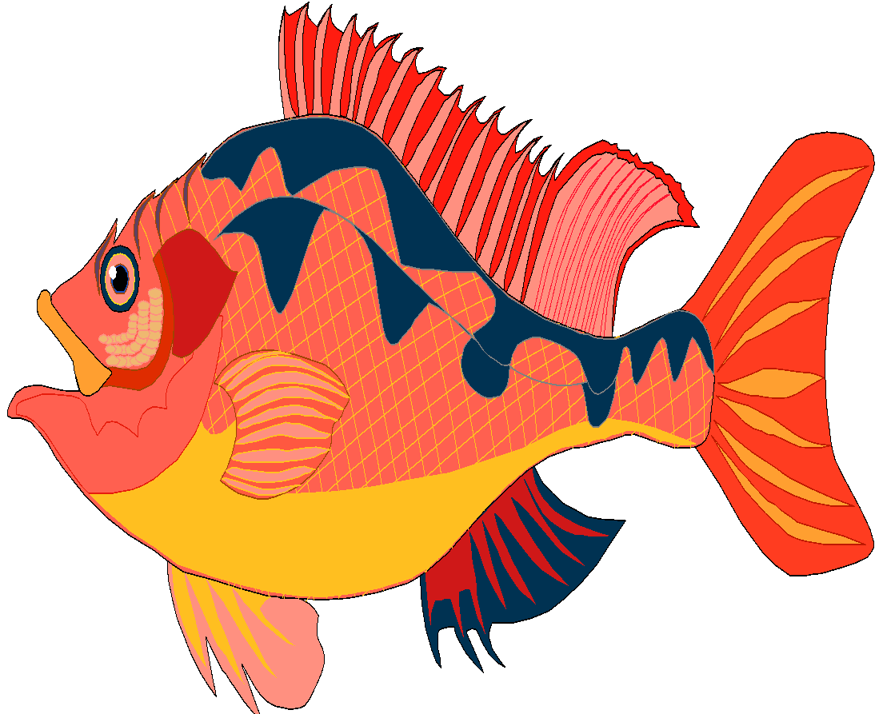
e) The fish is ______________the basket.

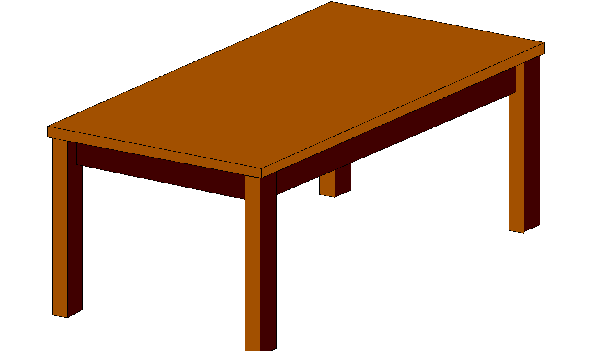
c) The cat is ______________the table.
Activity 2
Fill in the correct preposition
a) Mary is sitting _____________the mat.
b) The boy is pointing _____________the sun.
c) The bird is flying ______________the tree.
d) The fish is _________________water.
e) Is she looking _________________the flower.
Underline the preposition in the sentence
a) Tom is looking ( to, on, at ) the aeroplane.
b) Marvin is pointing ( under, to, over) the bird.
c) The aeroplane is flying ( near, over ) the church.
d) She comes to school ( by, on, in ) foot.
e) Mother goes to work ( on, by ) car
Make correct sentences using the picture.

a) _____________________________________________
b) _____________________________________________

c) _____________________________________________
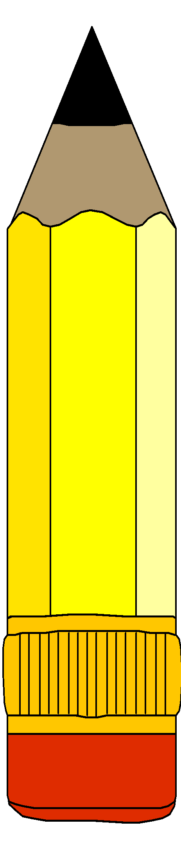
a) _____________________________________________

b) _____________________________________________
PLURALS
Changing y to ies
Lorry lorries fly ________________
Baby ______________ city ________________
Puppy ______________ country ________________
Family _______________ lady ________________
Society ________________
Activity 1
Complete the sentences by filling in the plurals of the words in the bracket.
1. A dog had two ______________________. (puppy)
2. My aunt has four _____________________. (lorry)
3. There are many ______________________in the toilet. (fly)
4. Those ___________________________are very smart. (lady)
5. The woman is carrying __________________. (baby)
Activity 2
Change the underlined nouns to the plural form
1. It is a big family. _____________________
2. I like my country. _____________________
3. she is a smart lady. _____________________
4. Kampala is a big city. _____________________
5. Tom is driving a lorry. _____________________
PLURALS

Changing f to v before adding es
Leaf - leaves half - halves
Calf - calves shelf - shelves
Knife - knives hoof - hooves
Thief - thieves loaf - loaves
Wife - wives
Activity 1
Complete these
One leaf three ____________
One knife four _____________
One thief two _____________
One loaf five _____________
One shelf six _____________
One wife seven _____________
PRESENT CONTINOUS TENSE
Verbs which double the last letter
get getting shut shutting
sit sitting swim swimming
dig digging mop mopping
run running win winning
cut cutting shop shopping
stop stopping put putting
skip skipping clap clapping
Activity 1
Add ing to the words in brackets and fill in the gaps

a) The man is ______________ in the garden. (dig)
b) The children are ___________________their hands. (clap)
c) We are ____________________to school. (run)
d) She is ______________________on the chair. (sit)

PUNCTUATION
a) comma
A comma is used to separate items and to show a pause in a long sentence.
Example
1. Peter, Jane and Sarah are my friends.
2. Marvin bought sweets, cakes, toys and pencils.
Activity 1
Put a comma where necessary
1. My mother gave me bread milk and eggs.
2. I have books pencils and money in my bag.
3. Kato Mary Bbosa and Jane are my friends.
4. John bought tomatoes meat fish and rice.
5. I have a bag a dress and a pair of shoes.
Capital letters
Write capital letters where necessary
a) today is Monday.
b) my name is alice.
c) He is going to bukoto.
d) bob and Alvin are friends.
e) I was born in december.

Short forms
Days of the week
Sunday - Sun.
Monday - Mon.
Tuesday - Tue.
Wednesday - Wed.
Thursday - Thur
Friday - Fri
Saturday - sat.
Activity 1
Write the names of days in short
a) Friday ________________ b) Wednesday ____________________
c) Saturday ________________ d) Monday ____________________
Write in full
e) sun ________________ f) Thur ___________________
g) Wed ________________ h) Fri ___________________
Months of the year
e.g. January - _______________ February - ____________
Activity 1
1) Write in short
a) December ____________________ b) March __________________
c) October ___________________ d) November ___________________
2. Write in full
a) Aug ____________________ b) Feb __________________
c) Jan ____________________
NB - There are some months which do not have short forms e.g.
April May June July
Short forms of other words
Doctor Dr. School Sch.
Hospital Hosp. Teacher Tr.
Road Rd number No
Master/mister Mr.

Activity
Write these words in short
Master __________________ school _________________
Hospital __________________ Teacher _________________
Road __________________ Number _________________
Write in full form
a) Dr. _____________________ b) Tr. _____________________
c) Mr. _____________________ d) Hosp. _____________________
e) No. _____________________

OPPOSITES
Give the opposites of these words e.g.
Long ___________________ open ___________________
Big ___________________ short ___________________
Clean ___________________ sad ___________________
Dry ___________________ good ___________________

Describing objects
- A tall tree
- A big box
- A dirty shirt
Activity 1
Use these words correctly
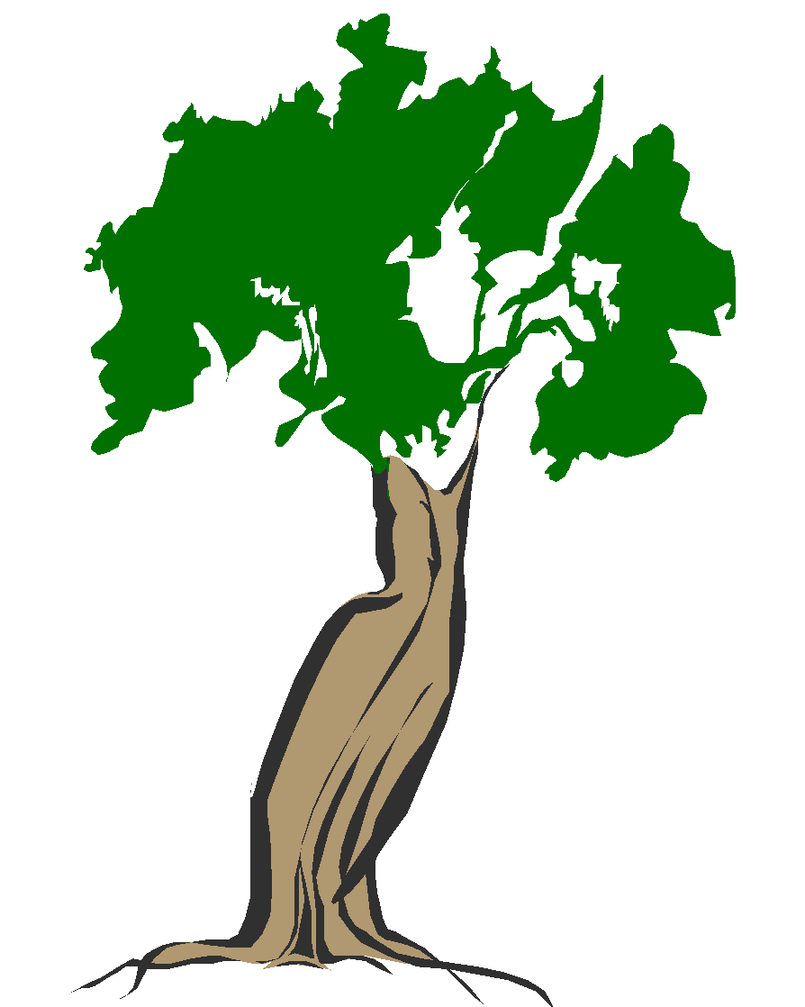
(big, short, tall, small, long)
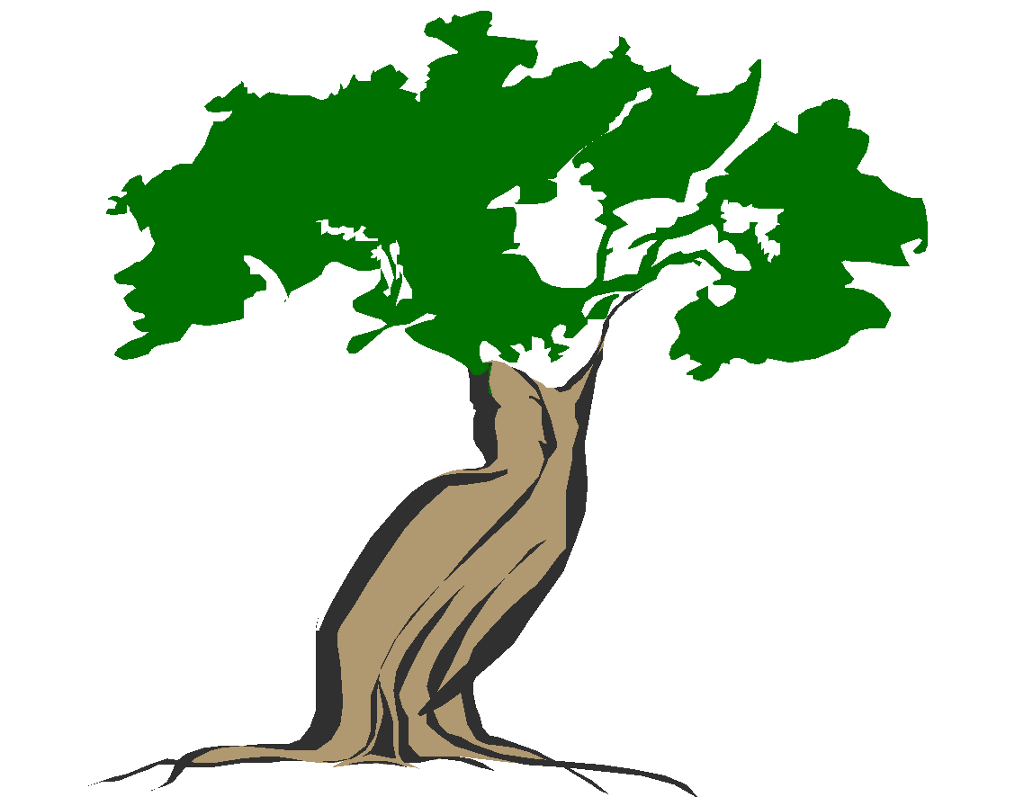
A is a _______________________ tree.
A B B is a _________________________tree.
A
B
A is a _______________________ box.
B is a _________________________box.
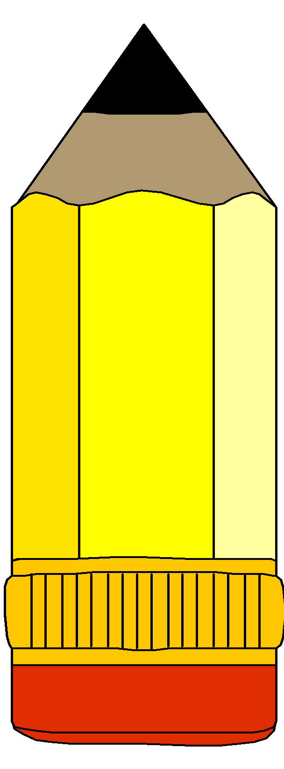
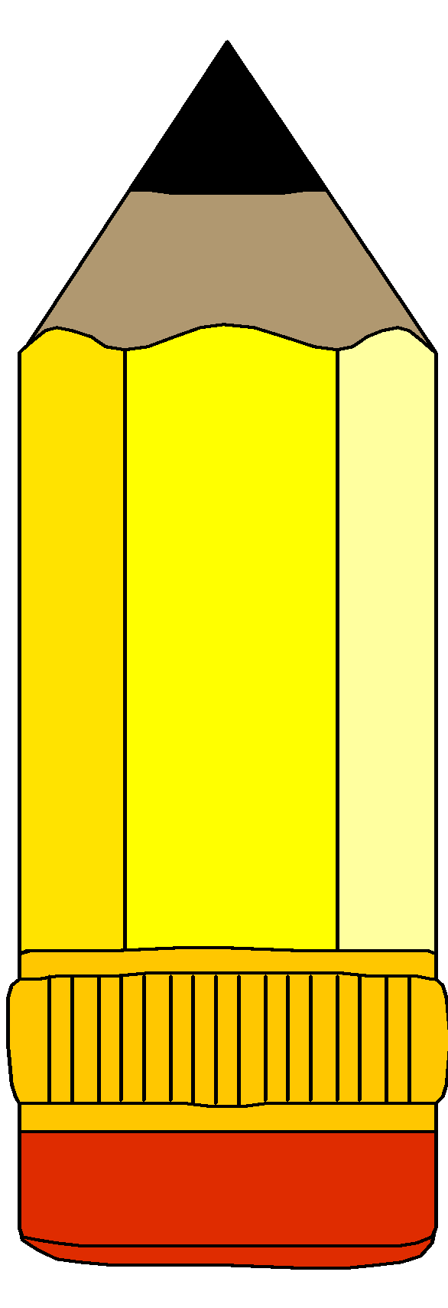
A is a _______________________ pencil.
B is a _________________________pencil.
A B
Adjectives - comparisons
long | longer | longest
tall | taller | tallest
small | smaller | smallest
short | shorter | shortest
smart | smarter | smartest
Complete the table
tall | __________ | tallest
__________ | smaller | smallest
short | smarter | smartest
long | longer | __________

The present simple tense
Vocabulary
Sleep store
Keep drive
Sweep cook
Peel dig
Move clean
Take bathe
Boil pay
Add “s” to the verb below
Verb present simple tense
Sweep sweeps
Bathe
Boil
Clean
Take
Pay
Move
Sleep
Cook
Change the word in brackets to present simple tense
- Rose …………………food every evening. (eat)
- Musa……………water every day. (boil)
- Daddy……………….us to school every morning. (drive)
- That boy…………….three times a day. (bathe)

Lesson twenty four
Present simple tense by adding “es”
Vocabulary
Wash watch preach teach hatch match go box do brush
NB: Verbs that end with sh, x, ch, o, s we add ‘es’ to form present simple tense
Examples
Wash washes
Watch
Preach
Brush
Box
Fetch
Activity I
Use the word in brackets to fill the gaps correctly
- Joy ……………her dresses every day. (wash)
- The hen……………….many eggs every month. (hatch)
- Sarah…………………her teeth every night. (brush)
- Who …………….water every morning? (fetch)
Lesson twenty five
Changing ‘y’ to ‘I’ before adding ‘es’
Examples
Cry cries
Fly flies
Carry carries
Marry marries
Copy copies
Try tries
Activity
Add ‘ies’ to the words in brackets
- The baby ………….every day. (cry)
- A bird……………..(fly)
- He………………..a big box on his heads. (carry)
- She………………groundnuts every day. (fry)
- Peter…………..his friend’s work every day. (copy)

Lesson twenty six
The present simple tense “do and does”
Does - is used for one thing or person. (he, she, it)
Do – is used for I, you, they, we
Examples
- I do my homework every day.
- Do you like that teacher?
- He does his best to help me.
Activity I
Make correct sentences from the table
He  She  It  Joy and Ruth  They | does  do | his  her  its  their  our | work weekly  homework  things daily  work.

……………………….
………………………….
……………………………..
Activity 2
Use ‘do’ or ‘does’ to fill the gaps
- Lucy ……………….her work neatly.
- I ……………….my homework every evening.
- You must………………..well in your exams.
- She…………….her work quickly.
- They………………..their work confidently
- ……………………..she sing sweetly.
- ………………you know your school anthem?
- ……………..it eat rats?
Lesson thirteen
The past tense
Adding “d” to verbs to change them to past tense
We add “d” to some verbs to change them to past tense
Examples
save - saved waste _______________
move - ____________ sneeze _______________
love - ____________ taste _______________
bathe - ____________ shore _______________
live - ____________ use _______________
chase - ____________ hope _______________
activity 1
discussing the verbs which take “d” in the past tense
activity 2
change the verbs in brackets to past tense and fll the blank spaces
1. Peter _________________loudly. (sneeze)
2. She _________________all the sugar. (use)
3. Joy _________________her new dress. (like)
4. He __________________ loudly last night. (snore)
5. They _________________to the new home. (move)
Lesson fourteen
Adding “ed” to verbs to change them to past tense
Look - looked help ______________
push __________________ end ______________
play __________________ wash ______________
stay __________________ touch ______________
fill __________________ borrow ______________
help __________________ post ______________
paint __________________ talk ______________
call ___________________
Activity 1
Make sentences using “any” of the above words orally
e.g. 1. James touched the hot saucepan.
2. she helped me to sweep the house.
3. Joy played with a doll yesterday.
Verbs which double the last letter before adding ‘ed’
Stop – stopped
Clap – clapped
Drop – dropped
Mop – mopped
Skip – skipped
Shop – shopped
Activity
Add ‘ed’ to the verbs in brackets and fill in the gaps
- I ……………………..a rope yesterday. (skp)
- The children……………their hands in the classroom. (clap)
- Daddy………………..at school last Friday. (drop)
- The policeman…………………the cars last week. (stop)
- She……………….the house neatly. (mop)
Verbs which drop ‘y’ and add ‘ied’
Examples
Verbs past tense
Dry dried
Fly flied
Cry cried
Marry married
Carry carried
Burry buried
Activity
Write the past tense of the following verbs
- Hurry
- Study
- Try
Complete the sentences with the words in brackets
- The baby ………….loudly. (cry)
- Father………………my mother. (marry)
- He…………………..driving a car. (try)

Pronouns
Pronoun is a word that is used in the place of a noun
Pronouns in singular and plural form
Singular plural
He they
She we
It you
You you
Examples
- Jerry is going to school. He is going to school.
- Mother is sleeping. She is sleeping.
- Paul and John are friends. They are friends

Activity 1
Constructing sentences using any of the above pronouns orally
Activity 2
Reading sentences
Activity 3
Match words to their correct pronouns
The children he
Paul it
The cat she
Mary and Jane thye
Daddy he
Juma and I we

Activity 4
Use the given pronouns in place of nouns correctly (it, she, they, he)
- Joan is cooking.
- The boy is washing the shirt.
- The cat has a rat.
- Annet and Aisha are playing.
- The cow is eating grass.
- Julius is running.
Activity 5
Underline the pronouns from these sentences
- He is eating a banana.
- We are going to attend a wedding
- They were school symbols.
- I was given one book.
- You opened the door widely.

TOPICAL QUESTIONS FOR TERM II P.1
The alphabet
1. Arrange these letters in alphabetical order
a) d, c, b, a b) m, j, k, l
c) h, f, e, g d) w, y, x, z
2. Arrange these words in alphabetical order
a) sun, clouds, wind, rain __________________________________________________
b) rainy, sunny, cloudy, windy __________________________________________________
c) cat, apple, bag __________________________________________________
d) jug, hut, kennel, leaf __________________________________________________
3. Arrange these words in alphabetical order
a) umbrella, jacket , gumboots, sweater
The prepositions

1. Write the correct prepositions for each picture
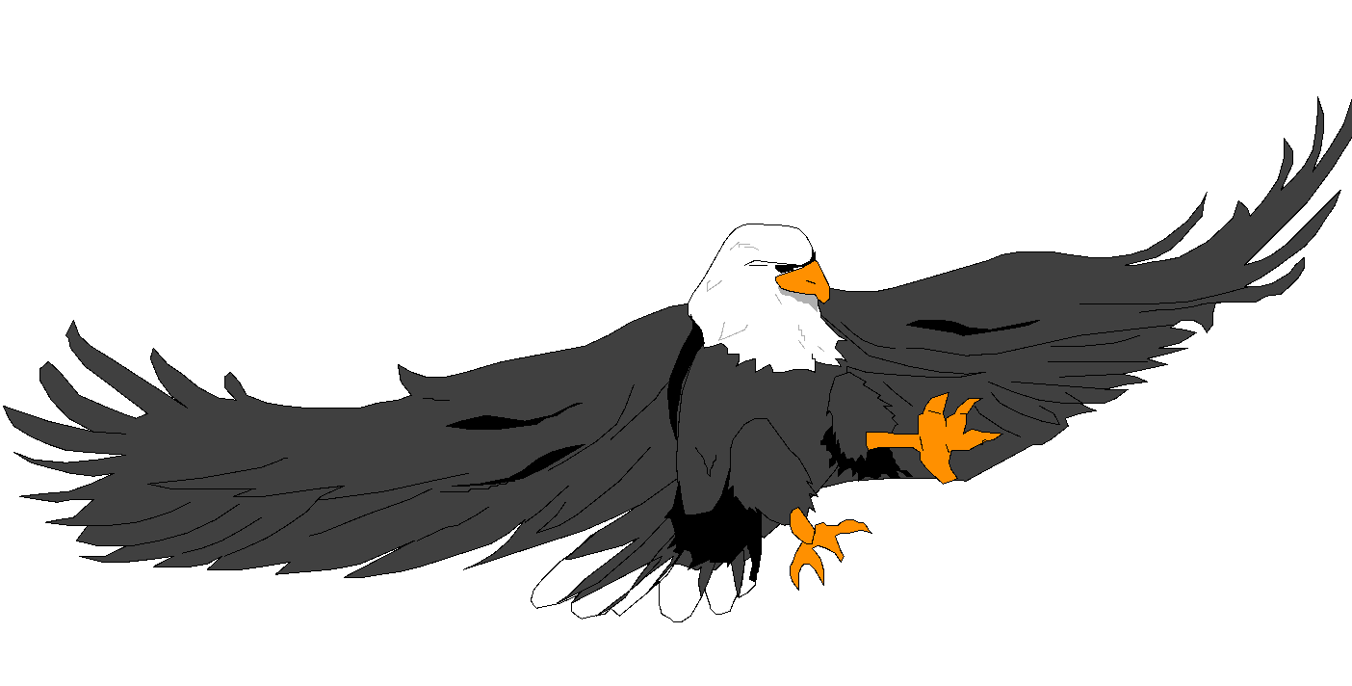
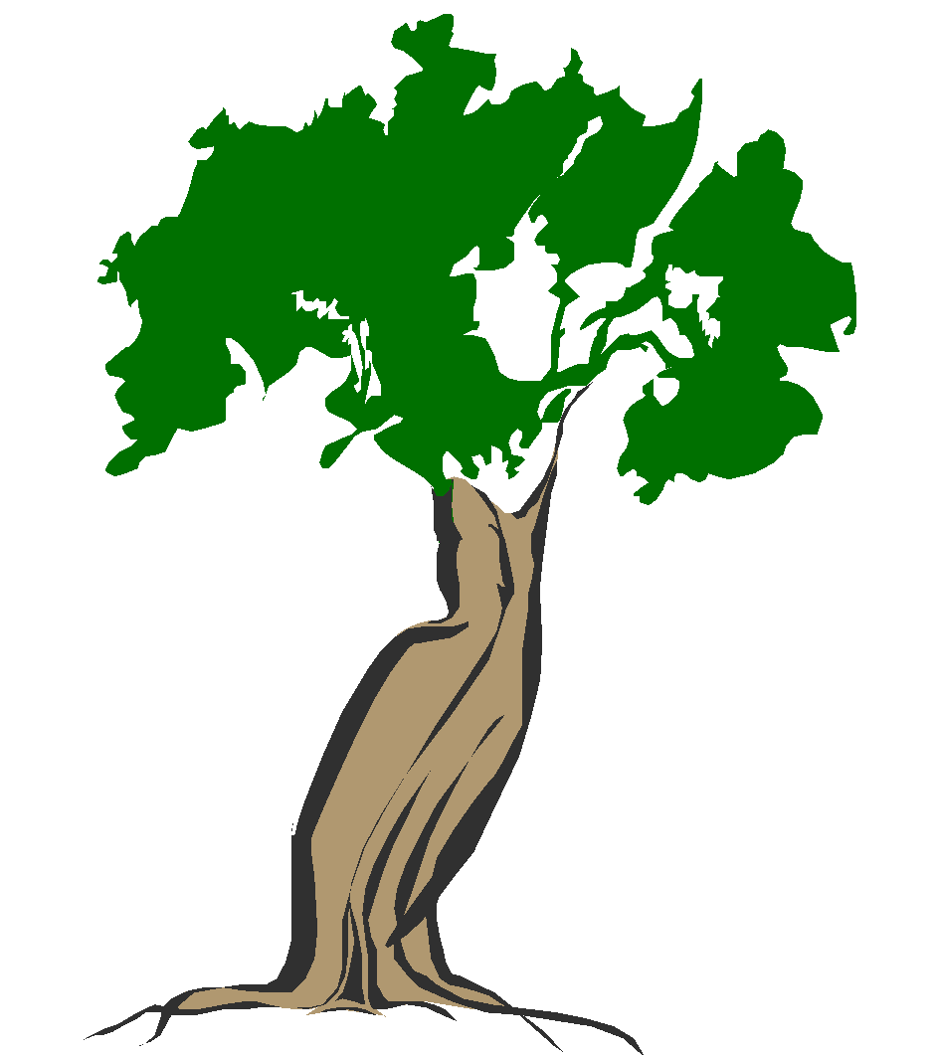


______________ __________ ______________ __________

2. Fill in the correct prepositions
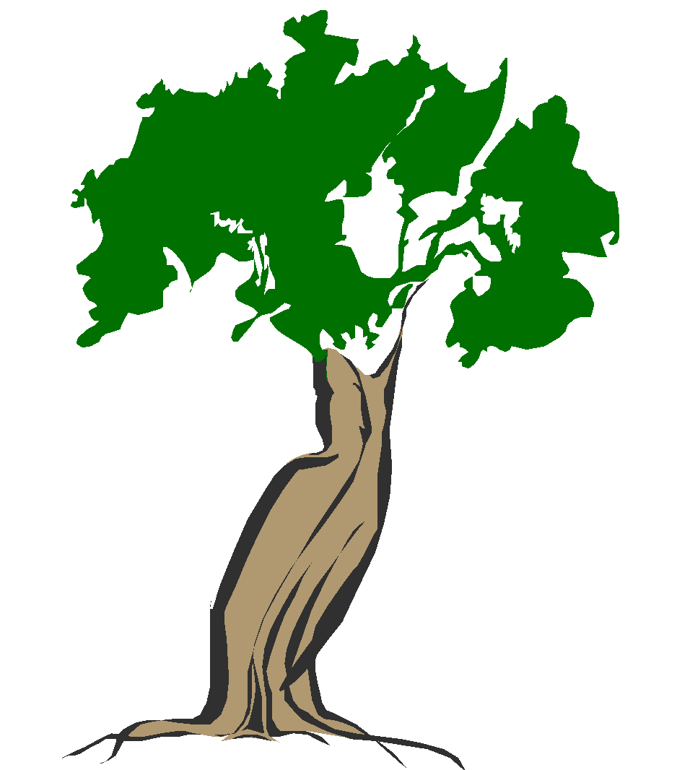
a)
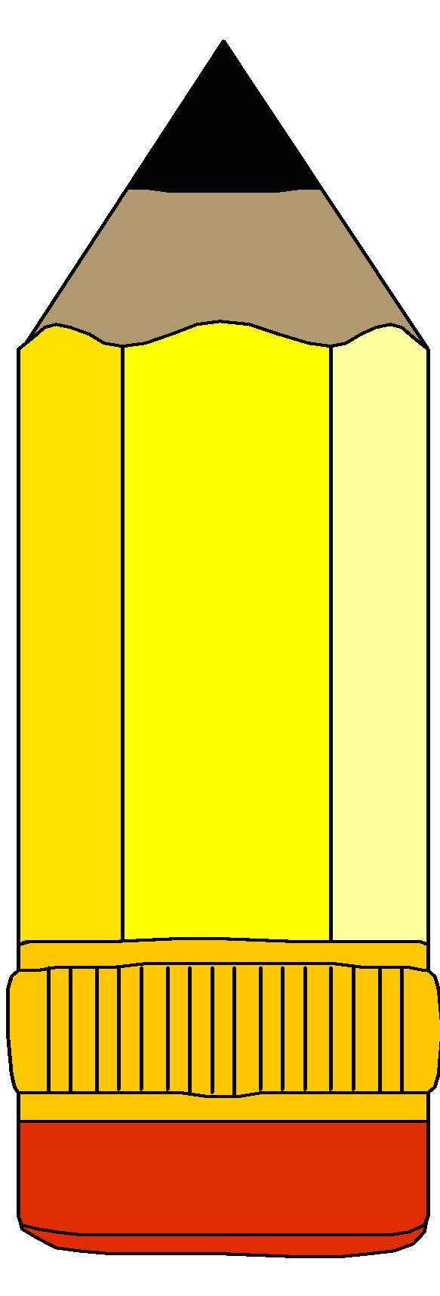
The aeroplane is flying ______________the tree.

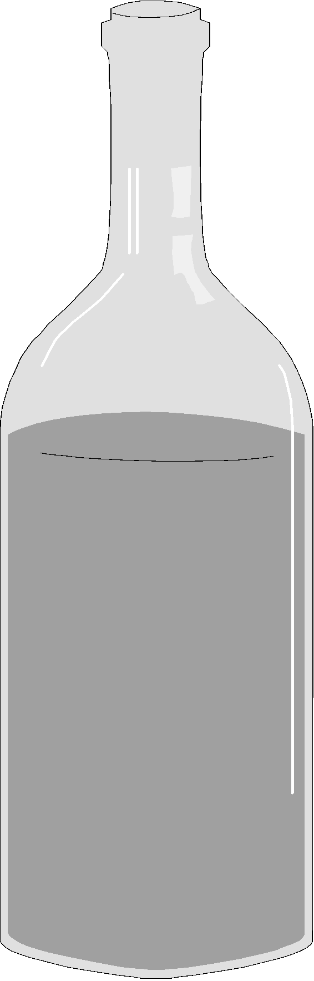
b) The pencils are _____________________the tin.

c) The bottle is ____________________the basket.
d) The ball is ______________________the chair.

3. Read and fill in the correct prepositions
a) The bird is flying ____________________the mosque.
b) Sarah is pointing ___________________the sun.
c) The boy is sitting _________________the chair.
d) The pencils are ________________the tin.
4. Tick the correct preposition in these sentences
a) Mary is pointing (under, to, at) the sun.
b) The aeroplane is flying (near, over) the hills.
c) Mummy goes to work (by, on, in ) car.
d) Safina comes to school (by, on, in ) foot.
e) Peter is looking (at, over, in ) the snake.
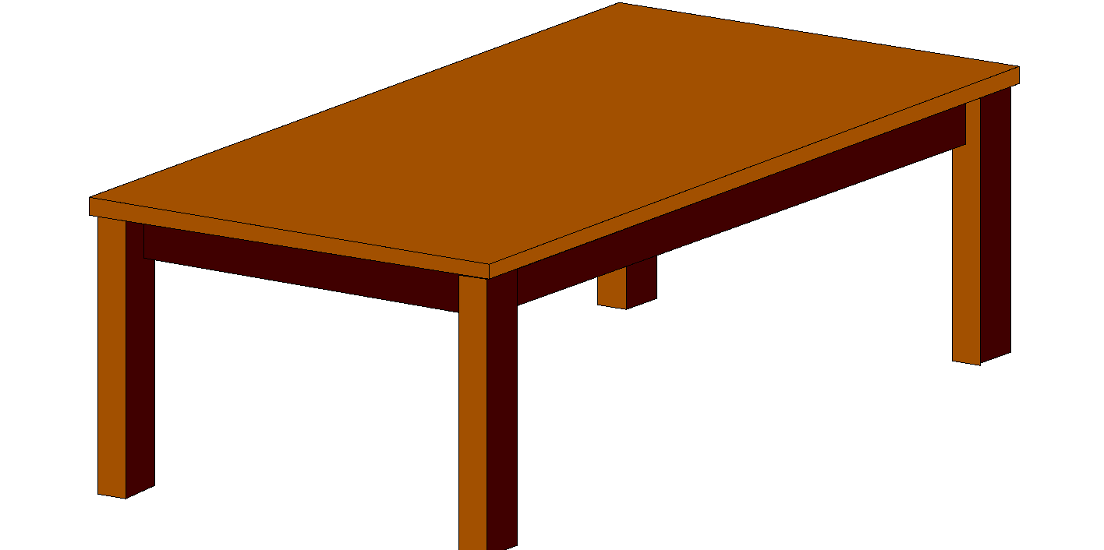
5. Make correct sentences using the snake.
a) __________________________________________________

b) __________________________________________________
c) __________________________________________________
Plurals
1. Give the plurals of these words
a) lorry ____________________ e) family ____________
b) berry ____________________ f) lady ______________
c) puppy ____________________ g) city _______________
d) country ____________________ h) fly ________________
2. Give the plurals of the words in the brackets
a) Daddy has four ____________________ (lorry)
b) There were many _________________in the saloon. (lady)
c) Mrs. Bbale has produced two ________________(baby)
d) There are many __________________at the pit. (fly)
e) Kampala and Nairobi are good _______________ (city)
Change the nouns to plural
a) Uganda is my country. __________________
b) Bob is carrying a baby. _________________
c) Dad has a lorry. _____________________
d) We have a big family. ___________________
e) She is a beautiful lady. __________________
Plurals f to v

1. Complete these
a) One leaf ten ______________ b) One wife two ______________
c) One shelf seven ________________ d) One loaf three ___________________
e) One thief six __________________
2. Give the plural of the words given
a) hoof ______________ d) calf _________________
b) knife ______________ e) half _________________
c) wife ______________
3. Change the underlined word to plural form
a) The cow has a calf. __________
b) Mr. Musis married a beautiful wife. ______________
c) The thief was found stealing our hens.____________
d) The leaf is on my bed _____________
Fill in the plurals of the words in brackets
a) The ___________________are green. (leaf)
b) The ___________________were killed and burnt. (thief)
c) Betty bought two _________________of bread for break. (loaf)
d) Our _______________are sharp. (knife)
Present continuous tense.
1. Change the given verbs to present continuous tense
a) get ___________ e) clap ________________
b) run ____________ f) win ________________
c) stop ____________ g) swim ________________
d) skip ____________ h) mop ________________
2. Use the given verb in the bracket and add “ing”
a) We are ____________________on the floor. (sit)
b) The children are ___________________for the visitors. (clap)
c) The girl is ______________ to school. (run)
d) Bbale is _________________in the garden. (dig)
3. Write a correct sentence about the pictures using these verbs
Sitting, skipping, digging, running
a) ______________________________________________________
b) ______________________________________________________

c) ________________________________________________________
d) ________________________________________________________
Past tense
1. Give the pas tense of the given verbs
a) stop ____________________ d) clap _______________
b) mop ____________________ e) skip ________________
c) drop ____________________ f) shop ________________
2. Add “ed” to the verbs in brackets and fill in the gaps
a) The children ______________________for the visitors. (clap)
b) The girls _______________________their classrooms last Saturday. (mop)
c) Sarah and Betty _____________________a rope yesterday. (skip)
d) Our driver _______________________ us at school in the morning. (stop)
Punctuations (comma)
1. Put a comma where necessary
a) Patricia has a book a pencil and a rubber.
b) Mary bought ice cream soda and safi juice.
c) My mother gave me bread milk and eggs.
d) Betty Berna and Bridget are sisters.
e) Mummy has a bag a coat and a scarf.
Capital letters
2. Write capital letters where necessary
a) my name is jane.
b) I live at busega.
c) my school is kampala model.
d) betty and bosco are friends.
e) I was born in april.
f) today is Friday.
Punctuate these sentences correctly
a) alice is a beautiful girl.
b) today is monday
c) keith is going to bwaise.
d) I have a bag a coat and an umbrella.
2. Write these words in full
a) sun. ___________________ b) Tue. _______________
c) Thur. __________________
3. Write the names of the days in short
a) Wednesday ___________________ b) Saturday _______________
c) Monday _______________________
4. Fill in the missing days of the week
a) Sunday, ______________, Tuesday, Wednesday, _____________, Friday, Saturday
5. Write in short these months of the year.
a) December ________________ b) October __________________
c) November ___________________
6. Write in full
a) Aug. ______________________ b) Feb. __________________
c) Jan. ____________________
7. Write the short forms of these words
a) Doctor ___________________ b) school _______________
c) Teacher ___________________
8. Write in full
a) Hosp. ________________________ b) Rd. _________________
c) No. _________________
Opposites
1. Give the opposites of these words
a) long ___________________ b) clean __________________
c) good ___________________ d) near ___________________
2. Give the opposite of the word given in brackets to complete the sentences
a) Mary’s pencil is _______________ . (long)
b) Our compound is very _______________ . (dirty)
c) I have a ______________ head. (small)
d) The baby’s tea is very ______________ . (cold)
3. Write the opposite of the underlined word
a) Sarah comes from far. ____________
b) Our school is big. __________________
c) A giraffe is very tall. _________________
d) The tea is very hot. _________________
Describing objects
Use these words correctly
(big, short, tall, small, long)
Tree A is a _______________________ tree.
A B Tree B is a _________________________tree.

B
Box A is a _______________________ box.
A
Box B is a _________________________box.
Ruler A is a _______________________ ruler.
Ruler B is a _________________________ruler.

A B
Adjectives
Complete the given table correctly
tall | ___________ | tallest
short | shorter | ___________
long | ___________ | longest
big | bigger | ___________
small | ___________ | smaller
Doing words
1. Add ies to the given verbs

a) try _______________ c) dry ____________
b) cry _______________ d) fly ____________
Use the verb given in brackets to complete the sentences
a) My grand mother _____________groundnuts everyday. (fry)
b) The baby ________________for milk.
c) An aeroplane __________________over our school everyday. (fry)
d) Teo _________________ a basket of yellow bananas every evening. (carry)

ENGLISH LESSON NOTES FOR PRIMARY ONE TERM III
THEME : TRANSPORT
Sub theme : types of transport
Vocabulary
Road, water, air, railway
Structures
What is this / that?
This/ that is ……………………………
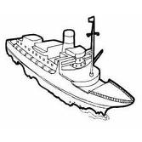
Examples
What is this?
This is water transport

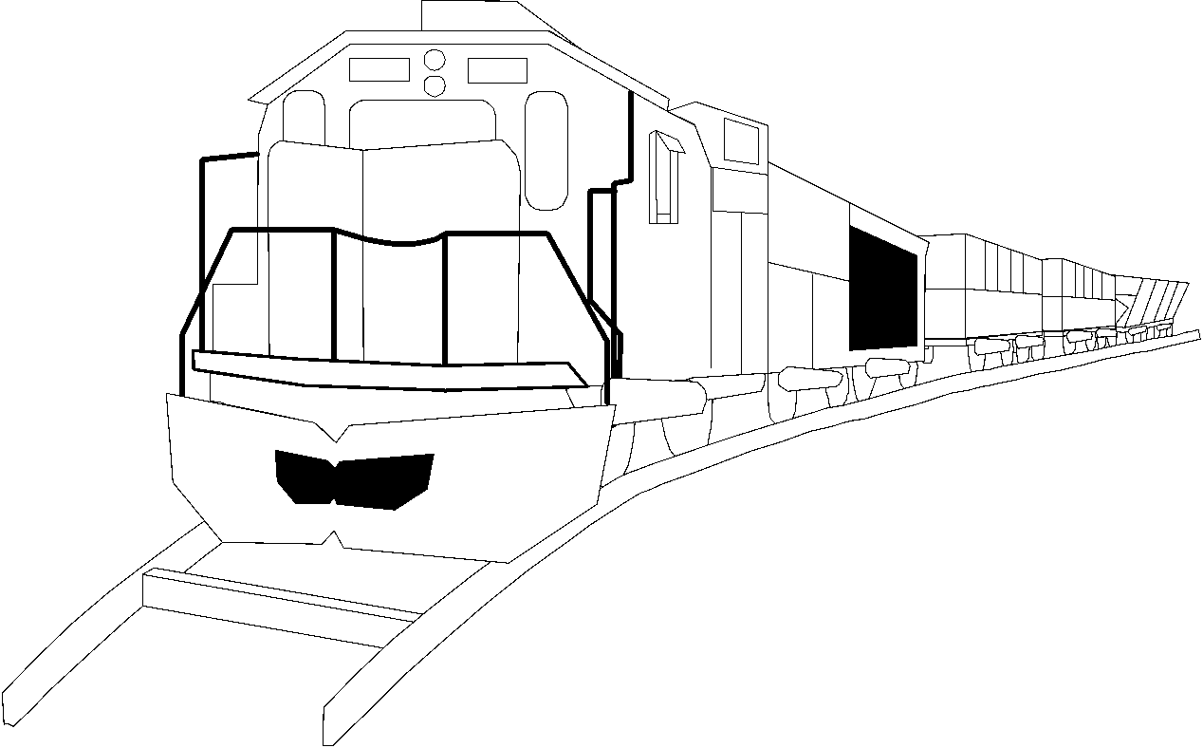

What is that?
That is railway transport

Activity
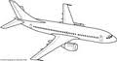
Answer correctly
What is this? (aeroplane)
……………………………………………..

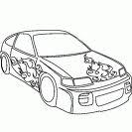

What is this? (car)
………………………………………..

SUB THEME: MEANS OF TRANSPORT
Vocabulary
Car, bus, train, aeroplane, bicycle
Structures
What are these/ those?
These are ……………….
Those are ……………………………..
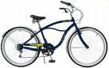
Examples
What are these?
These are bicycles.
What are those?
Those are cars.

THEME: THINGS WE MAKE
Sub theme: things we make
Content: vocabulary
Pots, ropes, baskets, balls, stools
Structures
Where is the…………….?
What are these?
Examples
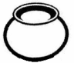
What are these?
These are……………….
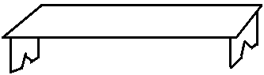
Where is the ball?
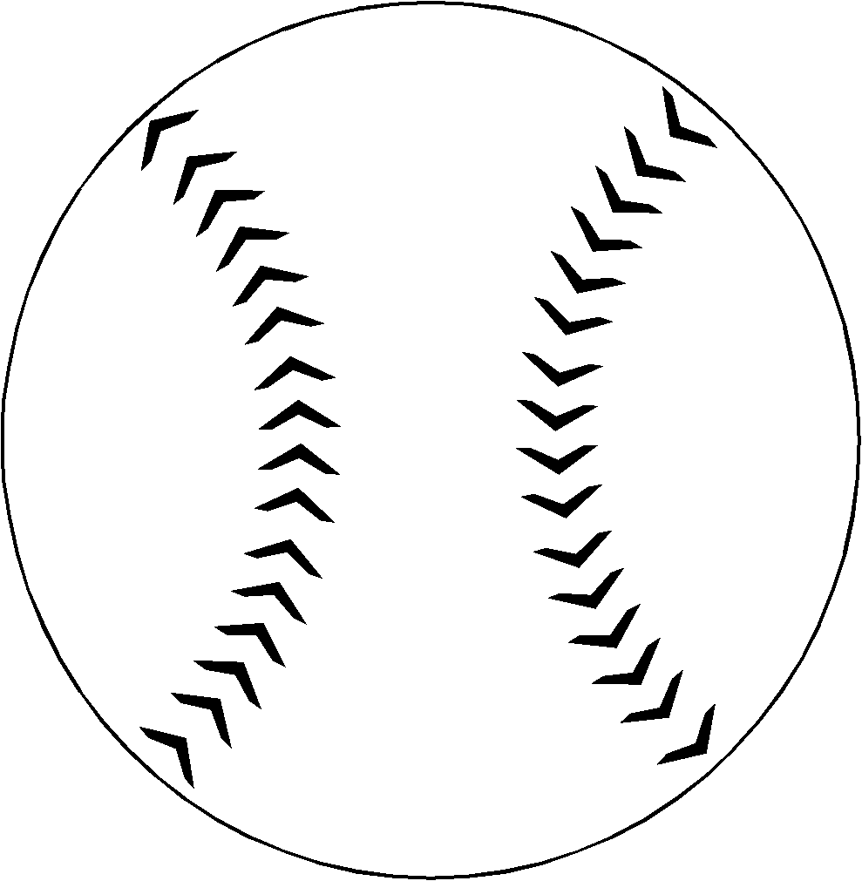
The ball is under the bench.

Activity

- What are they?
……………………………………..
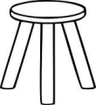
- Is this a stool?
………………………………………
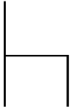

- Where is the pot?
……………………………………..


- Are these ropes?
……………………………….
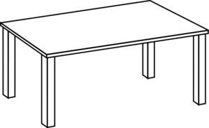
- What is this?
…………………………….

Sub theme: things we use to make crafts
Vocabulary
Banana fibre, strings, paper, papyrus, leaves
Structures
What do you use to make……………………….?
I use ……………….to make……………
Example
What do you use to make a mat?
We use palm leaves.
Activity
- What do you use to make a ball?
…………………………………………………
- What do you use to make a stool?
……………………………………………….

THEME: ENVIRONMENT
Sub theme: things found in our environment
Content: vocabulary
Animals, plants, stones, buildings, birds, insects
Structures
What are they? They are……………..
What are these? These are ……………..
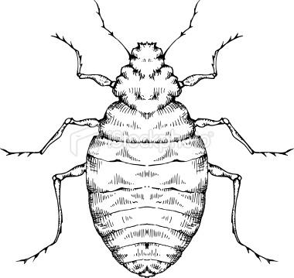
Examples
What are these?
These are insects.

Are these stones?
Yes, they are.
Activity
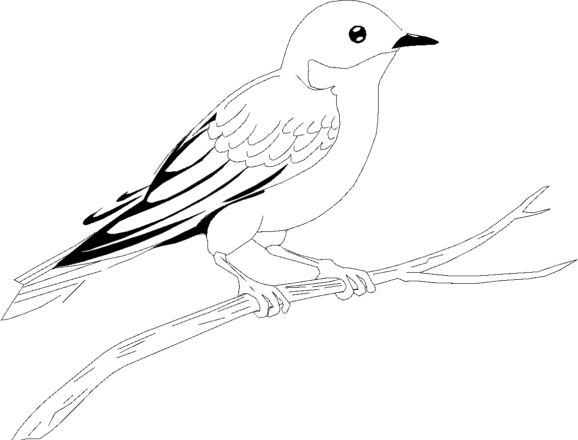
Answer correctly
- Is this a bird?
……………………………………………..
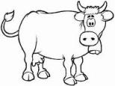
- Are these animals?
……………………………………………..

- Are these buildings?
………………………………………………
- These are ………………………
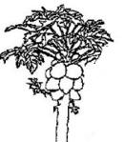

- They are……………………………

SUB THEME: ANIMALS IN OUR ENVIRONMENT
Vocabulary
Cow, pig, goat, sheep, monkey, lion, zebra, snake
Structures
What is this………..?
This is a ………………..
Is this a ……………….?
Yes, or No, it is ……………….
Examples
What is this?
This is a cow.

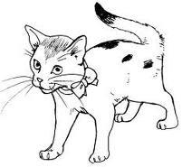
Is this a pig?
No, it is not.
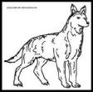
Activity
- What is this?
……………………………………………………..
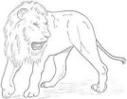
- Is this a monkey?
…………………………………………………..
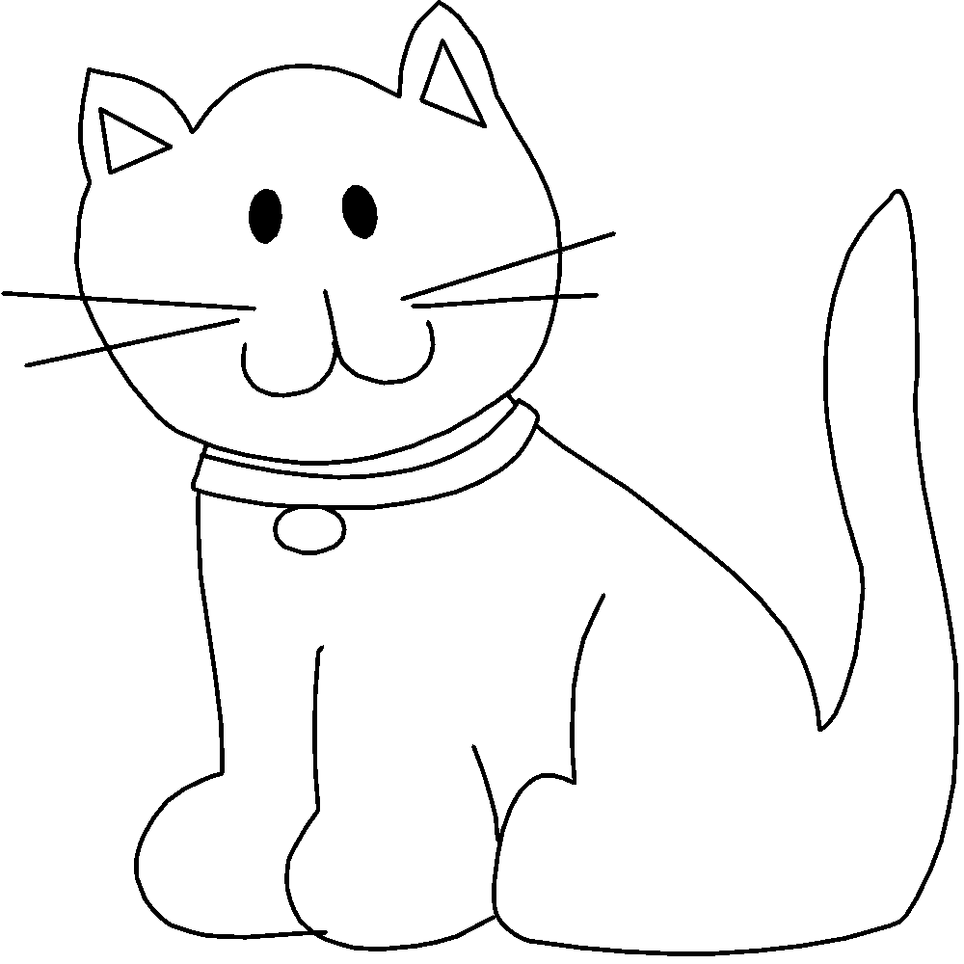
- What are these?
…………………………………………………..

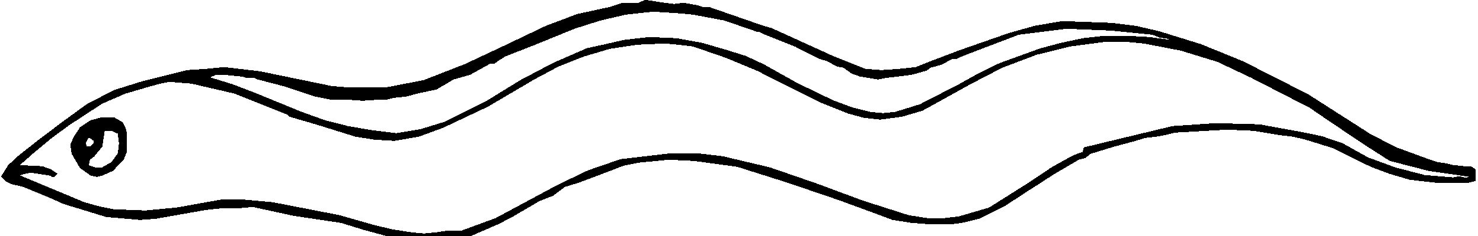
- Are these snakes?
………………………………………………….

THEME: PEACE AND SECURITY
Sub theme: good behavior
Content: vocabulary
Peace, love, safe, share, work, pray
Structures
What are they doing?
They are ………………….
Examples
We should work together.
We should love one another.
Activity
- We should keep………………………
- We should………………………
- We should ………………..one another.

Sub theme: things that cause harm
Vocabulary
Gun, spear, knife, needle, stone, stick
Structures
Do you have a ………………?
Yes or No
Examples
Do you have a gun? No, I don’t have a gun.
Do you have a knife? Yes, I have.
Activity
- Do you have a spear?
- Do you have a needle?

THEME : Transport and Communication
SUB THEM : Types of transport
CONTENT : Conjunctions
Joining sentences using “and”
Examples
1. Ali is going to the lorry. Ann is going to the lorry.
Ali and Ann are going to the lorry.
2. The bird is flying in the air. The aeropland is flying in the air.
The bird and the aeroplane are flying in the air.
Exercise
1. John drove the car very fast. Peter drove the car very fast.
2. Henry rode the bicycle. He went home.
3. Tom is a fat boy. Tim is a fat boy.
4. My father has a boat. My mother has a boat.
5. The baby is eating food. The baby is drinking milk.
THEME : Transport and Communication
SUB THEM : Types and means of transport
CONTENT : joining sentences using “but”
Examples
1. Musa went to the airport. He did not see the aeroplane.
2. Musa went to the airport but he did not see the aeroplane.
3. My brother went to the stage. He missed the bus.
My brother went to the stage but he missed the bus.
Exercise
1. Sarah has a bicycle. She doesn’t know how to ride it.
2. Tim fell off his motorcycle. He did not get hurt.
3. They went to the port. The ship had gone.
4. Sandra is ill. She does not want medicine.
5. The fox chased a rabbit. It did not catch it.

THEME : Transport and Communication
SUB THEM : Types and means of transport
CONTENT : joining sentences using “because”
Examples
- Tom went to the hospital. He was sick.
Tom went to the hospital because he was sick.
- I didn’t go to school. It rained heavily.
I didn’t go to school because it rained heavily.
Exercise
- The baby is crying. It is hungry.
- We go to school. We want to learn.
- The girl is using an umbrella. It is raining.
- The children are laughing. They are happy.
- Sarah was punished. She failed the work.

SIMILES
Examples
1. As green as grass
2. As cold as ice
3. As sweet as honey.
4. As hot as fire.
5. As white as snow.
7. As black as charcoal.
8. As fat as a pig.
9. As busy as a bee.
10. As easy as ABC
Exercise
Complete these sentences
This water is as cold as ________________
The tea is as _______________ as fire.
Her blouse is as white as ______________
My friend is as ____________as a pig.
THEME : Transport and Communication
SUB THEM : Types and means of transport
CONTENT : Group names
Examples
- Oranges, mangoes, apples, pineapples are fruits.
- Flat, bungalow, hut, unipot, are houses.
- Shirt, blouse, skirt, dress are clothes.
- Chairs, tables, beds, cupboards are furniture.
Exercise
Circle the odd word out
- Hen, turkey, monkey, duck.
- Monkey, cow, lion, elephant
- Plates, cups, saucepans, forks
- Blue, yellow, goat, black
THEME : Transport and Communication
SUB THEM : Types and means of transport
CONTENT : collective nouns
Examples
- A bunch of bananas/keys
- A pair of shoes.
- A suit of clothes.
- A herd of cattle.
- A flock of sheep.
- A crowd of people.
- A bouquet of flowers.
- A heap of sand.
Exercise
Complete these sentences using a correct word from the list below.
Bunch, bar, pair, people, cattle
- I am going to buy a _______________of soap.
- I saw a crowd of _________________
- Daddy bought a __________________of bananas.
- A herd of _______________
- She was given a _________________of shoes.
THEME : Transport and Communication
SUB THEM : Types and means of transport
CONTENT : punctuation
Use of a comma (,)
Why do we use a comma?
To separate items on the list and to show a pause.
We do not use a comma after “and”
Examples
- Peter, James and Sarah are my friends.
- My sister bought sweets, cakes toys and pencils.
Exercise
Put a comma where necessary.
- My brother gave me an egg a sweet and bread.
- I have books pencils and rubbers.
- Kato Bbosa and Brian are friends.
- Jane bought mangoes oranges pineapples and apples.
- We learn English Maths News and Literacy
HEME : Transport and Communication
SUB THEM : Types and means of transport
CONTENT : punctuation
Use of a question mark (?)
We put a question mark at the end of an asking sentence
Examples
What is your name?
Is this your pencil?
How old are you?
Exercise
- Why were you crying this morning?
__________________________________
- Can you lend me a pen?
__________________________________
- Have you seen that cat.?
__________________________________
- Is this your book?
__________________________________
- Where are you going?
__________________________________
THEME : Transport and Communication
SUB THEM : Types and means of transport
CONTENT : Past Simple tense
Examples
Go - went drive - drove
See - saw do - did
Eat - ate fall - fell
Run - ran sit - sat
Write - wrote draw - drew
Exercise
Verbs which don’t change
Example
Cut - cut burst - burst
Put - put cost - cost
Shut - shut set - set
Beat - beat read - read
Hurt - hurt hit - hit
Exercise
Give the past tense of these words
Put _______________ set __________________
Beat _______________ hit __________________
Burst _______________ cut _________________
Fill in the gap with the correct form of the verb given in brackets
- The boy ________________ a snake under the bed yesterday. (see)
- My father ___________________to London last week. (go)
- We __________________rice last night. (eat)
- Joseph _________________ a lorry last week. (drive)
- My teacher ___________________on the chalkboard yesterday. (write)
THEME : Transport and Communication
SUB THEM : Types and means of transport
CONTENT : plurals
Plurals of nouns which change
Examples
Man - men ox - oxen
woman - women child - children
tooth - teeth louse - lice
goose - geese mouse - mice
foot - feet
Exercise
Give the plurals of the underlined word
- My tooth is broken. _________________________
- The child is running in the field. __________________
- The cat caught a mouse. _____________________
- Mukasa is a man. ____________________________
- The woman is carrying a baby. ___________________
THEME : Things we make
SUB THEM : Things we make at home and at school
CONTENT : words with similar meaning (synonyms)
Examples
Close - shut big - large
correct - right sick - ill
begin - start happy - glad
fast - quick money - cash
Exercise
Make sentences using these words
big: _______________________________________________________________
sick: _______________________________________________________________
money: ______________________________________________________________
shut: ______________________________________________________________
right: ______________________________________________________________
THEME : Things we make
SUB THEM : Things we make at home and at school
CONTENT : analogies (comparing things)
Examples
A cat is to kitten as a cow is to calf.
A driver is to car as a pilot is to an aeroplane.
A puppy is to dog as a duckling is to duck.
Exercise
Complete these sentences
- A chick is to hen as a kid is to ____________________________
- A ____________________is to barking as a snake is to hissing.
- A teacher is to teach as a ___________________is to cook.
- A cow is to kraal as a lion is to _________________________
- A pencil is to write as a _____________________is to sweep.
THEME : Things we make
SUB THEM : Things we make at home and at school
CONTENT : Homophones
These are words with similar sound but different meaning.
Examples
Hear - here their - there
It - eat ship - sheep
Shut - shirt sun - son
Meet - meat sit - seat
Write - right knows - nose
Exercise
Match words with similar sounds
Ship son
It there
Meet sheep
Their eat
Sun meat

THEME : Things we make
SUB THEM : Things we make at home and at school
CONTENT : Vocabulary
Examples
mat toys
ball hats
rope chairs
pot stools
basket dolls
exercise
name these things we make

_____________________ _______________________

_____________________ _______________________

THEME : Peace and Security
SUB THEME : People who keep peace and security
CONTENT : Gender
Examples
Male Female
Boy girl
Man woman
King queen
Prince princess
He she
Mr. Mrs.
Lion lioness
Tiger tigress
Bull cow
Horse mare
Cook hen
Uncle aunt
Exercise
Change the female noun to male
- My ____________________is hardworking. (daughter)
- I love my ___________________ . (grandmother)
- _________________ has not come to school. (she)
- All the ________________________stood up. (girls)
- Faridah spent holidays with her ____________________ . (aunt)
THEME : Peace and Security
SUB THEM : People who keep peace and security
CONTENT : Adjectives
Comparing adjectives
Examples adjectives which double their last letters
big | bigger | biggest
Thin | Thinner | Thinnest
fat | fatter | fattest
Wet | Wetter | Wettest
Hot | Hotter | Hottest
Sad | Sadder | saddest
Examples
A cow is bigger than a goat.
Father is fatter than mother
Activity
Complete the sentences with the words in brackets
- Annet is ………………….than Lynn. (tall)
- My tea is ……………..tha yours. (hot)
- An elephant is……………..than a pig. (big)
Exercise
Complete this table
Wet | ______________ | Wettest
thin | thinner | ______________
______________ | Bigger | Biggest
Sad | ______________ | Saddest
Hot | Hotter | ______________

Apostrophe
It shows ownership or belonging
Sarah’s bag
Daddy’s car.
Activity 1
Put the apostrophe where necessary
Peter s bicycle
Mum s bag
Daddy s coat
Teacher s phone
Annets dress
Joining other words to pronouns in sentences
Examples
He is running
He’s running
Activity
Write the underlined words in short
She is sitting on the chair.
I am going to school.
It is raining.
I have a bag.
Activity
Write the short way of these sentences
- The car which belongs to Jane. Jane’s car.
- The den of the lion.
- The toil of the cat.
- The book belonging to Tom.
- The horn of the cow.
The apostrophe used to join two words
Not – n’t
Write in short using an apostrophe
Is not isn’t
Do not don’t
Have not haven’t
Does not doesn’t
Are not aren’t
Has not hasn’t
Did not didn’t
Cannot can’t
Activity
Write the short forms of the underlined words
- Peter does not like porridge.
- He did not go to school.
- I have not eaten food.
- Joshua is not my friend.
Write in short form using an apostrophe
Is – ‘s
Are – ‘re
Have – ‘ve
She is - she’s
We are – we’re
That is – that’s
They have – they’ve
It is – it’s
I have – I’ve
She has – she’s
Sentences
She is my friend
She’s my friend
That is her bag
That’s her bag.

Activity
Write the short form of the underlined words
- I have a book.
- We are singing.
- It is a bottle
- They have gone to school.

Possessive pronouns
Examples
Yours, ours, theirs, his, hers, mine
Sentences
This is your bag. It is yours.
That is our school. It is ours.
Activity
Fill in the correct pronoun below
- This is our dog. It is …………………..
- Here is my cat. It is …………………….
- This is Tom’s pencil. It is ……………………
- Here is Mary’s dress. It is ……………………

TOPICAL REVISION QUESTIONS FOR TERM III PRIMARY ONE
Join these sentences using “and”
- John is a boy. Tom is a boy.
____________________________________
- Sarah has a car. Sarah has a lorry.
____________________________________
2. Use “but” to join these sentences
a) Mary has a mat. Ann has a ball.
b) We went to the airport. We didn’t not see the aeroplane.
c) James fell off his bicycle. He was not hurt.
3. Complete these sentences
a) As green as ______________________
b) A __________________of sound.
c) Her porridge is as hot as _________________
d) We saw a ________________of cattle when going to village.
4. Underline the odd one out
a) blue mango black red
b) cow goat sheep lion
c) man woman girl tree

Past tense
- We ______________________to the airport the previous term. (go)
- Jane ___________________her finger yesterday. (cut)
- I was ___________________by a stone last night. (hit)
- The bird ___________________over the tree yesterday. (fall)
- She ____________________her books on the book shelf last evening. (put)
Plurals of nouns which change
Write the plurals of these nouns
- Child _________________ d) woman _________________
- Man _________________ e) louse _________________
- Foot _________________ f) ox _________________
Write the plurals of the underlined words
- My tooth is broken. _________________
- We have one ox at home.__________________
- A cat caught a mouse. ___________________
- Mukisa is a good man.___________________
- Change the given words to their correct form of plurals
- All the ___________________are very rich. (woman)
- We have many ___________________at home. (mouse)
- The _____________________are playing. (child)
- There are three __________________ . (man)
Synonyms:
- Match word with similar meaning
Sick large
Correct glad
Big cash
Happy ill
Money right
- Make sentences using these words
shurt ________________________________________________________
ill ___________________________________________________________
right _________________________________________________________
large ________________________________________________________
Write a similar word of the underlined word
- My answer is right. ________________________________
- The lesson has started. ____________________________
- Give me some cash. ______________________________
- Close the door. __________________________________
- My car is fast. ___________________________________
Analogies
- Complete these sentences
- A pen is to write as a _______________is to sweep.
- A dog is to _________________as a cow is to kraal.
- A chick is to hen as a kitten is to __________________
- A teacher is to _________________as a cook is to cock.
- A ____________________is to dog as a duckling is to duck.
- Carry is to __________________as go is to going
- Woman is to women as louse is to _____________________
- A _________________is to car as a pilot is to an aeroplane.
- A dog is to _____________________as a snake is to hissing.
Homophones
- Match words with similar sounds
Sheep sun
Their sit
Son ship
Meet hear
Seat there
Here meat
- Choose a correct word for the given sentence
- My father has one _________________ . (son, sun)
- We ate _______________ last supper. (meet, meat)
- He _______________my name. (nose, knows)
- My _________________is small for me. (shut, shirt)
- We travelled by a ________________on water. (ship, sheep)
- _____________ are many cars in town. (There their )
- _______________is mother and daddy. (Hear, Here)
Things we make at home and at school
Name these things we make

a) _____________________ e) _____________________

b) _____________________ f) _____________________

c) _____________________ g) _____________________

d) _____________________ h) _____________________

Write these words correctly
- oostl _____________________ b) tbale __________________
c) blal _____________________ d) basket __________________
e) hacir ____________________ f) pero __________________
3. fill in the missing letters
a) m____t b) cu ______ c) st ___ ____l
d) ta ____le e) de ____k f) be _____ch
g) b ____sk ____t h) ch ____ir
Gender
- Fill in a correct gender word
Male Female
Lion ______________
Prince ______________
____________ cow
Cock ______________
Uncle ______________
____________ queen
Horse ______________
- Change the given female nouns to male
- My ____________________is hardworking. (daughter)
- I love my ___________________ . (mother)
- _______________ has not come to school. (she)
- All the _________________stood up. (girl)
- My father’s _________________is dead. (cow)
- The __________________arrived very late. (queen)
- Write the opposite gender of the underlined words.
- Mary is a good girl. _________________
- The lioness is hungry. __________________
- The bitch has four puppies. _______________
- Mr. Kato is a tall man. ___________________
- The cock is scratching __________________
- Comparing adjectives
Complete the table correctly
big | ______________ | biggest
thin | thinner | ______________
strong | stronger | ______________
______________ | ______________ | fattest
wide | wider | ______________

TOPICAL BREAKDOWN FOR TERM I ENGLISH FOR PRIMARY ONE
Theme: our school
- Vocabulary: greetings (good morning, evening, good afternoon, fine, how are you)
Structures: a conversation
- Vocabulary: people in our school (teacher, bursar, cook, secretary etc)
Structures: is this a ……………?
- Vocabulary: (Things we do at school) mop, learn, sweep, write
Structures: the children are……….
- Vocabulary: things in the classroom (pencils, books, tables, desks etc)
Structures: is this a …………..?
- Vocabulary: (describing things) fat, thin, big, small
Structures: The table is……………
The book is ………………..
Theme 2: our home
- Vocabulary: people in our home (Father, mother, sister)
Structures: mother is cooking food.
- Vocabulary: Things found at home (cup, plate, basin)
Structures: that / this is a …………………
Theme 3: our community
- Vocabulary: People in our community (nurse, farmer)
Structures: Is this a …………?
- Vocabulary: Places in our community. (bank, shop, mosque)
Structures: where does a nurse work? A nurse works in a ………………….
Theme 4: the human body and health
- Vocabulary: parts of the body (head, hand, toes)
Structures: this is my………………..
These are my…………………….
- Vocabulary: things we use to learn our bodies. (soap, towel, water)
Structures: Is this a …………….
- Vocabulary: Common diseases (flu, malaria, cough, mumps)
Structures: Are you well?
No, I have……………
Sub theme: people in our home
- The alphabet
- Nouns
- A, or an
- Plurals (s, es)
- Is and are
- Has and have
- Verbs
- The present continuous tense (now tense)
- Dropping ‘e’ and adding ‘ing’
- Was and were
- Missing letters in verbs and nouns
- Writing words correctly
- Punctuation
- Capital letters
- Full stop
- Question mark
- Opposites
- Compound words
- Prepositions
- Forming small words from big words
- Finding the odd word out

TERM II TOPICAL BREAKDOWN FOR ENGLISH PRIMARY ONE
Theme 1: Weather
- Vocabulary on the elements of weather (sun, wind, rain)
- Structures: (IS this a ………, Is it raining?)
- Vocabulary on types of weather. (rainy, sunny, windy)
- Structures: (What is the weather like? It is ……………….)
- Vocabulary on garden tool
- Structures: What is this/ that , This / that is ………………)
- Vocabulary on things we use on during different weather (shirt, sweater, jacket, umbrella)
Theme 2: accidents and safety
- Vocabulary: (things that cause accidents) fire, razorblade
Structures: show me a knife
- Vocabulary: (Types of accidents) cuts, falls, burns
Structures: A ……………….cuts
Theme: 3: living together
- Vocabulary: (family members) sister, mother, father
Structures: He is my…………
Theme 4: Food and nutrition
- Vocabulary: (examples of food) bananas, fish, beans, peas, eggs etc
Structures: What are they?
Is this a …………….
- Vocabulary: (Places where we get food from) market, garden, lakes, shop
Structures: Where do we get eggs? / Is this a ………….?

- Arranging letters in alphabetical order
- Arranging words in alphabetical order
- Prepositions
- Plurals e.g. (y – ies)
- Plurals (f, ves)
- Doing words doubling the last letter, then add(ing)
- Doubling the last letter add(ed)
- Use of a comma
- Use of a capital letters
- Short forms for days of the week
- Short forms for months of the year
- Opposites
- Adjectives
- Comparing adjectives
- Pronouns
- Past tense of adding ‘d’
- Past tense of adding ‘ed’
- Past tense of adding ‘ied’
- Present simple tense of adding ‘s’
- Present simple tense of adding ‘ies’
- Do or does

TERM III TOPICAL BREAKDOWN FOR ENGLISH PRIMARY ONE
Theme 1: Our transport
- Vocabulary: Types of transport (road, air, water, railway)
Structures: What is this / that………?
Where is the ………….?
- Vocabulary: Means of transport (road – car, bus, bicycle etc and Air – aeroplane
Structures: Is this a car? Yes/ No it is……….
- Vocabulary: far , near, heavy, light
Structures: The ……………is heavier than a ……………..
Is it far/ near?
Theme 2: things we make
- Vocabulary: (examples of things we make) balls, ropes, baskets
Structures: Are these……….?
Can you make a ………….?
- Vocabulary: (Things used to make crafts) banana fibres, papyrus, clay
Structures: What do you use to make…………..?
- Vocabulary: (Where we get things used to make crafts) swamps, plants etc
Structures: Where do we get………?
Theme 3: our environment
- Vocabulary: (animals found in the environment) cow, goat, sheep etc
Structures: Is this a …………?
- Vocabulary: (plants found in the environment pawpaw, mango, orange
Structures: Is this a………..?
Theme 4: Peace and security
- Vocabulary: (fight, fire, like, hate, play, pray, share)
Structures: What do you like/ hate…………?
- Vocabulary: (gun, spear, knife, needle, stone, stick)
Structures: Do you have a……….
What is this?
- Vocabulary: (peace, love, safe, share, play, talk) What are they doing?
Structures: dialogue
- Vocabulary: (policeman/ woman, teacher, elder, soldier)
Structures: What can you see?
- What is she/he?

- And
- But
- Similes
- Because
- Group names
- Collective nouns
- Use of a comma
- Use of a question mark
- Past tense
- Plurals (man – men)
- Synonyms
- Analogies
- Homophones
- Things we make
- Gender
- Comparing adjectives
- Apostrophe
- Short forms using an apostrophe

