NAME INDEX

SCHOOL DATE

CROP PRODUCTION – LAND PREPARATION
- 1994
State 4 reasons for primary cultivation.
………………………………………………………………………………………………………………………………………………………………………………………………………………………………………………………………………………………………………………………………………………………………
- 1997
State four reasons for primary cultivation.
………………………………………………………………………………………………………………………………………………………………………………………………………………………………………………………………………………………………………………………………………………………………
- 1999
State four factors which determine the depth of ploughing.
………………………………………………………………………………………………………………………………………………………………………………………………………………………………………………………………………………………………………………………………………………………………
4. 2000
(a) Give two reasons why the use of fire should be discouraged in clearing land
during seedbed preparation.
………………………………………………………………………………………………………………………………………………………………………………
b) Give two reasons for secondary cultivation.
………………………………………………………………………………………………………………………………………………………………………………………………………………………………………………………………………………………………………………………………………………………………
c) State two benefits of minimum tillage in crop production.
………………………………………………………………………………………………………………………………………………………………………………………………………………………………………………………………………………………………………………………………………………………………
5. 2000
List four implements used to carry out secondary cultivation
………………………………………………………………………………………………………………………………………………………………………………………………………………………………………………………………………………………………………………………………………………………………
6. 2001
State two causes of hard pans in a crop field.
………………………………………………………………………………………………………………………………………………………………………………
7. 2001
Give the maintenance practices of a disc plough. ………………………………………………………………………………………………………………………………………………………………………………………………………………………………………………………………………………

- 2002
State reasons why use of fire in clearing land is discouraged.
………………………………………………………………………………………………………………………………………………………………………………………………………………………………………………………………………………………………………………………………………………………………
- 2003
Outline the main reasons for secondary tillage.
………………………………………………………………………………………………………………………………………………………………………………………………………………………………………………………………………………………………………………………………………………………………
- 2004
State the main benefits of minimum tillage
………………………………………………………………………………………………………………………………………………………………………………………………………………………………………………………………………………………………………………………………………………………………

11. 2004:
Give four farming practices that may help in achieving minimum tillage.
………………………………………………………………………………………………………………………………………………………………………………………………………………………………………………………………………………………………………………………………………………………………
12. 2005
a) State one condition under which a farmer would prefer to
use an ox-cart instead of tractor – drawn trailer.
………………………………………………………………………………………
b) Give three maintenance practices carried on an ox – plough.
………………………………………………………………………………………………………………………………………………………………………………………………………………………………………………………………………
13. 2007 Q1
Give four conditions of the land which may make it necessary to carry out reclamation practices. (2marks)
………………………………………………………………………………………………………………………………………………………………………………………………………………………………………………………………………………………………………………………………………………………………
14. 2009 Q24 P1
The diagram below illustrates a final seedbed after a tertiary operation done during land preparation. Study it carefully and answer the questions that follow.
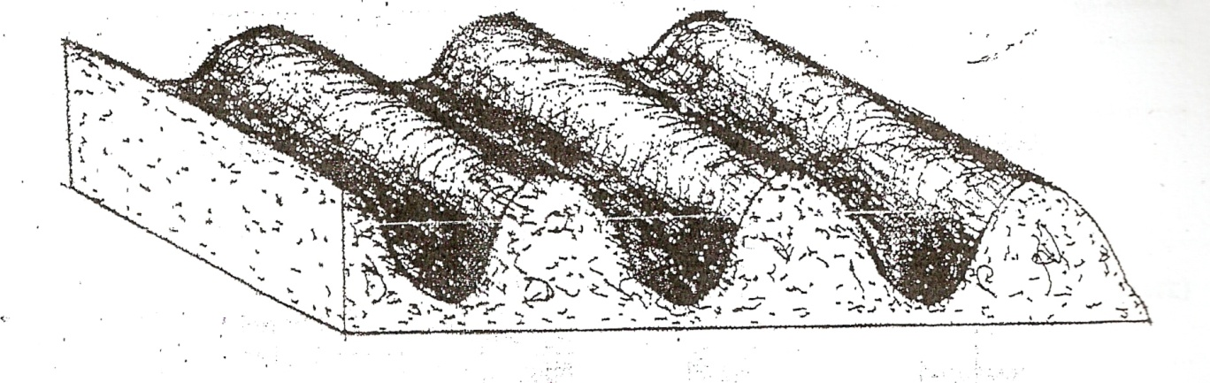
(a) Name the tertiary operation carried out on the seedbed (¹/₂ mark)
………………………………………………………………………………………
(b) Describe how the tertiary operation named in one above is carried out. (¹/₂ mark)
………………………………………………………………………………………………………………………………………………………………………………
- Give two advantages of planting crops on a final seedbed illustrated above
(2 marks)
15. 2010 Q12, 13 P2
12 Give three limitations of using solar power on the farm. (¹/₂ marks)
………………………………………………………………………………………………………………………………………………………………………………………………………………………………………………………………………

13 Why is it important to have a thermostat on a cooling system of a tractor engine?
(1 mark)
………………………………………………………………………………………………………………………………………………………………………………
16. 2011 Q4 P1
Give three reasons for early seedbed preparation (1¹/₂maks)
………………………………………………………………………………………………………………………………………………………………………………………………………………………………………………………………………

17. 2012 Q16 P1
Give four factors that influence the number of secondary cultivations in seedbed
preparation (2marks)
………………………………………………………………………………………………………………………………………………………………………………………………………………………………………………………………………………………………………………………………………………………………

